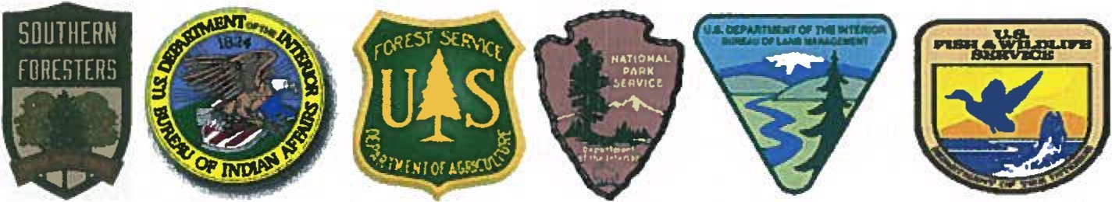
_________________________________________________________________________________________________
Southern Area Coordinating Group
1200 Ashwood Parkway, Suite 230
Atlanta, GA 30338

Delegation of Authority – FAST

Date:

To: FAST Team Leader

From: Southern Area MAC Group

Subject: Delegation of Authority FAST

The Southern Area Multi-Agency Coordination Group (SA MAC Group) hereby charters and delegates the following authority to the Southern Area Fire, Aviation & Safety Team effective DATE HERE.

The FAST will consist of the following positions:

Team Leader: NAME HERE

Occupational Health and Safety: NAME HERE

Aviation Safety: NAME HERE

Fire Operations: NAME HERE

Administrative Support: NAME HERE

The Team is to conduct an independent assessment and evaluation of operational and managerial activities on large fires throughout the Southern Area, and in the respective support and coordination centers within the area if necessary. The team should specifically review the following elements:
- Fatigue management and compliance with national direction on work/rest.
- Effectiveness of Coordination Center support, readiness, and communications.
- Incident Management Team staffing and specific safety impacts related to organization structure.
- Smoothness and effectiveness of IMT transitions, especially from extended attack or Type 3 IMT's to Type 1 or Type 2 IMT's.
- Safety issues arising from the use, or lack thereof, of contracted or local resources such as volunteer fire departments.
- Recognition by managers and incident staff of the unusual fire condition faced throughout the geographic area this year and any positive or negative safety implications of response actions for initial attack, extended attack, and large fire incidents.
- Aviation operations, command and control, training and qualifications, prevention activities, and other associated program elements as determined necessary by the FAST.
- Any issues the IMT, local unit line officer or FMO ask you to address.

The FAST is to visit Type 3 incidents in the designated incidents or areas, and other incidents as determined appropriate, but only after communication with the appropriate agency representative on the MAC group.

The Agency MAC representative will notify the fire host unit of the pending visit by the FAST. The Coordination Centers will notify the IC and host unit. The FAST will make positive contact with the IC and host unit upon arrival at the incident and closeout with the IC and host unit before departure, leaving a draft copy of the review report.

The FAST will contact the MAC Group Coordinator at least once per day providing an update on findings, issues, and proposed activities for the next day.

The FAST will provide a final written report to the SA MAC Group Coordinator upon completion of the review.

