How to Request UMA Roles:

First you need to login to NRM (formally I-Web) at: https://iweb.fs.usda.gov/login/welcome.html. Add the URL to your Internet favorites.

1. Choose: NRM Full Access>Default NRM Dashboard.

2. The eAuthentication Warning screen will appear. Agree to the statement. The eAuthentication access screen will appear. Enter your eAuth User ID and password and select Login. You cannot use your LincPass.

3. If this is your first time to login to I-Web you will go immediately to the Topics>System Maintenance>User Management Application>User Management Application Profile screen.

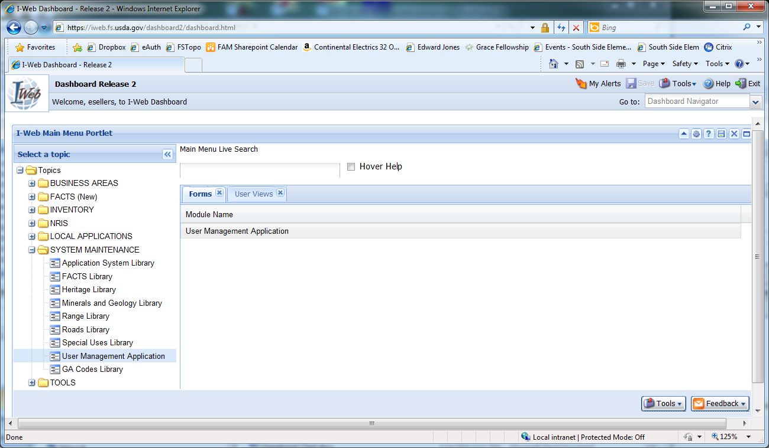

It is extremely important that you enter your phone number, select home organization, enter your supervisor’s name and save your profile.

Under My Profile choose View and Request Changes.

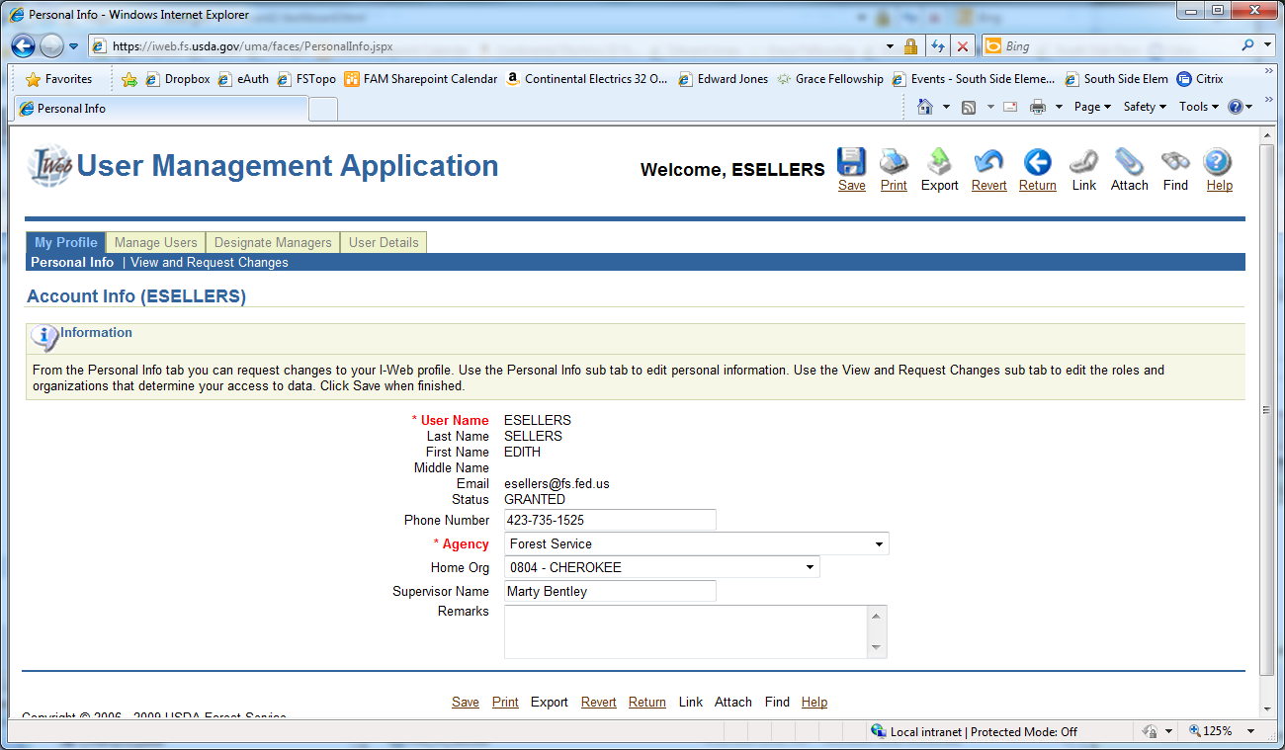

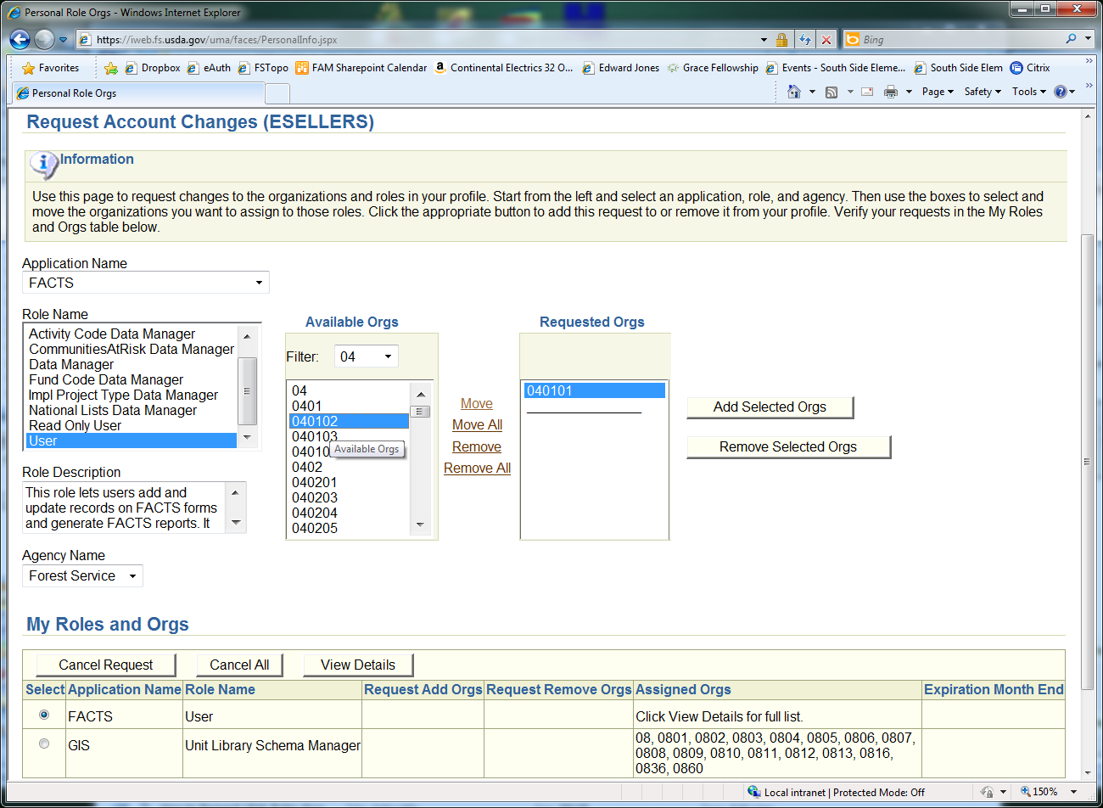

Be sure to click Save below My Roles and Orgs, then do the Same thing for GIS.

Once you save and close, you will need to talk with your local GIS Coordinator to give you access to edit your local Activity Polygons & access to your local T:Drive data folders. They will know what you mean. If not have he/she call me.

