NWCG TRAINING COURSES
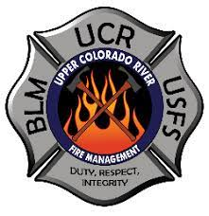
This course will be taught by instructors from the Upper Colorado River Interagency

S130/S190
Dates: February 24/25/26, 2023
March 3/4/5, 2023
    - Friday classes are 6pm to 10pm
    - Saturday classes are 8am to 6pm
    - Sunday classes are 8am to 6pm

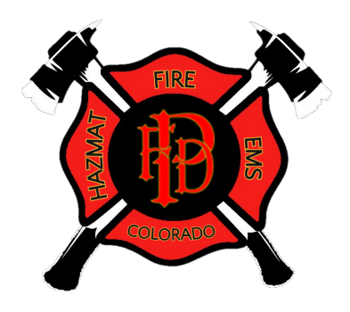
S131 Firefighter Type 1
Date: Saturday March 18, 2023
- Class is 8am to 6pm

Location:
Palisade Fire Department
341 W. 7th Street
Palisade, CO. 81526

Requirements:
Students will be required to provide their own PPE (Wildland Shirt, Wildland Pant, Leather Gloves, Leather Boots, Helmet). Lunch is on your own.

To Register Contact:
Charles K. Balke, Fire Chief
Palisade Fire Department
cbalke@townofpalisade.org
970-464-4747

