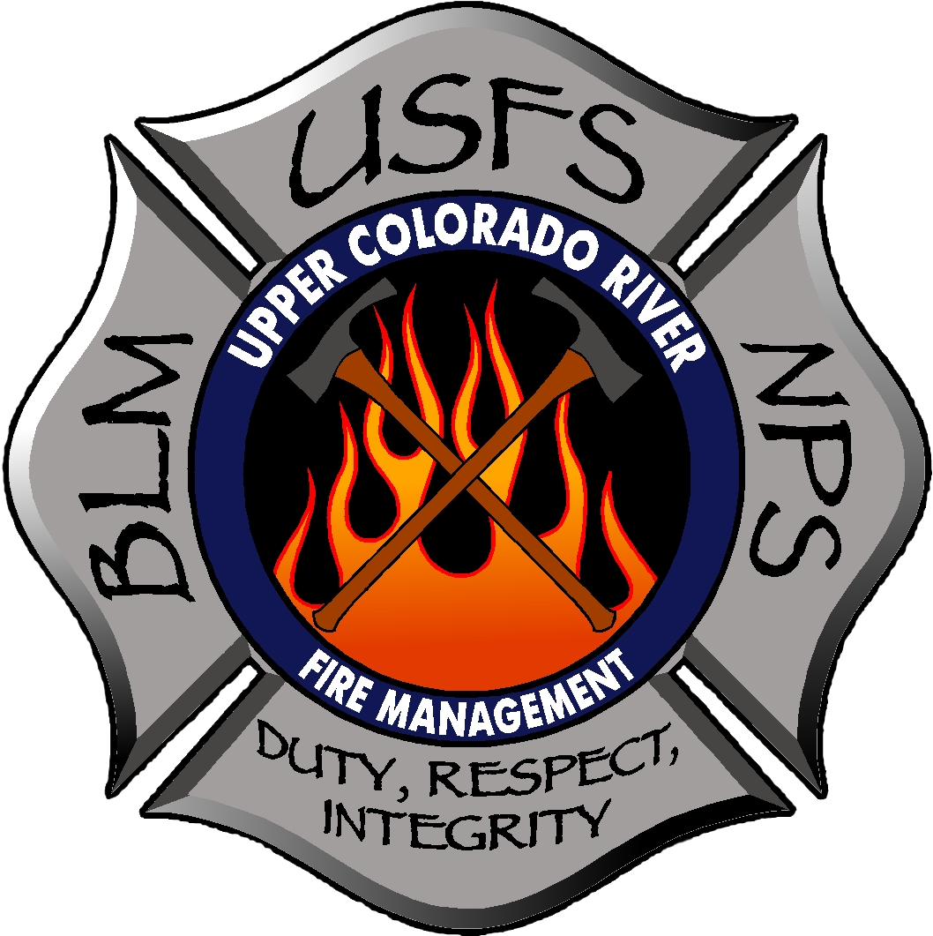

SERVICE & SUPPLY PLAN

2016

SERVICE & SUPPLY PLAN
2016

Section 1: Acquisition Contact Information:
- UCR AO/Contracting Officer/Purchasing Agents
- Region 2 Contracting Officers by Forest
- VIPR National/Regional Agreement Contracting Officers
SECTION 2: Incident Business Operating Guidelines
- National Interagency Incident Business Management Handbook
- RMCG Incident Business Site
  - RMCG Incident Business Management Guidelines
  - RMCG Incident Business Committee Members
SECTION 3: Agency Procurement Restrictions, Prohibitions, and Mandates
- UCR Restock and Replacement Procedures
- No local Restricted Items or Recycling Requirements refer to IIBMH
SECTION 4: Agency Policies
- UCR Operating Guidelines
- RMCG IIBMH Supplements Chapter 20
- Driver’s License and Driving Requirements
  - IIBMH Ch 10-17
  - BLM Red Book Chapter 2
- National USFS AD Pay Plan for Emergency Workers
- National DOI AD Pay Plan for Emergency Workers
OWCP
- Forest Service OWCP
- BLM OWCP
SECTION 5: Roles and Responsibilities

AQM
  - Provide oversight and expertise for extended attack incidents, based on incident needs; ensuring micro-purchasers are adequately supported
  - Provide CO support for incident only EERAs and LUAs

Purchaser
  - Communicates issues of concern to IBA/IBS as soon as issue occurs
  - Documents cost to the incident for purchases utilizing the National Buying Team Protocols, spreadsheet and file structure

Dispatch and/or Expanded Dispatch:
  - Provide procedures for local and geographic cache ordering
    - Provide a blocks of S#s for regional cache ordering and/or local purchases
  - Submits orders for items not under agreement to BUYT or AQM support personnel
  - Follows Dispatch SOPs for filling resource orders using DPL or competitive resource lists
- GJC Expanded Dispatch Plan

Local Cache:
  - Local warehouse inventory of non-cache items such as chairs, fax machines, phones, trailers, etc.
- RM Interagency Support Cache Main Site
- RM Interagency Support Cache Operating Procedures

Incident Finance (Forest Service):
  - Communicate and coordinate with BUYT or AQM support personnel for Land Use Agreements
  - Work closely with BUYT or AQM support personnel to process and track payments appropriately
  - Communicate with BUYT or AQM support personnel to track costs to incident
- ASC Incident Finance Branch Payment Procedures

IBA/IBS:
  - Ensure orders are being properly placed and filled for items not under agreement
  - Provide oversight for items requiring approval (e.g. incident replacement of non-standard cache items)
  - NOTE: The IBA/IBS, designated AQM Lead and Dispatch Center Manager should collaborate to recommend to the Agency Administrator whether to order a national buying team based on the following criteria:
    - A Type 1 or long Type 2 IMT is in place or has been ordered,
    - The AQM zone is exceeding its capacity,
    - There are multiple fires within the zone, or
    - Activity is expected to escalate
- UCR Agency Administrator Expectations

SECTION 6: Agency Information & Contacts
- UCR Incoming Briefing Guide
- GJC Field Procedures Guide
- UCR Fire Management Fire Organization Directory (Ch 70)
SECTION 7: National Contracts & VIPR Agreements
- National Contracts
  - National Mobile Food Service Contract
  - National Mobile Food Service Job Aid
  - National Mobile Shower Contract
  - National Mobile Shower Job Aid
  - National Mobile Food & Shower Request Form
  - National Aviation Contracts
- VIPR Agreement Resources
  - National Interagency Dispatch SOG for Contract Resources
  - Interagency Standards for the ROSS Operations Guide (ISROG)
  - RMA VIPR Ordering Guide
  - VIPR Dispatch Priority List (Choose: R-2, CO-GJC, Equipment Type)
SECTION 8: Open Market Sources
- NON-BPA
  - UCR NON-BPA Vendor Source List
  - Pack String Sources
SECTION 9: Emergency Service Providers
- Potable & Gray Water Service Sites – 2015
- Qwest Telephone Ordering Procedures - 2015
- Verizon Cell Phones and COW’s
SECTION 10: Land, Facility Sources
- Blank Land Use agreement Form – 2015
SECTION 11: Other Agency Contracts/Agreements
- Interagency Cooperative Fire Protection Agreements
  - CO Statewide Annual Operating Plan
  - Eagle County AOP
  - Garfield County AOP
  - Gunnison County AOP
  - Mesa County AOP
  - Pitkin County AOP
  - Rio Blanco County AOP
  - Routt County AOP
  - Summit County AOP
- BPA’s
  - List of Authorized personnel to place BPA orders
  - Heartland Resources
  - Catering
    - Cowboy and the Rose Catering

- R-2 Incident Rental Vehicles (Off-road)
  - Enterprise Rental Car BPA (W/ Off-road Option) - 2016
  - Enterprise Rental Vehicle Program Standard Operating Procedures – 2016
  - Enterprise Single Vehicle Rental Order Form – 2016
  - Enterprise Multiple Vehicle Order Form – 2016
  - Enterprise RENTER (Driver) Standard Operating Procedures – 2016
  - Enterprise Online Reservation Instructions – 2016?
  - Enterprise Rental Vehicle Payment Package Cover Sheet (SEND WITH DRIVER) – 2016
- GSA Rental Supplemental Vehicle Program (RSVP)
- Lodging
  - Courtyard, Marriott – Exp 8-2016
  - Residence Inn – Exp 8-2016
- Computer Rentals
  - Smart Source (R-6 avail national) – 2016
  - Plotter Supplies, Inc.

SECTION 12: Forms & Links

National Interagency Buying Team Guide: http://www.nwcg.gov/sites/default/files/products/buying_guide.pdf

Buying Team Tool Kit: http://www.fs.fed.us/business/incident/teamtoolkit.php

National Mobilization Guide: http://www.nifc.gov/nicc/mobguide/2015_Mobilization_Guide.pdf

National Standards for Fire and Fire Aviation Operations: http://www.nifc.gov/PUBLICATIONS/redbook/2015/RedBookAll.pdf

Interagency Incident Business Management Handbook: http://www.nwcg.gov/sites/default/files/products/pms902.pdf

Incident Business Committee Resources: http://www.nwcg.gov/committees/incident-business-committee/resources

Geographic Area and Cooperating Agency Incident Business Websites:
- Examples:
  - GB: http://gacc.nifc.gov/egbc/business.php
  - NR: http://www.fs.fed.us/r1/fire/nrcg/Committees/business_committee.htm
  - MT-DNRC: http://www.dnrc.mt.gov/forestry/Fire/Business/default.asp
  - ID-IDL: http://www.idl.idaho.gov/bureau/firemgt.htm
  - WY-TDC: http://gacc.nifc.gov/gbcc/dispatch/wy-tdc/fire-business.php
  - Add yours here….

National Mobile Food Services Contract: http://www.fs.fed.us/fire/contracting/food/food_contract.pdf

National Mobile Shower Facilities Contract: http://www.fs.fed.us/fire/contracting/shower/shower_contract.pdf

Dispatch Priority Lists (DPL's): http://www.fs.fed.us/business/incident/dispatch.php

Per Diem Rates: http://www.gsa.gov/portal/content/104877
Meals and Incidentals Breakdown: http://www.gsa.gov/portal/content/101518

2016 National Interagency Radio Support (NIRS): http://www.nifc.gov/NIICD/docs/2016_NIRSC_Users_Guide.pdf

NICC Reference Materials Page: http://www.nifc.gov/nicc/logistics/references.htm

NFES Catalog
Part 1: http://www.nwcg.gov/nwcg-nfes-catalog-part-1-fire-supplies-and-equipment
Part 2: http://www.nwcg.gov/nwcg-nfes-catalog-part-2-publications
Fillable Ordering Form: http://www.nwcg.gov/sites/default/files/nwcg-catalog-orderform-fillable.pdf
Credit Card Form: http://www.nwcg.gov/sites/default/files/CreditCardForm-fillable.pdf
Ordering Procedures: http://www.nwcg.gov/sites/default/files/OrderingProcedures.pdf

Forest Service Acquisition Management Incident Internet Homepage: http://www.fs.fed.us/business/incident/

BLM Acquisition Handbook: http://www.blm.gov/nils/AQ_handbook/h-2100-1/handbook-toc.htm

Forest Service Acquisition Management Incident Procurement Intranet Homepage: http://fsweb.wo.fs.fed.us/aqm/ (click on Incident Procurement, click on Buying Teams)

FS Incident Business Practices Website: http://www.fs.fed.us/fire/ibp/

National Response Plan: http://www.dhs.gov/xlibrary/assets/NRP_Brochure.pdf

DOI Casual Payment Center (forms): http://www.nifc.gov/programs/cpc_forms.html

Federal Travel Regulation Homepage: http://www.gsa.gov/portal/content/104790

GSA Global Link: https://www.gsaglobalsupply.gsa.gov/advgsa/main_pages/start_page.jsp?store=FSS

GSA Advantage Link: http://www.gsaadvantage.gov

USDA Advantage Link: https://usdaadvantage.gsa.gov/advgsa/advantage/main/start_page.do?store=USDA

