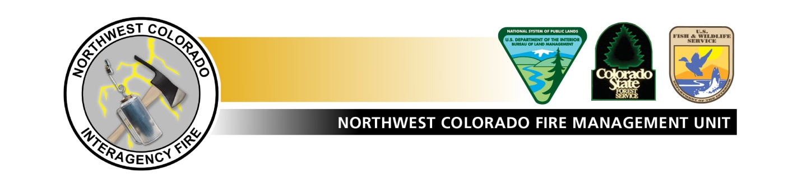

MOP UP STANDARDS FOR POWELL COMPLEX

Mop-up Standards: The intent of mop up is to make the likelihood of the fire escaping the containment perimeter very unlikely through the rest of the fire season or onset of significant monsoons. Mop up should not be based on a set distance in from the perimeter. Mop up should be implemented to the degree and location necessary to meet the above intent.

Mop up should be based on predictable potential threats to the containment lines based on experience, terrain, fuel types, the current and anticipated future fuel conditions, weather outlook, and use of infrared mapping and technology. The IMT2 should address the need for continued patrols, after the departure of the IMT2, which may influence the success of the fire not escaping.

Particular concern, given the receptiveness of very dry fuels, is torching and spotting. Existing spots outside of the main containment lines should be 100 percent out before turn back of the Powell Complex.

Suppression Repair Guidelines:

General
- Suppression repair is the work required to restore or mitigate impacts caused by firefighting actions, is funded by the fire job codes, and is included in the cost share agreement.
- All areas which need suppression repair work will be mapped and identified.
- Repair work will include disturbed areas such as; fire lines, safety zones, drop points, camps, helicopter bases, water-drafting sites, dozer lines, and established roads that have been used as fuel breaks.
- Remove signs, flagging and other materials including from all staging areas, access routes, and drop points.

Fireline
- Construct waterbars at 30 to 45 degree angles to the fireline.
- Assure the down slope end of waterbars is open and has adequate length to prevent runoff from reentering the control line.
- On slopes less than 15 percent, space waterbars 100 ft. apart, on Slopes of 15-30% space waterbars 50 ft. apart and on slopes greater than 30 percent, spacing at 25 ft. apart.
- Re-establish dozer lines to the natural grade and prepare for seed application.
- Within 100 feet of any public road:
  - Re-establish natural grade where needed by raking in berms,
  - Where feasible without compromising fire control, rake in organic material to disguise the line with slash.

Roads and Culverts
- Operations will check and map any culverts, other drainage structures, ditch lines, roads and power lines damaged by suppression activities.
- Repair any roads, culverts, or drainage structures, and ditch lines that have been impacted by suppression activities.
- Remove suppression debris 50 feet from ditch lines and culvert inlets.

Special Emphasis Areas:
- Repair drainage crossings to prevent flow obstruction and restore drainage where suppression activities impacted drainages.

