Craig Interagency Dispatch
FIRE RESTRICTION PLAN

This plan reflects the direction and guidelines provided by the ROCKY MOUNTAIN INTERAGENCY WILDFIRE PREVENTION and CLOSURE GUIDELINES adopted by the ROCKY MOUNTAIN Coordination Group in May 1996. This plan will apply to all wildland administrative agencies within the state of Colorado

OBJECTIVES:

1. Develop a plan which standardizes and simplifies the process for initiating and rescinding fire restrictions for all agencies in Colorado which have jurisdiction for public, state and/or private lands.

2. Establish fire restriction areas which have common fuels, fire behavior characteristics, easily identifiable and describable boundaries, and which enter the upper levels of fire danger periods at approximately the same time.

3. Develop a media plan which reduces confusion, provides a coordinated interagency approach, and better informs the public of restriction plan
.
4. Develop standard definitions for Stage one, two and three Restrictions that are interagency acceptable, understandable, by the public and are legally enforceable.

5. Develop standard, measurable, and predictive fire danger criteria that provides managers directions concerning when and where to initiate or remove restrictions.

6. Establish responsibility and time frames for dealing with the different phases of the plan.

GUIDELINES APPLICABLE TO ALL FIRE RESTRICTION AREAS:

Restrictions should be implemented only after all other reasonable prevention measures have been taken. These measures may include increased signing, public contacts, media campaigns etc. Fire restrictions should be considered only when very high or extreme fire danger is predicted to persist. Other considerations are the level of human-caused fire occurrences being experienced, potential high risk occasions (4th of July, etc.) and large fire activity occurring on your unit. Emergency closures have an extreme impact on the public and fire agencies and are discouraged except under the most severe conditions. They cannot be justified by fire danger alone and should be driven by high potential for human- caused fires, severe shortages of resources, numerous large fires, etc.
PROCEDURES FOR INITIATING OR RESCINDING FIRE RESTRICTIONINITIATION:

1. When the factors identified in the FIRE RESTRICTION EVALUATION GUIDELINES (page 4) approach critical levels for an area, begin considering the initiation of a fire restriction. The Fire Management Officer will be responsible for monitoring these conditions. The Mitigation/Ed/Prevent Specialist (MEP) will inform nonfederal cooperators of fuel conditions as they change during the normal fire season. The Fire Management staff will share information with the members of the Interagency Partners within the Northwest Colorado Fire Management Unit.

2. When conditions are identified as critical, the Fire Management representatives within the fire management area will confer, review conditions, recommend that a fire restriction is necessary for their area of responsibility and include a start date.

3. When an agency applies a restriction, they will coordinate with the other agencies and the respective Public Information Officers responsible for the media notification in developing a schedule and plan for public notification.

4. The respective Dispatch Center will be notified of the impending restriction. They will disseminate current information as appropriate to other Centers and to RMACC.

5. Each respective agency will be responsible for assuring their appropriate Orders and Restrictions, that authorize the special fire restrictions, are properly completed and signed by the authorizing Officer.

6. Law enforcement personnel for each agency should have an opportunity to review the Orders to assure they are correctly completed within their guidelines and enforceable prior to public release. Law enforcement and fire personnel should jointly develop a plan to enforce the restrictions

7. The agency/county Public Information Officer with responsibility for that fire restriction area will organize and initiate the media notification plan. When this involves news releases the releases should be distributed to the fire restriction group.

8. Each agency will post signs and notifications according to their guidelines to inform the public of the restrictions. Additional patrols may be initiated in high risk-high value areas.

9. Each agency will inform its personnel of the restrictions being enacted and discuss changes in their daily routine to compensate for the increased fire danger. Those responsible for public contact will be provided with a copy of the restrictions and appropriate map.

10. Public Information Officers for each agency are responsible for notifying the public, through media in their area. People can find the status of fire restrictions for any area in Colorado by visiting: http://www.coemergency.com/p/fire-bans-danger.html or local county, state and federal offices. The intent is to better inform the public of fire restrictions throughout Colorado when they’re traveling and have activities in areas away from their home.

RESCINDING A RESTRICTION:

Removing of the restrictions will follow the same procedures outlined above as the critical elements diminish.

FIRE RESTRICTION EVALUATION GUIDELINES FOR THE FOLLOWING COUNTIES: When weather factors or fire suppression impacts become a concern, the following criteria will be used to determine if a Fire Restriction should be considered by area. Use weather data from weather stations in each Fire Restriction Area to make determination.

Moffat County Fire Restriction Guidelines
Restriction Factor |  | East of Hwy 13 | West of Hwy. 13
1 | 1,000 fuel moistures content is 9% or less below 8,000 ft. or 12% or less above 8,000ft. | Yes 6-10% | Yes 6-10%
2 | Three day mean energy release component (ERC) is at 90% or above. | No | No
3 | Live fuel moisture content is 90% or less in sagebrush. | Yes 85% | Yes 85%
4 | Fires are impacting available resources | Yes | Yes
5 | Area is receiving a higher than normal occurrence of human-caused fires | No | No
6 | Drought Indicators (Palmer or Drought Outlook) | No | No
7 | Adverse fire weather is predicted to continue Zone 200 | Yes | Yes

Rio Blanco County Fire Restriction Guidelines
Restriction Factor |  | East of Hwy 13 | West of Hwy. 13
1 | 1,000 fuel moistures content is 9% or less below 8,000 ft. or 12% or less above 8,000ft. | Yes 6-10% | Yes 6-10%
2 | Three day mean energy release component (ERC) is at 90% or above. | No | No
3 | Live fuel moisture content is 90% or less in sagebrush. | Yes 85% | Yes 85%
4 | Fires are impacting available resources | No | Yes
5 | Area is receiving a higher than normal occurrence of human-caused fires | No | No
6 | Drought Indicators (Palmer or Drought Outlook) | No | No
7 | Adverse fire weather is predicted to continue Zone 202 | No | No

Routt County Fire Restriction Guidelines
Restriction Factor |  | All of Routt County
1 | 1,000 fuel moistures content is 9% or less below 8,000 ft. or 12% or less above 8,000ft. | Yes
2 | Three day mean energy release component (ERC) is at 90% or above. | Yes
3 | Live fuel moisture content is 90% or less in sagebrush. | No
4 | Fires are impacting available resources | Yes
5 | Area is receiving a higher than normal occurrence of human-caused fires | No
6 | Drought Indicators (Palmer or Drought Outlook) | No
7 | Adverse fire weather is predicted to continue Zone 201 | Yes

Jackson County Fire Restriction Guidelines
Restriction Factor |  | All of Jackson County
1 | 1,000 fuel moistures content is 9% or less below 8,000 ft. or 12% or less above 8,000ft. | Yes
2 | Three day mean energy release component (ERC) is at 90% or above. | Yes
3 | Live fuel moisture content is 90% or less in sagebrush. | No
4 | Fires are impacting available resources | Yes
5 | Area is receiving a higher than normal occurrence of human-caused fires | No
6 | Drought Indicators (Palmer or Drought Outlook) | No
7 | Adverse fire weather is predicted to continue Zones 211 & 218 | Yes

Grand County Fire Restriction Guidelines
Restriction Factor |  | All of Grand County
1 | 1,000 fuel moistures content is 9% or less below 8,000 ft. or 12% or less above 8,000ft. | Yes
2 | Three day mean energy release component (ERC) is at 90% or above. | Yes
3 | Live fuel moisture content is 90% or less in sagebrush. | No
4 | Fires are impacting available resources | No
5 | Area is receiving a higher than normal occurrence of human-caused fires | No
6 | Drought Indicators (Palmer or Drought Outlook) | No
7 | Adverse fire weather is predicted to continue Zone 213 | Yes

RESTRICTION STAGES
By Rocky Mountain Coordination Group direction, there are three fire restriction Stages. Each Agency in the Fire Restriction Area must write their own Special Order which authorizes the restrictions within their jurisdiction. Each is responsible for using their agencies format and having their Law Enforcement personnel review the Order to assure it is legally correct and enforceable. To reduce confusion and standardize the restrictions, the following criteria will be used in all Orders:

- 1,000 fuel moistures content is 9% or less below 8,000 ft. or 12% or less above 8,000ft.
- 3 day mean energy release component (ERC) is at 90% or above.
- Live fuel moisture content is 90% or less in sagebrush.
- Fires are impacting available resources
- Area is receiving a higher than normal occurrence of human-caused fires*
- Adverse fire weather is predicted
- Drought Indicators (Palmer or Drought Outlook)
PROCESS FOR IMPLEMENTING
COUNTY FIRE RESTRICTIONS
*High human caused risk may include holidays, such as the 4th of July or Labor Day or special events such as country fairs and hunting seasons.
**Stage III-area closures are extremely rare events, and will only be implemented in extraordinary situations, after significant interagency coordination.
At least 4 criteria are met, consider stage I restrictions
At least 5 criteria are met, consider stage II after stage I restriction have been in place.
Consider Stage III all criteria are met.**

STAGE ONE RESTRICTIONS:

The following acts are prohibited on Federal, State, and private lands including roads, and trails described herein, until further notice:

1. Trash or refuse fires between the hours of 6:00 am and
8:00 pm. except inside containers provided with spark arresters and located within a cleared area ten feet in radius.

2. Building or using any open fire or camp fire, except within agency provided fire grates at developed campgrounds, or within fully enclosed stoves, grills, or in stoves using pressurized liquid or gas.

3. Charcoal fires within enclosed grills are permitted.

4. Use of acetylene cutting torches or electric arc welders, except in cleared areas ten feet in radius.

5. Propane or open fire branding activities in cleared areas ten feet in radius are permitted.

6. Smoking cigarettes, except within an enclosed vehicle, building, developed recreation site or while stopped in a cleared area of at least three feet in diameter that is barren and cleared of all flammable material.

7. Operating a chainsaw without a properly installed USDA or SAE approved spark arresting device, a five pound fire extinguisher and a shovel.

8. Using explosives requiring fuses or electric blasting caps.

STAGE TWO RESTRICTIONS:

- All open fires and campfires are prohibited except petroleum-fueled stoves, lanterns and heating devices that meet the underwriter’s specifications for safety are permitted.

- Smoking is restricted to enclosed vehicles and buildings.

- All chainsaws and other internal combustion engines, including motorcycles and ATV’s, must have spark arresting devices that are properly installed and in working order.

- Use of explosives is prohibited.

- Use of welding and cutting torch devices is prohibited.

- Individual agencies may further restrict commercial activities not included in this plan such as construction, logging or oil and gas operations.

STAGE THREE RESTRICTIONS:

Stage three restrictions constitute the restriction of access to the full closure of public lands within the declared area.

GENERAL EXEMPTIONS TO THE ABOVE STAGES:

a. Persons with a written permit that specifically authorizes the otherwise prohibited act.

b. Persons conducting activities in those designated areas where the activity is specifically authorized by written posted notice.

c. Any Federal, State, or local officer or member of an organized rescue or firefighting force in the performance of an official duty.

ERC Charts
These charts are updated prior to each Fire Restriction conference call and other charts may be used as conditions warrant.
The following charts have been updated and used as information provided in this plan.

Figure 1 ERC's for Moffat County
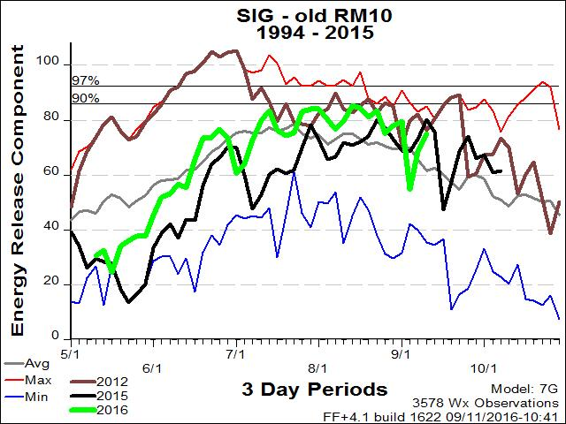

Figure 2 ERC's for Rio Blanco County

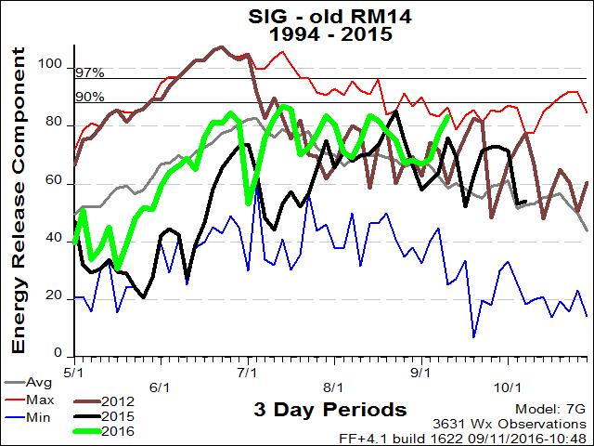

Figure 3 ERC's for Routt, Grand and Jackson Counties
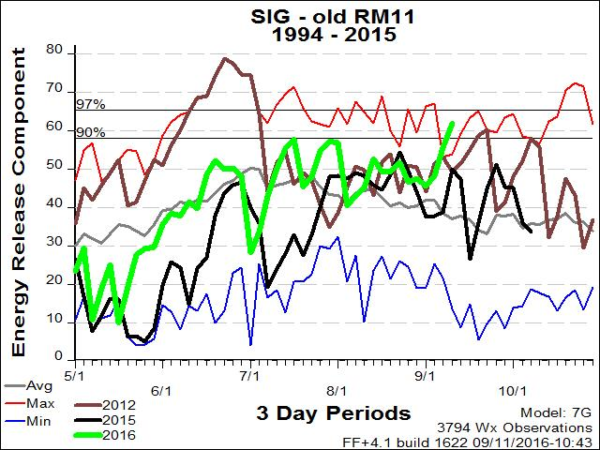

v

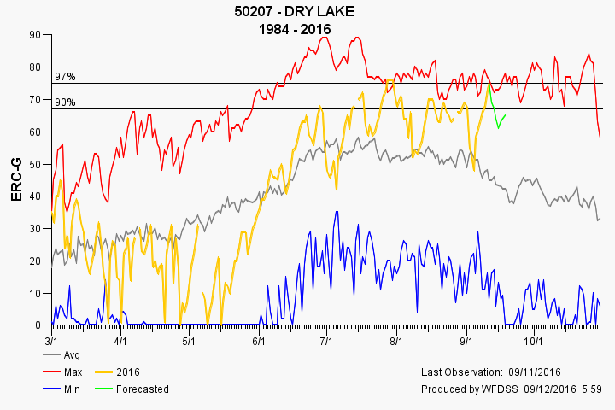
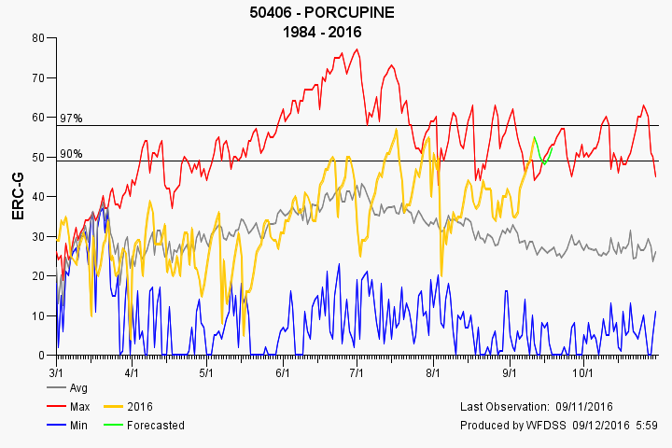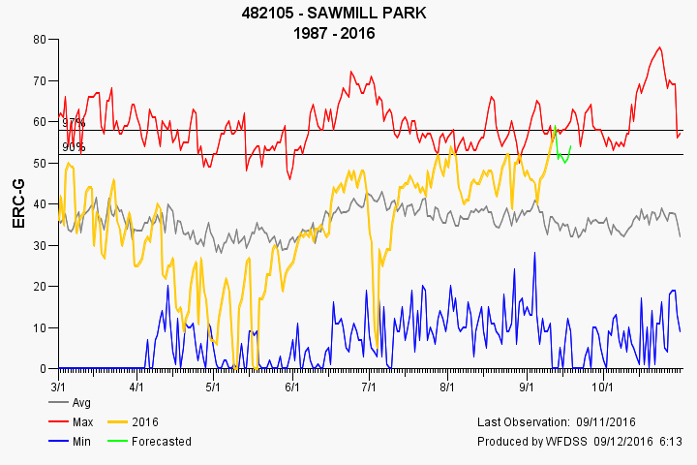

1000 Hour Fuel Moisture Charts
Figure 4 Moffat County 1000 hr Fuel Moisture
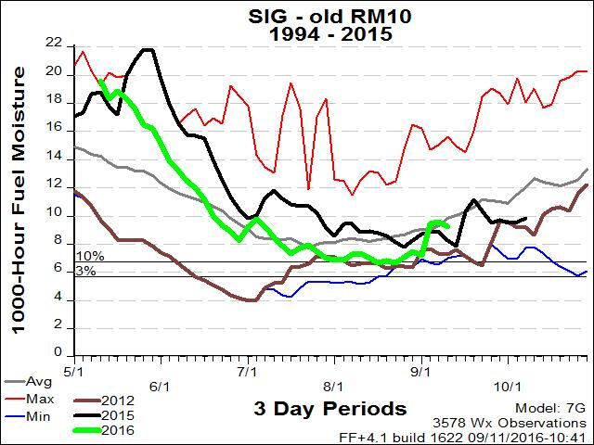

Figure 5 Rio Blanco 1000 Hr Fuel Moistures

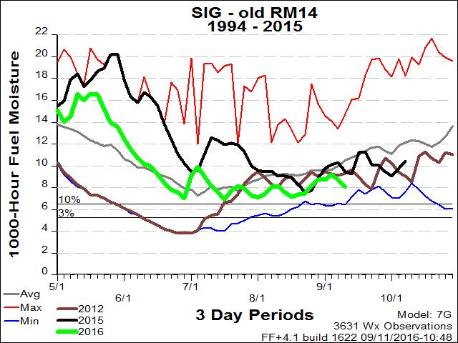

Figure 6 Routt, Jackson and Grand Counties 1000 hr Fuel Moistures

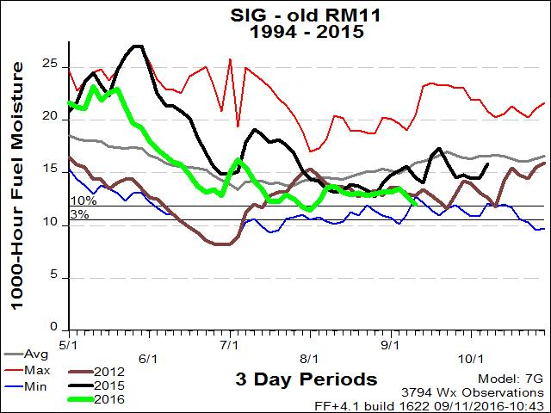

Drought Indexes
Figure 7 National Seasonal Drought Index

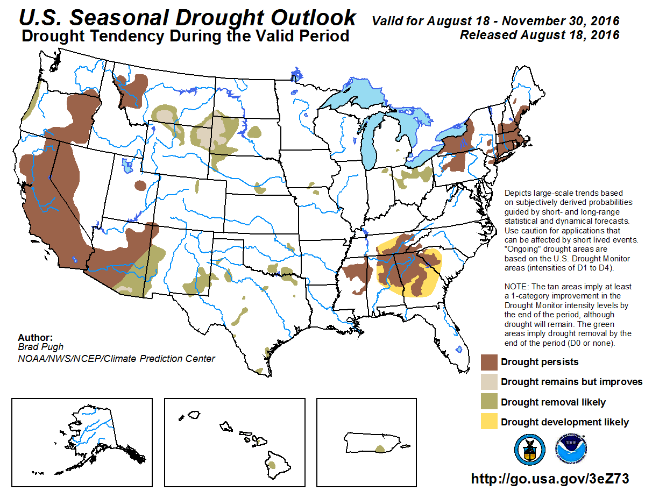

Figure 8 Palmer Drought Index (Notice the Dates)
