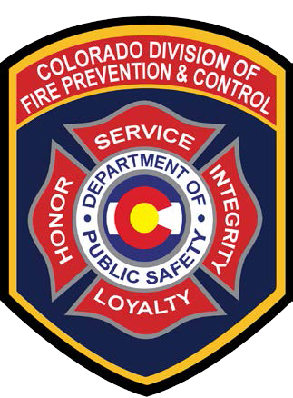Colorado Division of Fire Prevention and Control 2016 Multi-Mission Aircraft Ordering Process
Multi Mission Aircraft (N327 SF and N328 SF)
- For State, County, Fire Department and other non-federal agencies : Multi-Mission Aircraft (MMA) requests shall be placed through the Denver Regional Colorado State Patrol (CSP) Dispatch
- For In-State Federal agencies: MMA requests shall be initially placed through the Interagency Dispatch Center, who will place the order through Denver Regional Colorado State Patrol (CSP) Dispatch

Contact CSP Dispatch via the State Emergency Operations Line (303-279-8855). Request to order the DFPC MMA and to speak to the DFPC Duty Officer. Orders are to include information on the current DFPC MMA Request Form, as attached and also available for download on the Colorado Division of Homeland Security & Emergency Management (DHSEM) web portal: http://www.dhsem.state.co.us/ under the Colorado Daily Status Report Link

- For DFPC mission requests : call the DFPC Duty Officer Direct.
- For Out-of-State Requests:
MMA request shall be placed through the Rocky Mountain Area Coordination Center via the Resource Ordering and Status System (ROSS). RMACC will coordinate with the DFPC Duty Officer as needed.

Ordering of DFPC tactical fixed-wing and rotor-wing resources will follow current Rocky Mountain Area (RMA) standard Mobilization Guide procedures for ordering tactical aircraft.

