# Region 5 Night Air Operations Mobilization and Notification Procedures

The Forest Service Night Air Operations (NAO) will support wildfire suppression on Forest Service-protected lands within and adjacent to the Angeles, Cleveland, and San Bernardino National Forests, the Southern half of the Los Padres and the Southern half of the Sequoia National Forests. The NAO aircraft will also support wildfire suppression including wildland-urban interface areas within and adjacent to the forests, within a range of their primary bases of one (1) hour flight time. The one (1) hour flight time is based on 90 nautical miles for the helicopter and 240 nautical miles for the air attack. Maps depicting a one (1) hour flight time for the NAO helicopter and air attack are on pages 5-6 of this procedure.

Before committing night air operation resources outside the above-approved locations, approval must be granted from the Operations Southern California, Geographic Area Coordination Center (GACC) Duty Chief. The approval or denial of the request will be documented on the resource order by the GACC. The Unit making the request must ensure there is adequate staffing in dispatch. All aircraft should be dispatched by a qualified aircraft/aviation dispatcher or under the direct supervision of a qualified aircraft/aviation dispatcher. If a qualified aircraft/aviation dispatcher is not immediately available, a qualified initial attack dispatcher (IADP) may dispatch aircraft for the night operations, flight following, and in case of an emergency. The GACC Federal Aviation Duty Officer will ensure the appropriate dispatch organization is in place before the NAO aircraft launches to the incident.

If the air attack is dispatched outside of the pre-approved area and they return to their home base, they will be released each morning, reordered and reapproved by the GACC Duty Chief.

# The following procedures and responsibilities will be followed at all times:

When a Mishap Plan is initiated for a mishap or an accident the GACC Federal Aviation Duty Officer will be notified by the ECC (see contact list for phone number).

For all planned need mapping missions for the NAO Air Attack, the host ECC will ensure that there is an incident contact name and phone number included in the resource order. This will allow the ATGS to contact the incident directly to determine and discuss incident needs.

# Angeles National Forest, Emergency Communication Center (ECC):

The Angeles ECC will notify the GACC Federal Aviation Duty Officer anytime there is a status change with NAO aircraft and when the NAO aircraft are dispatched to an incident (see contact list for phone number) and provide the following information:

* Incident name, incident number, geographical location, latitude, and longitude, identify which night air resources are being committed and any other mission or incident pertinent information.

When night flying aircraft are canceled or back on base, ANF ECC will notify the GACC Federal Aviation Duty Officer.

**Ordering Process for the Night Air Attack ATGS and Support Personnel:**

The current ATGS or support personnel will order their relief at least two days before their relief is required to travel. The order will be communicated by e-mail to the ANF ECC and the GACC as outlined in the Night Air Operations Air Attack Operating Plan**.** The e-mail will contain the pertinent information to process the resource order, including the name request, qualification of the individual, their home unit or current assignment, date and time needed, the reporting location and special instructions.

ANF ECC will order individual overhead as an “O” number on a preposition order, then roster the aircraft once the individual is in place with the aircraft.

In cases where the air attack is not at their home base or assigned to the ANF, the GACC will request through the incident ordering point (host dispatch) an “A” subordinate number for the requested personnel, and then place that order to the ANF for the fill.

When the night air attack (AA-51) is mobilized to an incident, the individuals will then be “A” number under the aircraft (rostered).

**Preapproved Units:**

The requesting ECC will request AA-51 and H-531 direct from ANF ECC. When requesting night-flying aircraft, the requesting ECC will provide the required information pursuant to FC-106 California Interagency Aircraft Dispatch (CIAD). Immediately after making the request for night flying aircraft, the requesting ECC will follow up with the resource requests direct to ANF ECC. If H-531 is requested, the on-duty helicopter manager will determine primary and secondary water points (helispots) and advise ANF ECC. ANF ECC will then advise the requesting unit ECC of the primary and secondary water points (helispots) and the requesting unit will reference the Night Helispot Guide for any particular requirements (notifications, engine required, etc.) for those helispots.

Once the night flying aircraft have been requested from ANF ECC, the requesting ECC will notify the GACC Federal Aviation Duty Officer (see contact list for phone number) and provide the following information:

* Incident name, incident number, geographical location, latitude, and longitude, which night flying resources are being committed and any other mission or incident pertinent information.

When the night flying aircraft are canceled or released, the host unit will notify the GACC Federal Aviation Duty Officer and ANF ECC.

**The Hosting Unit Responsibilities:**

Once night-flying aircraft are committed to a unit other than the ANF, the host unit ECC will be responsible for mobilization of night flying aviation resources. This includes receiving requests from the GACC for initial attack. The host unit ECC will have a nighttime dispatcher on-duty and available to dispatch NAO aircraft for initial attack.

The host unit ECC where the aircraft are assigned will be responsible for determining night dispatch procedures either directly with the aviation resource or with the incident they are assigned. The host ECC and incident will establish a point of contact for mobilization of the night-flying aircraft.

The requesting ECCs will request AA-51 and H-531 through the GACC when the night flying resources are not on their home unit. When requesting night-flying aircraft, the requesting ECC will provide the required information pursuant to or the FC-106 California Interagency Aircraft Dispatch (CIAD), and an incident report of conditions. Immediately after requesting for night flying aircraft, the requesting ECC will follow up with the resource order requests to the GACC. When H-531 is requested, the on-duty helicopter manager will determine primary and secondary water points (helispots) and advise the host ECC, who will advise the GACC, who will, in turn, advise the requesting ECC. The requesting unit should reference the Night Helispot Guide for any particular requirements (notifications, engine required, etc.) for those helispots.

When the night flying aircraft are canceled or released, the host unit will notify the GACC Federal Aviation Duty Officer.

**GACC Responsibilities:**

The GACC Federal Aviation Duty Officer will be the contact for all night flying mobilization (see contact list for phone number).

The GACC Federal Aviation Duty Officer will ensure the appropriate dispatch organization is in place before the NAO aircraft launches to the incident. The GACC Federal Aviation Duty Officer will deconflict the airspace with the military and relay the status of Military Training Routes (MTR) traffic to the sending and receiving ECCs. The GACC will also deconflict with National Infrared Operations (NIROPS). When the night air attack is assigned to incidents for mapping, the GACC will relay this information to NICC for deconfliction. When the NIROPS flight plan is received at the GACC, it will be forwarded to ANF ECC for the night air attacks awareness.

If a TFR or additional frequencies are needed, they will be requested through the GACC Federal Aviation Duty Officer and will be followed up with the resource order request to the GACC.

For all planned need mapping missions for the NAO Air Attack, the host ECC and GACC will ensure that there is an incident contact name and phone number included in the resource order. The GACC will place all planned need mapping orders in the resource ordering system, corresponding FC-106 Interagency Aircraft Dispatch(s) and incident priorities to ANF ECC so they could relay the information to the NAO air attack. The GACC will then retrieve all of the orders except the first assignment and place the resource orders to the correct unit ECCs in order the missions will be flown.

NOTE: If multiple initial attack requests for the night flying aircraft occur at the same time, ANF ECC will call the GACC Federal Aviation Duty Officer, who will determine which incident will receive the aircraft based on the following Risk Assessment Prioritization and the incident report of conditions.

* What are the critical values at risk?

1. Lives are or will be threatened.
2. Structures are or will be threatened.
3. Resources of significant value are or will be threatened.
4. Excessively high suppression costs will be prevented.

* What is the chance the critical values will be impacted?
* What is the relative probability of success associated with the alternatives being considered?

The GACC Federal Aviation Duty Officer is responsible for Regional notifications to the pre-determined contact list of the NAO aircraft status and missions.

**GACC Night Operations Contact List:** GACC Federal Aviation Duty Officer: **951-320-2093**

If the GACC Aviation Duty Officer does not answer, the ordering ECC will call the GACC Duty Officer at **951-276-6725.**

***GACC Aviation Duty Officer will notify the following via text:***

|  |  |  |  |  |  |
| --- | --- | --- | --- | --- | --- |
| NAME |  | POSITION | CELL NUMBER | UNIT | E-MAIL |
| Yolanda Saldana |  | Deputy Director | 530-638-6378 | R5 | Yolanda.saldana@usda.gov |
| Josh Mathiesen |  | RAO | 530-515-9272 | R5 | [joshua.mathiesen@usda.gov](mailto:joshua.mathiesen@usda.gov) |
| Lyndsay Johnson | | ASO | 661-565-6843 | R5 | [Lyndsay.Johnson@usda.gov](mailto:Lyndsay.Johnson@usda.gov) |
| Kyle Tolosano |  | Heli Prog. Mgr. | 530-605-7334 | R5 | Kyle.tolosano@usda.gov |
| D. Scott Smith |  | Fixed Wing Prog. Mgr.(detail) | 530-307-9171 | R5 | [David.s.Smith@usda.gov](mailto:David.s.Smith@usda.gov) |
| Matt Muller |  | HOS | 916-767-9787 | R5 | [matthew.p.muller@usda.gov](mailto:matthew.p.muller@usda.gov) |
| Josh Hutchison |  | HOS | 916-709-6747 | R5 | [Joshua.Hutchison@usda.gov](mailto:Joshua.Hutchison@usda.gov) |
| Casey Jones |  | HOS | 559-696-3878 | R5 | [casey.jones6@usda.gov](mailto:casey.jones6@usda.gov) |
| Anthony Herbert |  | NAO Prog. Mgr.(acting) | 503-521-4854 | R5 | [anthony.herbert@usda.gov](mailto:anthony.herbert@usda.gov) |
| Jerry Spence |  | AS Prog. Mgr. | 530-262-4733 | R5 | [gerald.spence@usda.gov](mailto:gerald.spence@usda.gov) |
| Matt Ahearn |  | AD Operations | 951-315-5856 | OSC | [matthew.ahearn@usda.gov](mailto:matthew.ahearn@usda.gov) |
| Andrea Lannen-Littlefield | | GACC Mgr. | 951-269-9021 | OSC | [Andrea.lannen-littlefield@usda.gov](mailto:Andrea.lannen-littlefield@usda.gov) |
| David Raphael |  | Dep. GACC Mgr. | 909-518-4363 | OSC | [David.Raphael@usda.gov](mailto:David.Raphael@usda.gov) |
| Open |  | Dep. GACC Mgr. |  | OSC |  |
| Steve Reyes |  | Aviation Coordinator | 951-295-6630 | OSC | [steven.reyes@usda.gov](mailto:steven.reyes@usda.gov) |

**NAO Helicopter One (1) hour Response Map, 90NM from Fox Field**

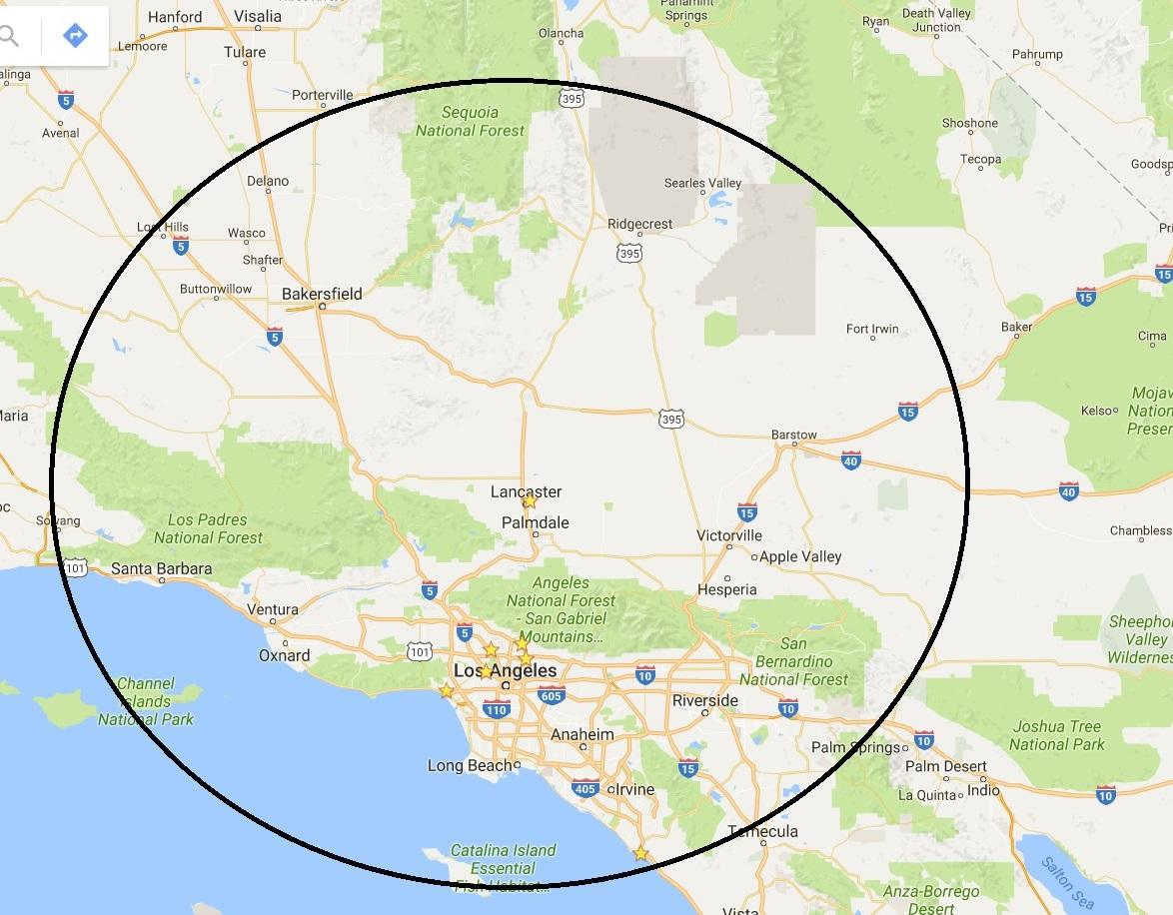

**NAO Air Attack One (1) hour Response Map, 240 NM from Fox Field**

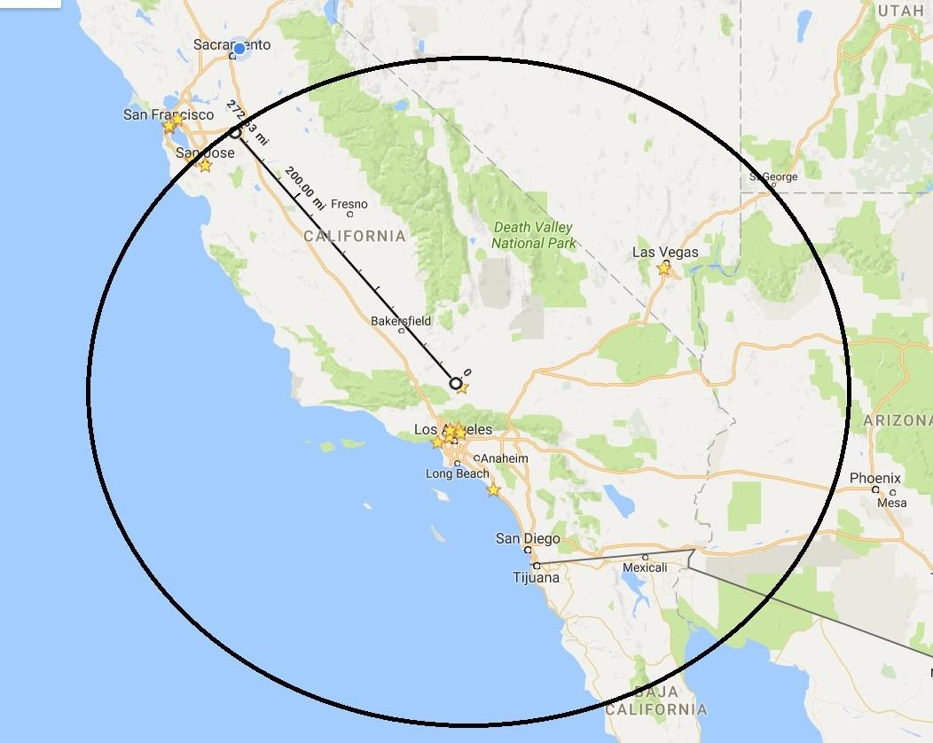

**Night Air Operations Checklists**

GACC Aviation Duty Officer: **951-320-2093**

***If the GACC Aviation Duty Officer does not answer, the ordering ECC will call the GACC Duty Officer at 951-276-6725.***

**Unit Dispatch (ECC) Checklist:**

Requesting ECC is staffed for NAO

The requesting ECCs will request AA-51 and H-531 through the GACC when the night flying resources are not on their home unit.

Incident contact name and phone number in the resource order.

Requesting ECC prepare FC-106 and call ANF/host ECC to relay new order information. ANF/Host ECC calls GACC Aviation DO and advises of a new request for night flying aircraft.

Hosting ECC - Relay primary and secondary Helispots from the on-duty helicopter manager to the receiving ECC when mobilizing the NAO Helicopter.

Receiving ECC - Reference primary and secondary Helispots for any particular requirements when mobilizing NAO Helicopter.

If dispatched outside of the pre-approved area, release each AM

***Relay all aircraft status changes to GACC Aviation Duty Officer, Including but not limited to***

New orders (including required Interagency Aircraft Dispatch information),

Canceled/released back on base

In/out of service

In/Out of service mechanical

**Mishap Plan Initiated –Notifications**

FAA Date/Time____________ Person Notified___________________

Unit Duty Chief Date/Time____________ Person Notified___________________

Unit Aviation Officer Date/Time____________ Person Notified___________________

GACC Aviation D.O. Date/Time____________ Person Notified___________________

**GACC Checklist**

Ensure ECC is staffed for NAO

If requested from outside of the pre-approved area, GACC Duty Chief approval/denial is documented in the resource order.

If dispatched outside of the pre-approved area, ensure night-flying aircraft are released each AM

***Airspace Deconfliction***

Deconflict the airspace MTR’s and relay to sending and receiving ECCs.

Deconflict with National Infrared Operations (NIROPS), when NAO air attack is assigned to incidents for mapping.

Forward NIROPS Flight Plan to ANF ECC or host ECC.

Place all planned need mapping orders in resource ordering program, corresponding FC-106 Interagency Aircraft Dispatch(s) and incident priorities to ANF ECC so they could relay the information to the NAO air attack

Retrieve all of the orders except the first assignment and place the resource orders to the correct unit ECCs in order the missions will be flown.

Request Temporary Flight Restriction (TFR) from the FAA when ordered by the hosting unit ECC.

***Regional Notifications***

GACC Aviation Duty Officer is responsible for Regional notifications to the pre-determined contact list of the NAO aircraft status and missions (new incident request, off base, back on base/released, etc.)

**Multiple initial attack requests**

What are the critical values at risk?

1. Lives are or will be threatened.
2. Structures are or will be threatened.
3. Resources of significant value are or will be threatened.
4. Excessively high suppression costs will be prevented.

What is the chance the critical values will be impacted?

What is the relative probability of success associated with the alternatives being considered?

**Mishap Plan Initiated –Notifications**

Aviation Coordinator Date/Time____________ Person Notified___________________

GACC Duty Chief Date/Time____________ Person Notified___________________

Assistant Director Date/Time____________ Person Notified___________________

ASO Date/Time____________ Person Notified___________________

RAO Date/Time____________ Person Notified___________________