Northern California Geographic Area Coordination Center

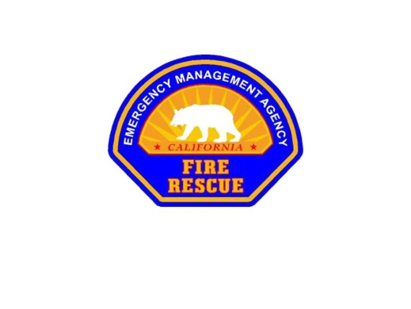



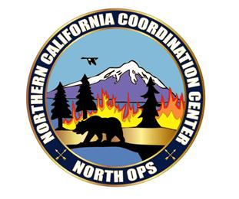

Northern California Geographic Area Coordniation Center (ONCC) is located at the

Northern California Service Center (NCSC) facility.

The NCSC is home to:

Northern California Operations

USDA Forest Service

DOI Bureau of Land Management

CAL FIRE Operations Center

6101 Airport Road

6105 Airport Road

Redding, CA 96002

(530) 226-2800

Flight Follow 800-231-5584

***Northern California Geographic Area Coordination Center***

**Table of Contents**

***Introduction***

Mission Statement 4

Brief Profile 4

Working Atmosphere 5

Supervisors Expectations 5

Appropriate Attire 6

Chain of Command 6

ONCC Staffing 6

Lodging, Meals and Transportation 7

***Personnel Items***

***ONCC Emergency Procedures*** 8

ONCC Security 8

Timekeeping 8

Lunch and Breaks 9

Smoking Policy 9

Restrooms 9

Handicap Accessible 9

Sick Leave/On the Job Injuries 10

***ONCC General Office Procedures***

ONCC General Office Procedures 10

Telephone Usage and Procedures 10

Computers 12

Internet 12

Appendix A – NOPS Organization Chart 14

Appendix B – ONCC Emergency Command Centers map 15

Appendix C – NOPS Survey 16

***Introduction***

***Northern California Geographic Area Coordination Center Mission Statement***

Our mission is to provide the highest quality customer service possible that will reflect the values and ideals of our organization from a national to a local level. These values and ideals will be reflected in areas of trust, respect, commitment, purpose, training, safety, professionalism and responsibility.

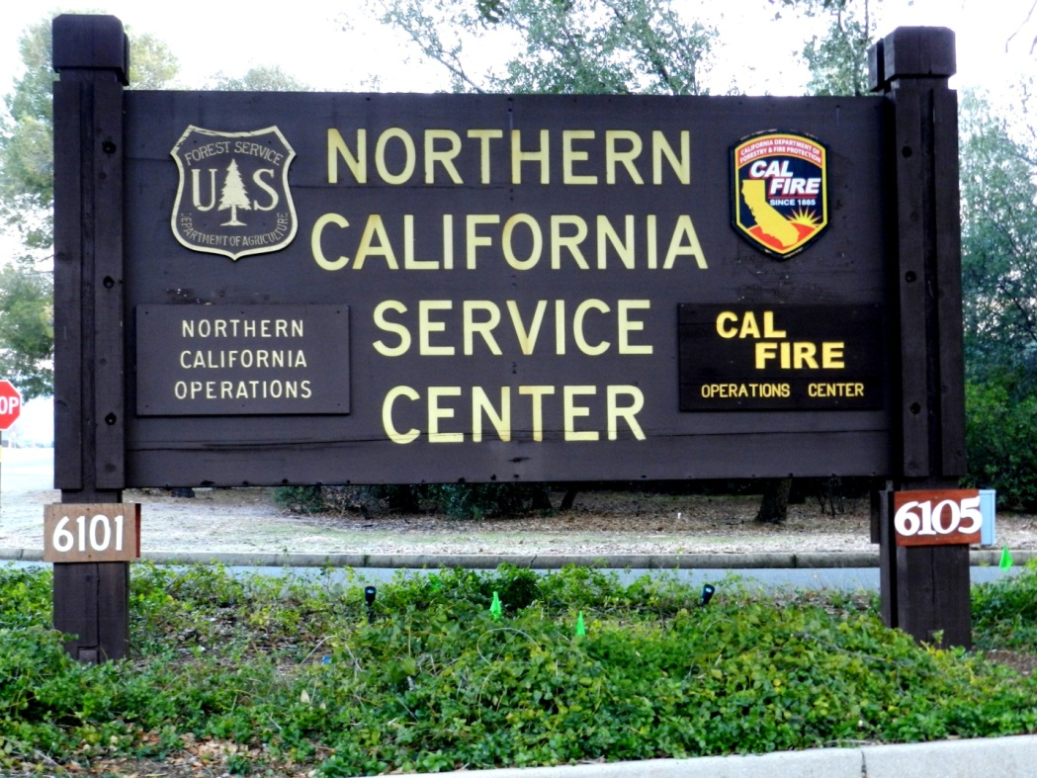

**LEADERSHIP CREED**

Listen - to those we support and strive to provide the ultimate customer service.

Empower – each other to provide creative solutions to problems.

Achieve - your goals and help others achieve theirs.

Demonstrate - by being a role model. Lead by example.

Encourage - others to achieve and reach for a higher standard.

Remember – what our mission is and those we are here to support.

Share - what you know and ask when you do not know.

Hold – oneself accountable.

Inspire – people to lead others.

Prepare - people to succeed.

**Welcome to North Ops**

Northern California Operations is the Geographic Area Coordination Center (GACC) for the northern half of USFS Region 5 (California), and the Regional Emergency Command Center for the Northern California Region of the California Dept of Forestry and Fire Protection (CAL FIRE). It provides service for the Northern District of the Bureau of Land Management within California, National Parks of the Pacific West Region, Fish & Wildlife Service (FWS), and Bureau of Indian Affairs (BIA). North Ops provides support for 16 Northern California Emergency Command Centers (ECC’s) when additional assistance is requested (attached map).

The compound itself includes an Administrative building, the Northern California Training Center, an Operations building, and is home to the Redding IHC, North Zone Cache and the Redding Smoke Jumpers. Also located on the compound are facilities related to the Shasta Trinity NF and the Shasta Trinity Unit including maintenance facilities, machine shops, CAL FIRE Station 43, and an Air Tanker Base with state and federal Air Tankers, Air Attack and Lead planes.

The Operations Building provides office space for USFS, USDOI, and CAL FIRE personnel who support and manage the interagency mobilization of resources requested for major incident support in the geographic area. The Operations Building consists of a National Interagency Support Cache and the Smoke Jumper Loft on the ground floor, and the Operations Center on the second floor. The Operations Center has offices for the Interagency Coordinators, Intelligence section to include the Redding Fire Weather Center and Predictive Services personnel, an Initial Attack Aircraft dispatch floor, and an Expanded Dispatch / Coordination room. The dispatch center is linked by intercom to all the local command centers in northern California and also to Sacramento CAL FIRE and Southern California Operations. North Ops provides Initial Attack aircraft for northern and southern California Units from 6 fixed-wing bases and 16 helicopter bases. Additional resources can be requested through the mobilization process from other GACCs or NICC as the needed.

There are 2 GACCs in California – North Ops and South Ops. Both of these GACCs are different from other GACCs within the nation because of the partnership with the State’s CAL FIRE, which has the largest state firefighting organization in the country. They are the only Coordination Centers that provide Initial Attack dispatching for aircraft owned and operated by both federal and state organizations. Because of the multitude of resources available to the centers from federal, state and local governments, it is imperative that proper ordering channels are observed. For instance, when state resources are requested for out-of-state assignments, only the CAL FIRE channels can be used to approve their personnel to respond. Normally the state will approve only a few orders to be filled for out-of-state requests due to their responsibilities within California. Ordering through ROSS is common with all Units but before an out-of-state request can be placed or filled with other than federal resources, it first must be approved by the CAL FIRE Duty Officer who will clear each request. The same applies to local government personnel and that system changes periodically so following the most current direction is imperative. Federal Coordinators or CAL FIRE Battalion Chiefs must be advised when orders for local government resources are received to assure the most current ordering protocol is being followed.

***Working Atmosphere***

North Ops has a zero tolerance policy for harassment of any kind. All Employee’s cooperators, contractors and volunteers who participate in wildland fire operations have the responsibility to treat one another with respect. Every employee at North Ops takes personal responsibility for creating and ensuring a healthy and safe work environment.

Every individual assigned to North Ops has a responsibility to report harassment, inappropriate behavior, and take positive action to mitigate the effects. Promptly notify the Expanded Supervisor, Coordinator or a Duty Officer should any situation develop.

North Ops takes pride in maintaining a professional and service oriented working atmosphere while still allowing for some informality. We want you to have fun working here, but we also expect you to use common sense and do your assigned job to the best of your ability. If you have questions do not hesitate to ask for help. Open communication is expected and appreciated.

***Supervisor’s Expectations***

The North Ops Mobilization Coordinator has established expectations of Federal employees who work here at North Ops.

* Show up to work and on time for your planned shift. You must advise your assigned supervisor or their acting before leaving for your 30-minute lunch. Any lunches longer than 30-minutes must be approved by your assigned supervisor or their acting prior to your leaving. If neither is available, clear it with the current duty officer. In addition, before leaving your work area for any extended period, you must plan coverage of your current operational area prior to leaving.
* We are entitled to two 15-minute breaks during our shift. We are all encouraged to take those breaks. These breaks are for getting out of the office to get some air or conducting personal business if needed. Do not abuse government time for conducting personal business. Notify the supervisor prior to leaving.
* **Cell Phones** All Federal Coordination personnel are to place ALL cell phones on vibrate while in the Coordination Center. Cell phone calls and personal calls will be kept at an absolute minimum and must not affect your ability to perform duties as assigned. Personal phone calls are to be taken out of the office and away from others as to not disrupt them in the performance of their official duties. Texting while working is allowable as long as it does not infringe on your duties. Radio traffic will always take priority over the phone and especially personal phone calls.
* **Office Phones** While at your desk, please answer your phone in a timely manner rather than making the receptionist take messages for you. Try to limit the number of calls that you transfer to someone while they are on the phone. If the person asked for is on a call, please take a message for them or place them on Park if they’re willing to hold.
* **Work area** Prior to leaving at the end of your shift, clean & organize the desk area where you are working by making it as presentable as possible. Use disinfecting wipes on all surfaces to prevent the spreading of germs. Do not leave dirty dishes in any work area, take them to the kitchen and do not leave them in the sink for someone else to put in the dishwasher.

***Appropriate Attire***

In order to maintain a professional atmosphere at North Ops, we request that visitors and detailers wear casual business apparel if they are not an agency employee. If you are an agency employee, uniforms are preferred Monday through Friday, except for holidays. Questions and or concerns on appropriate attire will be addressed by the immediate supervisor.

***Chain of Command***

Chain of command is essential to do our jobs effectively. We all maintain an open door policy and value individual input. If there is a question or concern, address it to your supervisor first. If requested to complete an assignment by someone other than your supervisor, advise your supervisor of the request. When you are asked to do more than one task at a time, clarify with your supervisor. Your supervisor will know where you are at all times while you are on duty. It is your responsibility to keep your supervisor informed.

***Questions/Concerns***

If you have any questions or concerns, please direct them to the Expanded Supervisor, or a Coordinator. If your question concerns cannot be met at this level, please contact a Duty Officer either federal or state.

***ONCC Staff***

An organization chart is located in Appendix A .

Current staffing of the Operations Center at North Ops:

|  |  |  |
| --- | --- | --- |
| **Name** | **Position** | **Agency** |
| Dept. of Agriculture |  |  |
| Gwen Sanchez | Assistant Director - Operations | USFS |
| Anthony Masovero | GACC Center Manager | USFS |
| Curtis Stanley | Deputy GACC Center Manager | USFS |
| Laurie Forni | Mobilization Coordinator | USFS |
| Megan Heffentrager | Aircraft Coordinator | USFS |
| Andre Charton | Aircraft Dispatcher | USFS |
| Robin Milovich | Logistics Coordinator | USFS |
| Juel Moore | Logistics Coordinator | USFS |
| Keren Sites | Logistics Coordinator | USFS |
| Nikki Niesen | Logistics Coordinator | USFS |
| Patrick Howard | Logistics Coordinator | USFS |
| Troy Russell | Intelligence Officer | USFS |
| Vacant | Assistant Intelligence Officer | USFS |
| Vacant | Fire Management Specialist | USFS |
| Stephan Leach | Meteorologist/Forecaster | USFS |
| Brent Watcher | Meteorologist/Forecaster | USFS |
| Billy Gardunio | Fire Analyst | USFS |
| Mark Garland | Supervisory Supply Management Specialist - Cache Manager | USFS |
| Sean Phelan | Supply Management Specialist – Assistant Cache Manger | USFS |
| Amanda Goodman | Supply Technician | USFS |
| Jim Mitchell | Supply Technician | USFS |
| Dave “Rocko” Juenke | Materials Handler | USFS |
| Michelle Frisbee | Materials Handler | USFS |
| Lisa Ussery | Materials Handler | USFS |
| Ed Ames | Materials Handler | USFS |
| Don Davis | Materials Handler | USFS |
| Dept. of Interior |  |  |
| Nate Gogna | Dept. of Interior Coordinator | BLM |
| Steve Leach | Meteorologist | BLM |
| California Dept. of Forestry |  |  |
| Mike Bradley | Region Chief | CALFIRE |
| Mike Hebrard | Assistant Region Chief | CALFIRE |
| Mark Kendall | Staff Chief ,Operations | CALFIRE |
| Gabe Shultz | Staff Chief Resource Management | CALFIRE |
| Dennis Nolan | Deputy Chief Operations | CALFIRE |
| Dale Barnett | Deputy Chief Training & Safety | CALFIRE |
| Tena Sjolund | Deputy Chief Tech Services | CALFIRE |
| Scott Henry | Deputy Chief Resource Management | CALFIRE |
| Aaron Burrough | Division Chief Tactical Air Operations | CALFIRE |
| John Wilson | Division Chief, Operations | CALFIRE |
| Dave Munro | Battalion Chief | CALFIRE |
| Chris Hardy | Battalion Chief | CALFIRE |
| Vacant | Battalion Chief | CALFIRE |
| Andy Emerick | Battalion Chief | CALFIRE |
| Jeremy Huntsman | Captain | CALFIRE |
| Joshua Vereb | Captain | CALFIRE |
| Katie Mason | Captain | CALFIRE |
| Chet Swancey | Captain | CALFIRE |
| Mike Crane | Communication Operator | CALFIRE |
| Shanon Radford | Communication Operator | CALFIRE |
| Sylviane Owens | Communication Operator | CALFIRE |
| Marie Fields | Communication Operator | CALFIRE |
| Vacant | Division Chief - Intel | CALFIRE |
| Phillip Selegue | Battalion Chief - Intel | CALFIRE |
| Christine Engel | Captain - Intel | CALFIRE |
| Mark Steele | Captain - Intel | CALFIRE |

***Lodging, Meals and Transportation***

* It is the responsibility of each federal employee to maintain an active travel card and utilize according to travel card rules and regulations.
* Travel Card Program: <http://fsweb.asc.fs.fed.us/bfm/programs/financial-operations/travel/TCP/TravelCardProgramPage.php>
* Perdiem Data:

[www.gsa.gov/perdiem](http://www.gsa.gov/perdiem).

***Operations Center Kitchen***

For the convenience of the employees there is a full kitchen located in the Operations Center building. The kitchen is shared by all the employees. There are 2 refrigerators, 2 microwave ovens, stove, toaster, blender, coffee makers, cookware, and various utensils. It is **each individual’s responsibility** to clean up after themselves. There is a coffee fund for those who wish to drink the center’s coffee, please contribute!

During periods of extended operation, CALFIRE will at times generously provide meals for those working at the center. These meals are sometimes provided as a convenience to the dispatchers during very busy days. However, these meals are not always provided or can end abruptly so be prepared. See the receptionist before 10am to sign up for meals.

Federal policy requires individuals who are on per-diem to declare meals provided at government expense. It is the responsibility of you, the claimant, to show these meals on your per-diem claims.

If you request a meal, please be sure that you eat your meal and not let it go to waste. If you have leftovers, you may label (name & date) and store them in the refrigerator. Please ensure that any food that you stored is removed prior to your demobilization.

We also have a designated area for food to be shared with everyone. You are welcome to bring in food to share or help yourself to whatever is being offered.

***ONCC Security***

Only authorized personnel shall have access to the Operations Center. Those personnel authorized shall be agency personnel permanently assigned to the office or those that are on temporary assignment. Permanently assigned personnel shall be issued necessary codes to gain access to the compound and buildings. All other temporarily assigned personnel shall make arrangements with the supervisor to obtain access codes. These codes are confidential. Doors to the Operations building should remain locked and access codes may change periodically according to the Site Security Plan. If the main gate is closed, you may call the Operations Center Phone Number at 530-226-2800 and someone will remotely open the gate.

**FACILITY EMERGENCY ACTION PLAN ( COOP )**

* **ONCC Emergency Procedures**
  + **Emergency Evacuation:** In the event an evacuation of the building is needed, there are no fire alarms in this facility. The Aircraft desk will signal by sounding 4 horn blasts. Leave the facility and assemble in the guest parking lot, just west of the building there is a sign identifying the Evacuation Safety Zone. Your supervisor will guide you to the proper area. 5 horn blast’s will be given when it is all clear to come back in. In the event of a longer term evacuation, your supervisor will instruct you on the Continuity of Operations Plan or COOP plan. This may involve relocating to a different facility.
* **Located on the wall across from the receptionist desk**
* **ONCC 24 hour number Federal (530) 226-2800**

***Timekeeping***

You are responsible for keeping track of your own time. You should use an OF-288 (Emergency Firefighter Time Report). It is recommended that you complete the form daily and have the form signed off by the Functional Area Supervisor at the end of each column (Block 12). When your assignment is over, the Functional Area Supervisor will sign block 26 after you sign block 25. If you have further questions, please ask a Coordinator or the Duty Officer.

***Lunch and Breaks***

Please notify your functional supervisor or the Duty Officer when you take a break or lunch to ensure adequate staffing. A meal period of 30 minutes must be taken for each work shift. If an extended break is needed, contact your Expanded Supervisor, or the Duty Officer.

The North Ops kitchen has two refrigerators, an oven, two microwaves, and a toaster. If you choose to bring your lunch into the office, you are welcome to eat at your desk. At this time, ONCC does not have an official break room. When storing your food items label them before placing them in the kitchen or refrigerator with your name and the current date. If it is not labeled it could be considered community food, also remember to take your items with you on your scheduled days off or at the end of your assignment, this helps with space issues for those that are on duty.

***Please use the dishwasher and put clean dishes away. Remember to clean up after yourself.***

***Smoking Policy***

**Smoking Area:** Smoking is prohibited per state law within 25 feet of a public building. There is a designated smoking area located at the south end of the Cache. Please utilize this area to smoke. Ensure you advise your supervisor before going to the smoking area. All buildings are smoke free. Follow the smoking regulations in adherence to federal and local policy.

***Restrooms***

Restrooms are located on the west side of second floor main hallway. Please allow the IA dispatchers quick access to the restroom located directly across from the receptionist desk during peak hours. Additional restrooms are located on the main floor hallway East of the cache main entrance.

***Handicapped Accessible***

The Northern Operations compound is handicapped accessible. If you have any special needs please contact a staff member for assistance.

***Contact with Inmate Crews***

Fire crews from the California Department of Corrections may be assigned to the ONCC compound for general maintenance projects. Do not communicate in any way and avoid contact with inmates to minimize any potential problems.

***Sick Leave/ On-the Job Injuries***

If you become ill while on duty, notify the Expanded Supervisor or the Duty Officer immediately. If you cannot come in for your scheduled shift, please call the Duty Officer before your shift starts so that we can make arrangements to cover for you. If you feel that your illness or injury will prevent you from staying on your assignment, let the duty officer know so that your demobilization arrangements can be made.

If you are injured while on duty, please see the Duty Officer as soon as possible to have a CA-1 or CA-2 Notification of Injury Form filled out. If further medical attention is needed a CA-16 Medical Authorization Form must be filled out prior to visiting a doctor or hospital.

***ONCC General Office Procedures***

* Be Professional
* Receive assignment from immediate supervisor.
* Review the shift brief and verbally debrief the person you are relieveing
* Review all resouce orders, take note of the status of pending requests
* Review all database reports/ files related to your functional area
* Refer personnel problems and employee suggestions to the Moblization Coordinator
* Notify immediate supervisor or Mobilization Coordinator of changes to personnel schedules which may affect staffing/shifts.
* Keep your desk area clean and orderly for the next shift or day.
* Immediately notify supervisor or Moblization Coordinator of any problems relating to improper ordering procedures or problems.
* Refer questions concerning policy or interpertation to immediate supervisor or Moblization Coordinator.
* At the end of your shift, review shift notes to ensure complete documentation.

***Telephone Usage and Procedures***

During the summer months we employ 1-2 receptionists to answer and disseminate phone calls. The receptionist(s) duties include answering incoming calls promptly and professionally, and transferring the call to the appropriate personnel. Occassionally there may not be a receptionist on duty, in which everyone will answer the phone promptly and professionally, takes messages, or transfer the call. Most phones do not have direct lines so calls must be forwarded frequently.

If someone asks for aircraft, you will need to determine if they want Initial Attack/State Aircraft which would be transferred to the Initial Attack (IA) or Initial Support (IS) dispatcher, or if they want the Federal Aircraft Desk.

If a caller is questioning policy or dispatch procedures, is irate, upset, has a major problem, or is with any media, they need to be immediately transferred to the supervisor or mobilization coordinator.

**Never give out home or personal cell phone numbers of employees** even if they are published in books and/or lists. If a caller insists on reaching an employee at home, you or the receptionist can call the employee at home or on their cell, give them the message, and let the employee decide whether or not to return the call.

Do not volunteer personal information about an employee. If an employee is out on sick leave, annual leave, or on vacation, simply say they are out of the office or not on duty today.

Messages should be delivered in person to the recipient. If they are not in or unavailable, ensure the message is left on their desk in a highly visible place, such as taped to their phone or computer screen.

Always remember we are here to serve the caller. Always remain courteous, polite, respectful, and professional regardless of the caller’s demeanor.

**Phone system**

There are 2 types of handsets utilized in the building. There is a 20 key phone and a 28 key phone at NOPS. There are complete instructions located in the Isotec Digital System User Guide at the receptionist desk. Spending a little time with an experienced user will speed up your understanding and successful use.

Specific to NOPS are 3 lines for use:

Green Line = State Phone System

ATSS Line = State Regular Business Line

FTS Line = Federal Regular Business Line

**To make an Outgoing call**

First select one of the 3 lines listed above, dial 9 to access the outgoing line followed by the number you wish to call.

*Remember the Green line is for calling the Units and other statewide offices within CALFIRE.

**Receiving an Incoming call**

You will pick up the receiver, push the button of the line that is blinking red and answer “North Ops, this is ________”. Some folks also say “how may I direct your call?”. Please do not talk on the speaker as it disrupts your co-workers. If using a headset, push the blinking line and push the button on your headset to life the receiver.

**Transfer or Park a call**

Transfer

After answering a call: 1). select the **‘Cnf/Trn’** button, 2). refer to the Operations Floor Phone Extension Map located at each desk, 3). dial the extension and hang up.

**Transfer to another building:** After answering a call: 1) select the ‘Cnf/Trn’ button 2) pick a line, GREEN ATSS or FTS 3) dial 9 and the complete number you are transferring to, wait until someone answers and push Cnf/Trn again and hang up.

Park

After answering a call: 1) place the call ‘on hold’ by selecting the **PARK** button and the * button - make note of the Orbit Line Number (51-59) in the display window! 3) select the **PAGE** button and announce “ (Name), you have a call on Park 51 (whatever the line number is)” and hang up by pressing the disconnect button – do not clatter the receiver down. Or instead of paging, you may tell the person the call is for. Remember which line number you parked the call on. A ‘parked’ call is retained in orbit for 90 seconds. If not picked up, it will ring back to the one who ever parked the call. You will need to take a message or transfer the caller. We don’t recommend using the ‘Hold’ feature as it only holds the line for 60 seconds and is not transferrable.

Speed Dial

Many numbers are pre-programmed on the Speed Dial feature for each extension. Each work station has a list of speed dial numbers that include frequently called numbers such as the Emergency Communication Centers, other GACCs, as well as Air Tanker Bases. Select a line (FTS or ATSS), then select **‘Spdial’** and enter the corresponding number as indicated on the list.

Call another Extension

Pick up your receiver and dial the extension # listed on the Operations Floor Extension Map.

***Computers***

Due to security protocol, visitors will be assigned a managed account profile for logging in from the Expanded Dispatch Supervisor and will have to complete security training. Please do not use personal profiles on the NOPS computers.

***Internet***

Follow the respective agency standards set in regards to Computer and Internet use.

For Forest Service users: <http://fsweb.wo.fs.fed.us/irm/security/>

***COPY MACHINE and PRINTERS***

A black and white copy machine and a color printer are located in the hall leading to the Intelligence Office. Additional printers are located in Expanded Dispatch and on the IA Floor.

White paper is located in the cabinet above the copier or in cabinets under or near printers & fax machines. Colored paper and cardstock are located in the cabinet above the fax machine by the Intelligence office and in the supply room. Toner cartridges are stored in the Intelligence room closet. If one of the printers runs low on supplies please ask the Expanded Dispatch Supervisor or a Coordinator for assistance. Additional cases of paper can be obtained from the Cache.

***RECYCLING***

North Ops recycles. In an effort to support the Green Program, recycling bins are located throughout the Operations building. A list of paper products that can be recycled is posted by the copy machine. Plastic, aluminum and glass is recycled in the kitchen bin. Boxes shall be flattened and placed in the cardboard recycling bins in the Cache.

***FAX MACHINES***

The Operations Center has 4 fax machines. One is located by the copy machine in the hall leading to the Intelligence Office. This is the primary FAX and the number is (530) 226-2742.

Second one is located in Expanded Dispatch - the number of this machine is (530) 223-4280.

Third one is located on the IA Floor by the Mobilization Coordinator’s office – (530) 224-4308.

Fourth one is located at the Federal Aircraft desk, primarily for aircraft only – (530) 222-5489.

These numbers are also listed on the Operations Floor Extension Map at each desk.

The FAX machines are set up with pre-programmed numbers for quick dial to the unit ECC’s and other frequently used numbers. Report problems or maintenance issues with any printer, copy or fax machine to your floor supervisor.

***SUPPLIES***

Each work station should have necessary office supplies at the desk. Basic supplies are located in the storage room between the Intelligence office and the main hall. Please advise the supervisor or a coordinator if supplies are low or out so we can order more stock.

***CACHE***

The Northern California National Interagency Support Cache (NCK) is located below the Operations Floor on street level. Large fire supplies are located in this facility. The Cache has a staff of 1 supervisor and 6 permanent personnel, with temporary personnel brought in when activity dictates. Requests for NFES Cache items will now be placed in ROSS directly to the Cache. When an order is placed with North Ops (ONCC) for supplies from the Cache, print a copy of the ROSS order, highlight the required resources along with the date needed and take it down to the Cache. Any additional information, such as how they are to be transported, should also be noted. The Cache will fill the request and notify the ECC of fill information. It is also very important that when these items are returned that both the ECC and the Cache are notified. Cache hours are variable depending on activity.

***FIRE WEATHER FORECAST***

North Ops has a staff of meteorologists that work on the Operations Center floor at the west end of the building. There are 4 fire weather meteorologists that provide incident support throughout the fire season and training and coordination support throughout the winter months. Normally there will be a morning weather briefing held throughout the season once fire season is declared. This will be at 1030 and held in the second floor briefing room. The briefing is open to everyone who would like to go. Predictions of upcoming weather events will often result in increased floor activity to preposition resources in areas where increased fire activity may result from lightning or wind.

***CONFERENCE ROOM:***

During busy times, there will be several conferences going on in the Weather Briefing room throughout the day. Please do not disturb the attendees unless it is urgent. A phone message may be taped to the door during meetings or left with the receptionist at the front desk. Be mindful while having conversations in the hallway either in person on while on the phone as this may disrupt the meeting. If you need to take a cell phone call, take a walk outside or inside the front entryway.

**Fire and Aviation Management – Northern Operations Branch**

DOI

Emergency Ops Cord

Nate Gogna

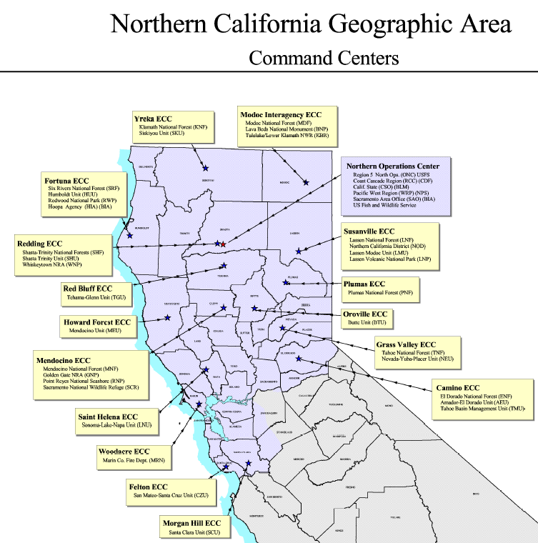

The purpose of this survey is to identify ways to help us improve our operations and customer service needs. Your constructive feedback is very important to help us with our continuous improvement process.

ONCC visitors and detailers are asked to complete the following survey; all sensitive comments will be kept confidential. Please feel free to use the back of the form if additional space is needed.

1. What recommendations or changes would you suggest to our office procedures to help us streamline operations?
2. Did ONCC provide an adequate orientation and work materials? What information was not provided that would be beneficial to other visitors in the future?
3. Was the ONCC staff helpful during your detail?
4. Were the facilities adequate? If not what improvements would you suggest?
5. What did you enjoy most about your visit to ONCC?

Please submit completed form to: Laurie Forni