GENERAL ROSS DISPATCHING TIPS

Following are dispatching tips on how to order specific types of resources as well as general tips applicable to ordering any type of resource:

Telecommunication Orders

All telecommunication orders have mandatory information that must be contained in the special needs block; i.e. (DO NOT PUT IN NAVIGATION INSTRUCTIONS AS THEY DO NOT PRINT ON THE RESOURCE ORDER)
- “Bill To”
- “Ship To
- “Jetport”
- “Contact Name & Phone No.”
- “FBO” and any other details pertinent to the order (you can find the FBO for your airport by going to the website www.airnav.com).

See the example below.
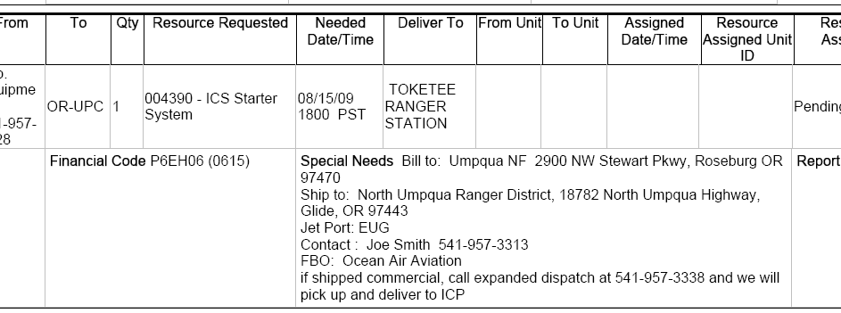



NOTE: If the incident wants the kit chartered due to a critical date and time; the following statement must also be included in the special needs block

“CHARTER AUTHORIZED TO MEET DATE AND TIME NEEDED”;

This is a very expensive option; note in the documentation screen who authorized the charter.

Food Service Orders

The following information is required in the SPECIAL NEEDS block of any food service request order (DO NOT PUT IN NAVIGATION INSTRUCTIONS AS THEY DO NOT PRINT ON THE RESOURCE ORDER):

- Physical Address (if none, a very detailed description how to get to the incident)
- Contact Name and Phone Number

See example below.

Fax food service request form to NWCC (most recent form in the 2009 mob guide, white pages, Ch.20, pg. 95) at the same time the ROSS order is placed.

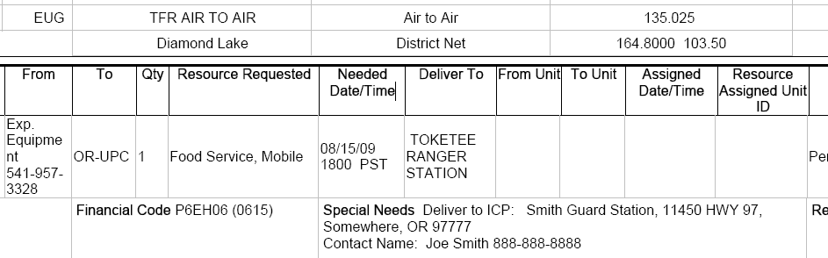

Mobile Shower Orders

The following information is required in the SPECIAL NEEDS block (DO NOT PUT IN NAVIGATION INSTRUCTIONS AS THEY DO NOT PRINT ON THE RESOURCE ORDER):

- Physical Address (if none, a very detailed description how to get to the incident)
- Contact Name and Phone Number
- Size of Shower Unit Requested: indicate large or small (read description below)

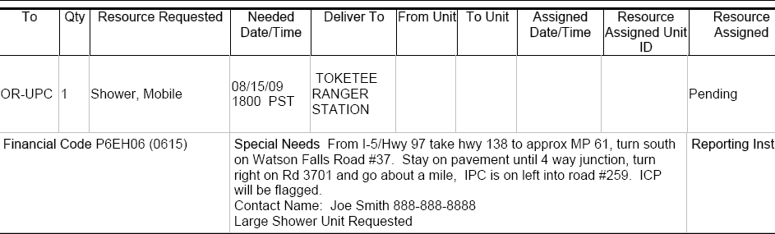

Large units are (12+ stalls starting at $2400/day) or small units (4-11 stalls-costs starting at $1600/day)
Contracting indicates their rule of thumb for shower unit production is 75 persons per shower head. Keep in mind that historically the "large" units are the units we have mobilized, so if an incident's expectation is consistent with what they had in previous years under similar circumstances, then a "large" unit is what they are looking for.
There are a total of eight small units nationally. These units can best be utilized where access is limited, or on incidents where the personnel numbers do not warrant a "large" unit. Based on the quantity of the new small units, there is no plan to make any changes in ROSS.
Another change for the 2009-2013 shower contract is that there are no longer any ADA accessible units under contract. Should the need arise for such a unit, local contracting can provide one under an EERA.

Other Misc Tips to remember when ordering resources in ROSS:

TRAVEL

A new Resource Needs Transportation checkbox (see below) has been added to the dialogs for filling, reassigning and releasing overhead and crew resources. This allows the dispatcher to indicate that once
the resource(s) reach the arrival location, additional transportation will be needed to the incident or to home. The checkbox is disabled when the No Travel option is selected.



If you do not check the “Resource Needs Transportation” block and the incident receiving the resource runs a ROSS report to see who is flying in, the report will show the resource does not need transportation to the incident.

See the example of the ROSS report below and how important it is to pay attention to this feature.
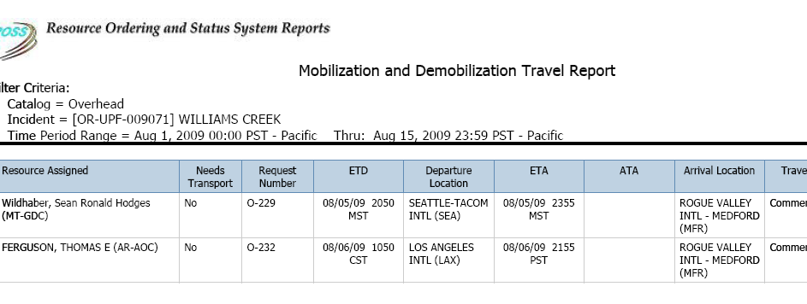

AIRCRAFT

- On aircraft orders tie personnel to the aircraft. For example ATGS should be ordered as a subordinate to the aircraft. This should be done with the receiving aircraft desk rather than the overhead desk.

See example below
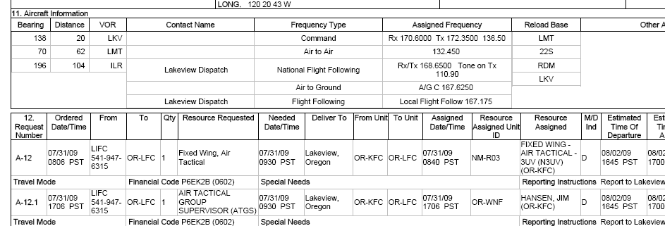

- Use search for resources screen to look for an aircraft before using the fill with agreement in the pending orders screen.

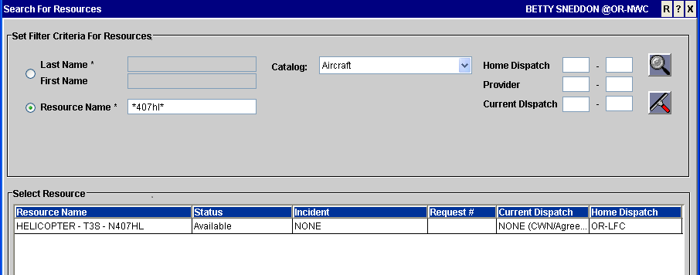

- When aircraft is swapping out make sure you include good documentation about who pays for flight costs and that vender sends back the same aircraft.

CREWS

- Don’t forget to view the reminders when creating the request.

- When you fill an order with a contractor and click “Manifest” you can free type. If you roster, the resource becomes a permanent record in ROSS. You can fill/edit a contractor’s manifest after they have left for assignment by going into Request Status and clicking the action button and choose edit assignment. After the screen opens choose edit manifest or choose new.
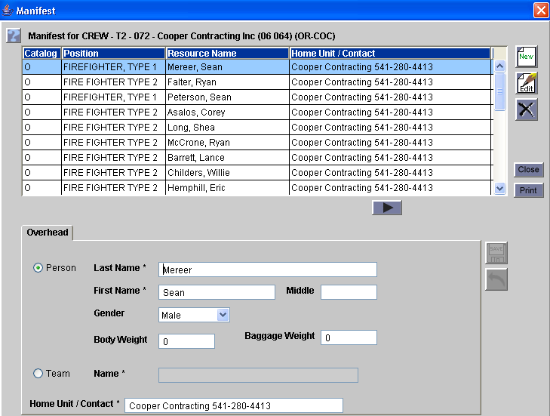

EQUIPMENT

- All agreement tenders are ordered as “Support”. Don’t order as tactical because all NW agreement tenders are entered into ROSS as “ Support”

Support Requests

When you create support requests on out of area resource you will see this pop up before the request is created. Do not choose Yes if the support request is to remain with the resource for example a rental vehicle. The only time you would choose Yes is if the support request was for example a driver/BUS taking a resource to the airport.

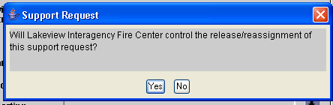

To yield control of a support request on a non local incident: Open the incident resources screen. Click the radio button for non-local support requests. Relinquishing control of a selected resource can be done under the “Action” button.

MISCELLANEOUS

Navigation Instructions
DO NOT use this block. It does not print on the resource order. Always use reporting instructions as these instructions will print on the order.

Name Requesting Contract Resources
You can not name request Regional resources or Best Value resources. These resources are arranged in a Best Value order by the Contracting Officer and must be dispatched in the order provided to the host units.

When should you put “fill information” in the order
Once you have confirmation a resource is available to fill an order, immediately fill the order in ROSS even if you don’t yet know the travel. The travel can always be added later when the information is known.

By doing this (1) the requesting unit will not be able to pull the order from you without you knowing about it; and, (2) the requesting unit can see the order is being worked on and not just sitting at the unit getting no attention.

Contracts

A contract Strike Team resource item can not be attached to the contract but it must be a resource item in your database in order to roster the engines. However the individual contract engines must be attached to the contract. See example below:

ENGINE S/T - T6 - 003 - C2C Wildfire ( not attached to the contract )
ENGINE - T6 - 017 - C2C Wildfire Inc – 705 ( attached to the contract)

ROSS Reports
If you need to run reports in ROSS, use the User Community Option as shown below.

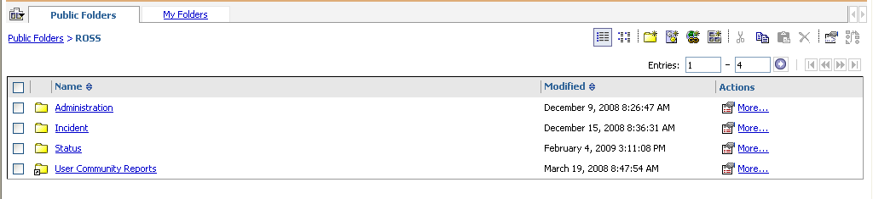

Acronyms

IBPA – Incident Blanket Purchase Agreement
VIPR – Virtual Incident Procurement System
DPL – Dispatch Priority List
BV – Best Value
ITEAM – Incident Training and Equipment Acquisition Management
EERA - Emergency Equipment Rental
EAUTH – Employee Authentification

And finally

Here is the best tip. There is a very good user guide available to users under the ROSS website.
Click on any of the subjects and you will see another screen open up with the most up to date information for that topic. I strongly urge the dispatch centers print a copy of the user guide and keep it for reference.

