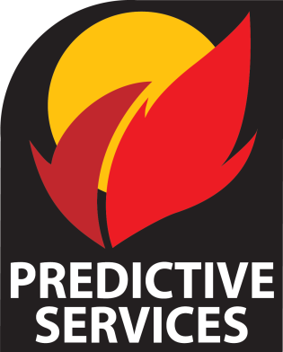
ROSS Reports Info Sheet
2013 NW Dispatch Workshop

ROSS Reports Management Board

Purpose
The ROSS Reports Management Board is committed to developing a broad community of users capable of accessing and utilizing Basic ROSS Reports, as well as supporting these users with a network of subject matter experts well-versed in Query Studio and AR Historical reporting.
RRMB Business Lead - Northwest  Isaiah Hirschfield  (NWCC Intelligence Officer)  (503)808-2734 desk iahirsch@blm.gov | RRMB Chair  Dan O’Brien  (NWCC Center Manager)  Desk: 503-808-2732 d1obrien@blm.gov

ROSS Reports Training

User Groups
ROSS Reports draws its information from the Resource Order and Statusing System (aka ROSS), but ROSS Reporting is not the exclusive domain of dispatchers or even the National Coordination System. Anyone who has a need for real-time or historical information on resource numbers, status, or availability, has a need for ROSS Reports and subsequent ROSS Reports training. This would include members of an incident management team, coordinating groups, or anyone else with operational or planning responsibilities requiring the use of resource information.
Coursework
There is no “required” training for ROSS Reports. A user only needs a ROSS user ID to receive access; however, a user won’t get far without at least going through the Basic User training in order to understand the in’s and out’s of the COGNOS reporting system that encapsulates ROSS Reports. And though ROSS Reports Training really doesn’t advertise prerequisite training, sequencing training from Basic User to Query Studio to AR Historical provides the user with the necessary knowledge and skills to build competency in the subsequent stages of training.
For Query Studio and AR Historical, a user will not receive access to the systems without first attending the training. Contact the Geographic Area Business Lead for training information.
Go here to see scheduled training: http://ross.nwcg.gov/train/ROSS_Training_calendar.pdf
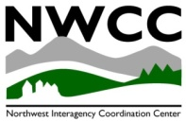
Basic User Training - Basic User of Standard and User Community (UC) Reports
Basic User training is intended to give access to standard and user community reports. It is the most basic level of training—allowing an understanding of folder structure and navigation—and provides the level of skill most needed to support day –to-day operations.
Target Audience – ROSS account holders
Objectives:
- Working with Standard and UC reports
- Scheduling report
- Understanding Cognos Viewer
- Saving/Exporting reports in many different formats
- Using preset filters
- Familiarity with ROSS Reports Index
- Introduction to ROSS Terminology
Expectation:
- Maintains basic competencies in the use of standard/UC reports.
- Provides constructive feedback through established communication networks to improve existing reports/process and/or suggesting new ones.

ROSS Reports Basic User References

COGNOS Sign-in http://rossreports.nwcg.gov/cognos/c8/cgi-bin/cognos.cgi
Basic Reports Module (Self-Guided or Instructor-led). Accessed through the ROSS webpage. Completion Time, approx. 4 hours. Recently updated: 04/05/13
http://ross.nwcg.gov/instructor_dispatch.htm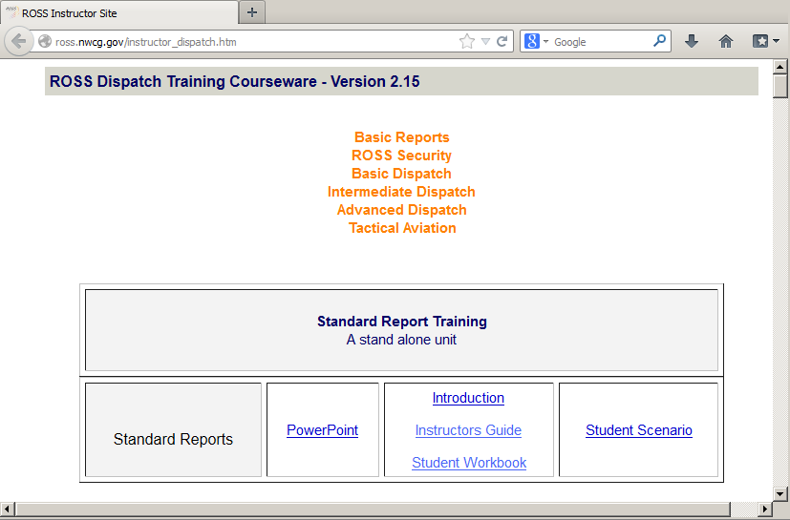
Student Workbook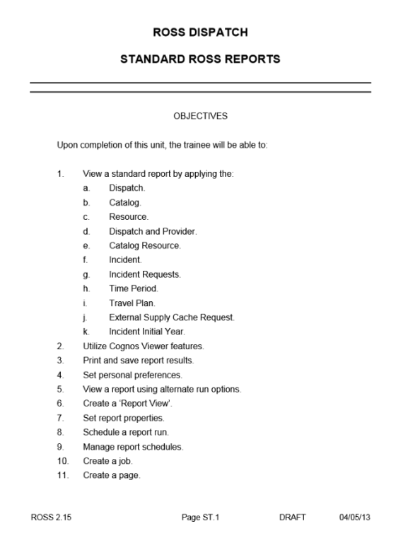
User Community Reports References

COGNOS Search Function
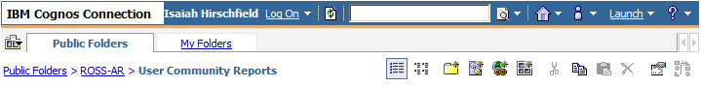

Standard and UC Reports Index (pdf, 116 pgs.) A catalog of example screenshots of finished reports. Very helpful resource for finding the right report in the User Community!
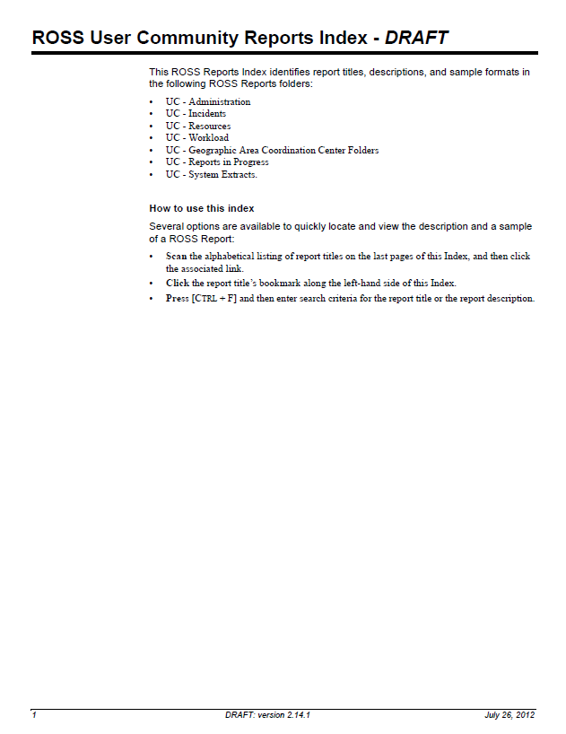

Task-Specific References
ROSS Quick Reference Cards, See, “Printing / Reports” Section
http://ross.nwcg.gov/quick_reference.htm
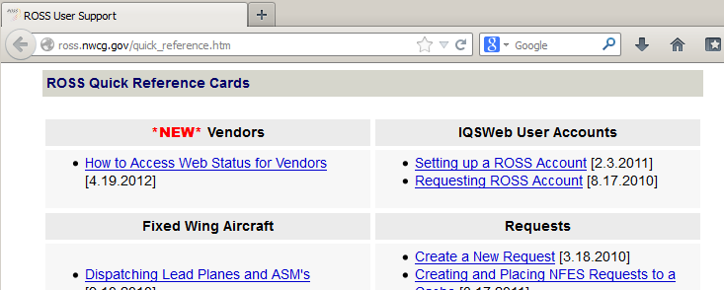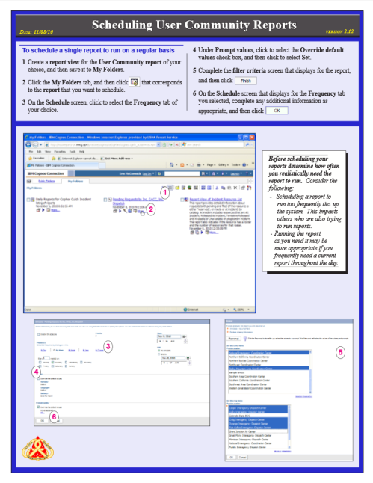

User Suggestions:
Users wishing to submit suggestions for the ROSS system are encouraged to complete a Change Request Form and e-mail it to ross-suggestion@dms.nwcg.gov.

