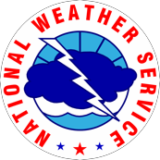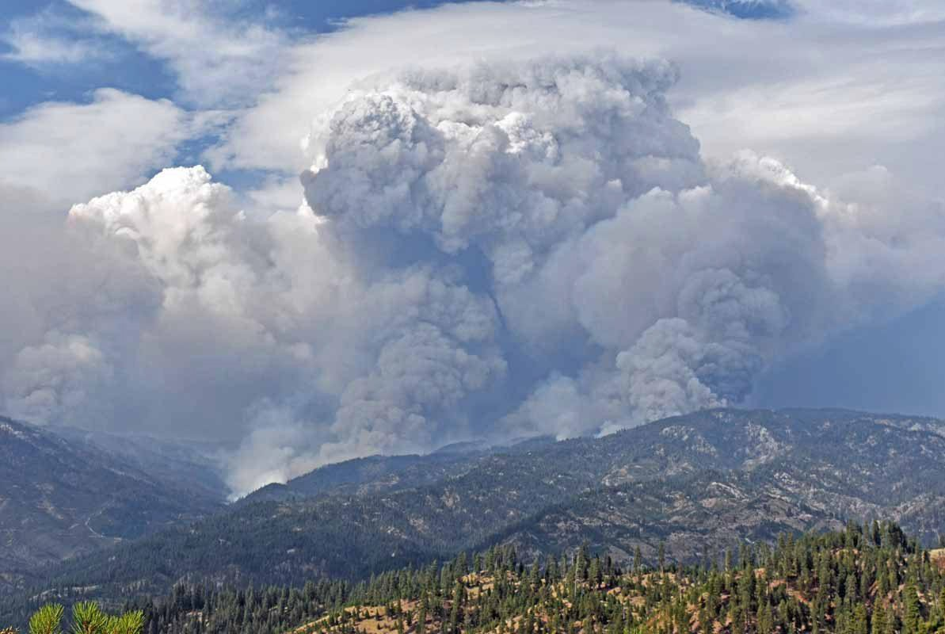Northwest Fire Weather Operating Plan

Oregon
Washington May 2018

1

This page intentionally left blank

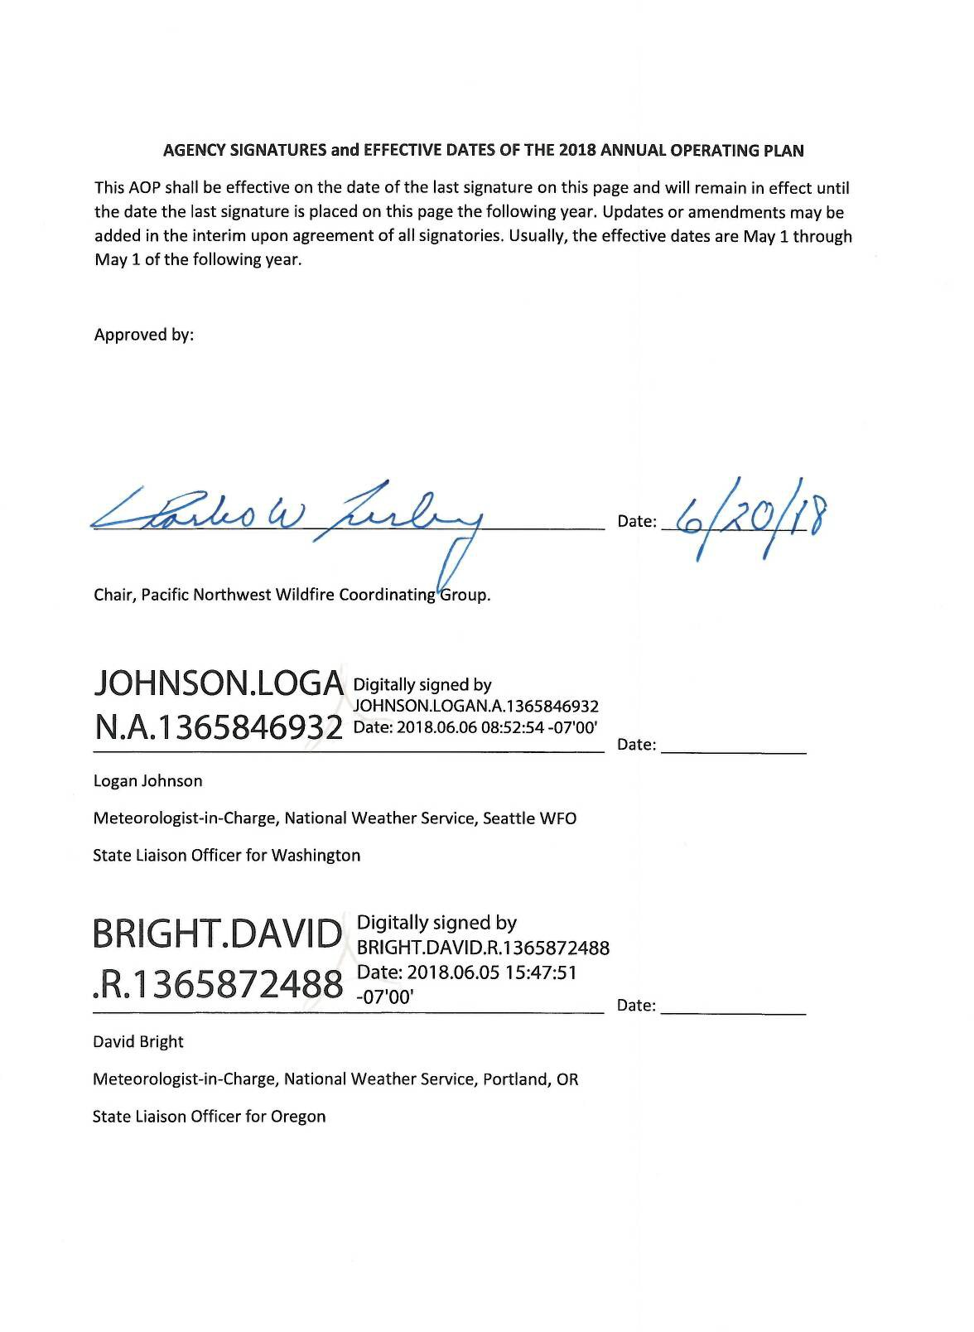

Table of Contents
Agency Signatures/Effective Dates of the AOP 3
Chapter 1 – Administrative 5
Introduction 5
NWS services and responsibilities 6
Wildland fire agency servicesand responsibilities 10
Joint responsibilities 11
Chapter 2 – Operating Plans 13
NWCC Predictive Services 14
NWS Boise 20
NWS Medford 24
NWS Pendleton 32
NWS Portland 43
NWS Seattle 56
NWS Spokane 68
Oregon Department of ForestryWeather Center 78
Washington Department of Natural Resources Fire Danger Program 81
Appendix A: Fire Weather Agreements and Documents 86
Appendix B: Forecast and Service Performance Measures 87
Appendix C: Reimbursement for NWS-provided Training 89
Appendix D: Meteorologist Position Description Form 90
Appendix E: IMET Billing Points of Contact 91
Appendix F: HYSPLIT Request Instructions 93

Chapter 1 Administrative

INTRODUCTION

- The Pacific Northwest Fire Weather Annual Operating Plan (AOP) constitutes an agreement between the Pacific Northwest Wildfire Coordinating Group (PNWCG), which is comprised of state, local government and Federal land management agencies charged with the protection of life, property and resources within the Pacific Northwest from threat of wildfire; and the National Weather Service (NWS), National Oceanic and Atmospheric Administration, U.S. Department of Commerce, charged with providing weather forecasts to the Nation for the protection of life and property.

The AOP provides specific procedural and policy information for the delivery of fire weather information to the fire management community in the Pacific Northwest. It is the objective of the NWS and PNWCG to ensure that quality of service is maintained through a mutual analysis of services provided. The NWS and PNWCG work closely in all phases of the fire weather forecast and warning program to resolve concerns and avoid potential inconsistencies in products and services prior to delivery to fire agency customers. The goal of all agencies is to maximize firefighter and public safety through a coordinated delivery of consistent services.

Fire weather services are a critical building block to fire management agencies in decision-making because human lives and valuable natural resources are at risk. It is the role of the NWS to provide fire weather services and products to fire managers. It is the role of the fire management agencies to analyze and interpret fire weather forecasts into fire danger and fire potential predictions when making decisions essential to the success of fire management actions.

It is to the mutual advantage of PNWCG and NWS and in the public interest and for firefighter safety to coordinate efforts for weather services for fire management activities in the Pacific Northwest to minimize duplication of efforts and improve efficiency and effectiveness.

- The general relationship between the NWS and the interagency fire management community is set forth in the following reference documents:

Interagency Agreement for Meteorological Services Among the Bureau of Land Management, Bureau of Indian Affairs, U.S. Fish and Wildlife Service, and National Park Service of the U.S. Dept. of Interior, the Forest Service of the U.S. Dept. of Agriculture, and the National Weather Service of the U.S. Dept. of Commerce (National MOA or National Agreement);

National Weather Service NWSI 10-4: Fire Weather Services;

2016 National Mobilization Guide; and

Pacific Northwest Mobilization Guide

- The PNWCG is comprised of the following Federal and State fire agencies: State of Oregon, Department of Forestry; State of Washington, Department of Natural Resources; USDA Forest Service, Pacific Northwest Region; USDI, National Park Service, Pacific West Region; USDI, Fish and Wildlife Service, Pacific Region; USDI, Bureau of Indian Affairs, Portland Area Office; USDI, Bureau of Land Management, Oregon and Washington.

NWS SERVICES AND RESPONSIBILITIES

The National Weather Service will collaborate with the fire agencies when proposing alterations to the fire weather program and services provided in the Pacific Northwest. NWS-developed proposals are provided to PNWCG for review, assessment, and comment prior to adoption and implementation. NWS considers any concerns expressed by PNWCG, especially as related to performance integrity, in its assessment of change proposals in the fire weather program and other services provided.

Fire Weather Services

  - Core grids and web-based fire weather decision support
National Digital Forecast Database (NDFD) grids are used to produce a wide variety of products and services for fire weather support. Operational status of NWS grid elements is available at the following website:

http://www.weather.gov/ndfd/resources/NDFD_element_status.pdf

NWS offices produce several web-based digital planning tools to assist fire weather customers. These include FARSITE weather input data, hourly weather graphs, point forecast matrices, activity planners, hourly weather graphs, and 48- hour element meteograms. Please contact your local servicing NWS office with any questions or for more information.

NWS fire weather grids for the Pacific Northwest are graphically displayed at http://graphical.weather.gov/sectors/pacnorthwestFireDay.php#tabs.

Fire weather watches and red flag warnings
Fire weather watches and red flag warnings are issued when the combination of dry fuels and weather conditions support extreme fire danger and/or fire behavior. These statements alert land management agencies to the potential for widespread new ignitions which could overwhelm initial attack activities, or conditions which could cause control problems on existing fires, etc. Any of these outcomes could pose a threat to life and property.

Fire Weather Watch: A fire weather watch is issued when there is a high potential for the development of a red flag event. A watch is issued 18 to 96 hours in advance of the expected onset of criteria. The watch may be issued for all, or selected portions within a fire weather zone or region. The overall intent of a fire weather watch is to alert forecast users at least a day in advance for the purposes of resource allocation and fire fighter safety.

Red Flag Warning: A red flag Warning is used to warn of impending or occurring red flag conditions. Its issuance denotes a high degree of confidence that weather and fuel conditions consistent with local red flag event criteria will occur in 48 hours or less. Longer lead times are allowed when confidence is very high or the fire danger situation is critical. Forecasters can issue a warning for all or selected portions within a fire weather zone.

Prior to issuance, all red flag warnings are coordinated with affected agencies and neighboring fire weather offices, in order to assess fuel conditions and general fire danger. Each issuance, update or cancellation of a fire weather watch or red flag warning is also relayed by telephone to the dispatch office(s) affected by the watch/warning. Red flag warnings and fire weather watches will be issued using a bulleted format.

Spot forecasts
Spot forecasts are site specific forecasts issued by the NWS in support of wildfire suppression and natural resource management. Spot forecasts may also be issued for hazardous materials incidents, search and rescue missions and other threats to public and responder safety. All spot forecast requests should be accompanied by a representative on-site weather observation.

Issuance Criteria: Spot forecasts are non-routine products issued at the request of the user. WFOs will provide spot forecast service upon request of any federal, state, tribal, or local official who represents the spot forecast is required to support a wildfire.

For non-wildfire purposes, resources permitting, WFOs will provide spot forecast service under the circumstances and conditions outlined in NWS Instruction 10-
401. Spot forecasts will not be provided to private citizens or commercial entities not acting as an agent of a government agency.

Requesting a Spot Forecast: Spot forecast requests are normally made via the Internet through local NWS fire weather pages. When web access is not available, spot forecasts may be requested and disseminated via fax - using the spot forecast request form D-1 (NWSI-401) in Appendix E. An electronic fillable pdf version of WS form D-1 can be found at:
6 http://www.srh.noaa.gov/ridge2/fire/docs/WS_FORM_D_SPOT.pdf

The requestor must provide information about the location (latitude/longitude), slope aspect, drainage name, fuel type(s), top and bottom elevations of fire or project, size of fire or project, ignition time, and contact names and telephone numbers of the responsible land management personnel. It is critically important that each spot forecast request also include quality, representative observations at, or near, the site. A detailed description of the observation location relative to the project (if not at the site) should be provided. The description should include, at a minimum, distance and direction from the project or fire site, station elevation and aspect.

An exception to the rule regarding on-site weather observations is as follows: a spot forecast request can be made without an observation if it is on an initial attack fire of less than two hours, there are red flag warnings or fire weather watches in effect, or the available fire weather forecasts is not representative of what is observed at the site. Even in this situation, a representative observation will result in a better forecast.

Fire agencies are strongly encouraged to call the WFO after submitting a spot request to ensure it was received properly. The WFO will attempt to notify field personnel and/or the dispatch office whenever there is a significant change in the expected weather.

For detailed instructions submitting a Spot Forecast Request, go to: http://www.wrh.noaa.gov/sew/NW_SpotRequestInstructions.pdf

Updates to Spot Forecasts: Spot forecasts are considered one-time requests, and are not routinely updated. Spot forecasts may be updated when new representative observations are available to the forecaster or if the forecaster deems the current forecast does not adequately represent current or expected weather conditions. Land or emergency management personnel are encouraged to contact the appropriate WFO for a spot update if forecast conditions appear unrepresentative of the actual weather conditions. The spot forecast will be corrected when a typographical or format error is detected that could confuse the intended meaning. Updated and corrected spot forecasts will be delivered to users in the same manner as the original spot forecast when possible.

Spot Forecast Feedback: Good communication between fire managers and the NWS is critical for quality spot forecast services. Land management personnel should provide feedback to the NWS forecasters about the quality and accuracy of the spot forecast. Responsibility for providing fire line observations for the verification of forecast accuracy rests with the land management agencies. Onsite observations taken during the operational period the forecast is valid for are to be provided back to the WFO via the feedback box online spot forecast form, or by phone, fax or e-mail.

Hysplit Trajectory Output: Hysplit trajectory output is available when requesting a Spot Forecast. See Appendix F for details.

Fire weather planning forecasts
The Fire weather planning forecast is a zone-type product used by land management personnel primarily for input in decision-making related to pre- suppression and other planning. The decisions impact firefighter safety, protection of the public and 7 property, and resource allocation. Weather parameters represent average conditions across the given zone.

Headlines are included in the fire weather planning forecast (FWF) whenever a red flag warning or fire weather watch is in effect or to highlight other critical weather information. A brief, clear, non-technical discussion of weather patterns that will influence the forecast area will begin the forecast with the emphasis on the first two days of the forecast period. A discussion of latter periods will be included if significant weather is expected to impact safety or operations. Sky and weather, maximum and minimum temperature and relative humidity, wind speed and direction, Haines index, lightning activity level and chance of wetting rain are included in the FWF by all of the WFOs in the Pacific Northwest. Several offices also forecast mixing height and transport winds.

Two forecasts will be issued daily during fire season – a morning forecast between 5 AM and 9 AM and an afternoon forecast around 3 PM. Once-a-day forecasts will continue through the spring and fall burning seasons at the request of the land managers with some offices continuing land management forecasts through the winter. Local start and stop dates shall be coordinated between the NWS offices and fire weather customers, including the geographic area Predictive Services Units.

NFDRS forecasts
The National Weather Service role in NFDRS is providing weather forecast input, which combined with fire agency input, allows the NFDRS software in WIMS to predict the next day's fire danger indices. These indices impact agency resource management decisions, firefighter safety, and protection of the public and property.

Numerical point forecasts for NFDRS stations are prepared and disseminated to WIMS by 1540 each afternoon from April or May through early October. The point forecasts are used to compute the expected NFDRS indices valid the following day. The number of NFDRS point forecasts made by the weather office depends only on the number of NFDRS observations input into WIMS by the fire agencies. If observations are not entered into WIMS by 1500 however, a forecast may not be produced for those stations. A weather forecaster may also not produce a forecast for sites with highly questionable observations.

Phone briefings

All Pacific Northwest NWS Offices provide daily fire weather phone briefings each morning during fire season. Local Fire weather users are encouraged to participate in these briefings. The forecaster hosting the briefing will verbally highlight current and forecast fire weather conditions with the help of weather graphics on an internet web page or through a GoToMeeting® webinar. Briefing times, conference call telephone numbers and passcodes can be obtained by contacting the local WFO. A link to the web briefings can be found on the local fire weather page.

Forecast verification
Routine verification is made on Red Flag Warnings and NFDRS forecasts. Results of the verification will be published in the Fire Weather Annual Summary. Spot forecast turnaround time and other statistics are available from your local NWS office.

Incident Meteorologist services
Each WFO in the Pacific Northwest has 2 or more Incident Meteorologists (IMETs) on staff available for wildfire, HAZMAT, Search and Rescue or other emergency dispatches. To request an IMET, contact the appropriate fire agency dispatch office.

Social media
Each NWS office in the Pacific Northwest has a Facebook page, Twitter account, and a YouTube channel. Current information about Fire Weather may be included in social media feeds as time allows, but such information is intended as supplemental information for the general public; NWS use of social media is not intended to meet the specialized needs of the wildland firefighting community.

Non-forecast services
Several duties fall into the non-forecast services including, but not limited to: teaching assignments, customer meetings, customer consultations, preparation of annual reports, preparation of annual operating plans, program management, research and in-house training of personnel. Experienced Fire Weather Forecasters will be available to help instruct the weather sections of standard fire behavior training courses offered by federal, state and local government fire agencies. These include S-190 through S-590 and other courses. In addition, a forecaster will be available for special speaking engagements and customer consultations. For scheduling purposes, requests for an instructor or speaker should be made at least three weeks in advance. Requests for NWS personnel to provide training should be accompanied by a separate reimbursement or advance of funds Agreement, if overnight travel is necessary. Every effort should be made to acquire invitational travel orders for the NWS resource, provided by the requesting Agency. Additional information can be found in the National Fire Weather Annual Operating Plan: http://www.weather.gov/fire under the Admin tab, or in Appendix C.

WILDLAND FIRE AGENCY SERVICES AND RESPONSIBILITIES

Provide coordination and recommendations for interagency fire weather activities in Oregon and Washington through the PNWCG. Continually review standards of performance for applicability and adequacy.

Provide weather observations seven days a week during fire season and coordinate and cooperate with the NWS in fire weather forecasting. The agencies will seek the advice and counsel of the NWS regarding observational issues (e.g. moving remote automatic weather stations).

Recognize that other severe weather emergencies may require the services of the fire weather forecaster to assist in WFO operations.

User agency responsibilities:
There are several responsibilities of the user agencies including:

  - Entering of 1300 LST NFDRS observations in WIMS
  - Site observations for Spot Forecast requests
  - Quality Control of RAWS observations
  - Timely maintenance of RAWS sites

JOINT RESPONSIBILITIES

Work cooperatively as partners to maintain and improve fire weather services to assure full compliance with mutually established performance, reliability, priority, and time standards.

Recognize that lands for which the States are responsible for wildland fire protection in Oregon and Washington, and the lands for which the respective Federal Agencies are responsible, are intermingled or adjacent in some areas, and wildland fires on these intermingled or adjacent lands may present a threat to the lands of the other. Recognize the primary role of the States in administering smoke management plans in their respective states.

Prepare an Annual Operating Plan (AOP – this document) that includes each WFO with fire weather areas of responsibility in Oregon and Washington as required in the National Fire Weather Agreement and fire and smoke management responsibilities (as appropriate) of DNR, ODF and NWCC Predictive Services. Fire weather zone and Predictive Service Area maps will be included in the AOP. The AOP will meet the guidelines specified in NWSI 10- 404.

Annually review the performance of the NWS and NWCC Predictive Services in meeting the needs of the fire management community. This review will be used to help determine what program adjustments are needed and appropriate. PNWCG directed subject matter experts (SMEs) and the NWS MICs from Boise, Medford, Pendleton, Portland, Seattle and Spokane shall conduct the review. NWCC Predictive Service, the

NWS, PNWCG SMEs and any interested members of the fire community shall meet annually around February. The meeting will evaluate the past season fire weather services and recommend changes for the next fire season. Proposed changes in fire weather services for the upcoming fire weather season will be discussed and if agreed upon reflected in the AOP. AOP sections from individual offices are expected to be finalized no later than April 1st (drafts are requested the February meeting) so that the compiled Pacific Northwest AOP can be submitted to the PNWCG and NWS signatories for final approval. Changes after April 1st should, if at all possible, be held off until after fire season. If extenuating circumstances require significant additional changes to be made for the current fire season, the AOP will need to be reapproved by the signing officials.

Respond to the other party's proposals within thirty (30) days, or advise the other party when the proposal will be addressed if the NWS or the PNWCG are unable to meet or discuss the proposal within their respective groups in that time frame. Except when necessary to meet emergency needs, significant proposals are expected to be discussed at the annual meetings.

Cooperate and coordinate plans for the weather-related training of fire personnel and fire weather forecasters to ensure that training needs are met.

Collaborate in fire weather research and development.

Chapter 2 Operating Plans

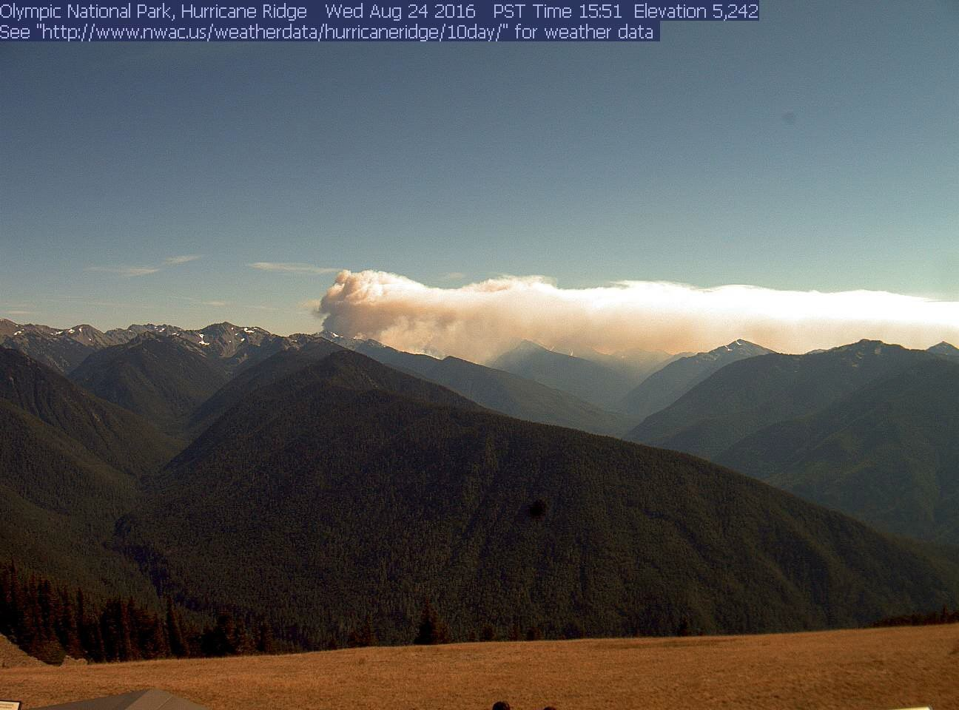
The Hayes Fire as seen from Hurricane Ridge during an east wind event. August 24, 2016.

NWCC PREDICTIVE SERVICES

Predictive Services Mission

The Predictive Services Program supports the wildland fire community and incident coordination system with decision support information. This typically includes a synthesis of fire danger, fire weather, fire intelligence, and fire management resource information. Information generated by NWCC typically revolves around decision support information for determining regional preparedness level and distribution of fire management resources.

Predictive Services Goals and Responsibilities

Predictive Services provides decision support and tools which enable proactive, safe and cost effective fire management. Predictive services actively partners with state and federal wildland fire agencies, cooperating agencies, research, academia, and the private sector to ensure the relevance of predictive services’ products and program.

LOCATION

Northwest Interagency Coordination Center 150 SW Harrison St. Suite 400
Portland, OR 97201

OPERATING HOURS

FIRE SEASON (June through early October)
0700-1700 PDT 7 days a week

NON FIRE SEASON
0700-1530 PDT 5 days a week

STAFF

The NWCC Predictive Services program is interagency. It encompasses two meteorologists, a Fire Management Analyst and assistants, an Intelligence Officer and a Geographic Information System (GIS) specialist and assistants from the different federal and state land management agencies.

METEOROLOGY
John Saltenberger Program Manager (503) 808-2737
Eric Wise Meteorologist (503) 808-2756 Various Detailers during fire season

INTELLIGENCE/FIRE MANAGEMENT
Vacant Fire Management Analyst (503) 808-2733
Monica Ramirez Intelligence Officer (503) 808-2734
Various Detailers during fire season (503) 808-2780

GIS
Barbra Haney GIS specialist (503) 808-2741
Various detailers during fire season (503) 808-2741

EMAIL
John Saltenberger jsaltenb@blm.gov Eric Wise Eric.Wise@bia.gov Monica Ramirez mramirez@blm.gov Barbara Haney bhaney@blm.gov

WORLD WIDE WEB
http://gacc.nifc.gov/nwcc/

PRODUCTS and SERVICES
Predictive Services provides products and services mainly intended for use by national and geographic area fire management decision makers such as NWCC and NICC coordinators and Multi-Agency Coordination groups (GMAC, NMAC).
Predictive Services analyzes current resource status, fuels conditions and fire danger, fire weather, and ignition data in order to produce and disseminate fire potential decision support products. These products are produced so that regional and national fire managers can make pro-active fire management decisions regarding prioritization and distribution of firefighting resources.

Daily Fire Activity Forecast

Updated daily during fire season, the Fire Activity Forecast is an internal NWCC product that summarizes anticipated new fire load over the several days in each Predictive Service Area (PSA) days by combining projections of:

  - Fluctuations in fire danger in each PSA.
  - The number of new fires expected in each PSA
  - The probability of new significant fires in each PSA

7-Day Significant Fire Potential

The 7-Day Significant Fire Potential is a subset of the daily Fire Activity Forecast mentioned above. Both are generated daily by combing weighted contributions of weather elements, fire danger indices, estimated ignitions, and the availability of firefighting resources. Recall that “Significant fires” are defined in the NWCG glossary as those fires large and costly enough to warrant movement of firefighting resources from outside the area where the fire originates. A daily risk factor is assigned to each PSA based on its unique contributing factors.

PSAs expected to undergo elevated risk of new significant wildland fires are denoted in the 7-Day products published by Predictive Services in varying colors based on their daily risk ranking. Red designations depict risk factors above the 20% threshold and are called “high risk” days for elevated risk of new large fires.

NWCC’s daily 7-Day Significant Fire Potential product is available at:

Northwest: https://gacc.nifc.gov/nwcc/content/products/fwx/guidance/DL.pdf National Map: https://psgeodata.fs.fed.us/forecast/#/outlooks?state=map

The Fire Activity Forecast and 7-Day Significant Fire Potential products were developed using objective data sources such as the FPA fires database, Fire Family Plus, and detailed meteorological data on a grid centered over the Pacific Northwest. Over two decades’ worth of data were gathered and compared to identify patterns of weather, ignitions, and fire danger that combine to boost the risk of Significant Fires (defined above).

Environmental elements that were considered as possible contributors to initiation of significant fires in various PSAs include:

  - Absolute values and fluctuations in fire danger as measured by the National Fire Danger Rating System (NFDRS).
    - Energy Release Component (for fuel model G)
    - 100hr dead fuel moisture

  - General winds averaged across the landscape of a PSA.
  - Instability in the atmosphere over a PSA.
  - Dryness in the atmosphere over a PSA.
    - Vapor pressure deficit
  - Numbers of ignitions concentrated in a 24hour period in a PSA.
    - Lightning sources
    - Human sources

Note on Interpreting the 7-Day Significant Fire Potential Product: Because it is not site specific, the 7-Day Significant Fire Potential Forecast is not intended to be interpreted as a fire weather forecast or a fire behavior forecast. It is not intended to be used for gauging safety risks due to fire activity. It does not necessarily reflect extreme conditions in different fuel types within any PSA. Rather, the 7-Day Significant Fire Potential Forecast simply depicts the daily risk of fires growing to meet the ‘significant’ size criteria in each PSA based on historical combinations of past contributing factors.

Regional Preparedness Level Forecast

Daily Preparedness Level for the Northwest geographic area is determined by the NWCC center manager and/or Operations Manager with guidance from the NWCC Predictive Services unit.

That guidance is based on objective assessment of the current demand and forecasts for future need of fire management resources from NWCC’s Fire Activity Forecast. Analysis of historical usage of fire management resources since 2004 was blended with numbers of reported ignitions and resulting large fires to model resource demand when similar conditions repeat themselves in the future.

NWCC’s daily Regional Preparedness Level Forecast is available at: http://gacc.nifc.gov/nwcc/brief

Monthly and Seasonal Significant Fire Potential Outlooks

The Monthly and Seasonal significant Fire Potential outlook identifies geographic regions across the US likely to expect above-average, average, or below-average significant fire load during the following four months.
Significant fires are defined as those severe enough to require mobilization of firefighting resources from outside the area the fire originates.

http://gacc.nifc.gov/nwcc/content/products/fwx/MonthlySeasonal.pdf http://gacc.nifc.gov/nwcc/content/products/fwx/MonthlySeasonal.ppt

NWCC’s narrated audio/video webcast of the Monthly and Seasonal Significant Fire Potential outlook is routinely updated at:

http://gacc.nifc.gov/nwcc/content/videos/Monthly_Seasonal.mp4

Monthly and Seasonal outlooks (maps and narratives) for the entire US are at:

http://www.predictiveservices.nifc.gov/outlooks/outlooks.htm

Fire Behavior and Fuels Advisories

When fire behavior is known or anticipated to be severe over a large section of the Geographic Area Predictive Services assists in the issuance of any fuels/fire behavior advisories. Fire Behavior and Fuels advisories can be seen at:

https://www.predictiveservices.nifc.gov/fuels_fire- danger/Fuels_FireBehavior_Advisories.png

Fuels and Fire Danger Information

Links to fuels and fire danger related information used to evaluate fire potential are located here.

https://gacc.nifc.gov/nwcc/predict/fire_fuel.aspx

Intelligence reports

During fire season NWCC’s Predictive Services intelligence unit publishes daily updates of fire activity, resource status, situation reports, and large fire maps at:

https://gacc.nifc.gov/nwcc/predict/intelligence.aspx

GIS

NWCC’s Predictive Services Geographic Information Systems unit gathers, decodes archives, and plots a plethora of fire and weather information daily during fire season. This includes:

  - Active fire mapping and fire perimeters in Google Earth
  - NFDRS summary maps
  - Daily lightning strikes

  - Daily rainfall total maps

Further documentation of NWCC’s GIS unit can be accessed at: https://gacc.nifc.gov/nwcc/predict/gis.aspx

NWCC Predictive Services Fire Danger Rating Operating Plan and Supporting Documentation.

A detailed explanation of NWCC Predictive Services’ fire potential system is at:

https://gacc.nifc.gov/nwcc/content/products/fwx/fdrop/FDROP.pdf

PREDICTIVE SERVICE AREAS (PSAs)

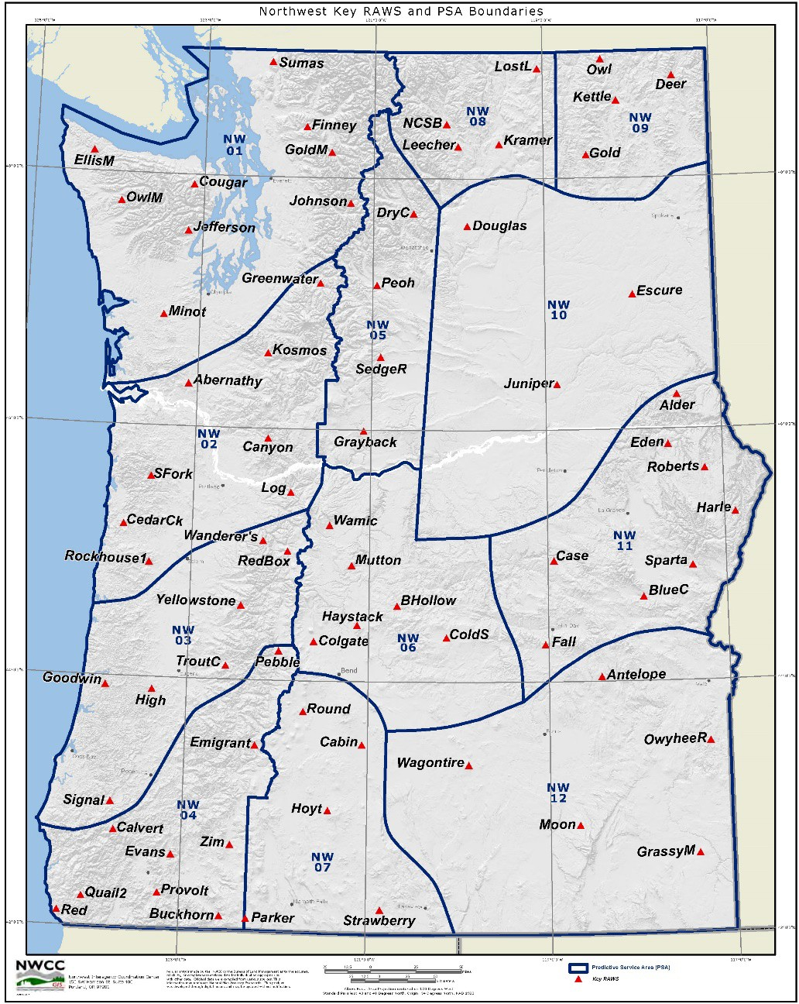

Twelve Predictive Service Areas (PSAs) were designated from a climatological study of daily relative humidity fluctuations over a period of more than a decade. Within each PSA “key” NFDRS sites have been selected to contribute to daily evaluations of fire danger averaged across each PSA. All key stations are given equal weighting as an NFDRS “sig” group. ‘Key’ NFDRS sites were determined by an objective study that compared stations and identified redundancy..

Most of NWCC’s Predictive Service fire potential products are based on these PSAs. Note that PSAs do not correspond to fire dispatch area perimeters, agency ownership, or political boundaries. They simply reflect large scale daily weather and fire danger fluctuations.
Most of NWCC’s Predictive Service fire potential products are based on these PSAs. Note that PSAs do not correspond to fire dispatch area perimeters, agency ownership, or political boundaries. They simply reflect large scale daily weather and fire danger fluctuations.

NATIONAL WEATHER SERVICE BOISE

NATIONAL WEATHER SERVICE BOISE
WHAT’S NEW

HOURS OF OPERATION

Once-a-day issuance of the Planning Forecast (FWF) will begin mid-May, but will be dependent on ongoing weather and fuel conditions. These forecasts will be issued Monday through Friday by 0730 PDT (0830 MDT).

Starting dates for the full complement of fire weather products, including NFDRS Forecasts and twice-daily Planning Forecasts, will depend on variables such as fuel dryness and customer needs. This typically occurs by early June.

Staff meteorologists are available anytime; 24 hours a day, 7 days a week. The fire weather desk is staffed from 0630 to 1430 PDT (0730 to 1530 MDT).

STAFF AND CONTACT INFORMATION
Boise Weather Forecast Office NIFC – National Weather Service 3833 S. Development Ave., Bldg 3807
Boise, ID 83705-5354

Phone: (208) 334-9060 / Fax (208) 334-1660
Fire Weather Webpage: http://www.wrh.noaa.gov/firewx/?wfo=boi
Facebook Page: https://www.facebook.com/US.NationalWeatherService.Boise.gov Twitter Page: https://twitter.com/NWSBoise
Twitter Handle: @NWSBoise

Name | Position | E-Mail
Chuck Redman | Fire Weather Program Leader/IMET | Chuck.Redman@noaa.gov
Michael Cantin | Meteorologist-in-Charge | Michael.Cantin@noaa.gov

FIRE WEATHER SERVICES
Map of the Boise Fire Weather District within the NWCC, OR636, OR637, & OR646.
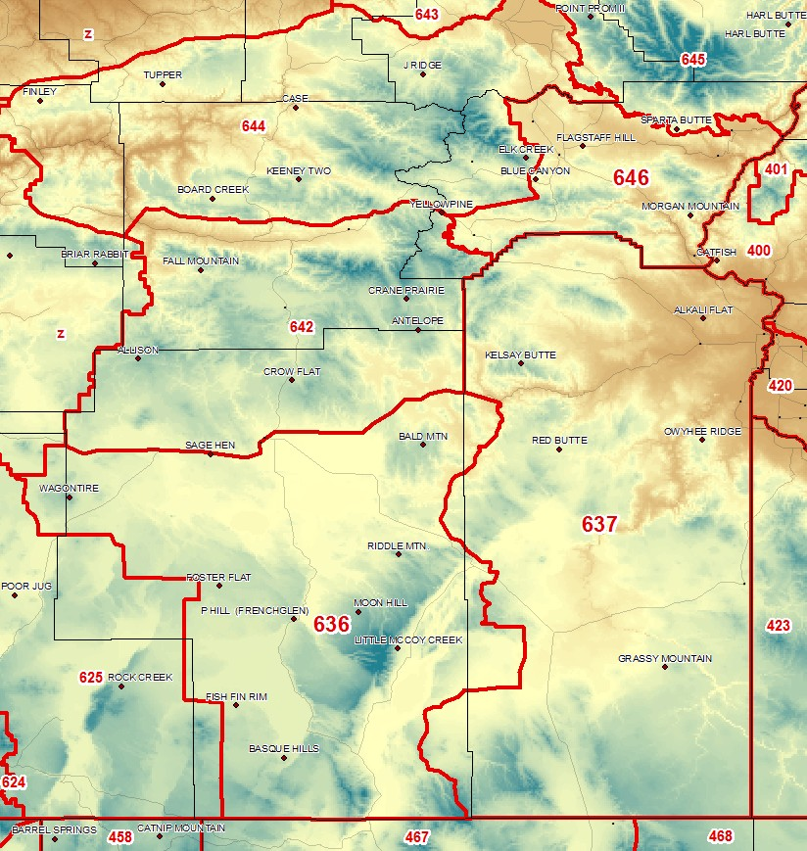

BASIC METEOROLOGICAL SERVICES

PRODUCT SCHEDULE:

Product: | Issuance time: (MDT) / (PDT)
Morning planning forecast | 0830 / 0730
Internet briefing | 0930 / 0830
Afternoon planning forecast | 1530 / 1430
NFDRS point forecast | 1530 / 1430
Fire Weather Watch / Red Flag Warnings Event Driven Spot forecasts Upon Request

RED FLAG EVENTS: High to extreme fire danger and dry fuels (defined by agency input), in combination with the following weather conditions:

- Areal thunderstorm coverage of scattered or greater (>25%), implying LAL of 4 or greater (see below).

- High Haines index of 6 in combination with RH<15%. (Zone 646 only.)

- Strong winds and low humidity. (See matrix below for sustained criteria.) In addition to sustained strong winds from the matrix, wind gusts >35 mph, combined with relative humidity 10% or less, are considered Red Flag Criteria. Red Flag Criteria are considered to be met if conditions are observed at any three RAWS stations within a combined area of Fire Weather Zone 636 and 637 for >3 hours (not necessarily consecutive). Alternatively, if a RFW is issued separately for Fire Weather Zones 636 and 637, it is considered to verify if conditions are met at three RAWS stations in Zone 636 or two RAWS stations in Zone 637 and 646.

SUSTAINED 20 FT WIND (10-MINUTE AVERAGE in MPH)

10 mph 15 mph 20 mph 25 mph 30 mph
20% W
15% W W
10% W W W

LIGHTNING ACTIVITY LEVEL:
The chart listed below will be used to forecast Lightning Activity Level (LAL): LAL = 1 No Thunderstorms
LAL = 2 Isolated Thunderstorms
LAL = 3 Isolated Thunderstorms (Increased Confidence/Threat) LAL = 4 Scattered Thunderstorms
LAL = 5 Numerous Thunderstorms
LAL = 6 Scattered (But Exclusively Dry) Thunderstorms

Interagency Coordination: Before the issuance of a Fire Weather Watch or Red Flag Warning, there will be coordination with the affected agencies and neighboring NWS Forecast Offices in order to assess fuel conditions and general fire danger.

Dissemination of Fire Weather Watches and Red Flag Warnings: Each issuance, update, or cancellation of a Fire Weather Watch or Red Flag Warning will be relayed by telephone to the dispatch office(s) affected by the Watch/Warning.

SPOT FORECASTS:

http://www.weather.gov/spot/

Please reference LAT/LON when requesting spot forecasts. Follow-up phone calls are always encouraged and feedback is extremely useful.

WEATHER BRIEFINGS:

A daily briefing will be conducted each day at 0930 MDT (0830 PDT) for all agencies via a GoToMeeting. During pre-fire season it will be held only on Mondays and Thursdays.
The briefing will include a general discussion of weather conditions and forecasts for the current day, as well a brief discussion of the extended period. Model data, satellite loops, and other items of interest will be addressed for the forecast period. The briefing will usually be about 10-15 minutes, but may be longer during active fire periods.

NATIONAL WEATHER SERVICE MEDFORD

WHAT’S NEW
- Staff and Certified Fire Weather Forecaster Staff has been updated.
- Webinar registration link for the 9:30 AM Daily Fire Weather Call has been updated.

HOURS OF OPERATION
24 hours a day, year round. Meteorologists are on duty 24 hours a day, 7 days a week. Additional forecasters will be brought in to staff for severe weather, to include that related to wildfire. Under the provisions of the National Fire Weather Agreement, special service provided by the Medford office will be done on a reimbursable basis.

LOCATION
National Weather Service Medford 4003 Cirrus Drive
Medford, Oregon 97504

STAFF AND CONTACT INFORMATION
The Medford office is staffed with 19 full-time meteorologists. 15 of these forecasters participate in producing fire weather forecasts after each has completed the training, which includes correspondence courses, computer-based Fire Weather Training Modules, mesoscale analysis, climatological and terrain familiarization, and spot forecast training.

Management staff:
John Lovegrove Meteorologist-in-Charge

Certified Fire Weather Forecaster staff:
Michael Stavish Science and Operations Officer
Ryan Sandler Warning and Coordination Meteorologist
Brett Lutz Meteorologist / Fire Weather & Asst. Climate Program Leader Frederic Bunnag Senior Met. / Asst. Fire Program Leader/IMET
Sven Nelaimischkies Senior Met. / Marine Program Lead & Webmaster/IMET (T) Ken Sargeant Internet Technical Officer (ITO)
Jay Stockton Senior Meteorologist
Tom Wright Senior Meteorologist, IMET

Connie Clarstrom Senior Meteorologist Shad Keene Meteorologist
Mike Petrucelli Meteorologist / Aviation Program Leader Marc Spilde Meteorologist
Dan Weygand Meteorologist
Brian Nieuwenhuis Meteorologist / Marine Program Leader Bradley Schaff Meteorologist
Misty Duncan Climate Program Leader Michelle Cohen
Charles Smith

NWS Medford
Homepage: http://www.wrh.noaa.gov/mfr Facebook
Page: https://www.facebook.com/NWSMedford?ref=ts Twitter Page: https://twitter.com/NWSMedford
Twitter Handle: @NWSMedford

FORECAST AREA
Southern Oregon, fire weather zones 615, 616, 617, 618, 619, 620, 621, 622, 623,
624,
and 625.

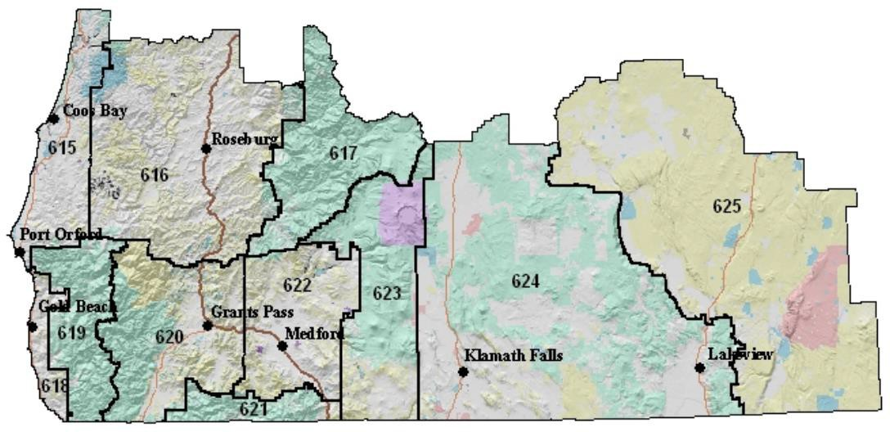

FIRE WEATHER SERVICES

Fire Weather and Land Management Forecasts: The Land Management Forecast/Fire Weather Planning Forecast is issued during the off-season, usually from mid-October through early May. This forecast is available on the webpage once daily by
0700 local time. The frequency of the Land Management Forecast and the forecast elements may be increased as the fire season approaches. The Fire Weather Program Leader will inquire with the user agencies as weather and fuel conditions warrant during the off season to determine as to when additional forecast elements and/or forecasts are needed. During the fire season, the Fire Weather Forecasts will be issued twice daily at 0700 and 1500 PDT.

ECCDA Forecasts: The Medford Weather Forecast Office also issues the grid- based Dispatch Area Forecast (ECCDA) twice a day by 0700 and 1530 local time, year-round. These forecasts are tailored to the operational area of each dispatch center and may also be accessed via the following
link: http://www.wrh.noaa.gov/mfr/fire/eccda.php

NFDRS Trend Forecasts: NFDRS Trend Forecasts are accomplished when needed by the fire agencies. This is usually from sometime in May through September, but can vary greatly from year to year. These trend forecasts are sent to WIMS by 1545 PDT with forecast parameters typically available from WIMS by 1600 PDT.

Medford WFO Daily Fire Weather Briefing Webinar: The Medford NWS Office will continue to produce once per day, recorded Daily Fire Weather Briefings, via a GoToWebinar format, during declared fire season (usually June 1st to Sep 15th).
These briefing will focus on important elements in the forecast as they relate to fire weather, both in the short term forecast and up to one month out, when pertinent. Additionally, these briefings may be done on an as needed basis prior to and after fire season has been declared if weather significant to fire operations is anticipated.
The briefing is held at 930am and can be registered for via the following link: https://attendee.gotowebinar.com/register/4494675281321657858

A recorded version of this daily webinar will be posted each day, usually by 1030am, at the following link:
http://www.wrh.noaa.gov/mfr/fire/Briefing.wmv

If you experience any difficulties registering or viewing, please contact the Medford NWS Office Fire Weather Desk at 541-776-4332.

Spot Weather Forecasts: Spot Weather Forecasts can be requested at http://www.weather.gov/spot/request/

Please provide on-site observations whenever possible and/or note the nearest representative RAWS in the “REMARKS” section. Spot forecasts for wildfire suppression and/or public safety take precedence over all office activities, except a Tornado Warning. Please request prescribed burn spot requests at least 2 hours in advance or, preferably, the day prior to the burn, whenever possible.
Please call the office on the direct fire line at 541-776-4332 after submitting a request if there are peculiarities with or sensitivities that cannot be detailed in the request. Detailed instructions for completing the Request Form and access links are available at:

http://www.wrh.noaa.gov/sew/NW_SpotRequestInstructions.pdf An overview of the Spot Forecast program begins on page 5 of this document.

Fire Weather Watches and Red Flag Warnings: Fire Weather Watches and Red Flag Warnings will be issued when the following weather criteria are expected, in conjunction with certain fuel situations.

Fuel Conditions: Fuel conditions must be determined to be receptive/dry enough for lightning fire starts during the occurrence period of the lightning event such that there will be an initial attack problem for the fire agencies in the Fire Weather Zone(s) in question. Fuel dryness/receptiveness can be determined by the following methods, in ranking level of importance:

- From the local Fuels Management Officer (FMO) for the Fire Weather Zone or Zones in question, or portion of the Fire Weather Zone or Zones in question. If the local FMO(s) determine(s) fuels are dry enough to constitute an initial attack problem in all or part of a zone, then it is dry enough to issue

a Fire Weather Watch/Red Flag Warning.

- High to Extreme Fire Danger as determined by the local fire management agency.

- The Fuel Dryness of the Northern California Geographical Area Coordination Center (GACC) and/or the Fire Environment (FEN) level of the Northwest Interagency Coordination Center’s 7-Day Significant Fire Potential Outlook. These Outlooks should only be used as part of the decision making process. Fuel Dryness and/or Fire Environment level on the chart in the yellow, brown, or red categories support issuance of a Watch or Warning. If the Fuel Dryness and/or Fire Environment level in the chart is green, the forecaster must determine if there will be an initial attack concern due to fuel dryness over all or part of the Fire Weather Zone or Zones. In rare cases, fuels may be or, may become, too wet for an imminent large fire concern for the GACC, but are still dry enough to be an initial attack concern.

Weather Conditions:

- Abundant lightning: Abundant lightning (scattered thunderstorm coverage or greater) in conjunction with sufficiently dry fuels (fuels remain dry or critical during and immediately after a lightning event). Thunderstorms must have forecast areal coverage of at least 25%. Warnings may be issued for isolated events (<25% areal coverage) when little or no precipitation is expected to reach the ground.

The LAL for all lightning based Fire Weather Watches and Red Flag Warnings must be three (3) or greater. Forecasters should have a high degree of confidence (~50% for watch, 70% for warning) that the Red Flag event will occur.

Strong wind and low relative humidity associated with a marine push, dry cold front, or passage of an upper level trough:
  - Zones 615, 618: Min RH < 30% AND 10-minute sustained wind 15+ mph and/or gusts 30+ mph lasting for 2 or more hours.

  - Zones 616, 617, 619, 620, 621, 622, 623: Min RH < 15% AND 10 minute
sustained wind 10+ mph or peak winds to 20+ mph lasting for 2 or more hours.

  - Zone 624: Min RH < 15% AND sustained wind 15+ mph or gusts 25+ mph lasting for 2 or more hours.

  - Zone 625: Min RH < 10% AND sustained wind 20+ mph for 2 hours or more. Min RH < 10-14% AND sustained wind 25+ mph for 2 hours or more. Min RH < 15-19% AND sustained wind 30+ mph for 2 hours or

more.

Poor relative humidity recovery with easterly winds

  - Zones 616, 617: Min RH < 30% AND sustained wind 10+ mph lasting 2+ hours.

  - Zones 618: RH recovery < 25% AND sustained wind 15+ mph and/or gusts 25+ mph lasting 2+ hours.

  - Zones 619 and 620: RH recovery < 30% AND sustained wind 15+ mph and/or gusts 25+ mph lasting 2+ hours.

  - Zones 621, 622, 623: RH recovery < 25% AND sustained wind 10+ mph lasting 2+ hours.

Haines 6 Conditions = Very Dry and Unstable Airmass
Haines Index forecast of 6 in conjunction with an ongoing fire.

The Medford Office will issue watches and warnings for the areas expected to experience watch or warning conditions rather than by entire fire weather zone. Thus, if only a portion a fire weather zone will be affected, the watch or warning will only be valid for that portion of the fire weather zone. All attempts will be made to coordinate a Fire Weather Watch or Red Flag Warning with the affected agencies and neighboring fire weather offices prior to issuance. In the event a Red Flag Warning must be issued before the coordination process can be completed, we will contact the affected agencies and neighboring forecast offices shortly afterward. Updates or cancellations of a Fire Weather Watch or Red Flag Warning will also be relayed by telephone to the dispatch office(s) affected by the watch/warning.

FIRE WEATHER ZONES:

AREA 1...COAST (Zones 615 and 618):
This area extends from the Pacific Ocean to the foothills of the Coast Range, which rises to a crest of 2500 feet, about 10 to 20 miles inland.

- Zone 615: South-Central Oregon coast. This zone extends from southern border of the Siuslaw National Forest in southern Lane county through Coos County to Humbug Mtn State Park in northern Curry County…and inland from the coast to about 10 to 20 miles inland. Elevations range from near sea level to 2500 feet.

- Zone 618: Southern Oregon coast. This zone extends from Humbug Mtn State Park along the coast to the California state line, and inland for 10 miles. Elevations range from near sea level to 2800 feet.

AREA 2...UMPQUA BASIN AND UMPQUA NF (Zones 616 and 617):
This is the area between the Coast Range of south-central Oregon in Coos and Douglas counties and the crest of the Cascade Mountain. The western portion of the area, mainly Zone 616 Umpqua Basin, extends from the Coast Range through the Umpqua valley to the foothills of the Cascade Mountain just east of Interstate 5, and varies in elevation with zone 616 ranging between 150 near Roseburg to almost 4000 feet in the Cascade foothills. The eastern portion, zone 617 which encompasses all of the Umpqua NF, rises from 1500 feet to 6000 feet with peaks reaching as high as 7400 feet in the Cascade Range.

AREA 3...SOUTHWEST INTERIOR INCLUDING THE CASCADE AND THE SISKIYOU MOUNTAINS (Zones 619-623):
This area has complex terrain. The western boundary begins with the Coast Range, and includes the Kalmiopsis Wilderness Area where elevations range from 3000 to 5000 feet. The northern boundary is the Umpqua Divide which separates the Rogue Valley from the Umpqua Valley. The area's eastern boundary includes the Cascade Mountains, where elevations can reach 6500 feet with a few peaks over 8000 feet high. Crater Lake is in the very northeast corner of this area. The southern part of the area is bounded by the Siskiyou Mountains, where elevations can reach 7000 feet. Mount Ashland is in the southern portion of this area.

- Zone 619: Southern Oregon coastal mountains. Elevations range from 200 feet in coastal valleys to 4600 feet.

- Zone 620: Western Rogue Basin including the Illinois Valley. Elevations range from 650 feet in western Rogue Valley to 5700 feet in the Siskiyou Mountain in southern Josephine County.

- Zone 621: Siskiyou Mountains, including the Siskiyou Fire Zone of the Rogue RiverSiskiyou NF. Elevation ranges from 1800 feet to 7000 feet.

- Zone 622: Eastern Rogue Basin. Elevations range from 1200 feet in the valleyto 5200 feet in the Cascade and Siskiyou Mountains.

- Zone 623: Southern Oregon Cascades including Crater Lake NP, the High Cascades Fire Zone of the Rogue River-Siskiyou NF and the Klamath District of the Fremont-Winema NF. Elevation ranges from 2400 feet to 8500 feet.

AREA 4...EAST OF THE CASCADE MOUNTAIN (Zones 624 and 625):
This area extends from the eastern foothills of the Cascade Mountains, eastward through the Klamath Basin and the Fremont-Winema NF, to the south-central Oregon desert. The eastern part of the area closely follows the border between Lake County and Harney County, is representative of high plateaus with desert-like climate and includes the Warner Valley which is the northwestern rim of the Great Basin.

- Zone 624: Klamath Basin and the Fremont-Winema National Forest. Elevation ranges from around 4000 feet in the Klamath Basin to the higher peaks of 8200 feet.

- Zone 625: South Central Oregon Desert including the Klamath-Lake District of the BLM and the Lakeview Unit of the State Forestry. Elevation ranges from 4200 feet to 7600 feet
.
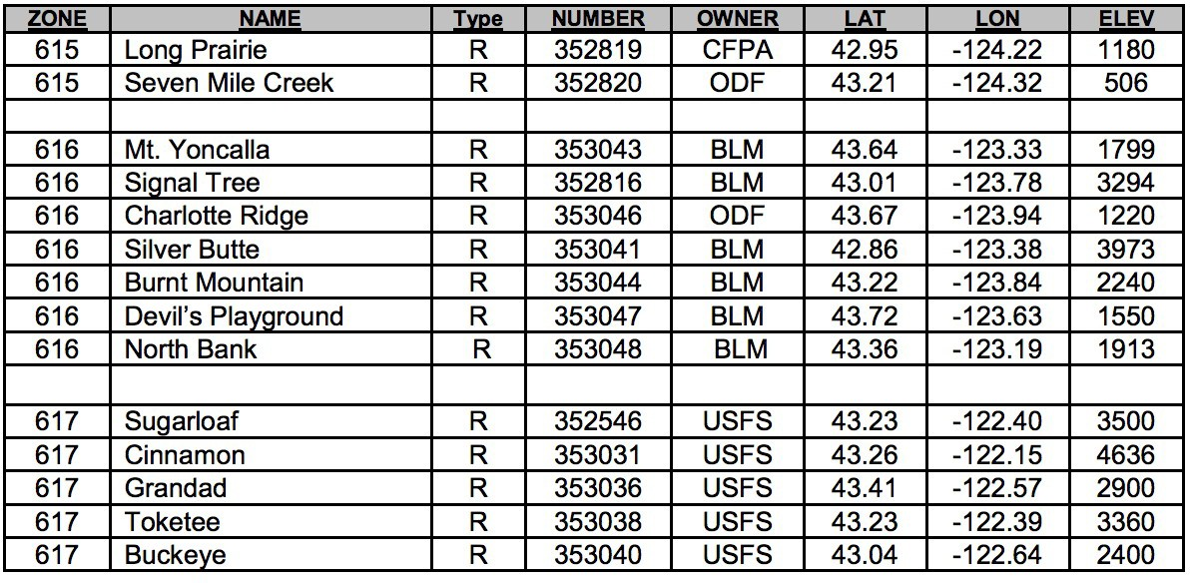

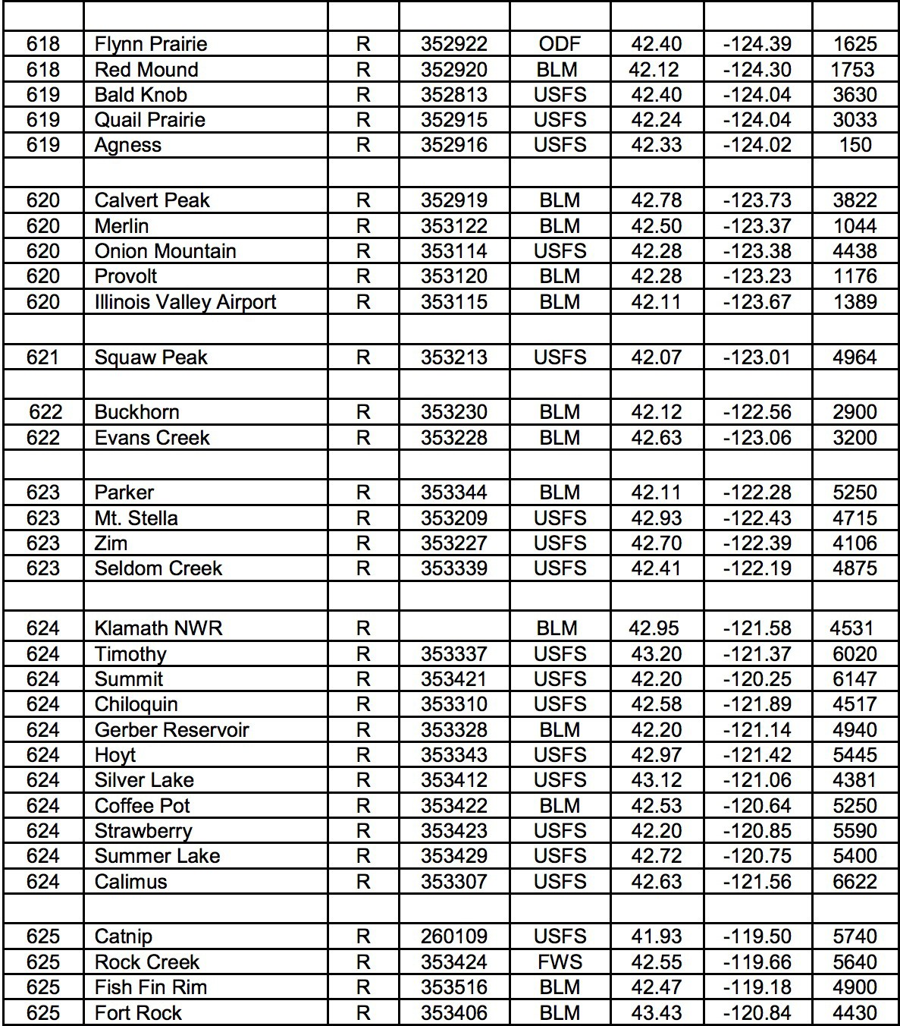

NATIONAL WEATHER SERVICE PENDLETON

LOCATION:
National Weather Service Office 2001 NW 56th Dr.
Pendleton, OR 97801

Office Homepage: http://www.weather.gov/pendleton
Fire Weather Webpage: https://www.wrh.noaa.gov/fire2/?wfo=pdt
Facebook Page: https://www.facebook.com/US.NationalWeatherService.Pendleton.gov Twitter Page: https://twitter.com/NWSPendleton
Twitter Handle: @NWSPendleton (Statement on use of Social Media)

OFFICE PHONE NUMBERS (all available 24-hours):
Fire Weather Desk (541) 276-8134
General (541) 276-4493
Fax (541) 276-8253

CHANGES FOR 2018:
- Staff changes.
- Hours of operation.
- Issuance time of the morning Fire Weather Forecast (FWF)

FORECAST DISTRICT:
The Pendleton Fire Weather District covers the east slopes of the Cascade Mountain range from the Deschutes National Forest north to the alpine reaches of the Yakama Indian Reservation, Central Oregon, the northeast quadrant of Oregon (including Wallowa county, portions of Baker county, and Harney county north of highway 20), and Southeast Washington (Benton, Franklin, Klickitat, Yakima, Walla Walla, Columbia, Garfield, and Asotin counties).

OFFICE HOURS:
The Pendleton Fire Weather Program is committed to a program with staff trained to respond to incident needs 24 hours per day, 7 days a week. Fire Weather shifts are currently scheduled during the following times with end dates remaining flexible to meet conditions and the needs of the community:

Spring / Fall Burning Seasons: 7:00 AM - 3:00 PM Monday - Friday
April 2rd – May 25th and October 1nd – October 26th

Summer Peak Wildfire Season: 7:00 AM - 3:00 PM 7 days a week
May 26th – September 30th

STAFF:  Name | Position | email Address
Mike Vescio | Meteorologist-in-Charge | michael.vescio@noaa.gov
Zaaron Allen | Science and Operations Officer | zaaron.allen@noaa.gov
vacant Mary Wister | Warning Coordination Meteorologist Fire Weather Program Leader/IMET | mary.wister@noaa.gov

All forecasters are certified to issue spot forecasts and will remain annually proficient. Mary Wister will provide the majority of Fire Weather Planning forecasts through fire season, with remaining shifts filled by the following certified fire weather forecasters.

Name Position
Zaaron Allen Science and Operations Officer Gordon Hepburn Senior Forecaster
Robert Cramp Senior Forecaster Diann Coonfield Journeyman Forecaster George Perry Journeyman Forecaster
John Peck Meteorologist Intern (training)

WEATHER BRIEFINGS:
Internet based weather briefings will be held at 0930 PDT beginning May 7th. The briefing page is located at: http://www.wrh.noaa.gov/pdt/forecast/fwxBriefing.php and also live through GoToWebinar.
To join the conference call: 1-877-996-7187 passcode: 564222#
During spring and fall burning seasons, briefings will be held Monday, Wednesday, and Friday. During peak fire season, normally mid-June-September, briefings will be held daily. Please call (541) 276-8134 for information on how to join the GoToWebinar.
Phone briefings are available 24 hours per day, year round, by calling the fire weather desk.

FORECAST SERVICES:
Forecast Grids/Graphics:
In addition to the core fire weather elements and forecast grids, this office produces a

Ventilation Index grid and graphic. These graphics are found
at: http://www.wrh.noaa.gov/pdt/forecast/fwxGraphicalVentilation.php?wfo=pdt . Additionally, several Fire Weather Threat Index grids and graphics attempt to graphically illustrate the potential for Red Flag criteria being met under the Wind/RH and Haines/RH categories.
These graphics are found on the briefing web page listed above.

Fire Weather Planning Forecasts:
Fire Weather Planning Forecasts are routinely issued when the Fire Weather desk is staffed. They are available twice a day Monday through Friday no later than 0830 PDT and 1500 PDT during the spring/fall burning seasons, and 7 days a week during peak fire season.

The Pendleton Fire Weather forecast area of responsibility is sectioned by Fire Weather Zones. OR639/WA639, OR641/WA641, OR643/WA643, and OR645/WA645 will typically be combined into single zone forecasts unless conditions warrant separating them. This usually results in 11 separate zone forecasts. These zones are based on terrain, elevation, weather characteristics, and political boundaries. Please see the district map on the following page for specific outlines of the Fire Weather Zones.

The zone names are as follows:

OR639 – East slopes of the northern Oregon Cascades WA639 – East slopes of the southern Washington Cascades OR610 – East slopes of the central Oregon Cascades OR611 – Deschutes National Forest
OR640 – Central Oregon Mountains OR641 – Columbia Basin of Oregon
WA641 – Lower Columbia Basin of Washington OR642 – Southern Blue and Strawberry Mountains OR643 – Northern Blue Mountains of Oregon WA643 – Blue Mountains of Washington
OR644 – Central Blue Mountains OR645 – Wallowa District WA645 – Asotin County
WA675 – Eastern Washington southern Columbia Basin WA681 – Yakama Alpine District

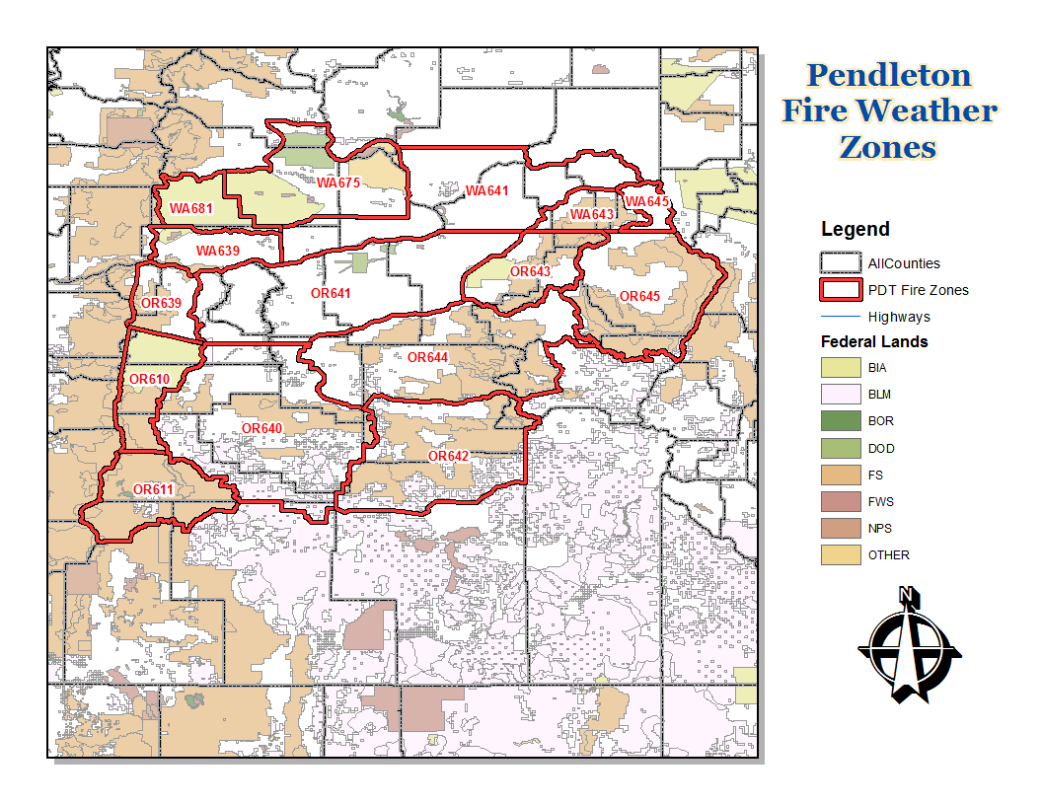

Fire Weather Watch and Red Flag Warnings:
Specific Red Flag criteria differ for each situation and district. The following are criteria that would warrant the issuance of a Fire Weather Watch or Red Flag Warning in the Pendleton Fire Weather area of responsibility:

Underlying conditions:
Fire Weather Watches or Red Flag Warnings are issued when the fuels will readily burn and weather conditions will promote extreme burning. The three steps below are forecaster guidelines for determining the need for a watch/warning.
- Refer to GACC “Overall Fire Environment” for probability of large fires. Levels should not be Green (less than 1% chance).
- The forecaster is required to check with fire/land management agencies to ensure fuels are considered critically dry enough to carry or spread fire. Usually, the fire weather program manager will have already done this and declare when a zone is eligible for RFWs for the remainder of the season. However, if a forecaster strongly feels that a RFW is needed but a zone has not yet been declared eligible, the forecaster can check with the fire/land management agencies themselves via the morning briefing call or with individual phone.
- Forecasters should have a high degree of confidence (60% for watch, 80% warning) that the Red Flag weather event will occur.

Red Flag Warning Criteria:
Any single event, or a combination, of the following events combined with critically dry fuels is criteria for the issuance of a Fire Weather Watch or a Red Flag Warning depending on the lead time:

  - LIGHTNING: Abundant lightning in conjunction with sufficiently dry fuels (fuels remain dry or critical during and after a lightning event). Warnings are not typically issued for isolated coverage events. Warnings not typically issued for events that will be accompanied by significant rain (greater than
0.25 inches). However, if a lightning event will occur with significant rain, but is then followed by very hot and dry conditions, a warning may be issued if holdover/sleeper fires are a concern.

Resulting Impact of the Event: Numerous fire starts can spread fire resources too thin resulting in a greater likelihood of a start becoming a large and potentially costly wildfire.

  - DRY & UNSTABLE AIRMASS: High elevation Haines Index of 6 in combination with RH of 15% or less over half or more of a zone. Warnings may also be issued for a Haines 5 in situations where large fires may be impacted. Ground truth indicates that there is very little to no difference in fire activity between Haines 5 and Haines 6 days.

Resulting Impact of the Event: Very dry and very unstable conditions create a high likelihood that a fire start will exhibit explosive growth and extreme

burning conditions. Extreme fire behavior is possible including rotating smoke columns and fire whirls (a.k.a. fire tornados) along with an increased threat to fire fighter safety. Note: this event does not start fires but can have a significant impact to ongoing fires.

  - WIND & LOW HUMIDITY: Significant sustained winds combined with low relative humidity (this includes significant dry cold frontal passages) that meets the criteria as defined below at TWO or more RAWS locations simultaneously for two consecutive hours. Other supplementary locations (converted to RAWS 20 foot/10 minute average wind standards) may also be used if they are deemed representative of burning conditions at the time.

Zones OR/WA639: Relative Humidity at 20% or less AND sustained wind speed 10 mph or greater. Greyback RAWS (located in zone WA681) will be included for verification purposes in this zone as well.

Zone OR610: Relative Humidity at 15% or less AND sustained wind speed 10 mph or greater. Haystack RAWS (located in zone OR630) will be included for verification purposes in this zone as well.

Zone OR611: Relative Humidity at 15% or less AND sustained wind speed 10 mph or greater. Timothy RAWS (located in zone OR624) will be included for verification purposes in this zone as well.

Zones OR640, OR/WA641, OR642, OR/WA643, OR644, OR/WA645,
WA675, & WA681: Refer to the following tables:

Columbia Basin - Zones OR/WA641 and WA675
 |  | Sustained Wind (MPH) Over Widespread Area
 |  | 10 | 15 | 20 | 25 | 30+
RH | 35% |  |  |  |  | W
 | 30% |  |  |  | W | W
 | 25% |  |  | W | W | W
 | 20% |  | W | W | W | W
 | 15% |  | W | W | W | W
 | 10% |  | W | W | W | W

The Central and Northeast Oregon Mountains / Yakama Alpine - Zones OR640, OR642, OR/WA643, OR644, OR/WA645, and WA681
 |  | Sustained Wind (MPH) Over Widespread Area
 |  | 10 | 15 | 20 | 25 | 30+
RH | 30% |  |  |  |  | W
 | 25% |  |  |  | W | W
 | 20% |  |  | W | W | W

 | 15% |  | W | W | W | W
 | 10% |  | W | W | W | W

Zone OR/WA 639, Zone OR/WA 641, Zone OR/WA 643, and Zone OR/WA 645 are considered combined zones for Wind/RH verification purposes. For example, if OR 639 verifies, WA 639 is also considered verified.

Red Flag Warning Dissemination:
A Red Flag Warning dissemination call list has been established in order to rapidly disseminate Fire Weather Watches, Red Flag Warnings, or other rapidly changing weather conditions that do not necessarily meet Red Flag criteria, but will affect fire control or pose a safety threat. NWS Pendleton will contact the affected dispatch centers who will then contact other affected land management agencies in those zones per the following table:

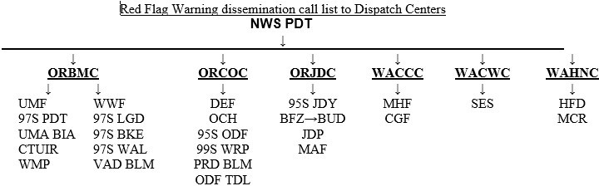

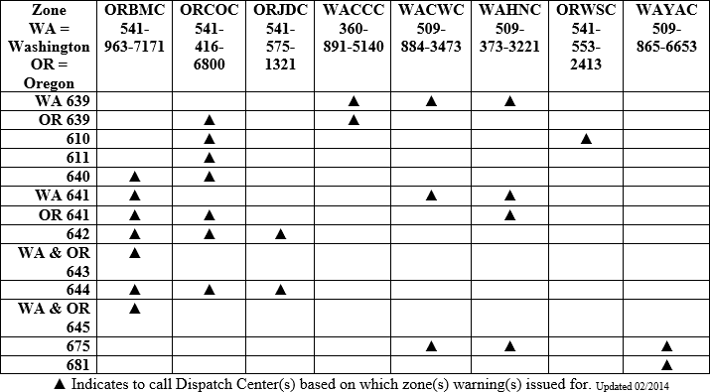

ORBMC = Blue Mountain Interagency Dis. ORJDC = John Day Dispatch
ORCOC = Central Oregon Dispatch WACWC = Central Washington Dispatch WAHNC = Hanford Fire WAYAC = Yakama BIA Dispatch WACCC = Columbia Cascade Dispatch ORWSC = Warm Springs BIA Dispatch

IMET Support: Forecasters at National Weather Service Pendleton will provide 24-hour forecast support to IMETs that may be dispatched in the local area. Forecasters will communicate either through direct phone calls, or the use of NWSChat. The chat room that should be used is pdtfire.

NON-FORECAST SERVICES
All requests for teaching assignments, customer meetings, and customer consultations will be honored provided they are scheduled more than three weeks ahead of time.
Every effort will be made to honor requests made within a period of less than three weeks depending on schedule availability. Please contact Mary Wister at NWS Pendleton (541) 276-8134, or by e-mail (mary.wister@noaa.gov) to schedule these services.

Pendleton NFDRS Fire Weather Station Index

Zone | Name | NFDRS | Type | Agency | Lat | Long | Elev | Slope/As  pe
WA639 | Goldendale | 452408 | RAWS | DNR | 45.8672 | 120.7230 | 1650 | Flat knob-S
WA639 | The Dalles | 452406 | Metar | FAA | 45.6190 | 121.1657 | 210 | W-E valley
OR639 | Middle Mtn | 350812 | RAWS | ODF | 45.5794 | 121.5970 | 2500 | N-S Ridge
OR639 | Pollywog | 350912 | RAWS | USFS | 45.4586 | 121.4464 | 3320 | Lwr slope- S
OR639 | Wamic Mill | 350913 | RAWS | USFS | 45.2333 | 121.4500 | 3320 | Upr slope- S
OR639 | Wasco Butte | 350919 | RAWS | ODF | 45.6167 | 121.3353 | 2345 | Butte top
OR610 | Sidwalter | 350909 | Manual | BIA | 44.925 | 121.5347 | 3600 | Butte top-
OR610 | Mt Wilson | 350916 | RAWS | BIA | 45.0397 | 121.6736 | 3780 | Midslo pe- SW
OR610 | Mutton Mtn | 350917 | RAWS | BIA | 44.9255 | 121.1978 | 4100 | S-N Ridge
OR610 | He He 1 | 350920 | RAWS | BIA | 44.9559 | 121.4992 | 2689 | Flat
OR610 | Shitike Butte | 352102 | Manual | BIA | 44.7449 | 121.6106 | 5000 | Butte top

OR610 | Eagle Butte | 352106 | Manual | BIA | 44.8399 | 121.2338 | 3100 | Butte top
OR610 | Warm Springs | 352108 | RAWS | BIA | 44.7750 | 121.2541 | 1632 | Valley
OR610 | Metolius Arm | 352110 | RAWS | BIA | 44.6275 | 121.6147 | 3440 | Butte-SW
OR610 | Colgate | 352620 | RAWS | USFS | 44.3156 | 121.6022 | 3280 | Flat
OR611 | Round Mtn | 352605 | RAWS | USFS | 43.7575 | 121.7102 | 5900 | Butte top
OR611 | Lava Butte | 352618 | RAWS | USFS | 43.9253 | 121.3429 | 4655 | Butte top-S
OR611 | Tepee Draw | 352622 | RAWS | USFS | 43.8322 | 121.0842 | 4740 | Lwr slope-E
OR611 | Black Rock | 353342 | RAWS | USFS | 43.527 | 121.8090 | 4880 | Lwr slope-S
OR611 | Cabin Lake | 353402 | RAWS | USFS | 43.4956 | 121.0597 | 4545 | Flat
OR611 | Tumalo Ridge | 352621 | RAWS | ODF | 44.0493 | 121.4001 | 4000 | Ridge-NW
OR640 | Haystack | 352107 | RAWS | USFS | 44.4494 | 121.1297 | 3240 | Flat
OR640 | Brown’s Well | 353428 | RAWS | BLM | 43.5628 | 121.2360 | 4500 | Flat knob-
OR640 | Cold Springs | 352701 | RAWS | USFS | 44.3550 | 120.1335 | 4695 | Flat
OR640 | Salt Creek | 352712 | RAWS | BLM | 44.0467 | 120.6694 | 4200 | Flat
OR640 | Badger Creek | 352711 | RAWS | USFS | 44.0311 | 120.4083 | 5680 | Midslope- flat
OR640 | Slide  Mountain | 352207 | RAWS | USFS | 44.4622 | 120.2945 | 5700 | Upr  slope-
OR640 | Brer Rabbit | 352208 | RAWS | USFS | 44.333 | 119.770 | 5900 | Valley-S
OR640 | Board Hollow | 350915 | RAWS | ODF | 44.6038 | 120.6847 | 4200 | Ridge-flat
WA641 | Juniper Dunes | 453201 | RAWS | BLM | 46.35  75 | 118.8683 | 950 | Flat
WA641 | Walla Walla  AP | 453302 | Metar | FAA | 46.09  45 | 118.2858 | 1166 | Flat
OR641 | Patjens | 351001 | RAWS | BLM | 45.32  19 | 120.9292 | 2230 | Ridge-SW

OR641 | North Pole Rdg | 350915 | RAWS | BLM | 45.0329 | 120.5357 | 3500 | Ridge-W
OR641 | Umatilla NWR | 351316 | RAWS | USFWL | 45.9180 | 119.5675 | 270 | Flat
OR641 | Pendleton AP | 351307 | Metar | FAA | 45.6975 | 118.8344 | 1482 | Ridge-flat

OR642 | Crow Flat | 353515 | RAWS | USFS | 43.8413 | 118.9521 | 5130 | Valley-S
OR642 | Allison | 353501 | RAWS | USFS | 43.9214 | 119.5964 | 5320 | Valley-S
OR642 | Fall Mountain | 353524 | RAWS | USFS | 44.2970 | 119.0370 | 5949 | SW-NE  Ridge
OR642 | Antelope | 353524 | RAWS | BLM | 44.0384 | 118.4163 | 6460 | N-S Ridge
OR642 | Crane Prairie | 352305 | RAWS | USFS | 44.1601 | 118.4704 | 5373 | Valley-S
OR642 | Yellowpine | 352124 | RAWS | USFS | 44.5263 | 118.3230 | 4200 | Lwr slope-E
WA643 | Alder Ridge | 453803 | RAWS | USFS | 46.2685 | 117.4983 | 4550 | Ridge-S
OR643 | Eden | 351518 | RAWS | USFS | 45.8763 | 117.6160 | 3500 | Upr slope-S
OR643 | Black Mtn Rdg | 351319 | RAWS | USFS | 45.5738 | 118.2385 | 4965 | Ridge-Sw
OR643 | LaGrande 1 | 351417 | RAWS | ODF | 45.5508 | 118.0133 | 3079 | Lwr slope-E
OR644 | Case | 352329 | RAWS | USFS | 44.9711 | 118.9297 | 3800 | Ridge-flat
OR644 | Tupper | 351202 | RAWS | USFS | 45.0667 | 119.4925 | 4200 | Lwr slope-S
OR644 | Board Creek | 352330 | RAWS | BLM | 44.5930 | 119.2770 | 5000 | Ridge
OR644 | Keeney 2 | 352332 | RAWS | USFS | 44.6661 | 118.9219 | 5120 | Ridge
OR644 | J Ridge | 351414 | RAWS | USFS | 45.1135 | 118.4051 | 5180 | Upr slope-
OR644 | Elk Creek | 352126 | RAWS | USFS | 44.7577 | 117.9711 | 6576 | Upr Slope
OR645 | Point Prom 2 | 351419 | RAWS | USFS | 45.3547 | 117.7044 | 6600 | N-S Ridge
OR645 | Minam | 351416 | RAWS | USFS | 45.3539 | 117.6328 | 3590 | SE-NW Vly

OR645 | Roberts Butte | 351520 | RAWS | USFS | 45.681 | 117.2067 | 4300 | N-S Ridge
OR645 | Harl Butte | 351502 | RAWS | USFS | 45.3282 | 116.8774 | 6071 | Butte top-S
OR645 | Sparta Butte | 352418 | RAWS | USFS | 44.8850 | 117.3383 | 4300 | Midslop e- SW
WA675 | Saddle Mtn | 452701 | RAWS | USFWL | 46.6944 | 119.6936 | 650 | Flat
WA675 | High Bridge | 452318 | RAWS | BIA | 46.0811 | 120.5440 | 2106 | Midslope-N
WA681 | Signal Peak | 452307 | RAWS | BIA | 46.2269 | 121.1375 | 5052 | Ridge-S
WA681 | Mill Creek | 452304 | RAWS | BIA | 46.2625 | 120.8622 | 2928 | Midslope-  flat
WA681 | Teepee Creek | 452317 | RAWS | BIA | 46.1642 | 121.0331 | 2980 | Midslope- flat
WA681 | Grayback | 452404 | RAWS | DNR | 45.9908 | 121.0838 | 3766 | Ridge

NATIONAL WEATHER SERVICE PORTLAND

Changes for 2018:

  - Inclusion of Mixing Height and Transport Wind elements in FWF

LOCATION

National Weather Service Forecast Office 5241 NE 122nd Avenue
Portland, OR 97230-1089

HOURS

The National Weather Service Office is open 24 hours a day, 7 days a week. The fire weather duty desk will be staffed with a CERTIFIED fire weather forecaster between the hours of 0630 and 1530 seven days a week during fire season, normally from Memorial Day through mid-October. The fire weather desk is staffed with a CERTIFIED fire weather forecaster from 0700 to 1600 Monday through Friday during Spring burning (mid to late March through Memorial Day), and also during the fall burning period (mid to late October).

STAFF

David Bright Meteorologist in Charge
Tyree Wilde Warning Coordination Meteorologist

Scott Weishaar Fire Weather Program Leader, IMET Shawn Weagle Asst. Fire Weather Program Leader, IMET Jon Bonk Fire Weather Forecaster, IMET

CONTACT

Telephone
Fire Weather Desk | 503-326-2420
Lead Forecaster (24 hrs) | 503-326-3720
FAX | 503-326-2598

Internet: http://www.wrh.noaa.gov/fire2/?wfo=pqr

Facebook page: http://www.facebook.com/US.NationalWeatherService.Portland.gov Office Twitter page: https://www.twitter.com/NWSPortland
Twitter handle: @NWSPortland

Email scott.weishaar@noaa.gov shawn.weagle@noaa.gov

FORECAST DISTRICT

Portland services Oregon fire weather zones 601-608 and 612. Portland also covers Washington fire weather zones 663-665, and 667. This area covers:

Northwest Oregon and Southwest Washington, North Oregon Cascades including the Columbia River Gorge (to about Hood River). South Washington Cascades and adjacent lowlands of Clark County.

See the attached map for a graphic description of individual areas/zones of the Portland district.

AGENCIES SERVED

U.S. Forest Service (USFS)
  - Bureau of Land Management (BLM) Oregon Department of Forestry (ODF)
Washington Department of Natural Resources (WDNR) Various urban and rural local fire districts

FORECAST SERVICES

    - FIRE WEATHER GRIDS

Fire Weather grids from the Portland Fire Weather Office can be found at: http://digital.weather.gov

    - RED FLAG WARNING/FIRE WEATHER WATCH

Fuels must be critically dry and fire danger moderate to high before a Red Flag Warning or Fire Weather Watch is issued from the Portland office. Evaluations of fuel conditions will be made in accordance with current NFDRS Energy Release Component (ERC) values and in consultation with fire managers.

FUELS STATUS DETERMINATION

Since 2015, NWCC no longer produces 7-day Dryness Level forecasts. Instead, NWCC will issue a 7-day Significant Fire Potential or Overall Fire Environment forecast. The Overall Fire Environment includes the former Dryness Level inputs, but also incorporates stability, wind and forecast lightning amounts. Thus, another objective means to determine fuel availability had to be determined.

The Portland Forecast Office will continue to experiment with a concept similar to the NWCC Dryness Levels, using zone-average ERC percentiles. The ERC values for all RAWS sites within the Portland Fire weather area will be evaluated daily, and then an overall zone color-code assigned: For a YELLOW or BROWN zone designation, one-half or more RAWS within a zone must have an individual ERC value at or above the 71st percentile.

70th PERCENTILE VALUE or less = GREEN
71st – 79th PERCENTILE VALUE = YELLOW
80th PERCENTILE or greater = BROWN

Assuming these conditions are met, Fire Weather Watches and Red Flag Warnings are issued for the following events:

      - COMBINATION OF WIND AND LOW HUMIDITY

Daytime: RH 25% or less AND 10-minute wind speed 10 mph AND/OR frequent gusts to 20 mph or more for 4 hours.

Night: RH 35% or less AND 10-minute wind speed of 15 mph AND/OR gusts to 25 mph or more for 3 hours.

      - DRY AND UNSTABLE AIR MASS

Mid and/or High level Haines 6, RH 25% or less, AND critical fuel conditions.

      - LIGHTNING

Scattered thunderstorm coverage, critical fuels AND no appreciable change in fuel conditions after the event.

RED FLAG VERIFICATION

Red Flag warnings will be verified using the following criteria:

- COMBINATION OF WIND AND LOW HUMIDITY
NIGHTTIME CRITERIA:

ZONES 601, 602, 664 AND 665: Two stations (RAWS) must report 35% humidity or less AND 10-minute wind speed of 10 mph AND/OR gusts to 20 mph or more for three hours in an 8-hour time block. Key RAWS: Cedar Creek, Rockhouse1, and South Fork.

ZONES 603 AND 612: Rockhouse1 RAWS reporting 35% humidity or less AND 10- minute wind speed of 15 mph AND/OR gusts to 25 mph or more for four hours in an 8- hour block AND one other RAWS reporting 35% humidity or less AND 10-minute wind speed of 10 mph AND/OR gusts to 20 mph or more for two hours. Key RAWS: Rockhouse1, Goodwin Peak, High Point, and Cannibal Mountain.

ZONE 604 and 667: Two stations (airports) must report 30% humidity or less AND 2- minute wind speed of 15 mph AND/OR gusts to 25 mph or more for at least four hours in

an 8-hour block. Typically occurs in the north part of the valley. Key STATIONS: Troutdale, Portland, Vancouver, and Hillsboro.

ZONES 605, 607, AND 660: One station (RAWS) must report 35% humidity or less AND 10-minute wind speed of 10 mph AND/OR gusts to 20 mph or more for four hours in an 8- hour block, AND at least TWO other stations reporting 35% humidity or less AND 10- minute wind of 10 mph AND/OR gusts to 20 mph for at least TWO hours. Key RAWS: Horse Creek, Log Creek, Wanderer’s Peak, Kosmos, Canyon Creek, Orr Creek, Elk Rock, and 3-Corner Rock. NOTE: Includes stations from zone 659.

ZONE 663: Buck Creek RAWS must report 35% humidity or less AND 10-minute wind speed of 10 mph AND/OR gusts to 20 mph or more for four hours in an 8-hour block. Dry Creek RAWS (eastern 660) must also report 35% humidity or less AND 10-minute wind speed of 10 mph AND/OR gusts to 20 mph or more for at least TWO hours.

ZONES 606 AND 608: One station (RAWS) must report 30% humidity or less AND 10- minute wind speed of 10 mph AND/OR gusts to 20 mph or more for at least four hours in an 8-hour block, AND ONE other station must report the same conditions for at least ONE hour. Key RAWS: Brush Creek, Trout Creek, Yellowstone, and Emigrant.

DAYTIME CRITERIA (ALL ZONES):

At least two stations within a zone must report 25% humidity or less AND wind-speed of 10 mph or more OR gusts to 20 mph or more (except 15 mph or gusts to 25 mph or more in zones 604 and 667) for at least four hours in an 8-hour block.

Typically for east wind (offshore flow), but can occur in the Coast Range and central/south Willamette Valley with north to northeast wind. Can also occur in the Central Cascades and foothills with shallow marine surges (west to northwest wind).

- CRITICALLY DRY AND UNSTABLE AIR MASS (HAINES INDEX 6)

At least ONE station within a zone must report 25% humidity or less, measure a mid and/or high-level Haines 6, or exhibit inferred mid and/or high-level Haines 6 characteristics, AND fuel conditions are in the “BROWN”, or “YELLOW” based on forecaster discretion.

- LIGHTNING IN COMBINATION WITH DRY FUELS

“Dry thunderstorm” Red Flag criteria is defined as follows: Abundant lightning in conjunction with sufficiently dry fuels.

Abundant Lightning:

  - Number of lightning strikes that meet climatologically significant criteria, or
  - Areal coverage of lightning such as “Scattered” or > 25%

Sufficiently Dry Fuels:

- No appreciable change in fuel conditions the day of and the day

following a thunderstorm event, or
- ERC or BI values meeting climatologically significant percentiles, or
- Land management declaration

This is a very rare event which, climatologically, has the highest likelihood of occurrence in the south half of the Willamette N.F..

Fuel Conditions SHOULD be in the “BROWN”, and expected lightning frequency such that multiple starts (5-7) are expected. (Typically “scattered” thunderstorm coverage). Under unusual or extreme conditions, a Red Flag Warning can also be issued when fuel conditions are “YELLOW”. Basically, “scattered” thunderstorms that do not produce enough precipitation to appreciably change the overall fuel conditions from “BROWN” or high-end “YELLOW”.

    - SPOT FORECASTS

Detailed weather information beyond what is presented in the general forecast may be obtained with a spot forecast request. Spot forecasts may be requested by a telephone call to the fire weather forecaster or through the spot forecast request web page available on the Portland fire weather web page at:

NWS Spot Request Page

NEW SPOT FORECAST WEB PAGE

Click on the above link to get to the spot request form. To monitor existing spots and to check the status of spot requests, click on the “Monitor” box at the top of the page. Contact the Portland Fire Desk for any questions or guidance using the new spot page.

    - GENERAL FORECASTS

Fire Season: Regularly scheduled general fire weather forecasts are issued twice per day by certified fire weather forecasters by 0900 and 1445.

Prescribed Burning Season: Regularly scheduled land management forecasts are issued by certified fire weather forecasters Monday through Friday by 0900 and 1430.

The Portland office will include wind gusts when the 10-minute wind speed is 10 mph or greater.

“Overall Fire Environment” (as developed by the Northwest Coordination Center) for the NWS Portland forecast district will no longer be included in the morning forecast. Refer to the NWCC Predictive Services web site for more information. NWCC Home Page

    - NFDRS TREND FORECASTS

Numerical point forecasts for NFDRS stations are prepared and disseminated to WIMS by 1530 each afternoon from April through mid-October. The point forecasts are used to compute the expected NFDRS indices valid the following day. The number of NFDRS point forecasts made by the weather office depends only on the number of NFDRS observations input into WIMS by the

fire agencies. If observations are not entered into WIMS by 1500 however, a forecast will not be produced for that station.

TELEPHONE BRIEFINGS

Daily internet conference call: Portland fire weather conducts a daily weather briefing at 0940 PDT via a conference call from about early June through early October. Fire weather users are encouraged to participate. The forecaster hosting the briefing will verbally highlight current and forecast fire weather conditions with the help of an internet web page. Conference call participants can follow along with the discussion while viewing graphics displayed on the web page. Conference telephone numbers (and passcodes) can be obtained by contacting the Portland weather office. The URL for the briefing graphics is: http://www.wrh.noaa.gov/pqr/fwb.php. Graphics will be available by 0700 PDT.

Unscheduled telephone briefings: Verbal weather briefings can also be obtained at any time. A certified fire weather forecaster should be requested to conduct the briefing during fire weather hours. Otherwise, a briefing will be available from the general forecast staff.

INCIDENT METEOROLOGIST SERVICES

Portland has three certified Incident Meteorologists (IMETs) on staff available for wildfire, HAZMAT, or other emergency dispatches. To request an IMET, contact the appropriate fire agency dispatch office or the National Fire Weather Operations Coordinator (NFWOC) in Boise, ID.

OTHER SERVICES

FIRE WEATHER TRAINING AND LECTURES

An experienced fire weather forecaster will be available to help instruct the weather sections of standard fire behavior training courses offered by federal, state and local government fire agencies. This includes S-190 through S-590 and other courses. In addition, a forecaster will also be available for special speaking engagements. For scheduling purposes, requests for an instructor or speaker should be made at least three weeks in advance.

To request an instructor contact Shawn Weagle at Portland NWS Forecast Office at (503) 326- 2420 or by email at shawn.weagle@noaa.gov.

SOCIAL MEDIA

NWS Portland has a Facebook page, Twitter account, and YouTube Channel. The Office Twitter webpage is:

Twitter webpage

The Office Twitter handle is: @NWSPortland

A YouTube weather briefing may be available during critical fire weather events. Web links to these briefings will be disseminated to users when applicable.

Information about current Fire Weather may be included in these social media feeds, but such information is intended as supplemental information for the general public; it is not intended to meet the specialized needs of the wildland firefighting community.

PORTLAND FIRE WEATHER ZONES

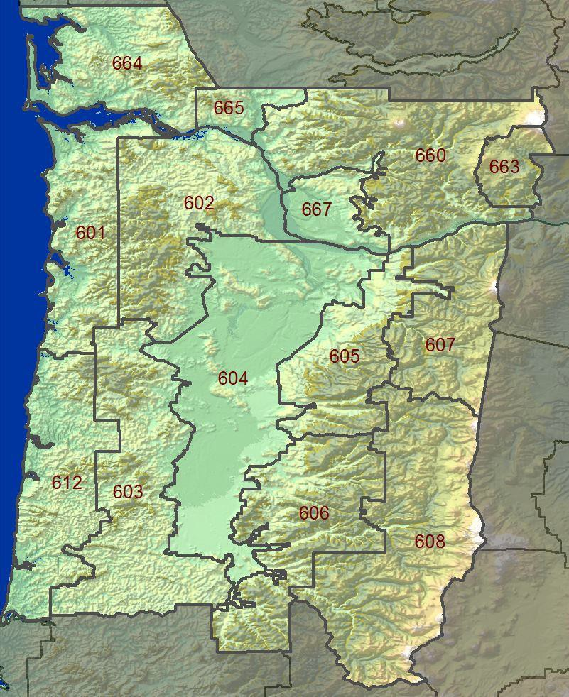

GEOGRAPHIC ZONE DESCRIPTIONS

Zone 601 – North Oregon Coast
Represents the North Oregon coastal strip including adjacent west slopes of the Oregon Coast Range. This zone includes the north portion of the Siuslaw N.F. and ODF protected private land.

Extends east-west from the crest of the Oregon Coast Range to the Pacific Ocean. Extends north-south from the Columbia River to Oregon State Highway 22 along the eastern boundary of ODF regulated use area NW-2.

Zone 664 – South Washington Coast including the West Willapa Hills
Represents the South Washington coastal strip, including adjacent west slopes of the Willapa Hills. The boundary extends from the Columbia River then north to encompass Pacific County. The zone extends east to include Wahkiahkum County.

Zone 612 – Central Oregon Coast
Represents the Central Oregon coastal strip including adjacent west slopes of the Oregon Coast Range. Includes southern portions of the Siuslaw N.F. and ODF protected private land.

Extends east-west from the crest of the Oregon Coast Range to the Pacific Ocean. Extends north-south from Oregon State Highway 22 to the Umpqua River along the west edge of the Siuslaw National Forest including ODF regulated use area SL-2.

Zone 602 – North Oregon Coast Range
Represents the east slopes of the North Oregon Coast Range. Mostly private land under ODF protection.

Bounded on the west by North Oregon Coast Range crest. Bounded on the east by the west periphery of the Willamette Valley and Columbia River. Extends north-south from the Columbia River to Oregon State Highway 22.

Zone 665 – East Willapa Hills
Represents mostly private land protected by DNR and covers the east slopes of the Willapa Hills. The zone includes western Cowlitz County, bounded on the north by the Cowlitz and Lewis county border. Bounded on the east along a line from near Toutle to Interstate 5 at Castle Rock. Bounded on the south by the Columbia River.

Zone 603 – Central Oregon Coast Range
Represents the east slopes of the Central Oregon coast range. Mostly ODF protected private land.

Bounded on the west by the Coast Range crest. Bounded on the east by the western periphery of the Willamette Valley. The north boundary is along Oregon State Highway
- The south boundary lies along Oregon State Highway 38.

Zone 604 – Willamette Valley
Bounded on the west and east by the foothills of the Coast Range and Cascades. Extends north-south from the Columbia River to just south of Cottage Grove Reservoir.

Zone 667 – Clark County Lowlands
Bounded on the west by the Columbia River and on the east by the South Washington Cascade foothills. Extends north-south from Lewis County to the Columbia River.

Zone 605 – North Oregon Cascade Foothills
Represents foothill elevations of the North Oregon Cascades. Mostly ODF protected private land.

Bounded by the east periphery of the Willamette Valley on the west and the National Forest boundary of the Mt. Hood and Willamette National Forests on the east. Extends from the Columbia River on the north, to the Crabtree Creek Divide, approximately 10 miles south of Oregon State Highway 22 (Santiam Highway) on the south.

Zone 606 – Central Oregon Cascade Foothills
Represents the foothill elevations of the Central Oregon Cascades. Mostly ODF protected private land.

Bounded by the east periphery of the Willamette Valley on the west (Interstate 5 south of Eugene) and the Willamette Forest boundary, and extreme north Umpqua Forest boundary on the east. Extends from Crabtree Creek Divide roughly 10 miles south of Oregon State Highway 22 on the north to the Lane/Douglas county line on the south.

Zone 607 – North Oregon Cascades
Represents all of the Mt. Hood NF west of the Cascade Crest along with interior Cascade wilderness areas.

Bounded by the Columbia River on the north, the Cascade Crest on the east, and the Mt. Hood forest boundary on the south and west.

Zone 608- Central Oregon Cascades
Represents the Willamette NF in its entirety along with interior high Cascade wilderness areas.

Bounded by the Cascade Crest on the east and the Willamette Forest boundary on the south, west, and north.

Zone 660 – South Washington Cascades and Foothills
Represents the Wind River and St. Helens Ranger Districts of the Gifford Pinchot NF, as well as adjacent Washington state DNR protected Cascade and Green Mountain

foothills to the south and west. This zone excludes the Columbia River lowlands of Clark County, WA and much of the Mt. Adams Ranger District.

Bounded on the east by the Gifford Pinchot forest boundary to the Indian Heaven Wilderness. The zone also includes the northeast peninsula north of Mt. Adams to the southeast boundary of FWZ659 and the northwest boundary of FWZ681. The southeast boundary follows the Columbia River west to the Clark County, WA line. The north and northwest boundary follows the contour of the Cascade Foothills to the Lewis River, then west along the Lewis River to the Columbia River. The zone boundary follows the Columbia River to Kelso, WA. The north boundary extends from Kelso, WA northeast following the contour of the Green Mountain/Cascade foothills to the Lewis County line.

Zone 663 – Eastern Gifford Pinchot including Mt. Adams District
Represents much of the Mt. Adams Ranger District. Bounded north of the Columbia River Gorge, at the boundary of the Columbia Gorge Natural Scenic Area, directly opposite FWZ607 on the Oregon side and including the current south boundary of FWZ660. This zone starts near Augspurger Mtn. and then closely follows the Pacific Crest Trail (PCT) to the south flank of Mt. Adams. The boundary would lie along the west side of the Indian Haven Wilderness. The east boundary would be the existing zone 660 and neighboring WFO zones 639 and 681. The zone includes the community of Trout Lake and includes the Buck Creek RAWS station.

ZONE | NUMBER | NAME | TYPE | AGENCY | LAT | LON | ELEV | ASPECT
601 | 350208 | Tillamook | R | ODF | 45.26 | -123.5 | 22 | Flat
 | 350215 | Cedar Creek | R | USFS | 45.21 | -123.77 | 2240 | Ridgetop
664 | 450404 | Willapa | M | DNR | 46.6 | -123.6 | 60 | W-in valley
 | 450407 | Huckleberry | R | DNR | 46.5 | -123.4 | 2500 | S-on mid-slope
602 | 350216 | South Fork | R | ODF | 45.58 | -123.49 | 2120 | S-on ridge
 | 350308 | Miller | R | ODF | 46.02 | -123.27 | 1090 | S-in valley
 | 350113 | Tidewater | R | ODF | 46.01 | -123.56 | 2035 | Ridge
 | 350505 | Rye Mountain | R | BLM | 45.22 | -123.53 | 1960 | S-on ridge

665 | 451207 | Castle Rock | R | DNR | 46.27 | -122.89 | 213 | S-in valley
 | 451209 | Abernathy Mtn. | R | DNR | 46.35 | -123.1 | 2000 | Ridgetop
603 | 351710 | Rockhouse1 | R | ODF | 44.93 | -123.47 | 2000 | Midslope
 | 351811 | Wilkinson Ridge | R | USFS | 44.33 | -123.72 | 1370 | W-on ridge
 | 352542 | Clay Creek | R | ODF | 44.02 | -123.21 | 1600
 | 352547 | Village Creek | R | BLM | 44.25 | -123.47 | 1500 | SE-on ridge
 | 353047 | Devil's Graveyard | R | BLM | 43.72 | -123.63 | 1550 | NW-near ridge
 | 350605 | Gellatly | R | ODF | 44.61 | -123.48 | 860 | NW-lower slope
 | 352550 | High Point | R | BLM | 43.91 | -123.38 | 1935 | N-on ridge
604 | 352561 | Willow Crk. | R | BLM | 44.03 | -123.17 | 456 | Valley
 | 351813 | Finley | R | USFWS | 44.42 | -123.33 | 330 | Valley
667 | 451306 | Vancouver | M | DNR | 45.7 | -122.7 | 210 | Flat
605 | 350727 | Horse Creek | R | BLM | 44.94 | -122.4 | 2000 | Ridge
 | 350728 | Eagle Creek | R | ODF | 45.37 | -122.33 | 744 | SW-midslope
606 | 352024 | Yellowstone | R | BLM | 44.6 | -122.42 | 3080 | NE-in valley
 | 352025 | Jordan | R | ODF | 44.72 | -122.69 | 778 | In valley
 | 352552 | Trout Creek | R | BLM | 44.11 | -122.58 | 2400 | SW-on ridge
 | 352562 | Green Mtn. | R | BLM | 43.73 | -122.81 | 3064 | Ridge

 | 352553 | Brush Creek | R | BLM | 44.28 | -122.85 | 2300 | N-on ridge
607 | 350718 | Red Box | R | USFS | 45.03 | -121.92 | 3250 | SW-on midslope
 | 350725 | Si Si Lookout | M | USFS | 44.92 | -121.83 | 5617 | SW-on ridge
 | 350726 | Wanderer’s Peak | R | USFS | 45.11 | -122.2 | 4350 | S-on ridge
 | 350604 | Log Creek | R | USFS | 45.51 | -121.9 | 2500 | W-on midslope
 | 350902 | Clear Lake | M | USFS | 45.15 | -121.58 | 4458 | W-on ridge
608 | 352554 | Pebble | R | USFS | 44.23 | -121.98 | 3560 | SW-on midslope
 | 352557 | Fields | R | USFS | 43.73 | -122.28 | 3360 | Flat-on ridge
 | 352558 | Emigrant | R | USFS | 43.47 | -122.22 | 3840 | S-on ridge
 | 351909 | Boulder | R | USFS | 44.98 | -122 | 3570 | Flat-in valley
612 | 351604 | Cannibal | R | USFS | 44.35 | -123.89 | 1946 | Ridgetop
 | 352545 | Goodwin Peak | R | USFS | 43.93 | -123.89 | 1826 | Ridgetop
 | 352559 | Dunes | R | USFS | 43.96 | -124.12 | 20 | Midslope
660 | 451208 | Elk Rock | R | USFS | 46.35 | -122.6 | 2500 | Ridgetop
 | 451921 | Canyon Creek | R | USFS | 45.92 | -122.17 | 2500 | W-on ridge
 | 451929 | 3 Corner Rock | R | DNR | 45.72 | -122.04 | 3000 | Ridge
 | 451924 | Dry Creek | R | USFS | 45.94 | -121.99 | 2549 | SE-on ridge
 | 451301 | Larch Mtn. | R | DNR | 45.72 | -122.35 | 1150 | Ridge-top

663 | 451917 | Buck Creek | R | USFS | 46.06 | 121.54 | 2690 | Meadow

NATIONAL WEATHER SERVICE SEATTLE

Changes for 2018:

  - The Fire Weather Planning Forecast will no longer include combinations of zones. Fire Weather Zones will be listed separately within the Planning Forecast. The goal is for this to reduce averaging of weather over very large areas, thereby making the forecast more representative of each Fire Weather Zone. This should make the forecast a more effective tool for planning and for firefighter safety.

  - Due to the low number of Views and the staff time needed for production, the 4-year trial of Fire Weather YouTube briefings is ending. A recorded version of the 9 AM phone briefing will be available instead.

  - Dedicated staffing and in-season levels of Fire Weather-related Decision Support will expand to include weekends starting in mid-June.

  - Ted Buehner has retired as Warning Coordination Meteorologist (WCM). The WCM position had not yet been filled as of April 2018.

  - Fire Weather Program Co-Leads are now best reached by phone via the Fire Weather Desk phone number, 206-526-6088.

  - Web address and visual appearance of NWS Seattle’s Fire Weather webpage have been updated. The new address
is https://www.wrh.noaa.gov/fire2/?wfo=sew. Re-directs continue from the old address.

  - Have given forecasters further discretion in issuing lightning-based RFWs with the following phrase describing Red Flag Criteria, “the forecast LAL will usually be 3 or higher, but may be 2 when fuels are extremely dry, e.g. by exceeding the 97th percentile ERC.”

LOCATION

The National Weather Service Forecast Office in Seattle is located at the NOAA Western Regional Center in northeast Seattle. The address is:

NOAA - National Weather Service

7600 Sand Point Way NE Seattle, WA 98115-0070

HOURS OF OPERATION

The National Weather Service (NWS) in Seattle operates 24 hours a day, 7 days a week, every day of the year. During wildfire season, a forecaster is dedicated to Fire Weather-related Decision Support from 7:00 a.m. to 5:00 p.m. These are the best hours to submit Spot Forecast requests. However, all NWS Seattle forecasters are trained in Fire Weather and can handle your requests anytime 24/7.

In-season levels of service will begin on the first Monday in June and end following the first Friday in October. For 2018, those dates are:

June 4: In-season level of service begins October 5: Last day of in-season service levels

In-season service levels can be extended further into October if environmental conditions warrant.

STAFF

Name Position E-mail
Logan Johnson Meteorologist-in-Charge logan.johnson@noaa.gov Andy Haner Fire Weather Program Leader / IMET
andrew.haner@noaa.gov
Steve Reedy Fire Weather Program Leader steve.reedy@noaa.gov Brent Bower Senior Service Hydrologist / IMET brent.bower@noaa.gov Vacant Warning Coordination Meteorologist
Kirby Cook Science and Operations Officer kirby.cook@noaa.gov

All of NWS Seattle’s forecasters are trained to provide Fire Weather-related Decision Support Services and will rotate through that service position during fire season.

PHONE NUMBERS
Fire Weather Desk 206-526-6088 (unlisted)
Public Forecaster (24/7) 206-526-6083 (unlisted) Logan Johnson, Meteorologist-in-Charge 206-526-6095 ext 222
Vacant, WCM 206-526-6095 ext 223
Kirby Cook, SOO 206-526-6095 ext 224 Andy Haner, FW Program Co-Leader 206-526-6088
Steve Reedy, FW Program Co-Leader 206-526-6088

INTERNET
NWS Seattle Homepage: http://www.weather.gov/seattle
NWS Seattle Fire Weather page: https://www.wrh.noaa.gov/fire2/?wfo=sew

Facebook
page: https://www.facebook.com/US.NationalWeatherService.Seattle.gov Twitter page: https://twitter.com/NWSSeattle
Twitter handle: @NWSSeattle

FORECAST DISTRICT
NWS Seattle has Fire Weather forecast responsibility for western Washington from the Cascade Crest to the Pacific Coast, and from the Canadian Border south through Lewis and Grays Harbor Counties. Responsibility also includes the Cowlitz Valley Ranger District on the Gifford-Pinchot National Forest, as well as the portion of the North Cascades National Park Complex east of the Cascade Crest. NWS Seattle’s Fire Weather area of responsibility is divided into 13 Fire Weather Zones that exhibit similar weather changes.

Seattle Fire Weather Zones
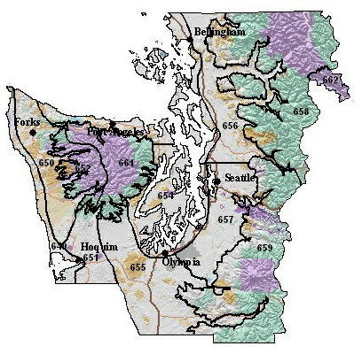

FORECAST PRODUCTS

- FIRE WEATHER WATCHES AND RED FLAG WARNINGS

Fire Weather Watches and Red Flag Warnings will be issued when the combination of dry fuels and weather conditions support extreme fire danger and/or fire behavior. Further overview of the Fire Weather Watch and Red Flag Warning programs is found on page 4 of this document.

LOCAL CRITERIA FOR FUEL DRYNESS

Fire Weather Watches and Red Flag Warnings will be considered in the Seattle Fire Weather District when the Energy Release Component (ERC), as described by the National Fire Danger Rating System (NFDRS), is equal to or greater than the 90th percentile value in the frequency distribution of historical ERCs.

Forecast zone-average ERCs must meet or exceed the values listed below to meet the prerequisite dryness for consideration of a Fire Weather Watch or Red Flag Warning.
Zone 649: 17
Zones 650, 651, 653, 656, 657: 25
Zones 652, 654, 655, 658, 659: 31
Zone 661: 34
Zone 662: 66

LOCAL CRITERIA FOR WEATHER “Moderate Breeze and Low Humidity”
Location and Time of Day | Duration | Wind Speed |  | Relative Humidity
 |  | RAWS | ASOS
West of the Cascade
Crest
Daytime (9 am to midnight) | 4+ hours in an 8-hour block | > 10  mph | > 12  mph | <= 30%
Nighttime (midnight to 9  am) | 5+ consecutive hours | >= 10  mph | >= 12  mph | <= 35%
Zone 662, Eastside Zone  (Very Rare) | 4+ hours | >=15  mph | N/A | <= 25%
Note: Wind and RH conditions must occur concurrently to meet Red Flag criteria

“Moderate Breeze and Low Humidity” events should be fairly widespread in

both time and space across a Fire Weather Zone, in contrast to an isolated occurrence that affects a small area or lasts a short time. Verifying stations for Wind/RH episodes are described in Appendix 3.

Lightning

Weather Criteria for lightning is defined as “abundant lightning, either wet or dry, within a Fire Weather Zone”. The thunderstorm activity should be at least scattered (25+% aerial coverage) or greater within a particular zone; the forecast LAL will usually be 3 or higher. Forecasters are given discretion to issue with LAL 2 when fuels are extremely dry, e.g. exceed 97th percentile ERC.

Forecasters are given discretion to view it as a negative consideration if excessive rainfall amounts are expected, e.g. greater than ~ ¾”.

By the same token, forecasters are given discretion to view it as a positive consideration if lightning will be followed the next day by warm, dry weather.

Very Dry and Unstable Air Mass
Zones
Haines Index
RH
Mid-Level High-Level
Opaque Sky Cover
Westside: 649-
661

Below 2000 feet
6
<= 20%
<= 25%
<= 15%
< 50%
Above 2000 feet
6
< 50%
Eastside: 662
6
Criteria must be met concurrently to meet Red Flag criteria

SPOT FORECASTS

An overview of the Spot Forecast program is found in the NWS section of this document.

FIRE WEATHER PLANNING FORECASTS (FWF)

The following table shows NWS Seattle’s anticipated dates, times, and format of Fire Weather Planning Forecasts (FWFs) in 2018:

Dates (2018) | FWFs on Weekends and Federal  Holidays? | # of FWFs  per day | Issuance Deadline (Local Time) | Format / Parameters Available
January 1 - June 3 | No | 1 | 0900 | Off-Season
June 4 – October 5 | Yes | 2 | 0830  1530 | In-Season
October 6 - December 31 | No | 1 | 0900 | Off-Season

These dates can be adjusted based on user needs and environmental conditions.

INTERNET-BASED BRIEFING CALLS

Statewide, Internet-based, Fire Weather briefing calls will be conducted each day at 9:00 AM PDT during peak fire season, and as needed near the beginning and end of the season. These calls are co-hosted by NWS offices in Spokane and Seattle. Contact this office for the appropriate telephone number and conference ID to participate. A recorded version of this call will be available under the Admin tab of the NWS Seattle’s Fire Weather webpage within 15-60 minutes of the briefing’s conclusion.

AREA FORECAST DISCUSSION

The Fire Weather Forecaster will write a Fire Weather section in the Area Forecast Discussion (AFD) when Fire Weather Watches or Red Flag Warnings are in effect, or when conditions are otherwise deemed critical or of interest.

FEDERAL AND STATE AGENCIES SERVED

U.S. Forest Service - Olympic National Forest, Mt. Baker-Snoqualmie National Forest, Gifford-Pinchot National Forest and Okanogan-Wenatchee National Forest

National Park Service - North Cascades National Park Complex, Olympic National Park, Mount Rainier National Park and San Juan Islands National Historical Park

Bureau of Indian Affairs - Olympic Peninsula Agency and Puget Sound Agency

Washington Department of Natural Resources -
Resource Protection Division, as well as the Northwest, Olympic, South Puget, and Pacific Cascade Regions

Department of Defense – Joint Base Lewis-McChord Forestry Program

Appendix 1: Fire Weather Zone Boundary Descriptions

Appendix 2: NFDRS Fire Weather Station List

Appendix 3: Methodology for Verification of a Red Flag Warning issued for Wind and Low Humidity

Appendix 1
FIRE WEATHER ZONE BOUNDARY DESCRIPTIONS

Zone 649 – The North and Central Coastal Strip:
Zone 649 contains land from the Pacific Coastline (including the eastern shores of Grays Harbor) to 5 miles inland, within Clallam, Jefferson and Grays Harbor Counties.

Zone 650 – The North Coastal Lowlands:
Zone 650 contains land from 5 miles inland of the coast to an elevation of 1,500 feet on the west side of the Olympic Mountains. The area includes the Calawah, Bogachiel, Hoh, Clearwater, Queets, Quinault, and the Humptulips River drainages. The southern boundary follows the Humtulips River. The northern boundary reaches the Strait of Juan de Fuca from Neah Bay to west of Sekiu.

Zone 651 – The Central Coastal Lowlands:
The western boundary of Zone 651 follows the Humptulips River and the eastern boundary of Zone 649 in Grays Harbor County. The 1,500-foot contour interval on the south side of the Olympic Mountains forms the northern border of Zone 651.
The Grays Harbor - Pacific county line forms the southern boundary. The eastern border follows the West Fork of the Satsop River south across US Highway 12 near the town of Satsop, continuing south along the west side of the Lower Chehalis State Forest.

Zone 652 – The West Portion of the Olympic Mountains:
Zone 652 includes land at or above 1,500 feet on the west-southwest facing side of the Olympic Mountains in Clallam and Jefferson counties, and the far northeast corner of Grays Harbor County. The area includes the Pacific Ranger District of the Olympic National Forest. Zone 652 represents the wetter, west side of the Olympic Mountains with a greater influence of marine air. The area includes all lands at or

above 1,500 feet drained by the Calawah, Sitkum, Bogachiel, Hoh, Clearwater, Queets, Quinault, and Humptulips rivers in Clallam, Jefferson, and Grays Harbor counties.

Zone 661 – The East Portion of the Olympic Mountains: Zone 661 includes land at or above 1,500 feet on the east side of the Olympic Mountains. Zone 661 represents the drier side of the Olympic Mountains, experiencing less rainfall, less influence of marine air, and a higher occurrence of lightning activity. The area includes land drained by the Wynoochee, Satsop, North and South Fork Skokomish, Hamma Hamma, Duckabush, Dosewallips, Quilcene, Dungeness, Elwha, and upper portions of the Sol Duc Rivers.

Zone 653 – The Strait of Juan de Fuca, the San Juan Islands and the Northwest Interior Lowlands: Zone 653 includes all land below 1,500 feet on the north side of the Olympic Peninsula from Sekiu on the west to Port Ludlow on the east. Zone 653 also includes land along and west of I-5 in Snohomish, Skagit and Whatcom Counties, as well Whidbey Island, Camano Island, and all of the San Juan Islands.

Zone 654 – The Central and South Puget Sound Lowlands:
Zone 654 represents land near Puget Sound and Hood Canal in Jefferson, Mason, Thurston, Pierce, King and Kitsap Counties. Zone 654 includes the entire Kitsap Peninsula. The western border follows the 1,500-foot contour on the west side of Hood Canal. The eastern and southern borders are near I-5 in King, Pierce, and Thurston Counties to Olympia. The southwest boundary runs northwest along U.S. Highway 101 from Olympia through Shelton to the southeast corner of Olympic National Forest.

Zone 655 – The Black Hills and the Southwest Interior Lowlands:
The western border of Zone 655 follows the West Fork of the Satsop River south across US Highway 12 near the town of Satsop, continuing south along the west side of the Lower Chehalis State Forest. The boundary continues southeast through Pe El to Vader in Lewis County. The boundary then turns east along the Lewis-Cowlitz County line to the 1,500-foot contour along the west slopes of the Cascades. The boundary turns north, wrapping around the Cowlitz River Valley, then north along the 1,500-foot contour to the location where Pierce, Thurston, and Lewis Counties meet near Alder Lake. It then follows the Pierce-Thurston County line northwest to I-5, then west along I-5 and US Highway 101 through Olympia, Shelton, and on to the southeast corner of Olympic National Forest. Zone 655 includes Capitol and Lower Chehalis State Forests, as well as the I-5 corridor south of Olympia through Lewis County.

Zone 656 – Northeast Puget Sound Lowlands Generally Below 1500 Feet: Zone 656 includes land in Whatcom, Skagit, and Snohomish Counties east of I-5 below an elevation of 1,500 feet. This includes the following river drainages: Nooksack, Skagit, Sauk, Stillaguamish, and the Skykomish east to the town of Skykomish.

Zone 657 – Southeast Puget Sound Lowlands Generally Below 1500 Feet: Zone 657 includes land below 1,500 feet east of I-5 in King and Pierce Counties. It includes the following river drainages: North, Middle and South Forks of the Snoqualmie, Green, White, Puyallup, and the Nisqually from Elbe to Ashford.

Zone 658 –West Slopes of the North Cascades Generally Above 1500 Feet: Zone 658 includes land at or above 1,500 feet in Whatcom, Skagit, Snohomish, and the northeast corner of King County in the Skykomish River drainage. The area includes the North Cascades National Park and the Ross Lake National Recreational Area; and the Mt. Baker, Darrington, and Skykomish Ranger Districts of the Mt. Baker-Snoqualmie National Forest. The eastern boundary is the Cascade crest.

Zone 659 –West Slopes of the Central Cascades Generally Above 1500 Feet: Zone 659 includes land at or above 1,500 feet in King, Pierce, and Lewis Counties, and the extreme northern portion of Skamania County. This includes the North Bend and White River Ranger Districts of the Mt. Baker-Snoqualmie National Forest, Mt. Rainier National Park, and the Cowlitz Valley Ranger District of the Gifford Pinchot National Forest. The eastern boundary is the Cascade crest.

Zone 662 – The East Portion of North Cascades National Park and the Lake Chelan National Recreational Area:
Zone 662 includes the North Cascades National Park Complex east of the Cascade crest in Chelan County, including Stehekin and the Lake Chelan National Recreational Area.

Appendix 2
2018 NWS Seattle NFDRS Station Index

ZONE | NAME | TYPE | WIMS NUMBER | OWNER | LAT | LON | ELE V
649 | Quillayute | Metar | 450120 | DNR | 47.938 | - 124.555 | 194
 | Hoquiam | Metar | 450314 | DNR | 46.971 | - 123.933 | 18
650 | Ellis Mtn. | RAWS | 450130 | DNR | 48.129 | - 124.305 | 2671
 | Forks | RAWS | 450105 | DNR | 47.955 | - 124.385 | 303
 | Black Knob | RAWS | 450321 | BIA | 47.414 | - 124.103 | 650
651 | Minot Peak | RAWS | 450306 | DNR | 46.892 | - 123.417 | 1768
652 | Toms Creek | RAWS | 450121 | USFS | 48.022 | - 123.959 | 2400
 | Owl Mtn. | RAWS | 450211 | DNR | 47.766 | - 123.965 | 3398

 | Humptulips | RAWS | 450312 | USFS | 47.367 | - 123.758 | 2400
661 | Hurricane Ridge | RAWS | 450124 | NPS | 47.970 | - 123.499 | 5262
 | Cougar | RAWS | 450117 | USFS | 47.923 | - 123.108 | 3000
 | Jefferson | RAWS | 450911 | USFS | 47.554 | - 123.215 | 2200
 | Buck Knoll | RAWS | 450131 | DNR | 48.028 | - 123.311 | 1630
653 | Bellingham | Metar | 451411 | DNR | 48.799 | - 122.539 | 157
 | Everett | Metar | 451614 | DNR | 47.923 | - 122.283 | 604
 | Whidbey Island | Metar | 450701 | DNR | 48.349 | 122.651 | 46
654 | Bremerton | Metar | 450801 | DNR | 47.490 | - 122.765 | 440
 | Quilcene | RAWS | 450207 | USFS | 47.823 | - 122.883 | 62
 | Sea-Tac | Metar | 451716 | DNR | 47.445 | - 122.314 | 427
 | Tacoma (McChord Field) | Metar | 451808 | DNR | 47.138 | - 122.476 | 322
655 | Olympia | Metar | 451001 | DNR | 46.973 | - 122.903 | 203
 | Chehalis | RAWS | 451103 | DNR | 46.610 | - 122.908 | 262
656 | Sedro Woolley | RAWS | 451507 | DNR | 48.522 | - 122.224 | 217
 | Marblemount | RAWS | 451504 | NPS | 48.539 | - 121.446 | 357
657 | Enumclaw | RAWS | 451702 | DNR | 47.220 | - 121.964 | 756
 | Ashford | RAWS | 451809 | DNR | 46.755 | - 122.110 | 1421
658 | Kidney Creek | RAWS | 451409 | USFS | 48.920 | - 121.943 | 3485
 | Hozomeen | RAWS | 451412 | NPS | 48.981 | - 121.078 | 1700
 | Sumas Mtn. | RAWS | 451415 | DNR | 48.908 | - 122.223 | 3200
 | Finney Creek | RAWS | 451509 | USFS | 48.392 | - 121.818 | 2160
 | Gold Hill | RAWS | 451613 | USFS | 48.243 | - 121.546 | 3350
 | Johnson Ridge | RAWS | 451611 | USFS | 47.801 | - 121.286 | 2048
659 | Fire Trng Academy | RAWS | 451721 | USFS | 47.457 | - 121.665 | 1580
 | Stampede Pass | Metar | 451711 | DNR | 47.277 | - 121.337 | 3960
 | Lester | RAWS | 451705 | USFS | 47.210 | - 121.489 | 1637
 | Greenwater | RAWS | 451718 | DNR | 47.116 | - 121.596 | 2405
 | Ohanapecosh | RAWS | 451119 | NPS | 46.731 | - | 1950

 |  |  |  |  |  | 121.571
 | Kosmos | RAWS | 451105 | DNR | 46.524 | - 122.190 | 2100
 | Hager Creek | RAWS | 451115 | USFS | 46.564 | - 121.628 | 3600
 | Orr Creek | RAWS | 451919 | USFS | 46.354 | - 121.604 | 3000
662 | Stehekin | RAWS | 452121 | NPS | 48.347 | - 120.720 | 1230

Appendix 3

Methodology for Verification of a Red Flag Warning issued for Moderate Breeze and Low Humidity

For Wind and Low RH episodes, Red Flag events will be considered to have occurred when Red Flag criteria are achieved at the following combination of stations:

Zone 649: Any two stations within the zone, usually Hoquiam and Quillayute
Zone 650: Any single station within the zone – or - Quillayute ASOS Zone 651: At Minot Peak RAWS – or – both Shelton and Hoquiam
ASOSs
Zone 652: Any one station within the zone and the Ellis Mtn RAWS Zone 653: Any two stations within the zone
Zone 654: Any two stations within the zone (including Olympia ASOS) Zone 655: Any one station within the zone (including Olympia ASOS) – or
– any two of the following sites: Shelton ASOS, Minot Peak RAWS and Hoquiam ASOS
Zone 656: Any two stations under 1500 feet within Skagit, Snohomish or Whatcom Counties (including Abbottsford, BC)
Zone 657: Any two stations under 1500 feet within King or Pierce County, and east of Puget Sound
Zone 658: Any NFDRS station within the zone – and – one of the following sites: Mt. Baker avalanche site, Marblemount, Fire Training Academy, or SMP
Zone 659: Any two NFDRS stations within the zone
Zone 661: Any NFDRS station within the zone (not followed within 12

hours

by the start of a wetting rain) Zone 662: At Stehekin RAWS

NATIONAL WEATHER SERVICE SPOKANE

WHAT’S NEW
- There will be a change to a revised Regional Fire Weather Webpage https://WWW.WRH.NOAA.GOV/FIRE2 or https://www.wrh.noaa.gov/fire2/main.php

LOCATION
National Weather Service Office 2601 North Rambo Road Spokane, WA 99224- 9164

HOURS OF OPERATION
Office hours at NWSO Spokane for Fire Weather will be as follows: Daily 24 Hour forecast and briefing coverage

The Fire Desk is staffed daily 0700-1700 Late March - Mid October

PHONE NUMBERS AND E-MAIL
Fire Weather (509) 244-5031
Public (509) 244-6395
FAX (509) 244-0554
andrew.brown@noaa.gov ronald.miller@noaa.gov robert.tobin@noaa.gov

STAFF
Vacant Meteorologist in Charge
Ron Miller Science and Operations Officer
Andy Brown Warning Coordination Meteorologist
Todd Carter ITO/IMET
Jon Fox Senior Forecaster/IMET
Bob Tobin Fire Weather Program Leader/IMET
Matt Fugazzi Senior Forecaster
Greg Koch Senior Forecaster
Jeffrey Cote Forecaster
Robin Fox Forecaster

Laurie Nisbet Forecaster
Rocco Pelatti Forecaster
Jeremy Wolf Forecaster
Steve Bodnar Forecaster
Steven Van Horn Forecaster

Joey Clevenger Forecaster
Jennifer Simmons Forecaster
Bryce Williams Forecaster

COMMUNCATIONS

All forecasts are available on WIMS, and on Spokane’s Internet home page. Customers who do not have access to WIMS, or Internet can still have forecasts faxed to them.

Internet
Address: http://www.wrh.noaa.gov/otx http://www.weather.gov/spokane http://www.wrh.noaa.gov/firewx/?wfo=otx

WEATHER BRIEFINGS

Internet based weather briefings are available from the Spokane office as needed. During peak fire season, normally mid June-early October briefings will be daily at 0900 PDT. These briefings will be recorded and should be available on the Fire Weather Page by 1000 PDT. During Land Management season briefings are available by customer request and are usually held twice per week for planning purposes. The phone number is 877-783-9070. The passcode is available by calling our office. Phone briefings are available 24 hours per day by calling 509-244-5031.

SOCIAL MEDIA

NWS Spokane has a Facebook page, Twitter account, and a YouTube channel. Information about current Fire Weather may be included in these social media feeds, but such information is intended as supplemental information for the general public; it is not intended to meet the specialized needs of the wildland firefighting community.
www.twitter.com/NWSSpokane

FORECAST DISTRICT
The NWS Spokane office has fire weather forecast responsibility for a large portion of protected lands in eastern Washington. Exceptions are the Blue Mountains area, the Yakama Indian Nation lands, the DOE Hanford Site, and portions of the Southeast

Department of Natural Resources (DNR) land. These protected lands are the forecast responsibility of the National Weather Service Office Pendleton Fire Weather program.

NWSO Spokane Fire Weather’s area of responsibility for Eastern Washington is divided into six districts for fire weather forecasting. In addition, these forecast districts are further sub-divided into ten fire weather zones. See the map for general locations of districts and zones for eastern Washington. The weather zones are comprised of fire danger stations with similar weather and similar trends in weather changes.

NWSO Spokane has forecast responsibility for the Central and Northern Idaho Panhandle. This district has one (1) zone (101) covering the Idaho Panhandle National Forests, Idaho State Lands, and Coeur d’Alene Indian Agency lands.

AGENCIES SERVED:
Land management agencies served by the Spokane Fire Weather Office include:

USFS.... Colville NF Wenatchee NF Okanagan NF
Idaho Panhandle NF

BLM.... Spokane District Coeur d’Alene District

BIA.... Confederated Tribes of the Colville Reservation Spokane Indian Tribe of Indians
Coeur d’Alene Tribe of Indians Kalispel Tribe of Indians

NWR... Turnbull National Wildlife Refuge Columbia National Wildlife Refuge Kootenai National Wildlife Refuge Lake Pend Oreille Wildlife Refuge Sinhalekin Wildlife Refuge

Washington DNR... Northeast Area Resource Protection Division
Southeast Area Resource protection Division

Idaho... Department of State Lands

Other Public Agencies... Coulee Dam National Recreation Area
Lake Chelan National Recreation Area

FORECAST SERVICES:

Fire Weather Watches and Red Flag Warnings: Red Flag criteria for eastern

Washington and Northern Idaho are as follows:
  - “Dry thunderstorm” Red Flag criteria is defined as abundant lightning in conjunction with sufficiently dry fuels.

“Abundant” and “Sufficient” are locally defined and verified by NWS offices and their fire agency customers using the following GACC AOP-wide guidelines:

Abundant Lightning:
- Number of lightning strikes that meet climatologically significant criteria, or
- Areal coverage of lightning such as “Scattered” or > 25%

Sufficiently Dry Fuels:
- ERC or BI values meeting climatologically significant percentiles or
- Land management declaration

  - Sustained surface winds exceeding a 10-minute average of 15 mph combined with relative humidity less than:
    - 15% in the Columbia Basin (zone 673)
    - 25% in the mountainous areas
    - 20% in the lower valley zones (including zone 674)
This is typically (but not always) associated with a dry cold front passage. These conditions must be verified by at least 2 observation sites (RAWS, METAR, DOT, Agrimet etc) for 2 consecutive hours. For Idaho Zone 101 the criteria will be at least 2 observations sites for any 3 hours in an 8 hour period. When using
observation sites other than RAWS sites wind speeds will be converted to 10 minute averages.

Special consideration will be given whenever very hot temperatures are combined with very low relative humidity.

  - Haines Index of 6 when combined with low relative humidity, typically 15% or below.

  - Strong winds that will overcome the environment no matter what the relative humidity.

  - An unusually unstable atmosphere This would be associated with a strong thermal trough which typically forms along the east slopes of the Washington Cascades.

The issuance of Red Flag Warnings will take into account fuel conditions, and will be coordinated with land management agencies and other applicable fire weather offices. Typically when 1000 hour fuels are at or below 11%, 100 hour fuels are at or below 8% and Live Fuels at or below 120%.

Spot Forecasts: Detailed instructions for completing the Spot Request Form and access links are available on our Fire Weather Web page in the upper left hand corner or at:

https://www.youtube.com/watch?v=4Or6flTaAHM&feature=youtu.be

Valid times for spot forecasts will be twelve hours from forecast issuance.

The spot forecast request web page available on the Spokane fire weather web page at: http://www.weather.gov/spot/monitor/
Weather Briefings: nternet based weather briefings are available from the Spokane office as needed. During peak fire season, normally mid June-early October briefings will be daily at 0900 PDT. These briefings will be recorded and should be available on the Fire Weather Page by 030 PDT. During Land Management season briefings are available by customer request and are usually held twice per week for planning purposes. The phone number is 877-783-9070. The passcode is available by calling our office. Phone briefings are available 24 hours per day by calling 509-244-5031.

Social Media: NWS Spokane has a Facebook page, Twitter account, and a YouTube channel. Information about current Fire Weather may be included in these social media feeds, but such information is intended as supplemental information for the general public; it is not intended to meet the specialized needs of the wildland firefighting community. www.twitter.com/NWSSpokane

GEOGRAPHICAL ZONE DESCRIPTIONS

The National Weather Service Office in Spokane has fire weather forecast responsibility for protected lands in the northern and central part of eastern Washington and the northern and central Idaho Panhandle. Exceptions are the Blue Mountains area, the Yakama Indian Reservation, and portion of the Southeast Department of Natural Resources (DNR) protected lands. Forecasts for these areas are handled out of the National Weather Service office in Pendleton (see zone descriptions below).

WFO Spokane’s eastern Washington fire weather area is divided into six districts. In addition, these forecast districts are further sub-divided into eleven fire weather zones. See the map for general locations of districts and zones for eastern Washington. The fire weather zones are comprised of fire danger stations with similar weather and similar trends in weather changes.

South Central District:
This district consists of two zones. Zone 676 lower elevations and Zone 680 higher elevations. The south central district covers those areas of the southern Washington

Cascades north of the Yakama Indian Reservation to Mission Ridge. The district boundary also runs west to east from the Cascade crest to Interstate 82. This includes the Naches and Cle Elum Ranger Districts of the Wenatchee National Forest. This district has pronounced climate differences, from the marine air influence near the Cascade crest, to the dry arid climate of the valleys. This district has a relatively low frequency of lightning, and averages about 7-10 storm-days per season from June through September.

Central District:
This district has two zones. Zone 677 lower elevations and Zone 682 are the two zones in this district. This district extends from Mission Ridge north to Sawtooth Ridge, and from the Cascade crest east to the Columbia River. It includes the northern part of the Wenatchee NF. Lightning frequency averages around 10-15 storm-days per season.
The summer climate is similar to the South Central District, but winds tend to be stronger and more persistent, and day to day weather changes are more pronounced. This district contains some of the highest fire hazard areas in the Pacific Northwest.

Northern District:
This district has three zones. Zone 687 is the Okanogan Highland zone. Zone 684 lower elevations, mainly the Okanogan River Valley, and zone 685 higher elevations of the North Cascades. This district extends across the north part of eastern Washington from the Cascade crest to the Kettle River Ranger District on the east. It includes the Okanogan NF, the Republic Ranger district of the Colville NF, land under the protection of Northeast Department of Natural Resources, and the western and central parts of the Confederated Tribe of the Colville Indians. The marine influence is minimal in this district compared to the south central and central districts due to its more continental location. Winds are generally lighter than central and south central districts. Lightning activity though is greater, averaging about 15 storm-days per season.

Northeast District:
Zone 686. The northeast district extends from the Kettle River to the Idaho border, and south to the Spokane and Little Spokane rivers. It covers the remainder of the Colville NF and The Confederated Tribe of Colville Indians, as well as lands under the jurisdiction of Northeast DNR and the Spokane Tribes of Indians. This district is normally a bit wetter than the other districts since it extends into the western foothills of the Rocky Mountains. The southern portion around the lower elevations in the vicinity of Deer Park is slightly drier, windier section of this district. Lightning frequency is the greatest of any of the districts averaging 15-20 storm-days per season.

Northern Columbia Basin District:
This district has two zones. Zone 673, and A NEW Zone 674 (See map on next page). Pendleton weather office has responsibility for a large portion of Washington State DNR Southeast Region lands, Yakama IA, and DOE Hanford. The southern boundary is I-90 for that part of the Yakima Firing Center in Kittitas County then follows county lines west to east across Grant, Adams, and Whitman Counties. The western part of the district boundary is the Columbia River at the Grant County line. The northern boundary is the

same as previous years following the Columbia River to the eastern Ferry County then south across the northeast part of Lincoln County to Highway-2 near Davenport then east along the Spokane and Little Spokane rivers to Idaho state line. Fuels in this district consist of mainly grass and sage with areas of mixed conifer developing for the northeast portion of zone 674. Zone 673 includes the Waterville Plateau which contains low ridges and coulees and the lower Columbia basin. Most of the district is at fairly low elevations between 900 and 3,000 ft...the exception being Badger Mountain near Waterville at 4,221 feet. Zone 674 includes the Washington Palouse to the south…the west Plains near Spokane and Mica peak to the north. This zone is slightly higher and wetter than zone 673 with elevations from 900-100- feet near the Snake river with several buttes and small mountains above 3000 feet with the highest point at Mica Peak at over 5000 feet. Due to the relatively low elevations and locations, these are the warmest and driest districts. Winds in some areas can be very strong. Lightning activity is the least of the districts, averaging about 6 storm-days per season.

Northern and Central Idaho Panhandle District:
This District is part of Region 1 and has one zone. Northern and Central Idaho Panhandle Zone 101 - Northern and Central Idaho Panhandle. This zone includes...Idaho Panhandle National Forests, Coeur d’Alene Tribes of Indians, and Idaho State protected lands in the following counties: Boundary, Bonner, Kootenai, Benewah, Shoshone, and the northern part of Latah County where a part of the St. Joe District resides. Zone 101 is broken into three (3) separate zones the Northern zone, Central zone and Southern zone. This area averages 12-15 thunderstorm days per season.

Spokane Fire Weather Forecast Zones in Washington
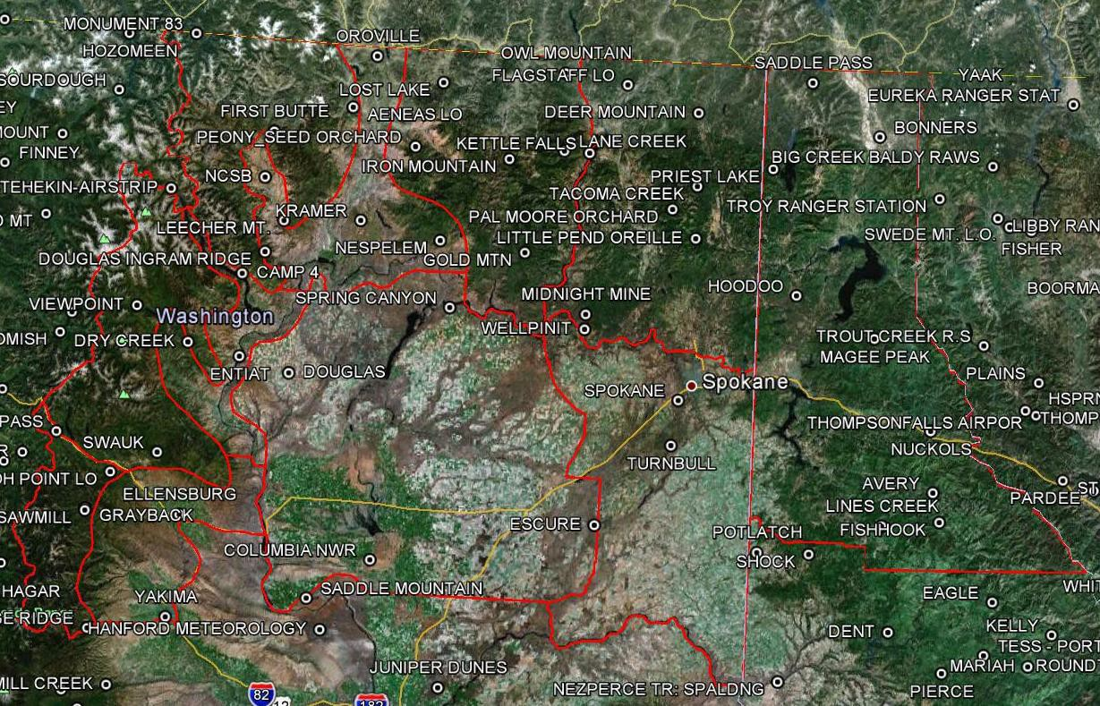
685
687
686
684
682
673
101

NWS Spokane NFDRS Station Index

ZONE | NAME | Type | NUMBER | OWNER | LAT | LON | ELEV
673 | Escure | R | 453601 | BLM | 47.07 | - 117.98 | 1725
673 | Columbia NWR | R | 453102 | FWS | 46.87 | - 119.33 | 890
673 | Spring Canyon | R | 453002 | NPS | 47.93 | - 118.93 | 1340
673 | Saddle Mtn | R | 452701 | FWS | 46.69 | - 119.69 | 650

673 | Douglas | R | 452601 | BLM | 47.6 | - 119.90 | 2530
674 | Escure | R | 453601 | BLM | 47.0 | - 117.98 | 1725
674 | Turnbull Wildlife | R | 453506 | FWS | 47.4 | - 117.53 | 2250
674 | Spokane Airport | M | 453505 | NWS | 47.6 | - 117.50 | 2365
676 | Ellensburg | M | 452203 | DNR | 47.0 | - 120.54 | 1560
677 | Dry Creek | R | 452134 | USFS | 47.7 | - 120.53 | 3480
677 | Camp 4 | R | 452132 | USFS | 48.0 | - 120.23 | 3773
677 | Entiat | R | 452136 | USFS | 47.6 | - 120.21 | 796
680 | Peoh Point | R | 452206 | DNR | 47.1 | - 120.95 | 4020
680 | Sawmill Flats | R | 452221 | USFS | 46.9 | - 121.08 | 3500
680 | Sedge Ridge | R | 452306 | DNR | 46.5 | - 120.90 | 4300
682 | Viewpoint | R | 452128 | USFS | 47.8 | - 120.87 | 3760
682 | Swauk | R | 452219 | USFS | 47.2 | - 120.67 | 3773
682 | Dry Creek | R | 452134 | USFS | 47.7 | - 120.54 | 3661

684 | NCSB | R | 452030 | USFS | 48.4 | - 120.14 | 1650
684 | Oroville | R | 452039 | BLM | 48.9 | - 119.49 | 1360
684 | Nespelem | R | 452009 | BIA | 48.2 | - 119.02 | 1782
684 | Douglas Ingram  Rdg | R | 452035 | USFS | 48.1 | - 120.10 | 3460
684 | Kramer | R | 452040 | BIA | 48.2 | - 119.52 | 2720
685 | Leecher | R | 452020 | USFS | 48.2 | - 120.00 | 5019
685 | First Butte | R | 452006 | USFS | 48.6 | - 120.11 | 5500
685 | Aeneas | R | 452001 | DNR | 48.7 | - 119.62 | 5185
686 | Midnite Mine | R | 452913 | BLM | 47.9 | - 118.09 | 2693
686 | Pal Moore Orchard | R | 452915 | USFS | 48.3 | - 117.43 | 3120
686 | Kettle Falls | R | 452916 | NPS | 48.6 | - 118.12 | 1310
686 | Tacoma Creek | R | 453413 | USFS | 48.4 | - 117.43 | 3300
686 | Little Pend Oreille | R | 453416 | FWS | 48.2 | - 117.43 | 2020
686 | Deer Mountain | R | 453412 | USFS | 48.8 | - 117.45 | 3300
686 | Wellpinit | R | 452918 | BIA | 47.8 | - 118.10 | 2240
686 | Cedar Creek  Orchard | R | 452917 | USFS | 48.9 | - 117.49 | 4300
686 | Teepee Seed  Orchard | R | 453414 | USFS | 48.6 | - 117.48 | 3280
686 | Flowery Trail | R | 453145 | USFS | 48.3 | - 117.41 | 2680
686 | Kettle Falls | R | 452916 | USFS | 48.5 | - 118.11 | 1310
686 | Fairchild 36 RQF | R |  | BLM | 48.4 | - 117.36 | 2450
687 | Peony | R | 452038 | USFS | 48.5 | - 119.21 | 3600

687 | Brown Mountain Ochd | R | 452514 | USFS | 48.5 | - 118.69 | 3210
687 | Owl Mountain | R | 452513 | USFS | 48.9 | - 118.30 | 4400
687 | Lane Creek | R | 452511 | USFS | 48.6 | - 118.28 | 4500
687 | Gold Mountain | R | 452510 | BIA | 48.1 | - 118.49 | 4636
687 | Iron Mountain | R | 452512 | USFS | 48.5 | - 118.62 | 4325
687 | Lost Lake | R | 452029 | USFS | 48.8 | - 119.06 | 3760
101 | Bonners Ferry | R | 100101 | USFS | 48.7 | - 116.35 | 2310
101 | Magee Peak | R | 100425 | USFS | 47.8 | - 116.31 | 4856
101 | Fish Hook | R | 100421 | USFS | 47.8 | - 115.91 | 4700
101 | Hoodoo | R | 100208 | USFS | 48.0 | - 116.84 | 2270
101 | Lines Creek | R | 100424 | USFS | 48.1 | - 116.29 | 5120
101 | Nuckols | R | 100423 | USFS | 47.5 | - 115.97 | 4000
101 | Priest Lake | R | 100204 | USFS | 48.6 | - 116.96 | 2600
101 | Saddle Pass | R | 100107 | USFS | 48.9 | - 116.79 | 5120

OREGON DEPARTMENT OF FORESTRY WEATHER

HOURS OF OPERATION
The Oregon Department of Forestry’s Salem Weather Center office hours vary depending upon fire and prescribed fire activity. The office is open from 0630 - 1700, five days a week between about November 25 - March 31 and July 1 - September 30. During the spring and fall burning periods, the office is staffed from 0630 - 1700, six days a week. Exact dates of five and six day-a-week service vary and are responsive to user needs for smoke management and other fire danger rating services.

LOCATION
Oregon Department of Forestry 2600 State Street
Salem, OR 97310

STAFF AND CONTACT
Nick Yonker Meteorology Manager
Nick.J.Yonker@oregon.gov Pete Parsons Meteorologist Peter.G.J.Parsons@oregon.gov Tom Jenkins Meteorologist
Thomas.S.Jenkins@oregon.gov Teresa Alcock Fire Program Analyst Teresa.Alcock@oregon.gov
Christina Clemons  Telephone: | Field Coordinator | Christina.T.Clemons@oregon.gov
Nick Yonker: | 503-945-7451
Pete Parsons: | 503-945-7448
Tom Jenkins: | 503-945-7452
Teresa Alcock: | 503-945-7226
Christina Clemons: | 503-945-7443
Forecast Desk: | 503-945-7401
Fax: | 503-945-7454

Internet: http://www.oregon.gov/ODF/Fire/Pages/Burn.aspx

FORECAST AREA

The ODF Salem Weather Center provides services statewide, supporting prescribed burning/smoke management activities on nearly all private, state, county and federal forestland in Oregon. The fire weather zones that are serviced are described below in

this operating plan. The Center also provides fire danger, fire severity and specialized weather (e.g. heavy rain, snow, wind, etc.) support to all ODF districts.

Note that prescribed burning on all forestland in Oregon comes under the jurisdiction of ODF Smoke Management Plan. Prescribed burning must follow the requirements of the Smoke Management Plan, regardless of the party or agency that is responsible for the ownership or management of the land. Forecasts and service provided by the National Weather Service should only be used for fire management purposes and not for smoke management approval.

AGENCIES SERVED
Oregon Department of Forestry (ODF) Private forest land owners
U.S. Bureau of Land Management (BLM)
U.S. Forest Service (USFS)
U.S. National Park Service (NPS)
U.S. Fish and Wildlife Service (USFWS) Bureau of Indian Affairs (BIA)

FORECAST SERVICES

General Forecasts:
Fire Season: ODF meteorologists provide smoke forecasts during major wildfire events statewide on a case-by-case basis. Wildfire smoke forecasts are issued as needed.
Special fire severity statements are issued on an as needed basis. ODF contracts with the Oregon Department of Agriculture to provide field burning forecasts from July through September in the north Willamette Valley, Jefferson County and Union County.

Prescribed Burning Season (which may overlap fire season): Smoke management forecasts and prescribed burning instructions and advisories are issued daily by 1500. Updated forecasts are released on an as needed basis, normally by 0800. Forecasts and burning instructions provide detailed information on a zone by zone basis.
Forecasts describe the expected weather in detail for the next day and provide two to four day outlooks in more general terms. Three separate forecasts are issued daily for different areas of the state:

- Western Oregon and the Deschutes National Forest (Zones 601-623, 639)
- Northeast Oregon (Zones 640-646)
- South-Central Oregon (Zones 624 and 625)

Open Burning Season: Open burning forecasts in support of the Oregon Department of Environmental Quality’s open burning program for the Willamette Valley north of Lane County are issued by 0730 year-round.

Off-season: Forecasters issue forecasts or special weather statements as needed in support of special prescribed burning requests and safety of agency personnel.

Smoke management spot forecasts: Detailed weather information beyond what is presented in the general smoke management forecast may be obtained with a spot forecast request. Smoke management spot forecasts are normally handled through oral briefings by contacting the duty forecaster at the forecast desk phone number shown above.

Telephone briefings: Telephone briefings may be provided by the ODF duty forecaster. These verbal weather briefings may be obtained at any time by calling the forecaster desk phone number shown above.

NON-FORECAST SERVICES
Smoke Management Training and Lectures: ODF forecasters are available to provide weather and smoke management training and program information at field locations.
These sessions would generally have to occur during the seasons when prescribed burning is not occurring.

Annual Summary and Operating Plan: The Smoke Management Annual Report is published by the staff of the Center. It provides a summary of prescribed burning activities for all landowners/land managers throughout the state.

An annual operating plan (this document) describing Salem Weather Center services, responsibilities, and procedures will be published each year. The operating plan is available on the ODF internet page shown in the "Contact" section of this plan.

GEOGRAPHICAL ZONES
Forecast zones may be found at the following web
site: http://www.oregon.gov/ODF/Documents/Fire/FIRE_WEATHER_ZONE_2015.pdf

WASHINGTON DEPARTMENT OF NATURAL RESOURCES

PREDICTIVE SERVICES SECTION

HOURS OF OPERATION
Staff in the predictive services section are generally in the office from Monday to Friday between the hours of 0700 and 1730. When fire season dictates, one or more staff may be present during the same hours on the weekend as well.

LOCATION
Washington Department of Natural Resources Headquarters, Wildfire Division
1111 Washington Street SE MS: 47037
Olympia, WA 98504

STAFF AND CONTACT

Management Staff:
George Geissler State Forester, Deputy Supervisor for Wildfire Chuck Turley Division Manager, Wildfire
Karen Arnold Ass. Div. Manager, Predictive Services and Operations Support

Predictive Services Section Staff:
Josh Clark Meteorologist, Weather and RAWS Program Manager Vaughn Cork Fuels and Fire Regulation Program Manager
Kirk Davis GIS Program Manager
Carolyn Kelly Smoke Management Field Coordinator Josh Mohler Fire Intelligence Coordinator

Contact | Phone | Email
Josh Clark | 360-902-1322 | josh.clark@dnr.wa.gov
Vaughn Cork | 360-902-1318 | vaughn.cork@dnr.wa.gov
Kirk Davis | 360-902-1330 | kirk.davis@dnr.wa.gov
Carolyn Kelly | 360-902-1387 | carolyn.kelly@dnr.wa.gov
Josh Mohler | 360-902-1333 | josh.mohler@dnr.wa.gov
Fax | 360-902-1757

Internet: http://www.dnr.wa.gov/programs-and-services/wildfire-resources Twitter: https://twitter.com/waDNR_fire

OPERATIONAL AREA
For fire danger, regulation, and weather support, all DNR-managed or protected lands (13.1 million acres) in Washington, divided in six regional jurisdictions: Pacific Cascade, South Puget Sound, Olympic, Northwest, Southeast, and Northeast. These areas may be further defined as districts or fire units.
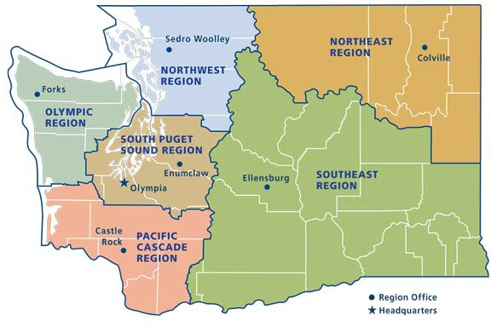

For smoke management/burn requests, all forested lands (public and private) in the state which meet the requirements for DNR approval as outlined in Washington RCW 76.04 and the State Smoke Management Plan or those which pay a Forest Fire Protection Assessment tax.

AGENCIES SERVED
Washington Department of Natural Resources Washington Department of Fish and Wildlife Washington Emergency Management Division Washington Military Department
Washington State Fire Marshal’s Office
Other federal and local partners when requested

SERVICES

Operational Weather and Climate Outlooks: During fire season, generally between July and October, the meteorologist provides a daily weather briefing to the executive and regional leadership of the Washington Department of Natural Resources, Emergency Management Division, and State Fire Marshal’s office. The meteorologist also provides a weather forecast

for DNR aviation operations.

Outside of fire season, weather forecasts and briefings are provided to agency leadership when a reasonable impact to natural resources operations can be expected. This includes: landslides, significant wind events, severe weather, earthquakes, and other weather scenarios.

All briefings and products are carefully coordinated with regional weather partners at the National Weather Service offices and the Geographic Coordination Center.

Smoke Management Approvals: The smoke management coordinator approves all state silvicultural burns over 100-tons in Washington. Smoke management requests and approvals may be made via SMOKEM here: https://fortress.wa.gov/dnr/protection/burnrequests/.

Our team, given enough notice, are available to support prescribed burns on-scene. We have a full complement of portable RAWS, handheld weather instruments, a remote observing system with a four camera payload, and an E-Sampler to provide continuous meteorological support for firefighter safety, satisfying burn plan objectives, or assessing air quality/smoke dispersion.

Note: the current state smoke management plan is being rewritten this year, which may result in changes to DNR’s role in smoke management in 2019.

Fire Regulation and Fire Danger: Our staff are available to provide interpretation and advice for industrial fire precaution levels, burn bans, staffing, NFDRS indices and other fire danger ratings. We represent the agency in

Fire Intelligence: We provide agency fire statistics including fire business metrics, trend analysis of financial and environmental data, fire reports and investigation status, and asset tracking.

GIS Analysis: Our section has advanced capabilities in performing in-depth spatial data analysis, predictive analytics (including machine learning), and custom map generation to support situational awareness needs either internally or externally.

RAWS Management: The Washington DNR currently maintains 31 RAWS (27 fixed and 4 portables), making it the fourth largest state fire weather network in the U.S. We pride ourselves in having one of the most dependable and accurate networks in the nation due to our consistent uptime and high maintenance standards. Six full-time radio technicians provide annual and emergency maintenance to the network and all DNR dispatch staff are trained to provide daily quality control of RAWS weather data using WIMS. For any issues with RAWS, please e-mail DNRDLRPRAWS@dnr.wa.gov and the appropriate technician will reply shortly.

We provide status reports to interested RAWS data consumers in the event of an issue or maintenance outage. If you are interested in receiving this report, please e-
mail josh.clark@dnr.wa.gov.

Incident Support: Staff in our section provide a variety of on-scene NWCG-certified capabilities. We currently have qualified personnel in the following positions: ARA, IMET, GISS, FFT2, FFT1, ICT5, ICT4, CRWB, ENGB, FAL1, FELB, FEMO, FIRB, FOBS, RXB3,
EMT, STCR, STEN, TFLD, RAWS maintenance (N-9035), and UAS operations (FAA sUAS).

Seasonal Outlooks: Beginning in April, the meteorologist provides a monthly outlook for Washington’s fire season. This outlook is normally published during the first week of the month and continues through October. Accompanying video or webinar style briefings are available as needed to any agency requesting one. Outlooks are also available to media or various communications staff. This product is carefully coordinated with our regional weather partners.

Fire Staff Training: We provide support (either full course or individual units) for S-130, S- 190, S-290, and S-390. We are also available for RT-130s as needed.

Appendices

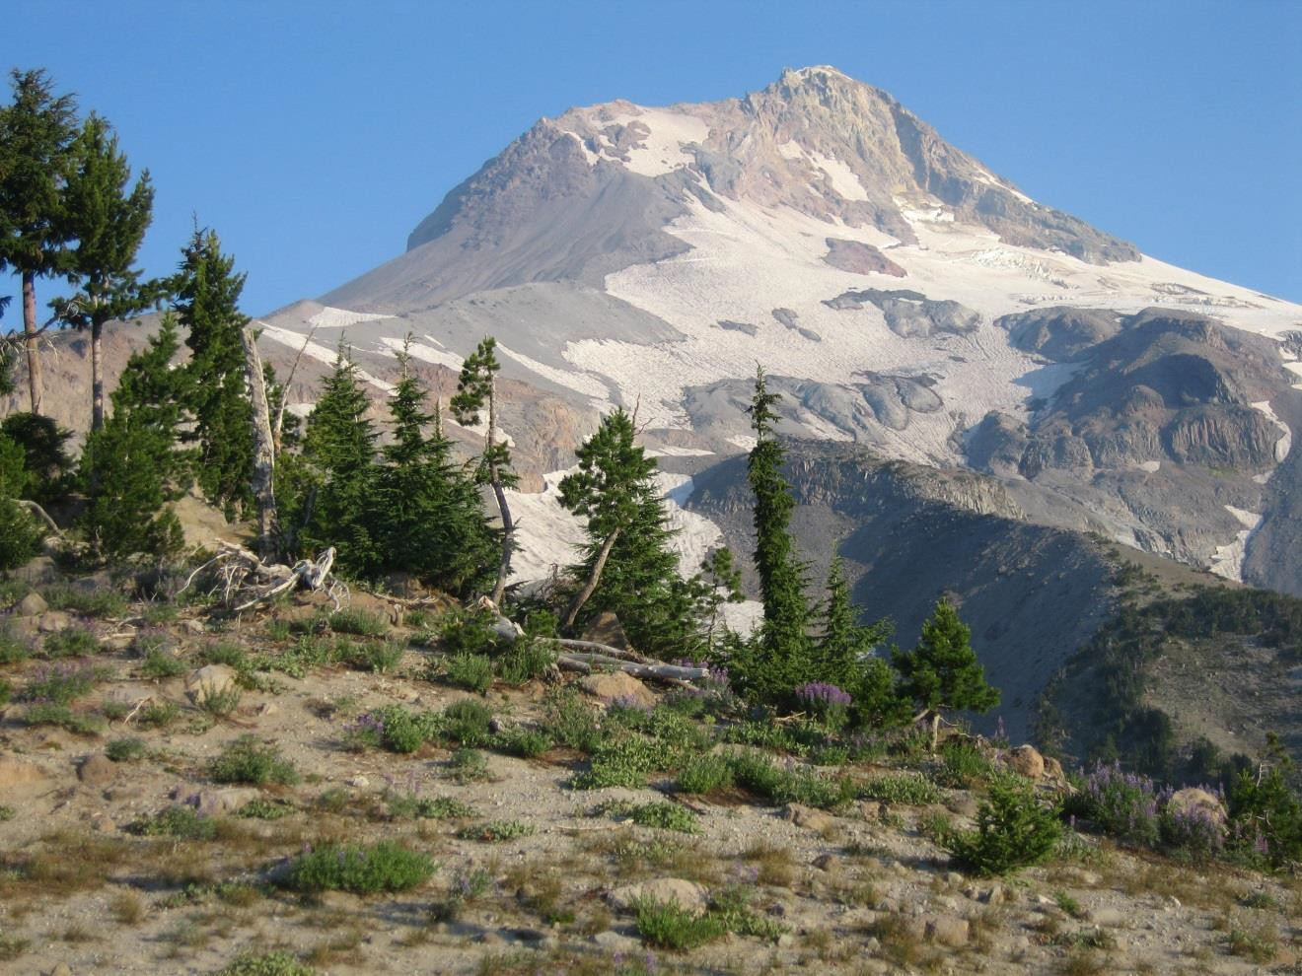

Picturesque Mt. Hood – Mt. Hood Complex August, 2006 – Photo by Scott Weishaar

APPENDIX A
Links to Fire Weather Agreements and Documents

Interagency Agreement for Meteorological Services and other Technical Services
http://www.srh.noaa.gov/ridge2/fire/docs/2012_National_Agreement.pdf

NWS Fire Weather Services Directives
✵ Product Specifications (NWS Instruction 10-
401) http://www.weather.gov/directives/sym/pd01004001curr.pdf
✵ On-site Support (NWS Instruction 10-402)
http://www.weather.gov/directives/sym/pd01004002curr.pdf
✵ Coordination and Outreach (NWS Instruction 10-
403) http://www.weather.gov/directives/sym/pd01004003curr.pdf
✵ Annual Operating Plan and Report (NWS Instruction 10-
404) http://www.weather.gov/directives/sym/pd01004004curr.pdf
✵ Training and Professional Development (NWS Instruction 10-
405) http://www.weather.gov/directives/sym/pd01004005curr.pdf
✵ Zone Change Process (NWS Instruction 10-
407) http://www.weather.gov/directives/sym/pd01004007curr.pdf
✵ Western Region Forecast Office Fire Weather Services (WR Supplement to 10- 401)
http://www.weather.gov/directives/sym/pd01004001w042005curr.pdf

Electronic copy of the NWS D-1 spot forecast request form
http://www.wrh.noaa.gov/sew/D1_V2005.pdf

National Mobilization Guide
http://www.nifc.gov/nicc/mobguide/index.html

Northwest Interagency Mobilization Guide
http://www.nwccweb.us/admin/publications.asp

Link to Washington DNR Fire Information
http://dnr.wa.gov/programs-and-services/wildfire-resources

APPENDIX B

Forecast and Service Performance Measures

- NFDRS Forecast Accuracy Performance Measures

The following performance measures are suggested as baseline standards for improvement over persistence forecasts on an annual basis for zone averages or key stations within a fire weather zone. The verification methodology will be consistent between all NWS offices (e.g. MAE, bias scores).

Suggested Annual Baseline Goals Parameter Improvement over persistence forecast

Temperature: | 35%
Relative Humidity: | 25%
Wind speed: | 10%

Wetting Rain: A "yes" or "no" field, correct 80% of the time as verified by the PD1 and PD2 forecast forecasts in NFDRS.

Lightning: A “yes” or “no” field, correct 70% of the time as verified by the LAL forecast. For verification purposes, an LAL forecast of 2 or more will be considered a “yes.” This verification effort will be a collaborative effort between NWCC and NWS.

Spot Forecasts for Wildfires, Prescribed Fires and other activities

Spot Forecast verification will be based on relevant agency provided observations at the fire site (e.g. a forecast for a 7 p.m. temperature must be validated by a 7 p.m. observation.) Suggested verification criteria are as follows:

Temperature: MAE <=5 degrees Fahrenheit Relative Humidity: MAE of following values:
RH 30%: <= 4%
RH 30-50%: <= 7%
RH > 50%: <=10%
Wind Speed: MAE <= 3mph for user defined measurement height
(20 foot wind or eye-level).

Red Flag Warning and Fire Weather Watch

Red Flag Warnings and Fire Weather Watches will be verified in accordance with NWSI 10-401 http://www.weather.gov/directives/sym/pd01004001curr.pdf and 10-401 WR Supplement.

http://www.weather.gov/directives/sym/pd01004001w042005curr.pdf. Verification statistics will be included in the Annual Report.

APPENDIX C

Reimbursement for NWS-Provided Training

IMETs and other NWS staff are frequently requested to provide fire weather training for fire crews as part of such interagency fire behavior courses as S190 and S290. Policy guidelines for fulfilling these requests are outlined in NWSI 10-403.

Requests for training by NWS personnel are not made using resource orders. Rather, both the USDA Forest Service and Department of Interior utilize training request forms that can be used by the NWS to obtain reimbursement for travel costs associated with the provision of weather training. The USDA Forest Service uses Form AD-672.

The Department of Interior does not have a single, standard form. However, a template Form 1681-3 is available that can be presented to the DOI requestor. It is the responsibility of the requesting agency to provide an appropriate agreement document for training.

If the request for training comes via a state agency, the NWS must use a NOAA General Counsel template. Training requests from California, Oregon and Washington do not need to use this form as their requests are covered by the same agreement used for IMET dispatches for those states.

There are no standard forms for gaining travel expense reimbursements from local agencies or colleges. Requesting agencies should pre-pay all travel expenses for instructors who must travel to the course, or at least cover lodging costs.

A secondary, more cumbersome option is for requesting agencies to reimburse the NWS by writing a check to the U.S. Department of Commerce for the amount of the travel voucher. If this is done however, the WFO must attach a “Gifts and Bequeaths Form” to the voucher prior to submission to their Finance Office. Under no circumstances can the requesting entity personally reimburse the NWS instructor for travel costs.

APPENDIX D

Incident Meteorologist Billing Points of Contact for Washington and Oregon

USDA Forest Service:
Elizabeth Martin
USDA Forest Service; Incident Business 101B Sun Avenue NW
Albuquerque, NM 87109

National Park Service, US Fish and Wildlife Service, Bureau of Indian Affairs, and Bureau of Land Management
David R. Burley
BLM, Incident Business Lead National Interagency Fire Center 3833 S. Development Avenue Boise, ID 83705

APPENDIX E

Spot Forecast Request Form D-1

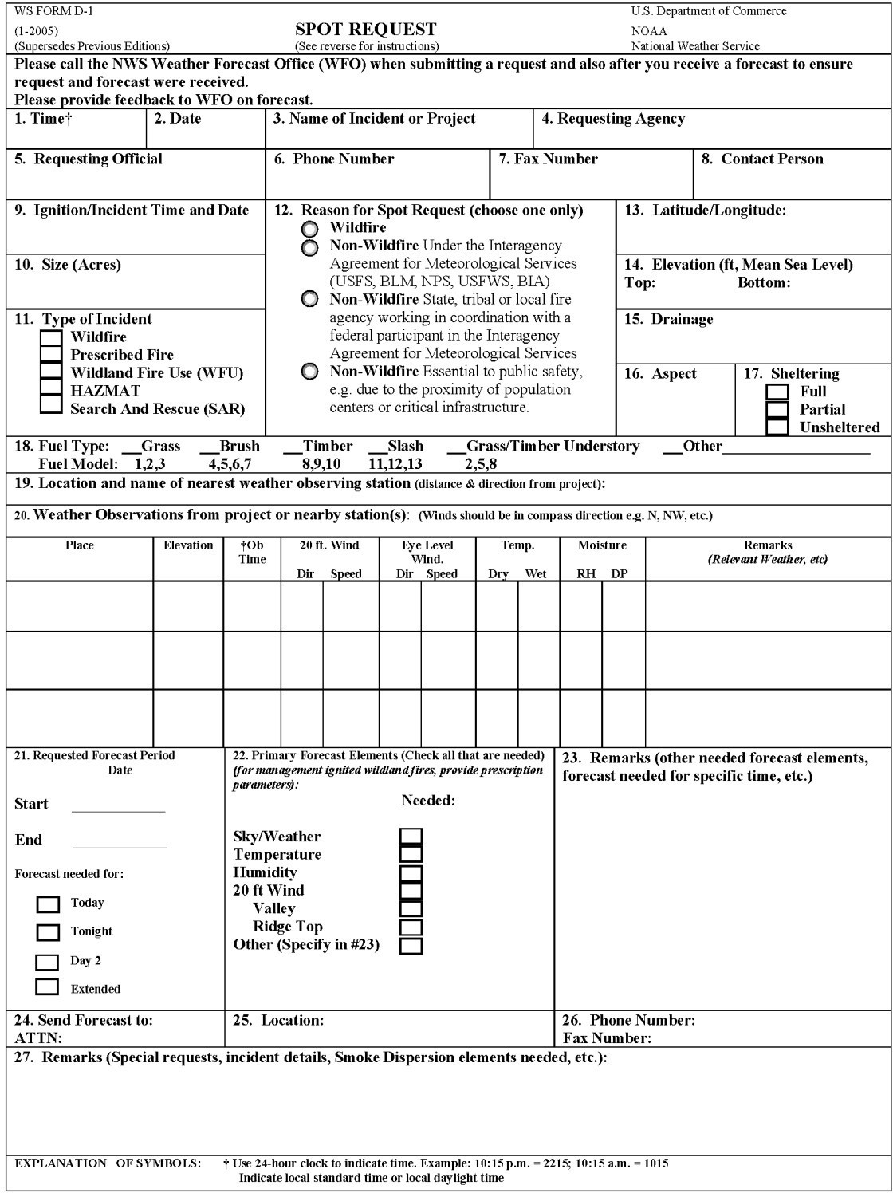

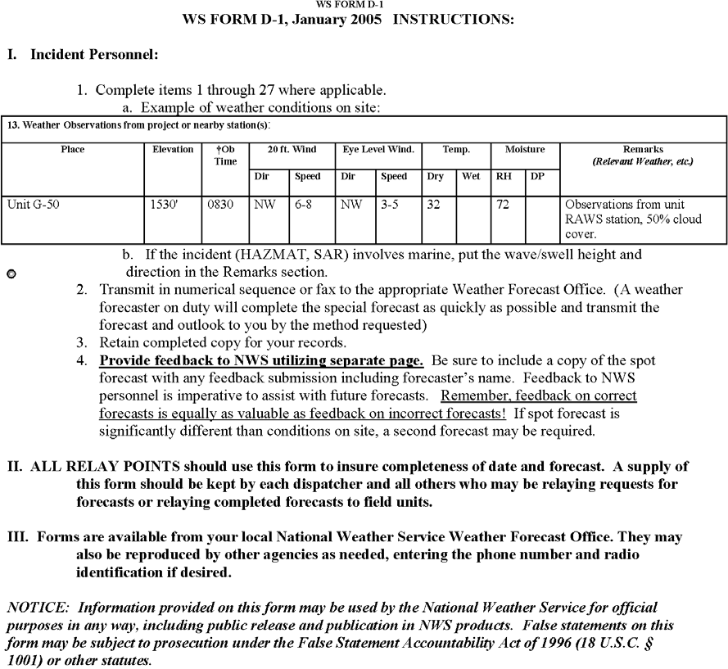

APPENDIX F
Hysplit Request Instructions

HYSPLIT is a model which determines trajectories for parcels at a given height above ground level. An easy method has been developed to take advantage of the base information that is already input into the spot request form to generate automated HYSPLIT Trajectory forecasts. The HYSPLIT trajectories can be used for many purposes (i.e. HAZMAT, smoke, etc.).

The HYSPLIT output represents computer model forecasts without any human interaction. They do not take into account information on burn size or fuels, thus generate trajectory forecasts for 500, 1500, and 3000 meters AGL without regarding for whether the fire plume height will reach those altitudes.

To utilize this feature, simply add the word Hysplit with your email address into the remarks section of a spot request:

Example: Hysplit to very.windy@web.address Any email address works.
It is recommended that you try this procedure and get a feel for its content before using it for actual guidance on a burn or fire. For more information, please
visit http://www.srh.noaa.gov/ridge2/fire/docs/HYSPLITone-pager_final_woSMEs.docx. If you have any questions, please contact your local fire weather program leader.

