I-TEAMS :
http://nwportal.fs.usda.gov/usfs_r6/welcome_nwportal.cfm
*This web-site link will direct you to your eAuthentication log on page*

Log in using your eAuthentication username and password. If you do not have access to eAuthentication you can go to http://www.eauth.egov.usda.gov/ and request level 2 access. You must have access to eAuthentication before you can request access to I-TEAMs.

Once you log in, you should be directed to the FAM Portal.

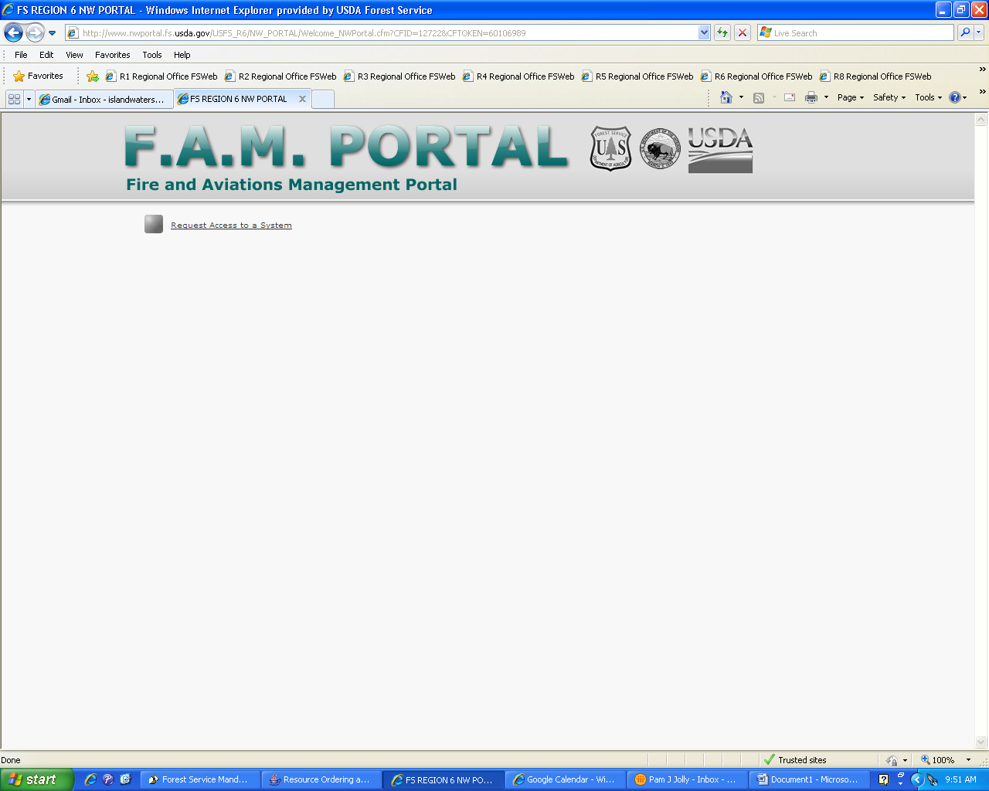
Select: Request access to a system
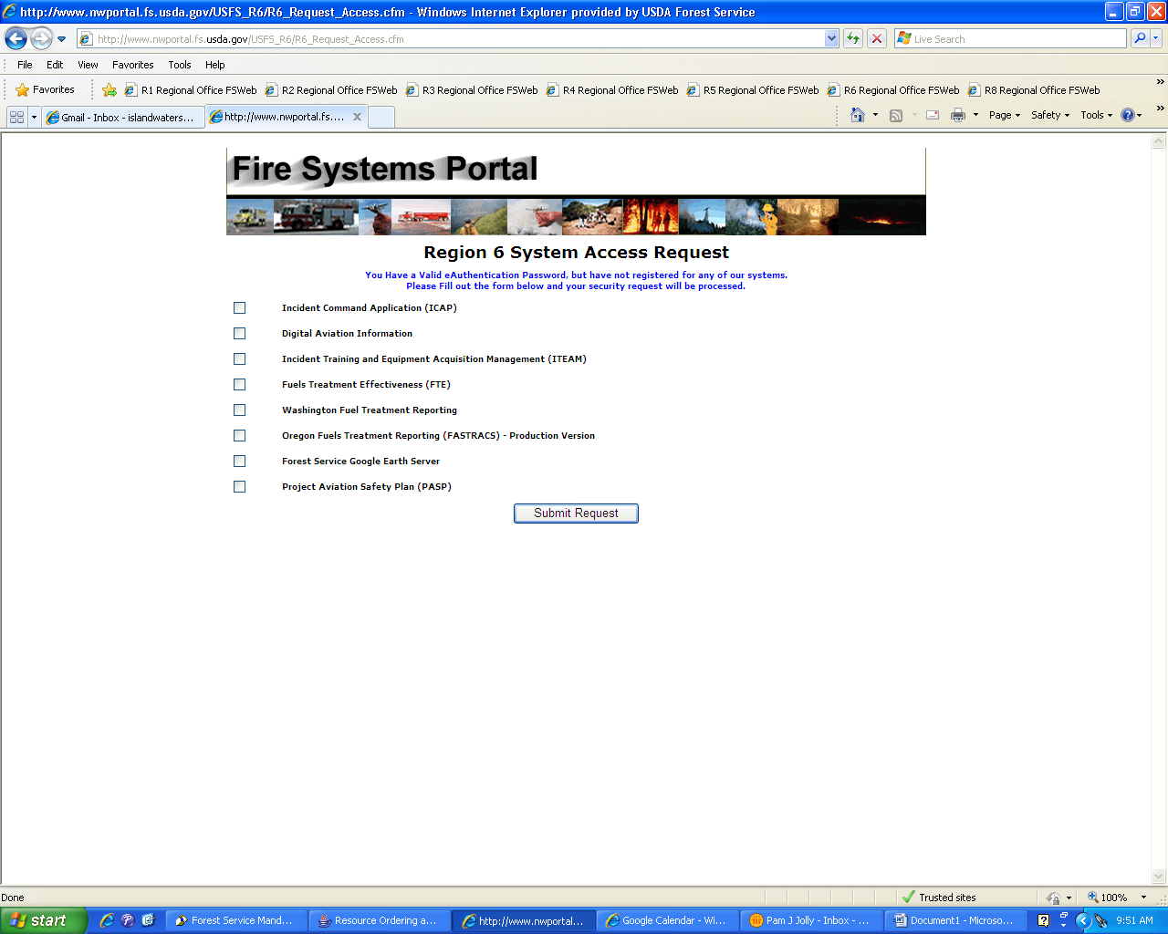Select: Incident Training and Equipment Acquisition Management (ITEAM)/ Submit Request

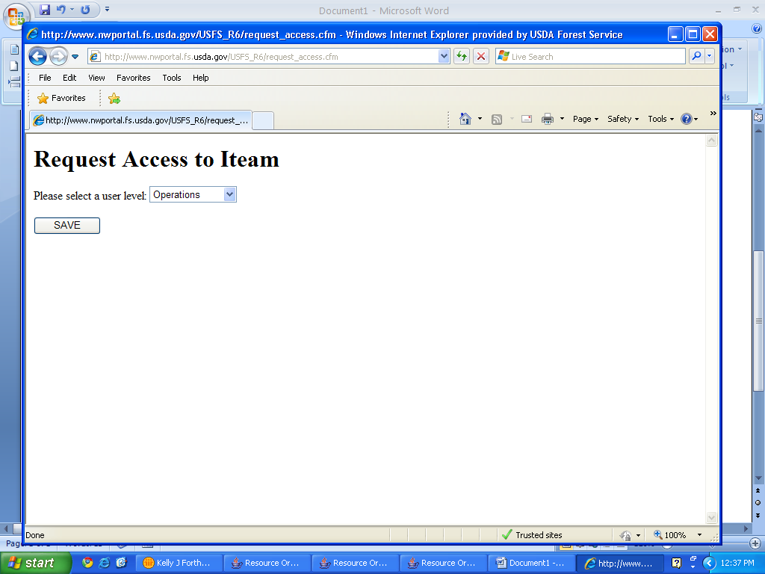Select: Operations /Save

After you have logged in and requested access to I-TEAMs, please send Dale Guenther an email (dguenther@fs.fed.us) stating that you are requesting access to I-TEAMs and provide your name, region, dispatch office name and agency you are affiliated with. Even though you are logging into I-TEAMs through eAuthentication, Dale receives the request directly to his email and just receives a name and is not aware of what region you work for. He needs the additional information so he can give you the right type of access to the system.
Example: Kelly Forthofer, R-1, Northern Rockies Coordination Center, US Forest Service and state that you recently requested access to I-TEAMs.
You should be granted access within a day or two.
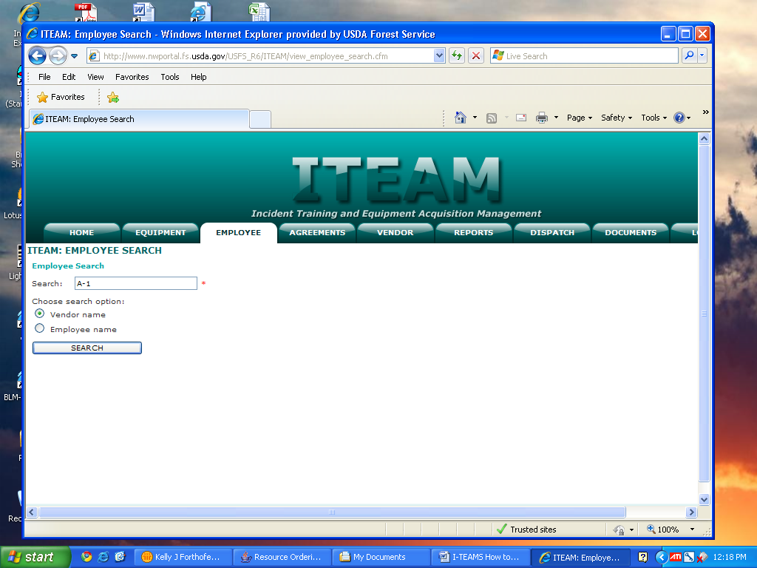Once you are granted access you will only have access to the Employee tab.
You can search by the Vendor name or Employee name
In the example above, I entered the company A-1, chose the search option Vendor name then clicked SEARCH.
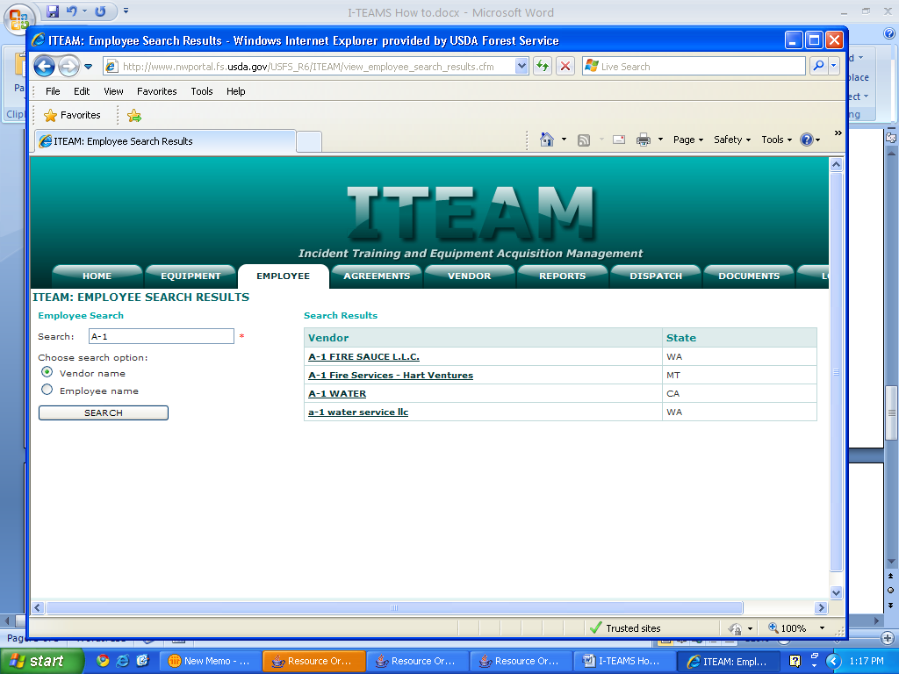You will have companies that are listed for WA, CA and OR too. The only companies you will be able to view are the ones listed for MT, ID and ND though.

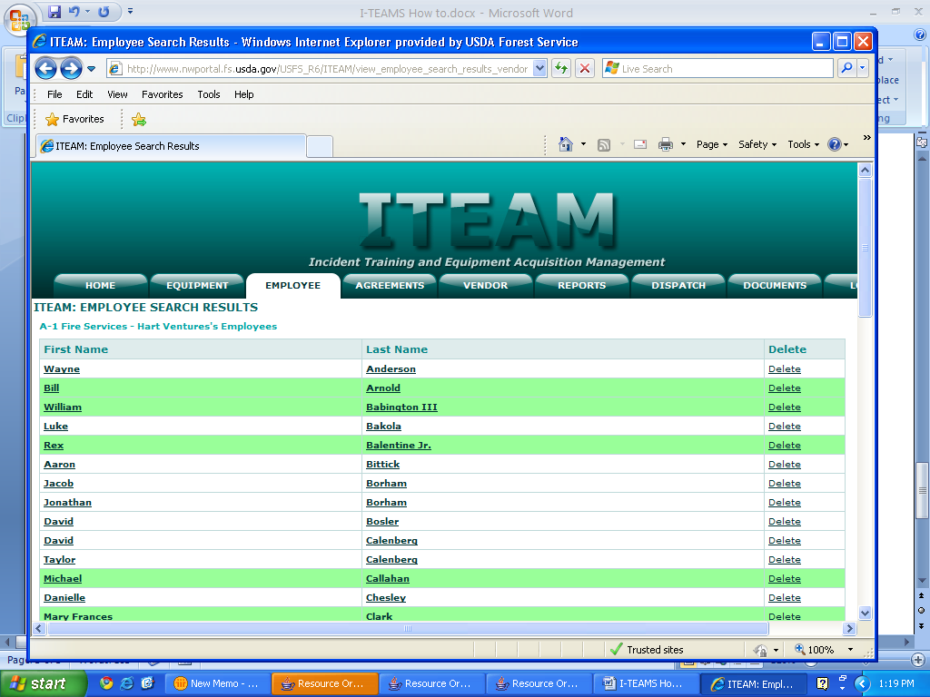Once selected, a list of all the employees affiliated with that Vendor will be listed. The employees highlighted in green are the ones current for the 2013 fire season.

When you select a name it will bring up their current qualifications, refresher training date and the year that WCFT training was completed. A Yes or a No will be selected if the employee has passed verification.
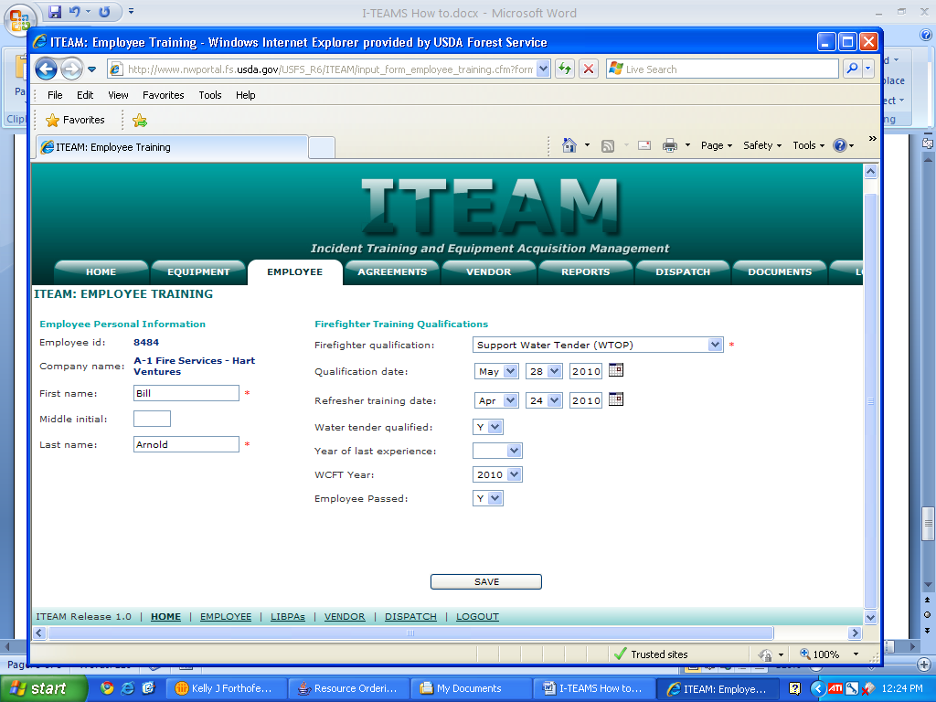If you have any questions at all, please give me a call. This is a new program that is replacing the employee verification spreadsheet from last year.
I would appreciate any input you may have on the program.

Thank you.

