***Bridger-Teton National Forest***

***[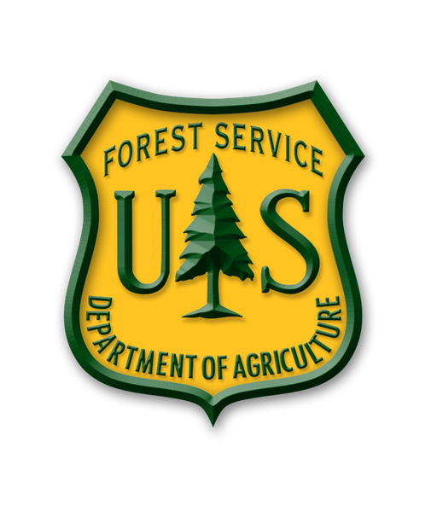](https://www.fs.usda.gov/btnf/)***

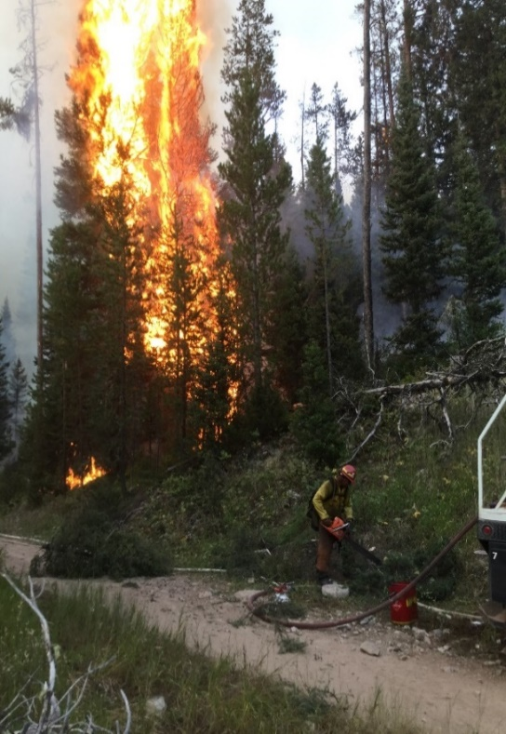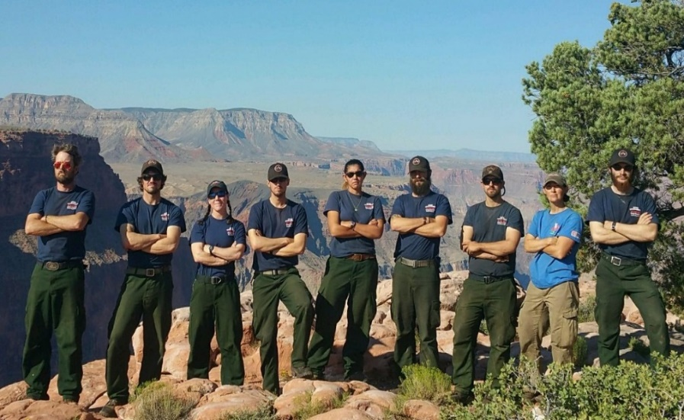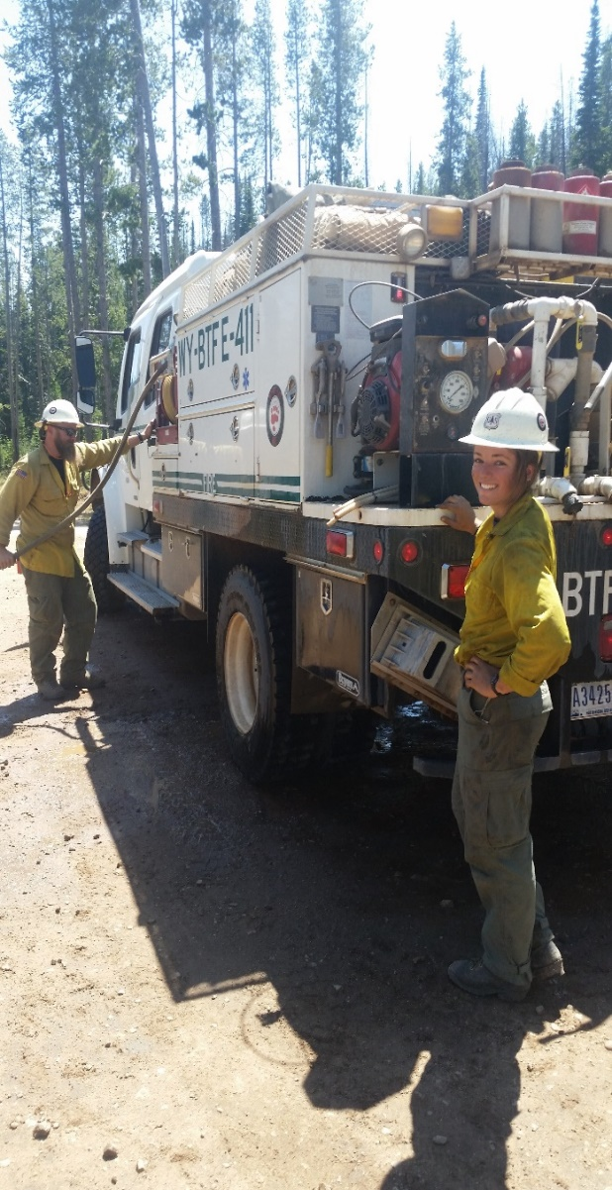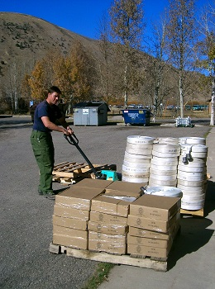

***2026* SUMMER SEASONAL**

**FIRE POSITION OUTREACH NOTICE**

|  |  |
| --- | --- |
| **Apply at** [**USAjobs.gov**](http://www.usajobs.gov) | **October 15 – October 29** |

**Fire Positions**

The Bridger-Teton National Forest will be hiring seasonal positions for the 2026 summer season starting **October 15th through October 29th, 2025.** Applicants must apply to the module vacancy by selecting the specific Duty Station in [USAjobs](http://www.usajobs.gov). You must have your completed application submitted by midnight EST (Eastern Standard Time) of the closing date of the vacancy. The Forest may fill several wildland fire positions, including: helitack, engines, fire module and fire cache. Housing may be available at some duty stations. These positions may start between mid-April to late May. More information on these positions may be found at [TetonFires](https://gacc.nifc.gov/gbcc/dispatch/wy-tdc/home/2021-12-13/bridger-teton-national-forest-vacancies).com.

More than one position may be filled for each job announcement listed below. These positions will be temporary, not to exceed 1039 hours. All positions will be advertised on USAJOBS, [www.usajobs.gov.](http://www.usajobs.gov/)

Successfully passing the work capacity test (WCT) at the arduous level is a condition of employment for all wildland fire positions except the fire cache laborer. The Arduous fitness (Pack) test requires completing a 3-mile hike within 45 minutes while carrying a 45 pound pack.

For positions that require fire certifications: S-290 or FFT1, you must attach those current certifications in the form of an up-to-date IQCS or Certificates of Completion. **Red cards are not acceptable.** Documents will not be accepted after the job announcement closes. Only documentation attached to the application will be considered.

**How to apply:** Apply online at [USAJobs.gov](https://www.usajobs.gov/). This online application process allows applicants to submit employment information that can be printed for personal use and/or edited on the website for future use. If you do not have a USAJOBS account the system will help you establish one. Your account can be used for other federal job vacancies.

**\*New this year:** Resumes limited to two pages. Starting on September 27, 2025, federal agencies will only accept resumes up to two pages in length**.** At this time, USAJOBS Resume Builder will allow for (1) start and end date per position for seasonal positions. The workaround for this is to build a resume outside of the USAJOBS system and upload a copy to USAJOBS when you apply for a job.USAJOBS will not allow the resume to be saved in the profile if it exceeds two pages.

**Tips on the new resume requirements:** Prioritize most relevant and recent experience; Use concise, results focused language; Align language from the job announcement and position description links below; Focus on demonstrating skills and competencies.

[Sign in to your profile and update your resume now](https://gcc02.safelinks.protection.outlook.com/?url=https%3A%2F%2Fwww.usajobs.gov%2Fapplicant%2Fdocument%2Fresumes&data=05%7C02%7Csusan.colligan%40usda.gov%7C52fa5a733e574e9a797c08ddfc488354%7Ced5b36e701ee4ebc867ee03cfa0d4697%7C1%7C0%7C638944110589679576%7CUnknown%7CTWFpbGZsb3d8eyJFbXB0eU1hcGkiOnRydWUsIlYiOiIwLjAuMDAwMCIsIlAiOiJXaW4zMiIsIkFOIjoiTWFpbCIsIldUIjoyfQ%3D%3D%7C0%7C%7C%7C&sdata=2MeWnTCiF1nAPa%2FHzXrpXXm3hXlCNW9%2FyMyqmM5jVu4%3D&reserved=0).

[Learn more about the new resume requirements](https://gcc02.safelinks.protection.outlook.com/?url=https%3A%2F%2Fhelp.usajobs.gov%2Ffaq%2Fapplication%2Fdocuments%2Fresume%2Fpage-limit&data=05%7C02%7Csusan.colligan%40usda.gov%7C52fa5a733e574e9a797c08ddfc488354%7Ced5b36e701ee4ebc867ee03cfa0d4697%7C1%7C0%7C638944110589694688%7CUnknown%7CTWFpbGZsb3d8eyJFbXB0eU1hcGkiOnRydWUsIlYiOiIwLjAuMDAwMCIsIlAiOiJXaW4zMiIsIkFOIjoiTWFpbCIsIldUIjoyfQ%3D%3D%7C0%7C%7C%7C&sdata=VgPkgOFCcd0vE8ssAhIpx3asRxhJY%2B0S1053dDQOvuQ%3D&reserved=0).

Be sure to mark yes to the following question. A temporary appointment is no more than 1,039 hours (~6 months).

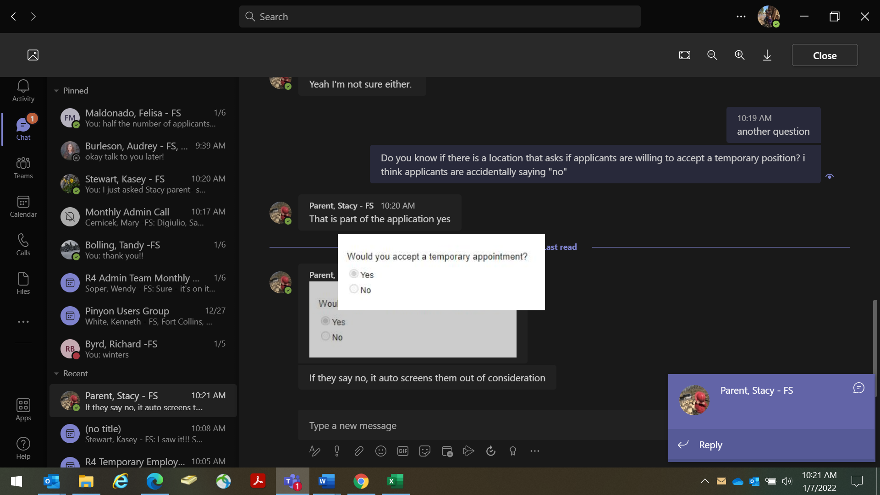*If “no” is marked, you will still be able to submit your application, but you will not be considered for employment for these positions.

By selecting the **"Location Negotiable"** option during the application process, implies your willingness to be considered for any official duty location listed on this announcement and/or those duty locations not listed for this Regional announcement.

**Important:**  If you wish to be considered for this position, you must apply prior to the closing date listed on the vacancy announcement-don’t delay. Please specify which duty location you wish to be considered for. For more information on qualifications and training for fire positions, click [here](https://gacc.nifc.gov/gbcc/dispatch/wy-tdc/home/administration/training) and reach out to the contacts below.

If you have any general questions or questions about the hiring process, please feel free to contact Susan R. Colligan at [susan.colligan@usda.gov](mailto:susan.colligan@usda.gov) or 307-739-5521.

**Follow us:** [USDA Logo](https://gcc02.safelinks.protection.outlook.com/?url=http%3A%2F%2Fusda.gov%2F&data=04%7C01%7C%7C64f512f930c942ce4e5b08d9886ff6bb%7Ced5b36e701ee4ebc867ee03cfa0d4697%7C0%7C0%7C637690836742136391%7CUnknown%7CTWFpbGZsb3d8eyJWIjoiMC4wLjAwMDAiLCJQIjoiV2luMzIiLCJBTiI6Ik1haWwiLCJXVCI6Mn0%3D%7C1000&sdata=ej6zMb6YMze%2B86%2FBFHCn3LiVD9DbqUW7K4erVVgRUog%3D&reserved=0)[Forest Service Twitter](https://gcc02.safelinks.protection.outlook.com/?url=https%3A%2F%2Ftwitter.com%2Fforestservice&data=04%7C01%7C%7C64f512f930c942ce4e5b08d9886ff6bb%7Ced5b36e701ee4ebc867ee03cfa0d4697%7C0%7C0%7C637690836742146349%7CUnknown%7CTWFpbGZsb3d8eyJWIjoiMC4wLjAwMDAiLCJQIjoiV2luMzIiLCJBTiI6Ik1haWwiLCJXVCI6Mn0%3D%7C1000&sdata=Mz09GOc2qzqOyyhsrGI6sX9JwS8E9W1qMdo6CCjzUEw%3D&reserved=0)[USDA Facebook](https://gcc02.safelinks.protection.outlook.com/?url=https%3A%2F%2Fwww.facebook.com%2Fpages%2FUS-Forest-Service%2F1431984283714112&data=04%7C01%7C%7C64f512f930c942ce4e5b08d9886ff6bb%7Ced5b36e701ee4ebc867ee03cfa0d4697%7C0%7C0%7C637690836742146349%7CUnknown%7CTWFpbGZsb3d8eyJWIjoiMC4wLjAwMDAiLCJQIjoiV2luMzIiLCJBTiI6Ik1haWwiLCJXVCI6Mn0%3D%7C1000&sdata=UFPywEE%2BQlxsDB%2FWsSo4s3AKjW7kQMPJS859YOahr7U%3D&reserved=0)

Contents

Laborer or Materials Handler (Fire Cache): 3

Helitack: 4

Engine Modules: Fire Suppression 5

Teton Wildland Fire Module: 6

About the Forest: 7

About the Duty Stations: 8

About the positions:

## Laborer or Materials Handler (Fire Cache):

The selected individual will serve primarily as an Assistant to the Teton Interagency Fire Warehouse Manager in Jackson, WY. The warehouse supports wildland fires on the Bridger-Teton National Forest and in Grand Teton National Park. The Fire Warehouse Manager works directly for the Bridger-Teton National Forest AFMO (Assistant Fire Management Officer).

Duties of the Fire Warehouse Assistant will include assembling and loading supply orders and filling out waybills, and other documentation; loading and delivering supplies to fires; organizing, stocking, and maintaining an inventory of supplies; supply ordering and tracking; unloading supplies returning from fires; forklift operation; large truck operation, and trailer pulling. The warehouse will often support multiple fires at one time and deliver supplies long distances over rough unpaved roads to remote locations. During busy periods with heavy fire loads additional personnel will assist with loading and delivery of supplies. The Fire Warehouse Assistant will manage the fire warehouse in the absence of the Fire Warehouse Manager.

On the B-T one can expect to work within a diverse fire management organization which places high expectations on individual and crew performance and provides some unique Fire Management experience opportunities.

|  |  |  |  |  |  |
| --- | --- | --- | --- | --- | --- |
| **Title** | **Number of**  **positions** | **Duty stations** | **Contact** | **Grade levels & Position Description #s** | **Announcement Link and Number** |
| Materials Handler  WG-6907-5 | 1 | Jackson | Heidi Zardus  307.739.5079 [heidi.zardus@usda.gov](mailto:heidi.zardus@usda.gov) | **WG-5** FS2540 | [26-TEMP3-R4-FS2540-5DT-GD](https://www.usajobs.gov/job/848035100) |
| Materials Handler  WG-6907-4 | 1 | Jackson | Heidi Zardus  307.739.5079 [heidi.zardus@usda.gov](mailto:heidi.zardus@usda.gov) | **WG-4** FS2539 | [26-TEMP3-R4-FS2539-4DT-SM](https://www.usajobs.gov/job/848038900) |

***Application period for all positions opens October 15th through October 29th, 2025***

## Helitack:

The Teton-Interagency Fire Management Program is planning to fill Seasonal Helitack Crewmember positions for the following summer fire season. These positions are Forestry Technician GS-0462-04/05. The Vacancy Announcement and application portal can be found at [www.usajobs.gov](http://www.usajobs.gov). These are seasonal positions for the Teton Interagency Helitack crew. They will be hired through the US Forest Service and tour of duty will be approximately early May to mid-October. We conduct our missions in support of fire and resource management for the Bridger-Teton National Forest and Grand Teton National Park. We are an Interagency crew comprised of Forest Service and Park Service personnel. The helitack crew is based in Jackson Hole, Wyoming and housing may be available.

|  |  |  |  |  |
| --- | --- | --- | --- | --- |
| **Title** | **Duty stations** | **Contact** | **Grade levels & Position Description #s** | **Announcement number** |
| Forestry  Technician – Fire (Helitack)  GS-0456 | Jackson | Erik Newell  307.739.5552  [erik.newell@usda.gov](mailto:erik.newell@usda.gov) | **GW-4**  [2PC048](AD332_2PC048.docx)  **GW-5**  FS0200 | [26-TEMPF3-R4-2PC048-4DH](https://www.usajobs.gov/job/848034400)  [26-TEMPF3-R4-2PC027-5DH](https://www.usajobs.gov/job/848033100) |

***Application period for all positions opens October 15th through October 29th, 2025***

## Engine Modules: Fire Suppression

These Engine Modules are part of the Teton Interagency Fire Management organization. The Bridger-Teton Fire organization is made up of three zones. There are three Type 3 and two Type 6 engines that provide 7 day coverage for fire response. The engine modules consist of 5 permanent staff and 2 seasonal crewmembers. Seasonal employees may be provided government housing.

A normal fire season for the area is late June thru mid-October. Fires on the Bridger-Teton National Forest have been reported as early as May and as late as December. Seasonal crewmembers can expect to start in mid-May to early June and work into October. These engine crews are highly motivated, with individuals who desire to work long, hard hours to complete any assignment. Expectations for the entire crew are high. Fire assignments include local Initial Attack to off-Forest, Extended Attack large fires. Assignments can be with the Engine or with the Teton Interagency Type 2IA hand crew. If not assigned to a fire, engine fire crews can be found out in the Forest prepping prescribed burn units, carrying out fuel reduction treatments or completing various other projects for the Districts.

|  |  |  |  |  |
| --- | --- | --- | --- | --- |
| **Title** | **Duty stations** | **Contact** | **Grade levels & Position Description #s** | **Announcement number** |
| Forestry Aid  Fire Suppression  GS-0456  Forestry Technician-  Fire Suppression  GS-0456 | Kemmerer | Adam Hansen  307.886.5335 adam.hansen@usda.gov | **GW-3**  [2PC033](AD332_2PC033.docx)  **GW-4**  [2PC049](AD332_2PC049.docx)  **GW -5**  [2PC029](AD332_2PC029.docx) | [26-TEMPF3-R4-2PC033-3DH](https://www.usajobs.gov/job/848040800)  [26-TEMPF3-R4-2PC048-4DH](https://www.usajobs.gov/job/848034400)  [26-TEMPF3-R4-2PC028-5DH](https://www.usajobs.gov/job/848035700) |
| Afton | Adam Hansen  307.886.5335 adam.hansen@usda.gov |
| Pinedale | Kendra Jackson  307.367.5713  Kendra.B.Jackson@usda.gov |
| Jackson | Brett Loomis  603.496.3221  [brett.loomis@usda.gov](mailto:brett.loomis@usda.gov) |

***Application period for all positions opens October 15th through October 29th, 2025***

## Teton Wildland Fire Module:

The Teton Wildland Fire Module (WFM) is a mobile, self-sufficient and tactically skilled resource that is used in a variety of wildland fire and fuels related work. The primary mission of the module is to provide a skilled, efficient workforce to accomplish the full range of wildland fire management tasks including prescribed fire preparation and implementation, managing fire for resource benefit, fuels reduction projects, hazard tree removal, and wildland fire suppression. The module consists of one GS‐9 Module Supervisor, a GS-8 assistant, three GS‐6 squad leaders, two GS‐5 Senior Firefighter and a few seasonals.

While working on Forest and Park projects, crewmembers routinely work long days that include hiking, heavy lifting, and extensive use of hand tools, chainsaws, and other equipment. Some projects are away from the duty station requiring the crew to camp at the project site. The Module is also available for wildfire assignments using a wide range of tools and skills to complete a variety of fire management objectives. Assignments may include ignition, suppression, monitoring, and data collection utilizing everything from chainsaws and drip torches to computers, weather stations, and motion-sensing cameras. Fire assignments last up to 21 days, prior to a day off, and are generally spent camping near the fire with few amenities. The crew participates on the Teton Crew, a 20-person Type 2 Initial Attack crew that is assembled for local and national assignments throughout the season. Safety and training are priorities for the crew. The Teton Fire Module is stationed at the Blackrock Ranger Station, approximately 9 miles east of Moran Junction, Wyoming.

Physical Training requirements:  
Whether on project work or wildfires, crewmembers routinely are hiking on steep mountain terrain carrying approximately 45 lbs of gear. Due to the physical nature of this position it is imperative that crewmembers are in excellent physical shape to prevent injuries. A physical evaluation will be conducted the first week of work which consists of the pack test (required for position), sit ups, push-ups, pull-ups, 1 ½ mile run and hiking Rosie's Ridge (800' elevation gain in 0.5 miles). The goal of the Teton Fire Module physical fitness training program is to prepare firefighters for the rigorous duties of wildland fire work and crew safety. Each member of the Teton Fire Module should arrive on the first day of work in top physical condition. Blackrock Ranger Station elevation is at 6890 feet, PT runs and hikes involving vertical climbs up to 1000 feet are common. Applicants are encouraged to maintain a rigorous physical training program before the season starts to prepare for the daily physical fitness training with the crew. Our workouts include stretching, strength training, power hikes, and 3 to 5 mile runs over varied terrain. More information [here.](https://gacc.nifc.gov/gbcc/dispatch/wy-tdc/home/2018-05-04/wildland-fire-module)

|  |  |  |  |  |  |  |
| --- | --- | --- | --- | --- | --- | --- |
| **Title** | **Duty stations** |  | **Contact** | **Grade levels & Position Description #s** | | **Announcement number** |
| Forestry Technician  Fire  (Handcrew/Hotshot)  GS-0456 | Moran | David Wilkins  307.739.5418  [david.wilkins@usda.gov](mailto:david.wilkins@usda.gov) | | | **GW-3**  [2PC033](AD332_2PC033.docx)  **GW-4**  [2PC049](AD332_2PC049.docx)  **GW-5**  [2PC029](AD332_2PC029.docx) | [26-TEMPF3-R4-2PC033-3DH](https://www.usajobs.gov/job/848040800)  [26-TEMPF3-R4-2PC049-4DH](https://www.usajobs.gov/job/848033600)  [26-TEMPF3-R4-2PC029-5DH](https://www.usajobs.gov/job/848025500) |

***Application period for all positions opens October 15th through October 29th, 2025***

## About the Forest:

The Bridger-Teton National Forest (BTNF) is part of the Greater Yellowstone Ecosystem, the largest intact ecosystem in the lower 48 states. This 3.4 million acre forest stretch from the southern border of Yellowstone National Park, along the entire eastern flank of Grand Teton National Park, wrapping around Jackson Hole valley, then south to include the Wyoming Range and southeast to include the western slope of the Wind River Range along the Continental Divide. The BTNF is characterized by high elevation coniferous forests, sage/grass steppes, mountain ranges and deep valleys, large expanses of wild lands and including three wilderness areas, abundant wildlife, and internationally recognized scenic and natural features.

The BTNF includes headwaters of three nationally significant rivers (Yellowstone, Snake and Green). Tributaries to these rivers are considered exceptional in trout habitat and home to native strains of cutthroat trout. Over three hundred miles of the Snake River is designated as a Wild, Scenic, or Recreational River. Some of the largest and most diverse populations of mammals in North America exist here. This ecosystem still includes all of the major carnivores, an indication of its ecological completeness. The BTNF includes undisturbed habitat for threatened and endangered species including the grizzly bear. The Forest’s wild lands are large and relatively unaltered by human activity, making them valuable for scientific study and determining baseline conditions for comparison elsewhere.

Recreation opportunities and scenic quality are internationally renowned. The BTNF attracts over 3.6 million visitors each year. The three wilderness areas cover over 1.3 million acres; the Bridger, the Teton and the Gros Ventre totaling more than one-third of the entire BTNF acreage, and containing major migration routes for wildlife. Hiking, horseback riding, hunting, fishing, climbing, mountain biking, boating, OHV riding, and camping are popular activities during the summer and fall. The Forest also offers some of the nation’s best opportunities for winter sports. Three ski resorts, Jackson Hole Mountain Resort, Snow King, and White Pine are located on the Forest. The backcountry landscape contains a multitude of cross-country skiing trails and miles of trails for snowmobiling. Summer recreation contains a trail system of some 3,000 miles and a network of scenic roads stretching more than 2,500 miles. The Forest also offers unique features such as the scenic and challenging Snake River Canyon, where more than 150,000 visitors float through its whitewater each year; the Gros Ventre Slide, one of the largest natural landslides in the country; Periodic Springs on Swift Creek near Afton, which is one of the few cold-water geysers in the world; Fremont Lake, the second largest lake in the State of Wyoming, and one of the deepest in the U.S.; Kendall Warm Springs known as the only home for the Kendall Warm Springs Dace; the Bridger Wilderness contains 7 of the 10 largest glaciers in the lower 48 states and Gannett Peak (elev. 13,804) the highest point in Wyoming.

The BTNF also has important commodity resources. Scientists believe that there are large reserves of oil and gas trapped beneath the Forest landscape. Pine, spruce and fir have long supported the logging industry. The Forest provides 16,000-20,000 ccf with about 8000-10,000 ccf of firewood annually. The BTNF also contains some of the most ecologically intact livestock grazing lands in Wyoming. Intact native plant communities on the BTNF support large ungulate grazers, including both native wildlife species and permitted domestic livestock use.  Most ranches in Western Wyoming rely on public land livestock grazing. Domestic livestock grazing is one of the many multiple uses provided for on the BTNF.

## About the Duty Stations:

*Kemmerer:*

The town of Kemmerer is a small community located high in the rolling hills of Western Wyoming in the Green River Basin along the Hams Fork River. The elevation is 6,927 feet with a population of approximately 3,126. The Kemmerer area offers an abundance of fishing, hunting, hiking, wildlife watching, and snowmobiling. Golfers also enjoy a challenging nine-hole golf course set near the Hams Fork River. Several benefit tournaments are conducted throughout the summer. Kemmerer offers four private quarries where you can dig your own fossils, and is the home of Fossil Butte National Monument, an 8,198 acre natural area that was established in 1972 and many historic cut-off trails of the Oregon, Mormon and California Trails. Housing may be available.

*Afton*:

The Greys River Ranger Station is located in Afton, which is the largest town in Star Valley. Afton has a population of about 2,000. Star Valley is 60 miles long by 5 miles wide, located between the Idaho-Wyoming border to the west and the Salt River Range on the east; town elevation is 6,134 feet. The town boasts the largest Elkhorn Arch in the world spanning 75 feet and containing over 3000 antlers donated by the Wyoming Game and Fish Department. Nearby Periodic Spring, which is an extremely rare cyclic stream or cold-water ‘geyser’, is a national forest visitor attraction, and forest access begins just east of town. Groceries and entertainment options are within walking or biking distance. Housing may be available, and a district bike makes getting around handy.

*Pinedale*:

The Town of Pinedale sits at an elevation of 7,200 feet at the base of the Wind River Range, providing amazing views of the Continental Divide.  The Pinedale Ranger District, located in Pinedale WY, is 80 miles southeast of Jackson, WY and 100 miles North of Rock Springs WY.  At 830,000 acres in size, the Pinedale Ranger District offers a wide range of recreation settings and opportunities for both locals and visitors, including the entire 428,169-acre Bridger Wilderness.  With over 2,300 lakes, 48 peaks above 12,500 feet (including Gannet Peak, the highest peak in Wyoming), and 500 miles of trails, the Bridger Wilderness offers internationally-recognized backpacking, fishing, climbing, hunting, and horseback riding opportunities.  Outside of the Wilderness you can find glacial-carved lakes providing excellent opportunities for developed and dispersed camping, fishing, boating, hunting, horseback riding, and motorized recreation.  Housing may be available.

*Jackson*:

The Town of Jackson is the county seat of Teton County and the only incorporated municipality in the county. “Jackson Hole" as it's often called, refers to the whole area which is a 50 mile long valley surrounded by high mountains. Jackson is a popular tourist destination because of its proximity to Yellowstone & Grand Teton National Parks, unmatched scenic beauty, world-class skiing, and western character. For tourism information, including listing of lodging, restaurants, and shopping, please contact the Jackson Hole Chamber of Commerce at 307-733-3316 or on the web at [www.jacksonholechamber.com.](http://www.jacksonholechamber.com/) This spectacular valley in the mountains offers residents and visitors alike an unparalleled array of outdoor activities for year-round enjoyment. From world-class skiing, snowmobiling, backcountry touring and dog sledding in the winter to hiking, rafting, fly fishing, paragliding, mountain biking and rock climbing in the summer. Government housing may be available.

*Moran*:

The Blackrock Ranger Station, formerly Buffalo, is located 40 miles North of Jackson and 8 miles east of Moran, Wyoming. The District manages approximately 750,000 acres of National Forest System lands, 585,486 acres of which are within the Teton Wilderness. The area is extremely beautiful with the Teton Range in full view from most of the District. There is an abundance of wildlife such as moose, elk, mule deer, grizzly bear, black bear, and trumpeter swan. The closest towns to Blackrock are Jackson and Dubois, each approximately 40 miles away. With a population of approximately 8000, Jackson is a full service community with shopping, hospital, movie theaters and an airport. Dubois is much smaller, with a population of 2,000, and has basic services. The nearest major city is Idaho Falls, (2 hour drive) with a population of 150,000. Government housing is available.

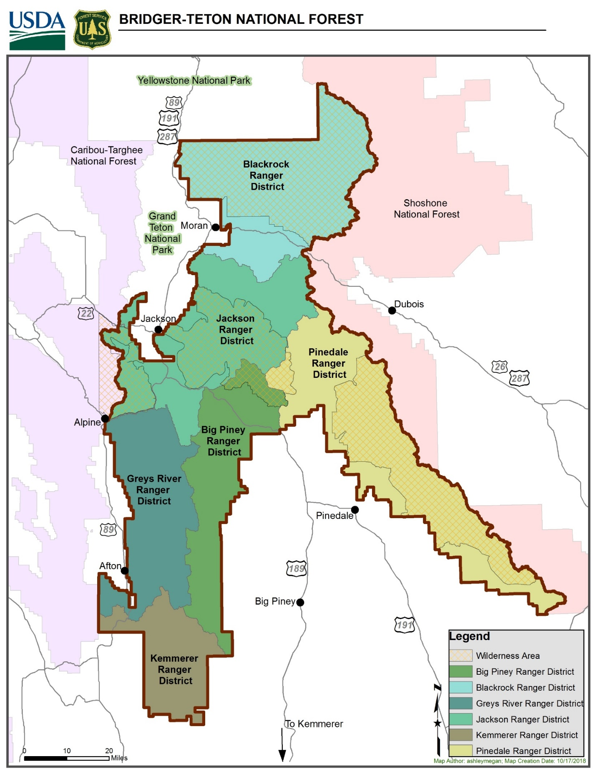

**The map shows the six duty stations on the Bridger-Teton National Forest.**