Richfield BLM Field Office
150 East 900 North
Richfield, UT 84701
Phone: 435-896-1500
and/or RIFC 435-896-8404
http://gacc.nifc.gov/gbcc/dispatch/ut-rfc/index.htm
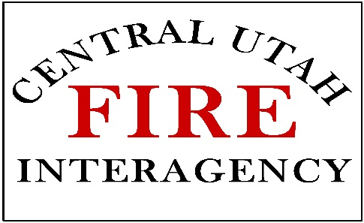

2024 CAMP CREW POSITION INFORMATION & QUALIFICATIONS
Central Utah Camp Crew Program Position Information
Camp Crew Member
- Pay Rate AD-A ($16.48/HR)
- 16 + years of age (need to be 16 years old by June 1st of the current calendar year)
- Performs various types of manual labor activities to meet incident objectives by completing various work duties and assignments during each shift, while on an incident.
- Must attend the mandatory (in person) training session.
- Needs a strong work ethic, good attitude, be accountable for your actions and quality of work,; willing to help with and work at completing numerous tasks safely, and capable of picking up and learning new skills
Crew Boss Trainee
- Pay Rate AD-C ($20.20/HR).
- 18 years of age (need to be 18 years old by June 1st of the current calendar year).
- 2 years of experience as a camp crew member or comparable work experience.
- Needs a strong work ethic, good attitude, be able to handle the pressure of being accountable and responsible for the actions and quality of work for others and yourself; willing to help with and work at completing numerous tasks safely and capable taking on new responsibilities and picking up and learning new skills.
- Provide leadership and supervision of camp crew members while performing various types of manual labor activities to obtain incident objectives; completing various work duties and assignments during each work shift while on an incident.
- Must attend the mandatory (in person) training session.
- Must complete the following ICS courses ICS-100 and IS-7000 and turn in a copy of your course completion certificate.
Crew Boss
- 21 years of age (need to be 21 years old by June 1st of the current calendar year).
- AD-D pay rate ($22.20/HR).
- 3 years of experience as a camp crew member or comparable work experience.
- Previous Supervisory skills.
- Needs a strong work ethic, good attitude, be able to handle the pressure of being accountable and responsible for the actions and quality of work for others and yourself, willing to help with and guide the work of others completing numerous tasks safely, and capable taking on new responsibilities and picking up and learning new skills.
- Provide daily leadership and supervision of camp crew members while performing various types of manual labor activities to obtain incident objectives. Must be able to organize, assign tasks, motivate, and deal with concerns and issues as they arise while completing various work duties and assignments during each work shift while on an incident.
- Must attend the mandatory (in person) training session.
- Must complete the following ICS courses ICS-100 and IS-700 and turn in a copy of your course completion certificate.

All selected participants must attend the mandatory training session for their selected position. These trainings will be scheduled and held this spring into the first part of summer. Notifications of the training sessions will be emailed to all selected personnel and posted on the Central Utah Interagency Fire webpage on the Camp Crew link.
All selected participants maybe requested to complete a background check and a drug test as pertaining to USDOI/BLM policies.

