Silver City Fire Cache (Google maps link)

To Silver City
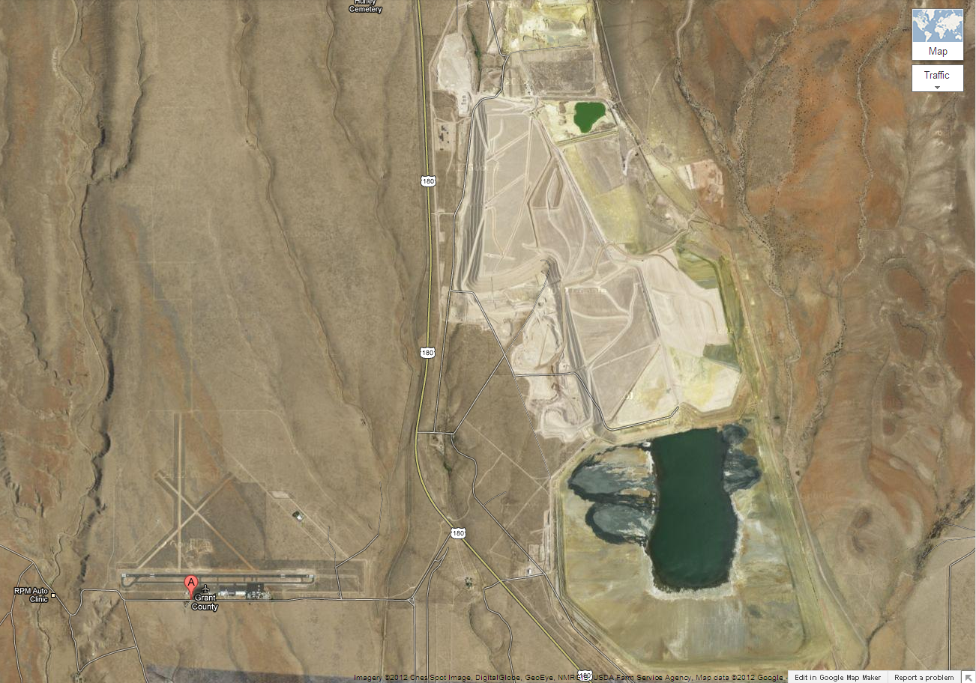
Silver City Fire Cache
158 Airport Rd

Airport Rd

