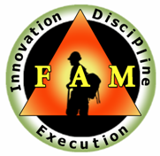
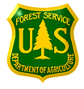
USDA Forest Service
Region 2 - Fire and Aviation Management
Advisory Board

Issue Paper

ISSUE STATEMENT:
Development and Support from Fire Management for a formal Rocky Mountain Engine Strike Team/Task Force.

SITUATION:
In the fall of 2008, the Rocky Mountain Engine Operators Committee formed a regional strike team working group with the purpose of determining the advantages of the region hosting one or two strike teams/task forces of engines.

TARGET:
The target is to have the Rocky Mountain Region host two on-call Engine Strike Teams/Task Forces, one in the north and one in the south. This would allow the fire management units within the Rocky Mountain Region an opportunity to provide national incident management teams as well as state and local extended attack organizations with highly trained, professional, agency engine resources in a strike team/task force configuration.
- A valuable and highly trained resource to meet incident objectives.
- Provide quality fire/engine experience to our firefighters
- Increase training assignments for employee/career development
- Increased communication between forests within the engine ranks

PROPOSAL:
See attached strike team proposal document

CONTACT:
Ken Watkins USFS Rocky Mountain Region Engine Committee Chair
(307) 746-2782 Ext. 3860 Office

FAMAB Disposition:

___Accept/Log-in/Date:

___Reject/Rationale:

RECOMMENDED COURSE OF ACTION:

