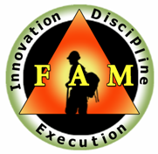
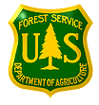
USDA Forest Service
Region 2 - Fire and Aviation Management
Advisory Board

Issue Paper

ISSUE STATEMENT:
Review, provide feedback, and approve (sign) the updated charter for the USFS Engine Committee.

SITUATION:
Need signatures on the charter from the Fire Management Units participating in the USFS Engine Committee.

TARGET:
The purpose of this committee is to provide leadership, guidance, mentorship, training, professionalism, enhance career development, and to make recommendations to fire management to ensure continuation and enhancement of a safe and professional wildland fire engine program.

PROPOSAL:
See attached document.

CONTACT:
Ken Watkins USFS Rocky Mountain Region Engine Committee Chair
(307) 746-2782 Ext. 3860 Office

FAMAB Disposition:

___Accept/Log-in/Date:

___Reject/Rationale:

RECOMMENDED COURSE OF ACTION:

