STANDARD ROSS REPORTS
HANDOUTS
table of contents

# | Title | # | Title | # | Title
1 | Buttons and Menus | 17 | Cognos Viewer Buttons | 33 | New Folder Wizard
2 | Logging On and Off | 18 | Set My Preferences 1 | 34 | New Job Wizard 1
3 | Public Folders | 19 | Set My Preferences 2 | 35 | New Job Wizard 2
4 | Filter Criteria Blocks | 20 | Set My Preferences 3 | 36 | New Job Wizard 3
5 | Required Blocks & Fields | 21 | Run with Options | 37 | New Job Wizard 4
6 | Dispatch Criteria Block | 22 | Run with Advanced Options | 38 | New Job Wizard 5
7 | Catalog Criteria Block | 23 | New Report Wizard | 39 | New Job Wizard 6
8 | Resource Criteria Block | 24 | Set Properties 1 | 40 | New Page Wizard 1
9 | Dispatch & Provider Block | 25 | Set Properties 2 | 41 | New Page Wizard 2
10 | Catalog Resource Block | 26 | Set Properties 3 | 42 | New Page Wizard 3
11 | Incident Criteria Block | 27 | Schedule Screen | 43 | New Page Wizard 4
12 | Incident Requests Block | 28 | My Activities & Schedules 1 | 44 | New Page Wizard 5
13 | Time Period Criteria Block | 29 | My Activities & Schedules 2 | 45 | ‘More…’ Link - Folders
14 | Travel Plan Criteria Block | 30 | My Activities & Schedules 3 | 46 | ‘More…’ Link – Reports
15 | External Supply Cache Block | 31 | My Activities & Schedules 4
16 | Incident Initial Year Block | 32 | My Activities & Schedules 5

Buttons and menus

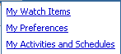 | 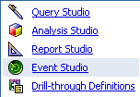 | 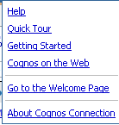

Logging on and off

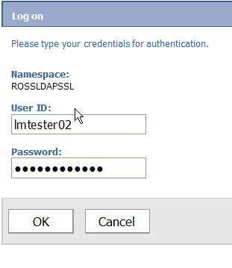

PUBLIC FOLDERS

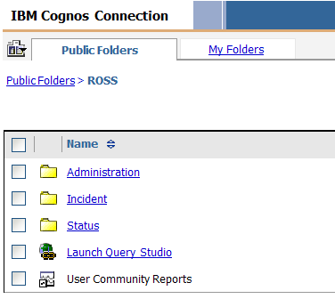

FILTER criteria blocks

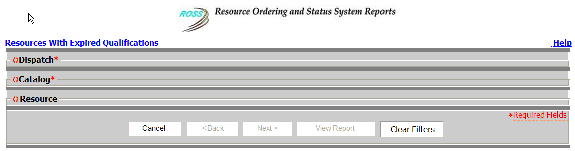

required criteria blocks and fields

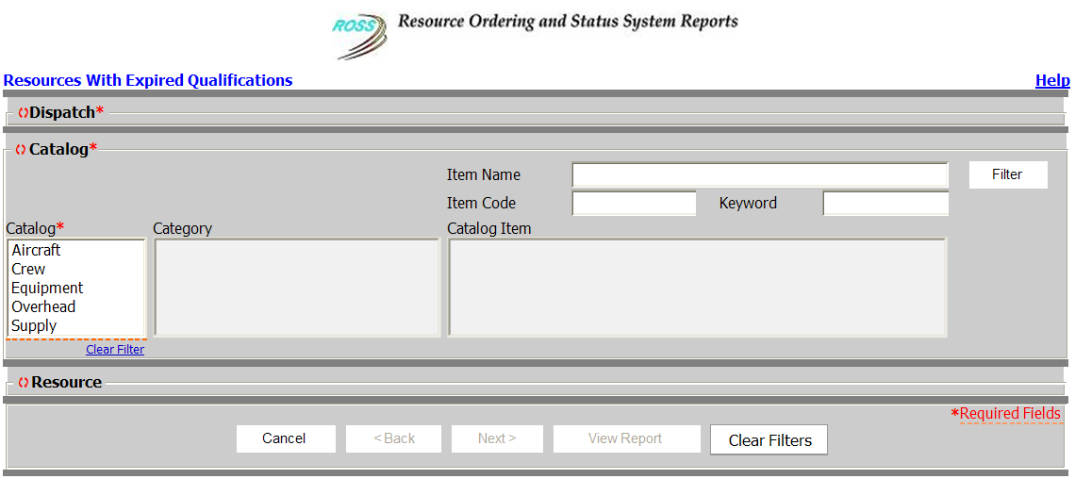

dispatch criteria block

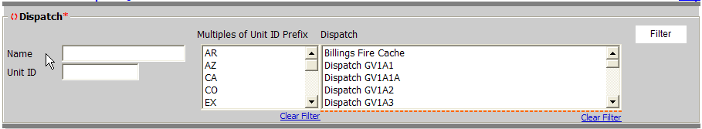
catalog criteria block

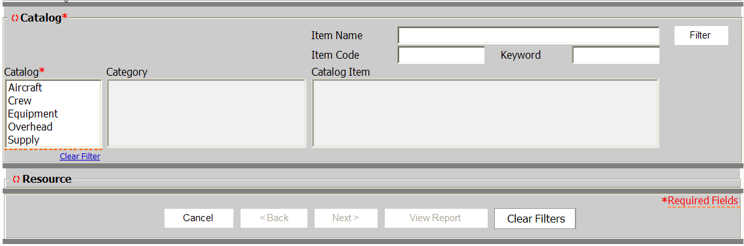
resource criteria block

dispatch and provider criteria block

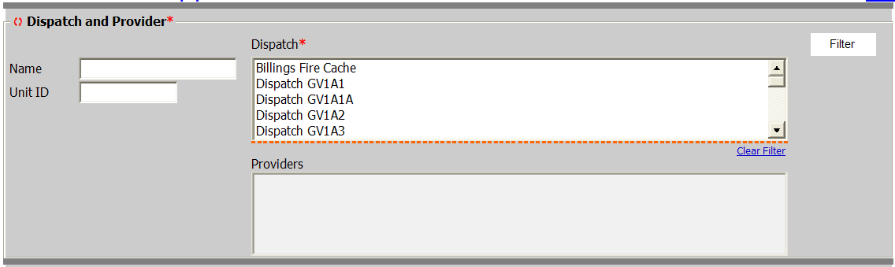
catalog resource criteria block

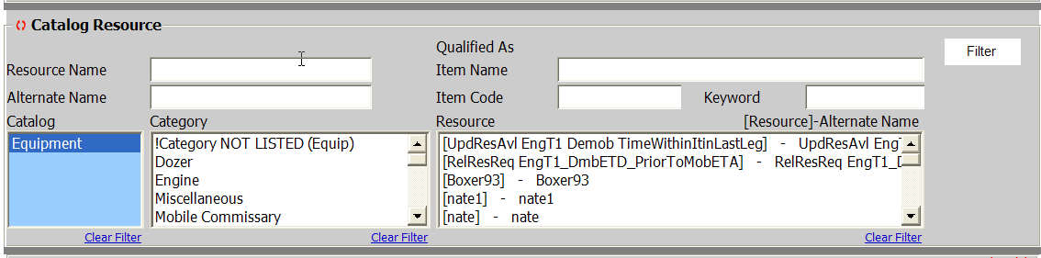
incident criteria block

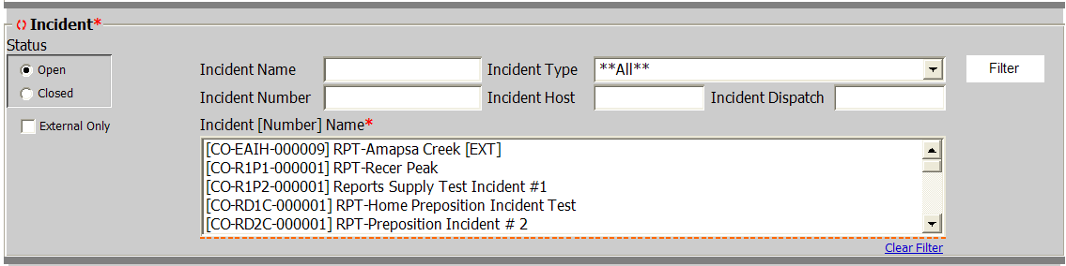
incident requests criteria block

time period criteria block

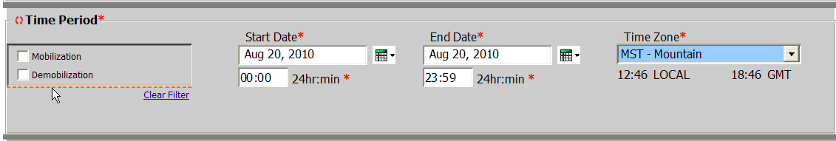
travel plan criteria block

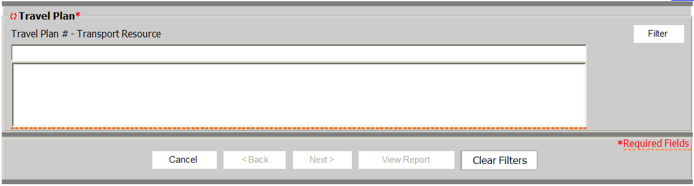
external supply cache requests criteria block

INCIDENT INITIAL YEAR criteria block

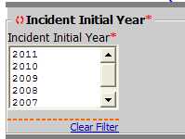

cognos viewer buttons

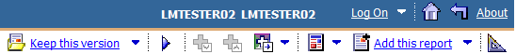

set (my) preferences screen – general tab

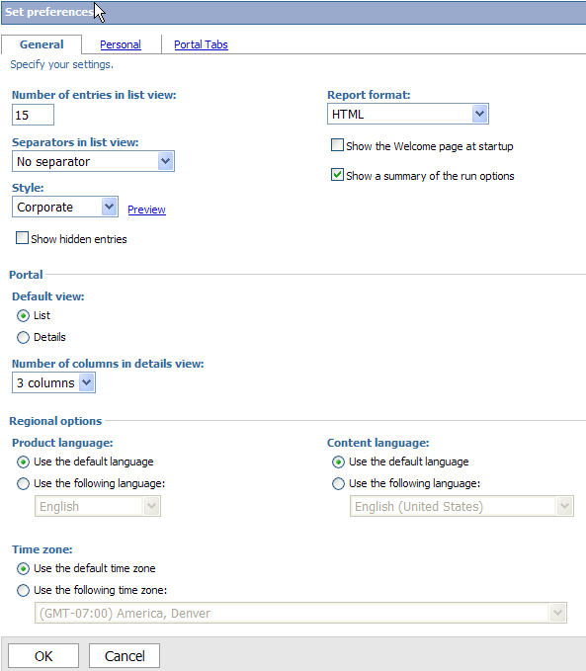
set (my) preferences screen – personal tab

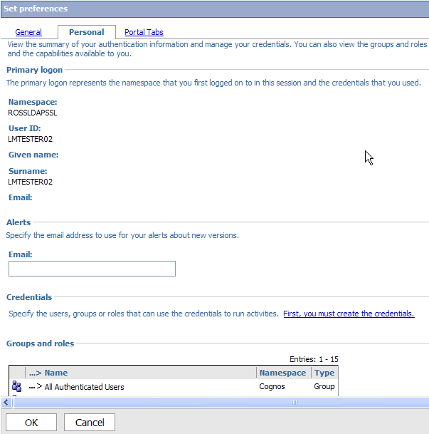
set (my) preferences screen – ‘portal tabs’ tab

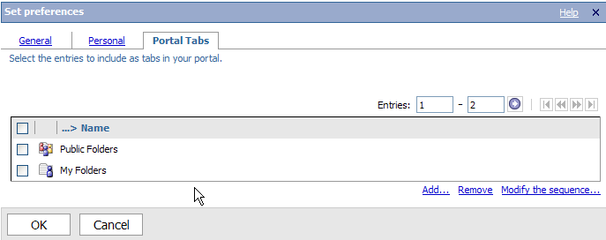

run with options

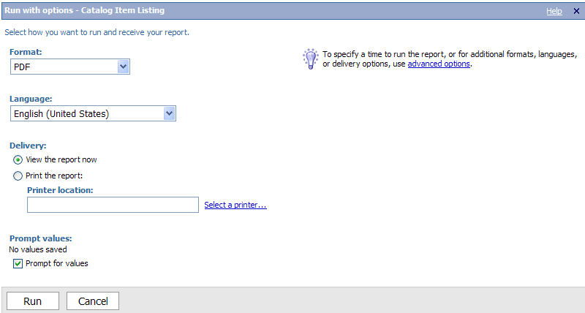
run with advanced options

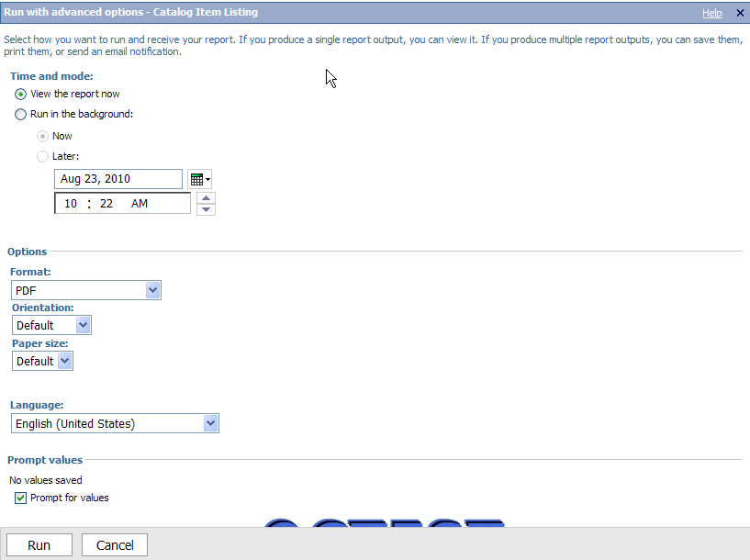

New report view wizard

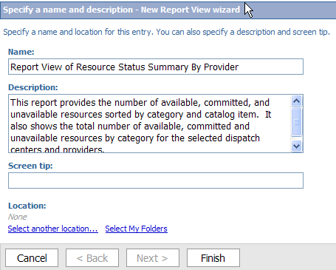
set properties screen – general tab

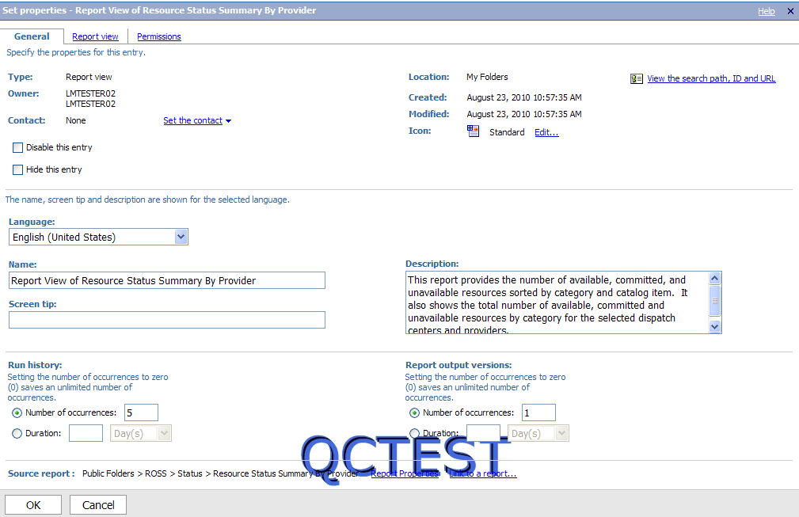
set properties screen – report view tab

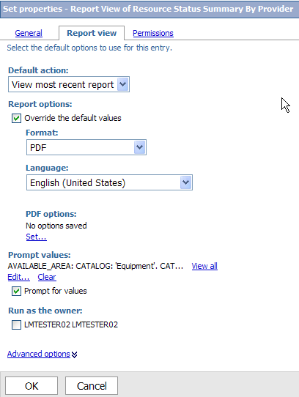
set properties screen – permissions tab

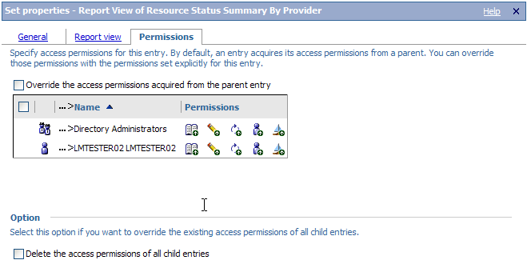

schedule screen

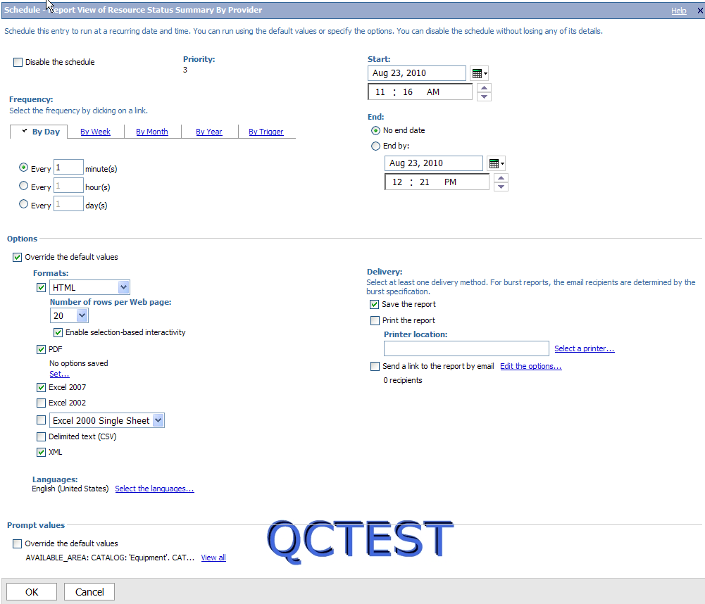
MY ACTIVITIES AND SCHEDULES screen – CURRENT activitIES tab

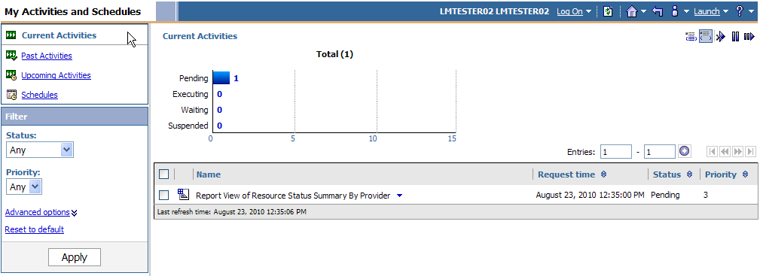

MY ACTIVITIES AND SCHEDULES screen – CURRENT activitIES tab – buttons

MY ACTIVITIES AND SCHEDULES screen – PAST activitIES tab

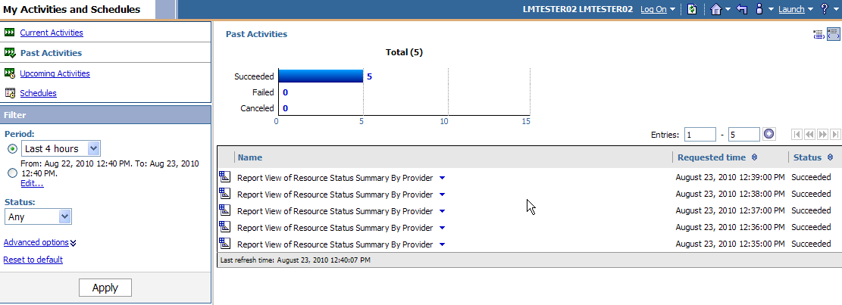
MY ACTIVITIES AND SCHEDULES screen – UPCOMING activitIES tab

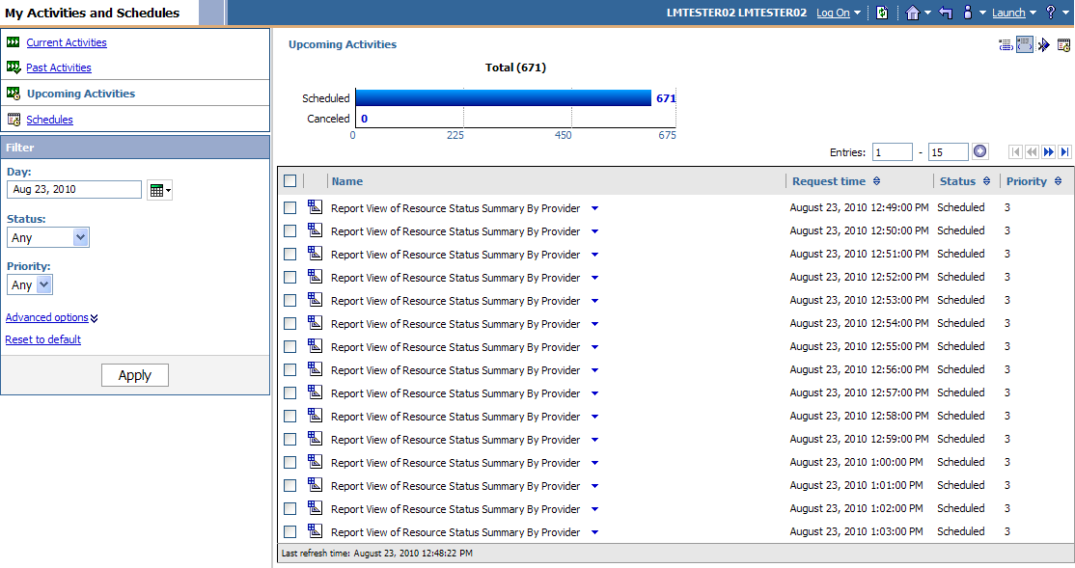
MY ACTIVITIES AND SCHEDULES screen – SCHEDULES tab

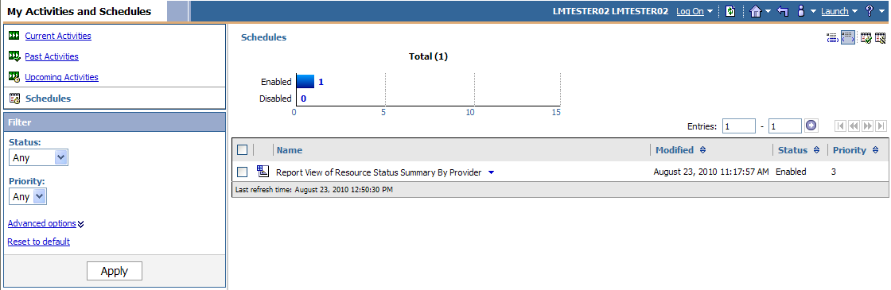

new folder wizard

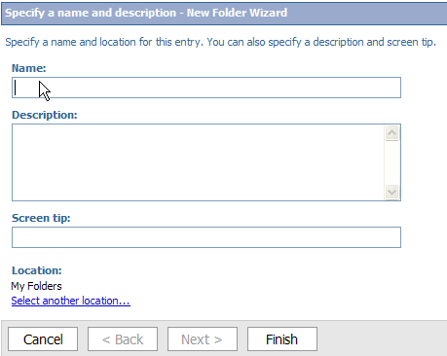

new job wizard – specify a name and description

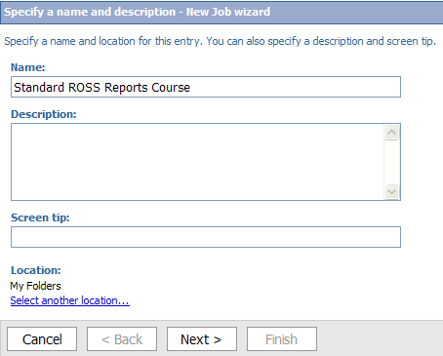

new job wizard – select the steps

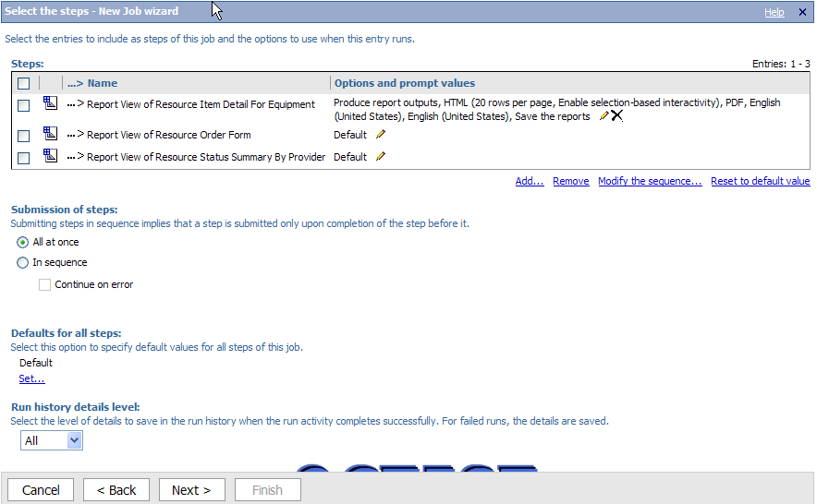
new job wizard – select entries

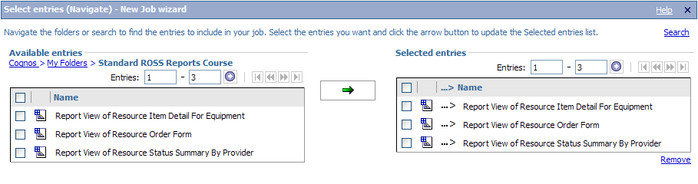

new job wizard – modify the sequence of steps

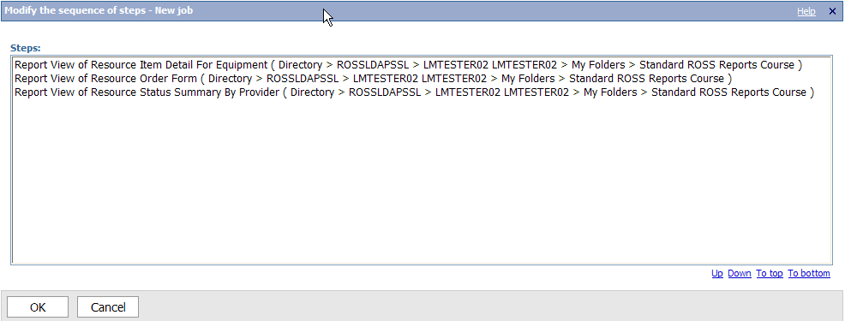

new job wizard – select the report options

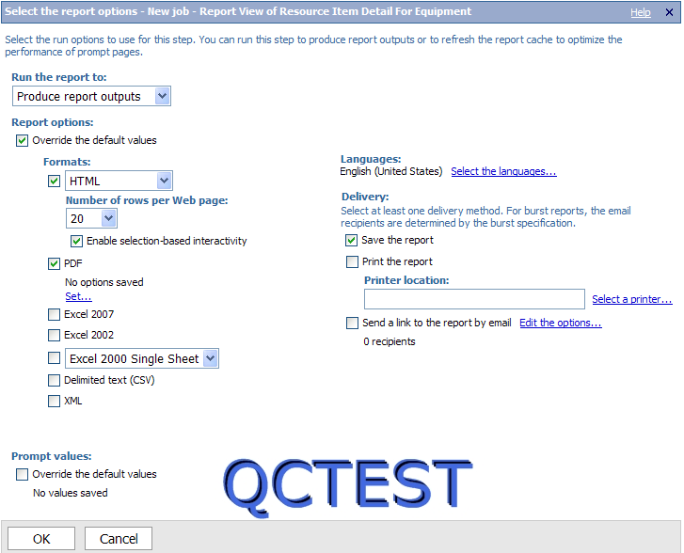
new job wizard – select an action

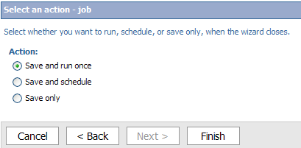

new page wizard – specify a name and description

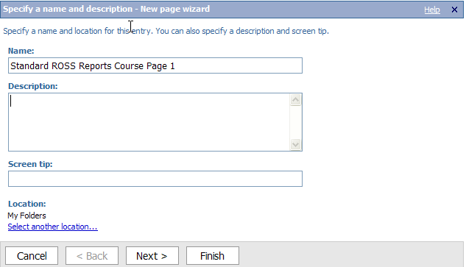
new page wizard – set columns and layouts

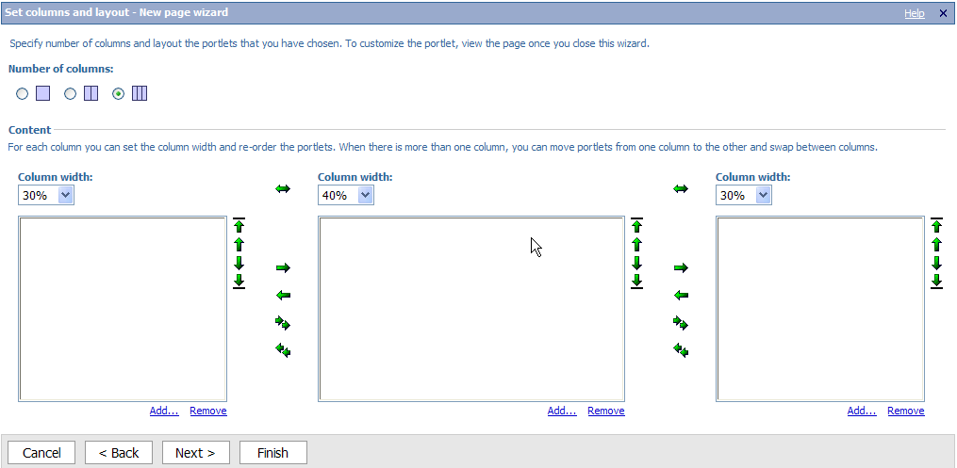
new page wizard – select portlets

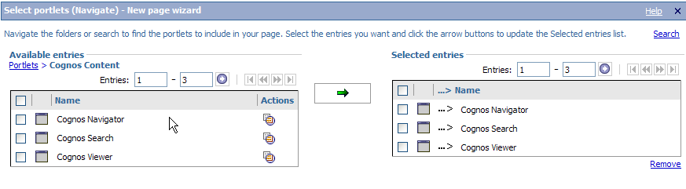
new page wizard – set page style

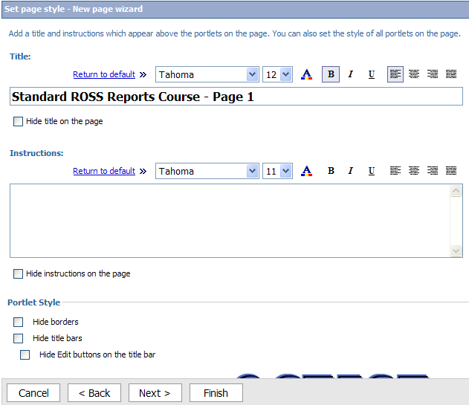
new page wizard – select an action

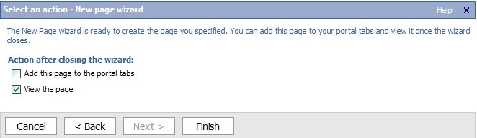

‘more…’ link for a FOLDER

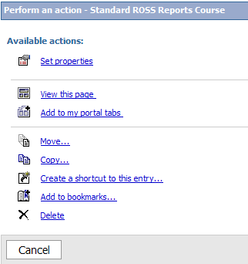

‘more…’ link for a report

