The Development of the
Project Activity Level (PAL) System

Background: An effort to review the Sale Activity Level (SAL) system began on the Plumas and Lassen National Forests in the late1990’s after a series of hot saw fires occurred. Fire records from the National Interagency Fire Management Integrated Database (NIFMID) show that from 1970 to 2004 there were 752 fires that related to timber harvest activities in California’s national forests. This does not include data from 1986 through 1993 when a change in manual direction reduced the level of detail required on agency fire reports (5100-29); however the problem was corrected in 1994. Since 1994, there have been 1,870 equipment fires documented in the NIFMID database. Of those fires, 172 were coded with a general cause of “timber harvest”, 61 as “forest and range management activities” and 51 were “harvest, other forest products”. Six of these ignitions related to these causes burned 35,334 acres and lead to suppression costs in excess of 22 million dollars.

To address the issue of industrial activity related fires, an interdisciplinary team of Fire and Aviation Management, Acquisitions, and Natural Resource Management Staffs were assembled in 2000 to review the SAL for deficiencies related to the science, technology or process. The objective of the team was to create an improved, scientifically based decision support system that could be consistently applied on all forests and which would be legally defensible.

Team findings: Industrial operations in the national forests have evolved significantly since the inception of the SAL, however the system to manage the risk associated with these operations has remained static. The current SAL system was implemented more than 20 years ago with the goal of preventing wildfires that were ignited by industrial operations on National Forest administered lands. The objective of regulating industrial operations was to avoid large, costly and damaging wildfires that were occurring as a result of these activities. The SAL process was developed using just two fire behavior variables and does not address fire danger over larger geographic areas. SAL uses the relationship between wind speed and the 10-hour fuel stick moisture (measured) to index the potential fire behavior. These fire behavior variables react strongly to day-to-day fluctuations in the local environment but do not reflect seasonal trends.

The ID team identified several weaknesses in the SAL system, including:

- The scientific foundation used in the development of SAL is limited and outdated
- The Region lacks the documentation on how SAL was developed
- SAL is not an indicator of fire danger at a landscape level and reflects only two site specific fire behavior characteristics
- SAL fails to consider seasonal trends such as drought, green-up or curing of fuels
- Large and damaging fires were occurring at low SAL levels

Other issues identified by the team included:

- Changes have occurred in forest health and the types of industrial operations, including how vegetation is processed, since SAL was developed
  - The types of equipment used by industry have changed (hot saws, mastication)
  - Declining forest health due to stand densification, disease, insect infestation, climate change and past fire suppression policies have increased fire risk
  - An increased management risk has resulted from escalating operations near the wildland urban interface/intermix.

- Changing technology
  - Contractually SAL requires that a 10-hour fuel stick be manually measured at an approved weather station each day.
    - Collecting the data and maintaining these stations is costly, makes inefficient use of personnel, and in the event of a fire, these weather stations may not be staffed, therefore no data is collected.
  - The manually operated weather stations have mostly been phased out and replaced by Remote Automated Weather Stations (RAWS) to provide standardization and consistent data collection. The weather data collected by the RAWS is used to produce National Fire Danger Rating outputs used to guide daily fire management decision processes.
  - Fuel moisture calculations are different
    - Fuel moisture values calculated in the National Fire Danger Rating System (NFDRS) processor and in the RAWS data collection software differs from the manually weighed fuel stick. The three are not equivalent.

Development of the Project Activity Level (PAL) System: Rather than revamp SAL, the interdisciplinary team determined an updated decision support tool was needed to improve the regulation of all contracted industrial operation activities on National Forest lands in California. A system based on NFDRS was selected due to the use of NFDRS to manage other fire business activities such as suppression staffing, forest closures, fire restrictions and pre-positioning of fire resources. The team’s objective was to:
- Give industrial operators opportunities to work with maximum flexibility in order to get critical work done and limit economic impacts
- Reduce the risk of large and damaging wildfires that had been associated with industrial activities
- Create a decision support tool which was scientifically based for regulatory purposes. This tool was to be defensible in court.

Key elements of the new system as developed by the team included:

- Predicted and actual outputs similar to SAL
- Utilization of standard NFDRS outputs - Energy Release Component (ERC) and Ignition Component (IC)

- NFDRS outputs calculated using the 1978 NFDRS Fuel Model G
- A single decision support matrix would be developed for Region-wide application
- The final product would be incorporated into WIMS
- The system would utilize thresholds for operational restrictions based on potential fire activity
- The analysis process would utilize:
  - Equipment related fires on each of the forests in California taken from fire reports (Individual Fire Report, Form 5100-29). Data is stored in NIFMID.
  - Weather data from the stations identified as belonging to the year-round network from each of the National Forests. (Forest Service Manual 5100, Region 5 Supplement 5125.12, 1995). Data is stored in NIFMID.
  - FireFamily Plus (fire danger analysis program) to calculate the historic ERC and IC values and link them to historic fire occurrence data.
  - EXCEL Spreadsheet to study how the ERC and IC values related to fire activity and size class, and calculate how often each of the PAL levels occurred at a particular weather station.

The analysis was accomplished by Beth Little (RAWS Coordinator, Region 5), Russ Gripp (Fire Management Specialist, Northern Province, Region 5), Larry Bradshaw (Meteorologist, Intermountain Fire Sciences Laboratory), and Jason Gripp (software development and computer support).

The “thresholds of concern" that define the different Project Activity Levels, are part pure science, using climate and fire history data; and part social science, encompassing elements of risk management. In developing the thresholds, the objective was to balance the risk of large, costly and damaging fires with attempting to meet industries need for operating windows. Figure 1 is used to explain how the “threshold of concern” was developed for one PAL. The complete analysis of thresholds, the numbers of fires and NFDRS components are included as Appendix A.

Figure 1. 1,000 Acre and Larger (Class F & G) Equipment Fires, R5 - 1972 – 2000
 |  |  |  |  |  |  |  |  |  |  |  | ERC | Ignitions
 |  |  |  |  |  |  |  |  |  |  |  | 0 - 10 | 0
 |  |  |  |  |  |  |  |  |  |  |  | 11 - 20 | 0
 |  |  | 1 | 1 |  |  |  |  |  |  |  | 21 - 30 | 2
 |  |  |  | 3 | 1 |  |  |  |  |  |  | 31 - 40 | 4
 |  | 1 |  | 2 | 3 | 1 |  |  |  |  |  | 41 - 50 | 7
 |  |  | 1 | 3 | 6 | 2 | 2 | 2 |  |  |  | 51 - 60 | 16
 |  |  | 1 | 1 | 3 | 3 | 3 | 2 | 1 | 2 |  | 61 - 70 | 16
 |  |  |  |  | 2 |  | 1 |  |  |  |  | 71 - 80 | 3
 |  |  |  |  |  | 1 | 2 |  |  |  |  | 81 - 90 | 3
 |  |  |  |  |  |  |  |  |  |  |  | 91 - 100 | 0
 |  |  |  |  |  |  |  |  |  |  |  | > 100 | 0
IC | 0 - 10 | 11 - 20 | 21 - 30 | 31 - 40 | 41 - 50 | 51 - 60 | 61 - 70 | 71 - 80 | 81 - 90 | 90 - 100
Ignitions | 0 | 1 | 3 | 10 | 15 | 7 | 8 | 4 | 1 | 2 |  |  | 51

In the Figure 1 example, there is a clear increase in the number of class F and G fires at an ERC class of 51-60. When Ignition Component is analyzed, a clear increase is seen at an IC class of 31-40. However, the threshold of concern was shifted to a higher IC class as the ID team viewed a threshold that began at an IC of 31 as being to restrictive on industrial operations. The shift of the threshold to a higher IC is acceptance of additional risk of a large fire by the agency and represents the social science portion of PAL.

A similar process of science and rational decision making was used in the development of all thresholds. Error: Reference source not foundThe goal of the team was to balance fire risk with the need to get work done. The thresholds provide managers with guidance in making decisions based on science while balancing fire risk.

The addition of the site specific variance, the “variance range or Ev”, and its placement on the matrix was a decision made by the ID team to allow agency managers to evaluate specific operations and through appropriate fire danger mitigation actions, authorize operations. The use of the variance allows for professional judgment to be involved in the decision process and was an attempt to provide the greatest possible operational window to industry. The variance region was placed at the lower end of the shut-down range.

The PAL variance procedures initially allowed for continued operations until 1:00 PM when appropriate mitigations were used for specific project sites during PAL “Ev” days. This was later expanded to allow the variance process to be utilized on “B’, “C”, and “D” days. The variance checklist, the methodology used to evaluate site specific conditions, is attached as Appendix B.

Initially the variance region of the matrix was constrained to a small region, Figure 2.

Figure 2. Matrix Variance Region (February 2003 version)
ERC/IC | 0-10 | 11-20 | 21-30 | 31-40 | 41-50 | 51-60 | 61-70 | 71-80 | 81-90 | 91- 100
0 - 10 | A | A | A | B | C | C | C | C | C | C
11 - 20 | A | A | B | B | C | C | C | C | C | C
21 - 30 | A | B | B | B | C | D | D | D | D | D
31 - 40 | A | B | C | C | C | D | D | D | D | D
41 - 50 | B | B | C | D | D | D | D | D | D | D
51 - 60 | B | B | C | D | D | Ev | Ev | E | E | E
61 - 70 | B | B | C | D | D | Ev | Ev | E | E | E
71 - 80 | B | B | C | D | D | Ev | Ev | E | E | E
81 - 90 | C | C | C | D | D | E | E | E | E | E
91 - 100 | C | C | C | D | D | E | E | E | E | E
> 100 | C | C | C | D | D | E | E | E | E | E

Industry feedback over the last three years and negotiation with the agency lead to the expansion of the variance region. The expanded variance region, Figure 3, creates the current approved matrix. This most recent version of the matrix (February 2004) increases the number of potential operating windows by inclusion of both higher ERC and IC in the variance region. The modification of the matrix shifts a greater level of risk to the local line officer and fire staff and requires that specific environmental conditions on the job site be evaluated via the variance checklist to help mitigate this risk.

This modification of the PAL matrix has been synchronized with the service contract fire plan and timber sale C-provisions.

Figure 3. Project Activity Level Matrix (February 2004 Version)
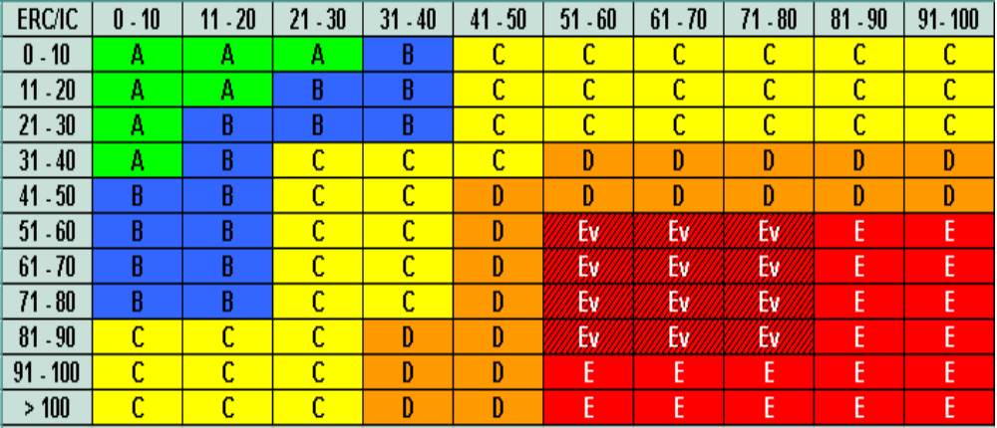

The increasing impacts in recent years of Limited Operating Periods (LOP) not related to fire danger have exacerbated the impacts of PAL on industrial operations. LOP are normally associated with either environmental (weather) or biological (nesting periods) time periods. The limits on operations created by these environmental and biological constraints have moved allowable work periods into the hottest, driest parts of the summer. This late summer operating period is the period most constrained by PAL.

The PAL matrix that exists today while based on climate and fire data, also evolved through negotiation with forest industry and agency line officers. One of the evolutions of the matrix that addressed industry concerns was the development of a new level of regulation at the upper left portion of the matrix. This “cool” end of the fire danger continuum created the “A” Project Activity Level, where “watchman” requirements are not placed on the operator. This results in a cost saving to industrial operators during environmental conditions that present limited risk of large fire development to the agency line officer. Appendix C shows the six evolutions of the matrix.

Comparisons of PAL vs. SAL:

- PAL is a fire danger rating-climatologic based system; SAL is a system based on two fire behavior variables
- PAL considers the effects of weather conditions during the last 30-45 days and is less sensitive to daily fluctuations; SAL considers the previous 24 hours.
- PAL considers seasonal trends, including drought; SAL does not
- PAL reflects the growth in the science of fire danger rating, utilizing contemporary computer and telemetry technologies. SAL is built on dated technology and does not integrate with other fire business management practices that use NFDRS as a decision tool.
- PAL considers weather, topography and a full range of fuel moisture conditions for both live and dead fuels. SAL considers wind speed and a single dead fuel moisture

During the 2003 field season, the Regional Forester requested a comparative analysis of the two systems be accomplished using data from Oak Knoll (KNF), Bogard (LNF) and Mt Elizabeth (STF). The results from this comparison are presented in Figures 4 through 7.
Figure 4. SAL vs. PAL - Oak Knoll - July 1 – October 31, 2003
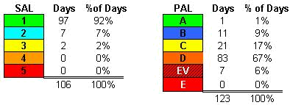

Figure 5. SAL vs. PAL - Mt Elizabeth - July 1 – October 31, 2003

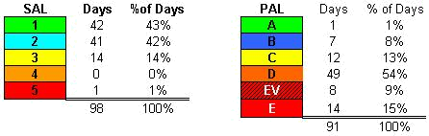

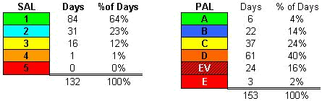
Figure 6. SAL vs. PAL – Bogard - July 1 – October 31, 2003

The analysis confirmed, given the same weather conditions, PAL produces more “hoot owl” and “shutdown” days than SAL.

PAL Analysis Review: The PAL system was reviewed by John Deeming in March 2002. Mr. Deeming was the principle developer of the Industrial Fire Precautions Level system for Oregon and Washington. He approved of the team’s approach and level of analysis; in particular he liked the matrix.

PAL was also presented to the National Wildfire Coordinating Group (NWCG) Fire Danger Working Team in June 2002. The group approved of the process and the level of analysis. Additionally, Jerry Westfall, Tahoe National Forest, presented an analysis of the variance process to the Regional Forester in March 2005. This analysis indicated that there
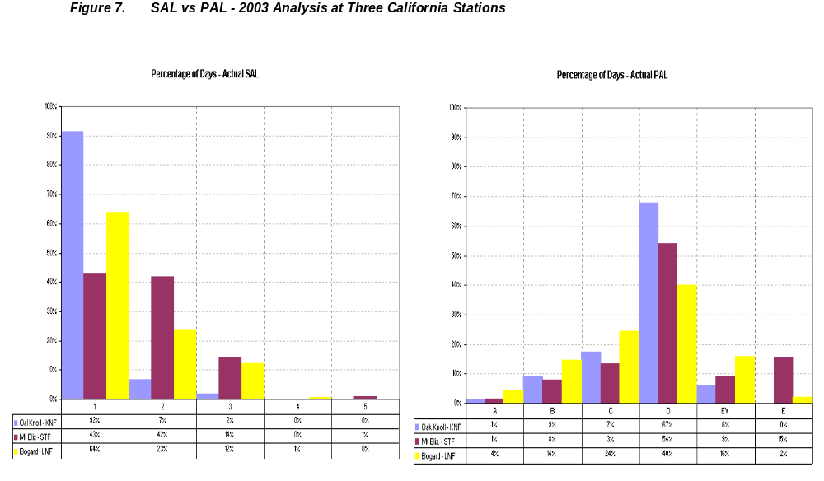
are not a substantial loss in operating days for industrial operations.

After careful consideration Regional Forester Jack Blackwell decided to implement PAL in his letter of June 2, 2005.

Conclusions: The PAL system uses the accepted interagency fire danger model that represents the interaction between fuels, weather, topography, and fire occurrence. The use of NFDRS principles into land management decision making is a logical extension of this program. It is incumbent on the agency to assure that maintenance of their RAWS is up to standard and that the aggregation (if any) of the stations used to develop the PAL is logical.

The PAL has been compared and analyzed against the past SAL. The PAL process provides an integrated decision support mechanism for forest managers. The integration of RAWS technologies with the NFDRS systems provides a scientific basis for the regulation of activities that have the potential for igniting wildland fire during adverse fire danger.

Finally, the PAL process has been modified to provide for greater operating periods while insuring that fire potential regarding ignition and spread is properly mitigated. The interdisciplinary team working with industry has made adjustments to the PAL matrix, the variance process, procurement contracts and the C-provisions in the timber sale contracts to provide the greatest possible operating opportunities while still managing the risk and potential damage associated with large wildfires.

Appendix A – Critical Threshold Development

Summary of 1000 Acre and Larger (Class F & G) Equipment Fires
Region Five, 1972 - 2000 (Calculated at the year around station(s) on each Forest).
 |  |  |  |  |  |  |  |  |  |  |  | ERC | Ignitions
 |  |  |  |  |  |  |  |  |  |  |  | 0 - 10 | 0
 |  |  |  |  |  |  |  |  |  |  |  | 11 - 20 | 0
 |  |  | 1 | 1 |  |  |  |  |  |  |  | 21 - 30 | 2
 |  |  |  | 3 | 1 |  |  |  |  |  |  | 31 - 40 | 4
 |  | 1 |  | 2 | 3 | 1 |  |  |  |  |  | 41 - 50 | 7
 |  |  | 1 | 3 | 6 | 2 | 2 | 2 |  |  |  | 51 - 60 | 16
 |  |  | 1 | 1 | 3 | 3 | 3 | 2 | 1 | 2 |  | 61 - 70 | 16
 |  |  |  |  | 2 |  | 1 |  |  |  |  | 71 - 80 | 3
 |  |  |  |  |  | 1 | 2 |  |  |  |  | 81 - 90 | 3
 |  |  |  |  |  |  |  |  |  |  |  | 91 - 100 | 0
 |  |  |  |  |  |  |  |  |  |  |  | > 100 | 0
IC | 0 - 10 | 11 - 20 | 21 - 30 | 31 - 40 | 41 - 50 | 51 - 60 | 61 - 70 | 71 - 80 | 81 - 90 | 90 - 100
Ignitions | 0 | 1 | 3 | 10 | 15 | 7 | 8 | 4 | 1 | 2 |  |  | 51

Summary of 100 acre to 1000 acre (Class D & E) Equipment fires
Region Five, 1972 – 2000 (Calculated at the year around station(s) on each Forest).
 |  |  |  |  |  |  |  |  |  |  |  | ERC | Ignitions
 |  |  |  |  |  |  |  |  |  |  |  | 0 - 10 | 0
 |  |  |  |  |  |  |  |  |  |  |  | 11 - 20 | 0
 |  | 1 | 3 | 2 |  |  |  |  |  |  |  | 21 - 30 | 6
 |  | 1 |  | 4 |  |  |  |  |  |  |  | 31 - 40 | 5
 |  | 2 |  | 4 | 2 | 2 |  |  |  |  |  | 41 - 50 | 10
 |  |  | 2 | 5 | 6 | 3 | 1 | 1 |  |  |  | 51 - 60 | 18
 |  |  | 1 | 4 | 3 | 3 | 5 |  | 2 |  |  | 61 - 70 | 18
 |  |  | 1 |  | 4 |  | 2 |  | 2 | 1 |  | 71 - 80 | 10
 |  |  |  |  |  | 1 | 2 |  |  |  |  | 81 - 90 | 3
 |  |  |  |  |  | 1 | 1 |  | 1 | 1 |  | 91 - 100 | 4
 |  |  |  |  |  |  |  |  |  |  |  | > 100 | 0
IC | 0 - 10 | 11 - 20 | 21 - 30 | 31 - 40 | 41 - 50 | 51 - 60 | 61 - 70 | 71 - 80 | 81 - 90 | 90 - 100
Ignitions | 0 | 4 | 7 | 19 | 15 | 10 | 11 | 1 | 5 | 2 |  |  | 74

Summary of 10 acre to 100 acre (Class C) Equipment Fires
Region Five, 1972 – 2000 (Calculated at the year around station(s) on each Forest).
 |  |  |  |  |  |  |  |  |  |  |  | ERC | Ignitions
 |  |  |  |  |  |  |  |  |  |  |  | 0 - 10 | 0
 |  |  |  |  |  |  |  |  |  |  |  | 11 - 20 | 0
 | 1 | 1 | 1 |  | 1 |  | 1 |  |  |  |  | 21 - 30 | 5
 |  | 2 | 8 | 7 | 5 |  |  |  |  | 1 |  | 31 - 40 | 23
 | 1 |  | 6 | 12 | 13 | 3 |  |  | 1 |  |  | 41 - 50 | 36
 |  |  | 2 | 9 | 10 | 9 | 4 |  |  |  |  | 51 - 60 | 34
 | 1 |  |  | 3 | 4 | 7 | 6 | 1 | 1 |  |  | 61 - 70 | 23
 |  |  | 1 | 2 | 2 | 5 | 5 | 11 | 2 | 1 |  | 71 - 80 | 29
 |  |  |  |  | 1 |  |  |  | 1 |  |  | 81 - 90 | 2
 |  |  |  |  |  |  |  | 1 |  |  |  | 91 - 100 | 1
 |  |  |  |  |  |  |  |  |  |  |  | > 100 | 0
IC | 0 - 10 | 11 - 20 | 21 - 30 | 31 - 40 | 41 - 50 | 51 - 60 | 61 - 70 | 71 - 80 | 81 - 90 | 90 - 100
Ignitions | 3 | 3 | 18 | 33 | 36 | 24 | 16 | 13 | 5 | 2 |  |  | 153

Summary of 0.25 acre 10 acre (Class B) Equipment Fires
Region Five, 1972 – 2000 (Calculated at the year around station(s) on each Forest).
 |  |  |  |  |  |  |  |  |  |  |  | ERC | Ignitions
 | 1 | 1 |  |  |  |  |  |  |  |  |  | 0 - 10 | 2
 | 1 | 3 | 3 |  |  |  |  |  |  |  |  | 11 - 20 | 7
 | 3 | 11 | 5 | 3 |  |  |  |  |  |  |  | 21 - 30 | 22
 | 4 | 13 | 31 | 16 | 8 |  |  |  |  |  |  | 31 - 40 | 72
 | 2 | 11 | 39 | 42 | 28 | 16 | 3 |  | 1 |  |  | 41 - 50 | 142
 | 2 | 3 | 22 | 41 | 58 | 38 | 16 | 1 | 1 |  |  | 51 - 60 | 182
 | 1 | 2 | 12 | 29 | 48 | 35 | 24 | 13 | 4 |  |  | 61 - 70 | 168
 |  |  | 1 | 15 | 18 | 16 | 22 | 26 | 5 | 2 |  | 71 - 80 | 105
 |  |  |  |  | 7 | 10 | 8 | 2 | 3 |  |  | 81 - 90 | 34
 |  |  |  |  |  |  | 1 |  |  |  |  | 91 - 100 | 1
 |  |  |  |  |  |  |  |  |  |  |  | > 100 | 0
IC | 0 - 10 | 11 - 20 | 21 - 30 | 31 - 40 | 41 - 50 | 51 - 60 | 61 - 70 | 71 - 80 | 81 - 90 | 90 - 100
Ignitions | 14 | 44 | 113 | 150 | 167 | 115 | 74 | 42 | 14 | 2 |  |  | 735

Summary of 0 to 0.25 acre (Class A) equipment fires
Region Five, 1972 – 2000, (Calculated at the year around station(s) on each Forest).
 |  |  |  |  |  |  |  |  |  |  |  | ERC | Ignitions
 | 3 | 3 | 2 | 1 |  |  |  |  |  |  |  | 0 - 10 | 9
 | 5 | 8 | 7 |  | 1 |  |  |  |  |  |  | 11 - 20 | 21
 | 13 | 29 | 33 | 17 | 1 |  |  |  |  |  |  | 21 - 30 | 93
 | 11 | 52 | 92 | 42 | 19 | 5 |  | 1 |  |  |  | 31 - 40 | 222
 | 13 | 45 | 110 | 117 | 94 | 28 | 9 | 2 |  |  |  | 41 - 50 | 418
 |  | 20 | 81 | 118 | 156 | 83 | 48 | 11 | 2 |  |  | 51 - 60 | 519
 | 1 | 4 | 32 | 56 | 121 | 106 | 68 | 29 | 19 | 1 |  | 61 - 70 | 437
 |  | 1 | 15 | 26 | 54 | 64 | 70 | 45 | 23 | 10 |  | 71 - 80 | 308
 |  |  | 2 | 2 | 17 | 29 | 23 | 17 | 9 | 10 |  | 81 - 90 | 109
 |  |  |  |  | 3 | 2 | 1 | 1 | 2 | 3 |  | 91 - 100 | 12
 |  |  |  |  |  |  |  |  |  |  |  | > 100 | 0
IC | 0 - 10 | 11 - 20 | 21 - 30 | 31 - 40 | 41 - 50 | 51 - 60 | 61 - 70 | 71 - 80 | 81 - 90 | 90 - 100
Ignitions | 46 | 162 | 374 | 379 | 466 | 317 | 219 | 106 | 55 | 24 |  |  | 2148

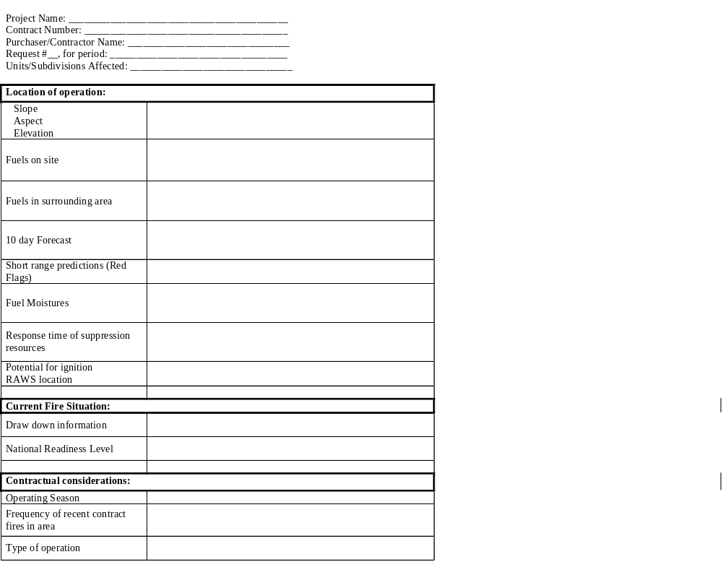
Appendix B – Project Activity Level Variance Checklist
Appendix C. PAL Matrix Evolution

Initial matrix as proposed after review of fire, climate and NFDRS data
ERC//IC | 0 - 10 | 11 - 20 | 21 - 30 | 31 - 40 | 41 - 50 | 51 - 60 | 61 - 70 | 71 - 80 | 81 - 90 | 91- 100
0 - 10
11 - 20
21 - 30
31 - 40
41 - 50
51 - 60
61 - 70
71 - 80
81 - 90
91 - 100
> 100

January 31, 2002 Version
ERC//IC | 0 - 10 | 11 - 20 | 21 - 30 | 31 - 40 | 41 - 50 | 51 - 60 | 61 - 70 | 71 - 80 | 81 - 90 | 91- 100
0 - 10
11 - 20
21 - 30
31 - 40
41 - 50
51 - 60
61 - 70
71 - 80
81 - 90
91 - 100
> 100

February 2, 2002 Version
ERC/IC | 0 - 10 | 11 - 20 | 21 - 30 | 31 - 40 | 41 - 50 | 51 - 60 | 61 - 70 | 71 - 80 | 81 - 90 | 91- 100
0 - 10
11 - 20
21 - 30
31 - 40
41 - 50
51 - 60
61 - 70
71 - 80
81 - 90
91 - 100
> 100

February 28, 2002 Version
ERC/IC | 0 - 10 | 11 - 20 | 21 - 30 | 31 - 40 | 41 - 50 | 51 - 60 | 61 - 70 | 71 - 80 | 81 - 90 | 91- 100
0 - 10
11 - 20
21 - 30
31 - 40
41 - 50
51 - 60
61 - 70
71 - 80
81 - 90
91 - 100
> 100

January 7, 2003 Version – Introduction of 5th Class and Variance Region
ERC/IC | 0 - 10 | 11 - 20 | 21 - 30 | 31 - 40 | 41 - 50 | 51 - 60 | 61 - 70 | 71 - 80 | 81 - 90 | 91- 100
0 - 10
11 - 20
21 - 30
31 - 40
41 - 50
51 - 60
61 - 70
71 - 80
81 - 90
91 - 100
> 100

February 2, 2004 Version – Includes Expansion of Variance Region
ERC/IC | 0 - 10 | 11 - 20 | 21 - 30 | 31 - 40 | 41 - 50 | 51 - 60 | 61 - 70 | 71 - 80 | 81 - 90 | 91- 100
0 - 10
11 - 20
21 - 30
31 - 40
41 - 50
51 - 60
61 - 70
71 - 80
81 - 90
91 - 100
> 100

The NFDRS provides the technical basis for establishing short and medium range fire presuppression decisions. NFDRS characterizes fire danger by evaluating the approximate upper limit of containment problems associated with wildfires occurring on a fire danger rating area during a 24-hour period. This is based on weather, topography and fuels. NFDRS is a decision support tool.
ERC is an estimate of the potential energy released in the flaming zone of the fire. It can be viewed as a number relating to how dry the fuels are. The ERC traces the seasonal trends in fire danger, rather than short term fluctuations. ERC can capture the effects drought, curing, green-up and precipitation on fuels.
IC is the probability of having an ignition that will spread to the point that it would require a management action. It considers the probability of ignition, which is sensitive to daily changing conditions such as air temperature, fuel temperature, relative humidity, and cloudiness and the NFDRS spread component. The SC is sensitive to percent slope, wind speed and fine fuel moisture. An IC of 45 indicates that potentially 45 out of 100 firebrands may start new fires requiring management action.
Fuel Model G is used for dense conifer stands where there is a heavy accumulation of litter and down woody material. Stands are typically over mature and may also be suffering insect, disease, and wind or ice damage. The duff and litter are deep and much of the woody material is more than three inches in diameter. The undergrowth is variable, but shrubs are usually restricted to openings. Fire researchers and NFDRS practitioners have found that this fuel model correlates the relationship between fire occurrence and fire danger outputs very well, and it produces replicable results irrespective of local vegetation types.
John Deeming, co-authored The National Fire-Danger Rating System – 1978.
NWCG Fire Danger Working Group is made up of federal and State forestry agencies committed to advancing the science and application of fire danger rating.

