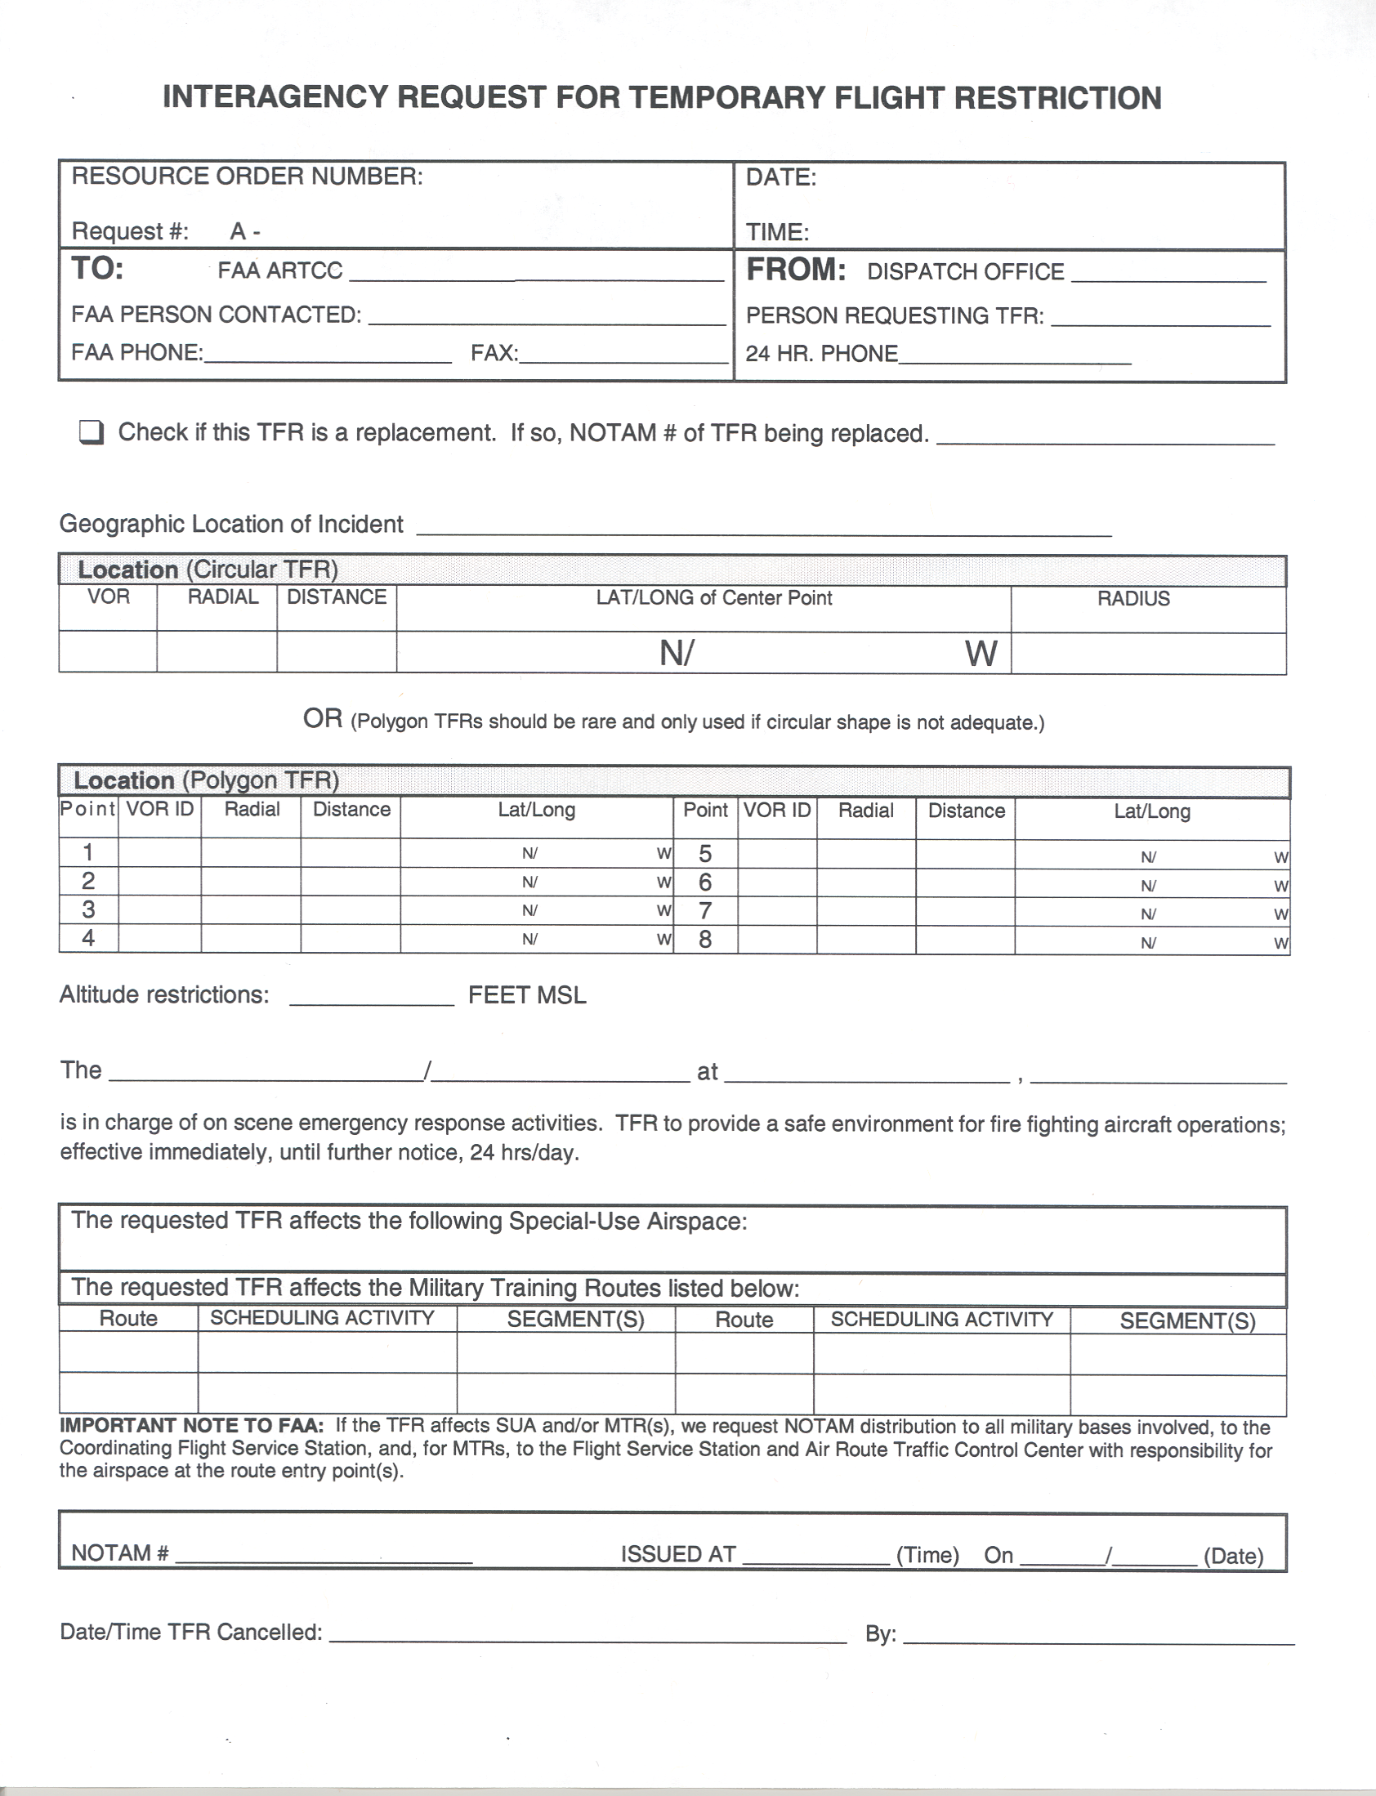
Agnecy Name Incident Name Phone Number Frequency

