Northern Rockies GACC Instructions for posting documents to the ftp.nifc.gov ftp site
All Northern Rockies data for the 2012 fire season will be filed underneath: ftp://ftp.nifc.gov/Incident_Specific_Data/N_ROCKIES
Data on the ftp site identified above is accessible for everyone to view or read without a password for all folders except the GACC_Support folder, which is intended specifically for secure information such as IAPs or Contracts. Except for the GACC_Support folder, anyone can download or copy data from the ftp site without need of a password.
To PUT non-secure data on the site in any of the folders underneath the N_ROCKIES folder except for the GACC_Support folder use:
Username nrgaccadm!n Password GAcc!066 (it is case sensitive)
Secure data, including IAPs & Contracts, must be put in the GACC_Support folder:
Username secsupport Password Big!Brother (it is case sensitive).
If you need information or help with this site you can visit http://ftpinfo.nifc.gov or call the NIFC Helpdesk The National Help desk will not be able to help you with FileZilla.
For Local Northern Rockies assistance call Anne Rys-Sikora 329-1005 or 370-3378 or Tyler Hackney 329-4935 or 544-0371
******************************************************************
Who ever is first to work on an incident must take the initiative to create a folder in the ../N_ROCKIES/2012 folder giving it the fire name. Copy the {Copy_ftpsite_(ICS_structure)_put_your_fire_name_here} folder to your C:/drive, rename it the new fire name, then copy it back.
The rules of ‘ftp land’ are that you cannot copy and paste within an ftp site. Whoever creates the new folders must copy the templet from the ftp site to their local C:/drive re-name it and then copy it back to ftp site. Finally, delete the folder from your C:/drive.
The GACC_ Support folder is at the same level as the 2012 folder. Once inside, copy the !sample_GACC_support folder to your C:/drive and rename and copy it back to the GACC_ Support folder; the same way you did in the 2011 folder. There are two sub-folders; IAP & Contracts. You are free to make as many folders as you need.
When posting anything to the ftp site, be sure to include the fire name the subject and the date. i.e. AlderFire_IAPMAP_072210.doc
These Logon’s & Passwords will allow you to PUT data onto the site, however you will not be allowed to delete! Anything!
*******************************************************************
- For Northern Rockies IMTs FileZilla will be loaded on Team Laptops.
- FileZilla is an easy to use (freeware) utility to transfer data to an FTP site.
- You may use FileZilla to post the Daily Fire Perimeters, Incident Action Plans and other documents to the ftp.nifc.gov site.
- Filezilla can be downloaded at: http://file-zilla.com/category/filezilla-ftp-software/

Instructions for FileZilla Use are as follows, however it may be useful to watch a 10 min video on Youtube: http://www.youtube.com/watch?v=yr_u2iKfAt0 You must type (not copy/paste) the username and password. You can log on using either the Quickconnect tool bar or set a logon in the Site Manger.
Instructions: To connect to an FTP server, enter the address of the server into the host field of the Quickconnect bar. Enter the port of the server into the port field if it is not the default port (21 for FTP). If a username / password is required, enter it in the corresponding fields, otherwise the default anonymous logon will be used. Click on Quickconnect or press Enter to connect to the server.
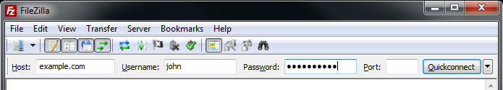
Please notice that the Quick Connect is for... quick connections - so there is no way to edit the quick connections list which stores the last 10 entries. To store FTP server names you should use the Site Manager, instead.
Quick Connect is good for testing the login info before making a site manager entry. Once you connect, you can choose File -> "Copy current connection to Site Manager..." to make a permanent entry. It is usually best to check your login info with Quick Connect before making a permanent entry.
After a successful connection attempt, a list of files and directories appears on the right side of the main window. The name of the current remote directory is listed in the edit field on the top. Below that you will see the remote directory tree. Under the remote directory is a list of the contents of the current remote directory.
To change the current remote directory:
- Type a directory name into the edit field and press enter, or
- Click a directory in the directory tree, or
- Double-click a directory in the list of the current directory contents
You will notice a directory called ".." listed in virtually all directories. Selecting this directory allows you to go up to the parent directory of the current directory.
Question marks ("?") appear on directories you haven't accessed yet, indicating that the FileZilla Client can't tell if there are subdirectories within those directories. If you access the directory the question mark will vanish.
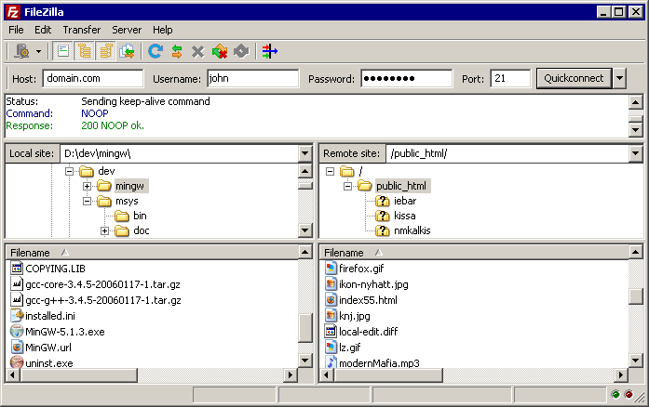

Navigating on your machine
Navigating on your machine works almost like navigating on the server. The current local directory and the local directory tree are displayed on the left side of the main window by default.
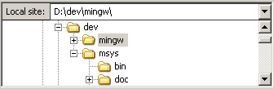

Transferring files
You can upload or download a file by double-clicking on it. It will be added to the transfer queue and the transfer starts automatically. To transfer directories and/or multiple files, select them and right-click the selection. Then you can click on Upload/Download in the popup menu.
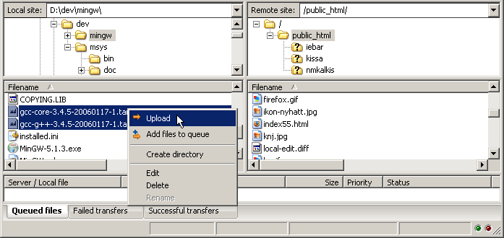
You can also drag the files from one side and drop them on the other side. To add files to the queue so that they will be transferred later, select them and click Add to Queue from the popup menu. You may also drag the files directly into the queue. Click on the button on the toolbar to start the transfer.
Or, you can click on a file, then drag the file (a box is added to the arrow cursor) to the directory where you want to move it. The directory will be highlighted when you are over it. Let go of the mouse button and the file will be moved to the directory.

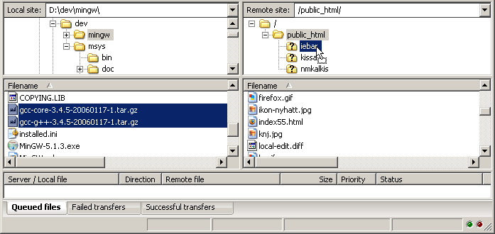

Utilizing Site Manager
If you want to create sites for easy access utilize Site Manager.
- Click File > Site Manager
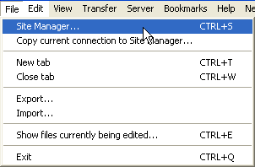
- Click New Site and enter a name i.e. “GACC Support” for the GACC support directory
  - In the host field enter ftp.nifc.gov
  - In the Logon Type dropdown select Account
  - In the user name field enter secsupport
  - Enter the password for this account in the password field
  - Enter an Account name of secsupport in the account field
  - Click on the Advanced tab and enter the following path in the Default Remote Directory field
/Incident_Specific_Data/N_ROCKIES/GACC_Support
  - Repeat these steps for the Incident Specific Data folder except change the account and password fields to reflect the nrgaccadm!n account and in the advanced tab enter /Incident_Specific_Data in the Default remote directory field
  - Refer to the screen captures on the following pages to ensure you have entered the correct information

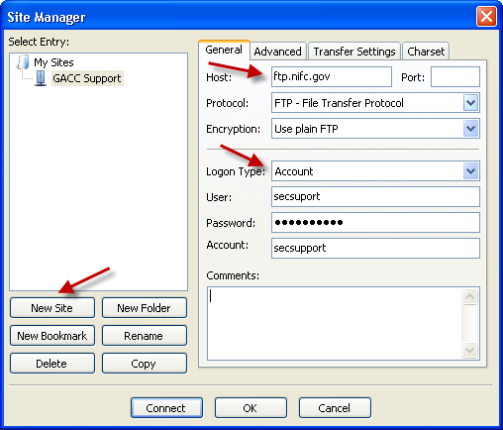

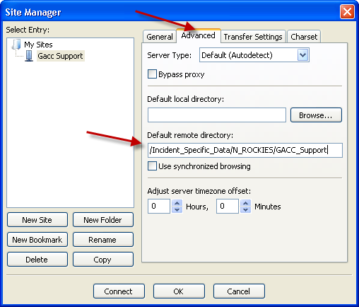
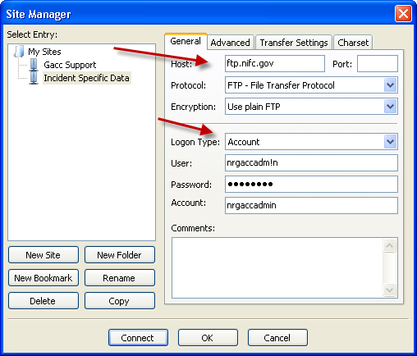

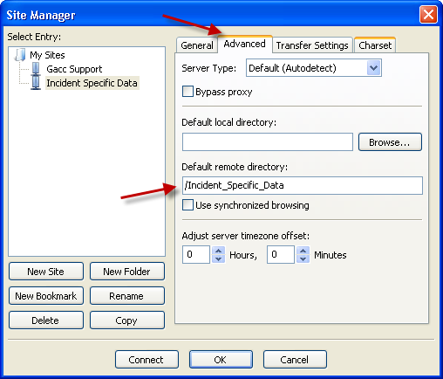
- Once you have configured both sites you will see both listed in the dropdown menu in the upper left hand corner and will be able to connect to the specific directories without having to enter the user name and password information each time.
