Creating and Producing the Web Briefing

1. Before producing a briefing you will need:
   1. Correct procedures in FXNet for exporting Water Vapor and 500mb info
   2. Access to the O drive to download the template and YouTube cover slide
   3. Generated password to log into YouTube
2. Open briefing template in PowerPoint
   1. O:\NFS\R04\Program\GBCC\PS\Products_Procedures\Webcast_Materials\Template.pptx
3. Save template as a new name (usually today’s date)
4. Populate template with current information
   1. Slide 2: create impact map highlighting significant impacts over the next few days. Slide 3 contains elements that can be used to create the impact map. Slide 3 is hidden, and will not show up during the briefing
   2. Slide 4: Past 24 hour info.
      1. Precip: <http://water.weather.gov/precip/index.php>
      2. Lightning: <https://lightning.nifc.gov/Account/Login?ReturnUrl=%2f>
   3. Slide 5: Observed Precip: <http://water.weather.gov/precip/index.php> or <http://www.intellicast.com/National/Precipitation/Daily.aspx?location=default&region=rno>
   4. Slide 6: Fire activity slide will be emailed the previous night
   5. Slide 7: Water Vapor Satellite. Images are exported from FXNet. You will need the procedure for the slides to have the correct naming convention
   6. Slide 8: Significant Fire Potential
      1. Link: <http://psgeodata.fs.fed.us/forecast/#/outlooks?state=map&forecastInView=2015-09-21>
      2. 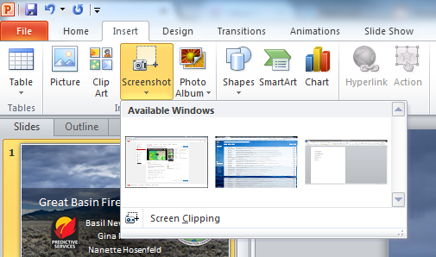To capture image for briefing, click on the placeholder for where the image will go. Then, click ‘Insert’ and then down arrow under ‘Screenshot’ and then select ‘Screen Clipping.’ The screen will grey out and you can use the cursor to highlight the image that you want included

1

2

3

* 1. Slides 10,12,14: NWS surface forecast
     1. Link: <http://digital.weather.gov/?zoom=6&lat=39.62439&lon=-111.81493&layers=00BFFFTTFTT&region=0&element=0&mxmz=false>
     2. Choose the elements that you want to highlight.
     3. Make the graphical display full screen in order to capture the whole area
     4. Take a screenshot of the images using the procedure in 3f
     5. 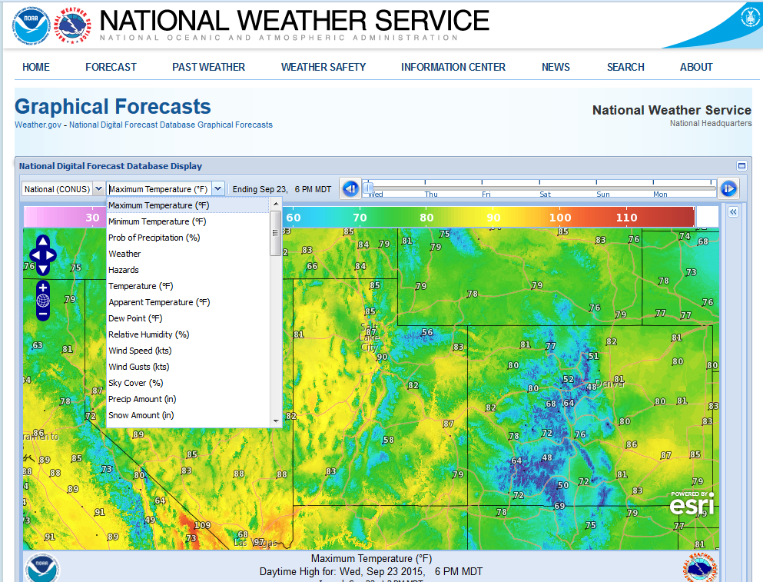Add titles and legends, available on Slide 9

3: Make graphical display full screen by clicking here

2: Drag slider bar to desired forecast time

1: select forecast element using the dropdown menu

* 1. Slides 11, 13, 15-18
     1. Export 500 RH/height from FXNet. You’ll need to have the correct procedure in order to get the naming convention that PowerPoint will recognize
     2. When images above are exported, 500 height info will automatically populate
     3. Take a screenshot of each day of the 7-day using the screen capture method from step 3f
  2. Slide 19: ERC
     1. Link:
        1. RAWS: <http://gacc.nifc.gov/gbcc/predictive/ERCMap/RAWS_ERC.html>
        2. PSAs: [http://gacc.nifc.gov/gbcc/predictive/PSA_ERCmap/PSAERCmap.html#](http://gacc.nifc.gov/gbcc/predictive/PSA_ERCmap/PSAERCmap.html)
     2. Take a screen capture of the ERC chart(s) that you want to highlight
     3. You can also include the PSA charts off to the right hand side
  3. Slide 20: Current Fuel Conditions
     1. Link:
     2. Pages are still from eastern/western GB, so you’ll have to take a screenshot of each and then combine them
     3. You can highlight a few stations that represent the area
  4. Slide 21: CPC outlook
     1. Link:
        1. Western Great Basin: <http://www.wfas.net/nfmd/public/gacc_map.php?gacc=WGBC>
        2. Eastern Great Basin: <http://www.wfas.net/nfmd/public/gacc_map.php?gacc=EGBC>
     2. Copy and paste the temperature and precip images from the website
  5. Slides 22-26: Closing slides
     1. These slides are all hidden, meaning that they won’t show up during the presentation. Choose which slide you want to display, right click, select ‘Hide Slide” and the slide will no longer be greyed out and will appear at the end of the presentation.

1. Record the briefing
2. On the top row in PowerPoint, click ‘Add-Ins’
   1. Click the ‘recording options’ button in the row that appears. It’s the second button from the right

2

1

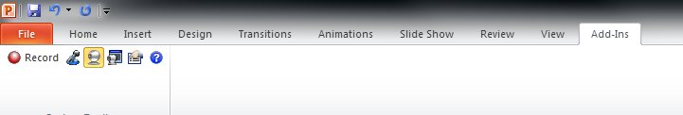

* 1. 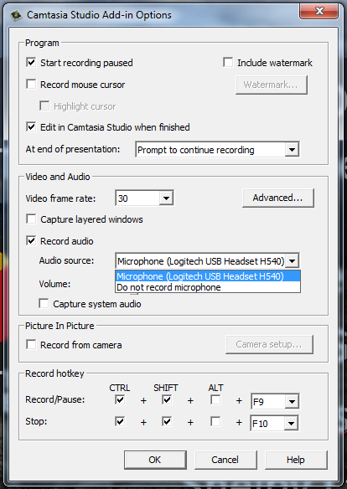A new options box will open. You want to make sure that your headset is selected as the Audio Source. To do this click on the dropdown next to ‘Audio Source’ and make sure that your headset is selected. You can test to make sure that your headset is capturing audio if the black bar lights up when you speak. Click OK.

Make sure your headset is selected.

Make sure this box is checked.

* 1. Click the ‘Record’ button on the left
  2. Your presentation will open full-screen
  3. Say a few words to see if the black status bar lights up. This verifies that your will record audio
  4. 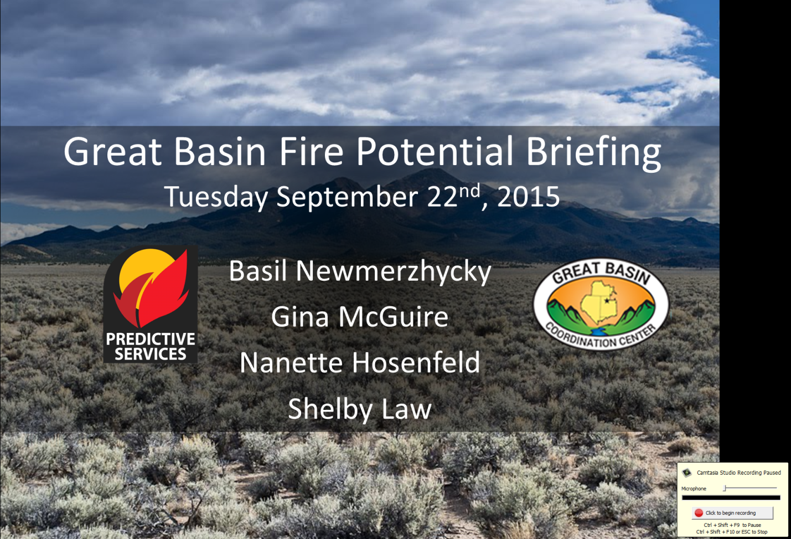Click the record button

Make sure the black bar lights up to verify that your audio is being captured.

* 1. Proceed through the presentation
  2. When you get to the end click on the last slide
  3. A box will pop up telling you that your presentation has ended
  4. 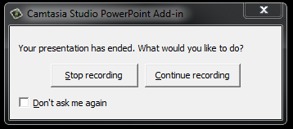If you’re done, click ‘Stop recording’
  5. Another window will open allowing you to save your presentation. Save it wherever you’d like. The filename doesn’t matter
  6. 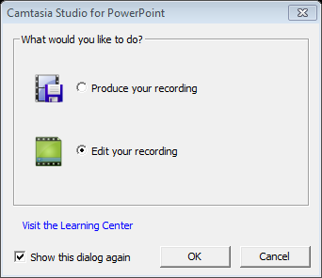Another window will open. Select ‘Edit your recording’ and click OK

1. Save and Produce the Briefing
   1. Camtasia will open automatically
   2. Another window will pop up asking for editing dimensions. Choose 1280x720

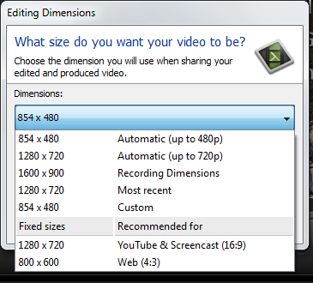

* 1. Listen to your briefing
  2. You can cut out any parts that you don’t like
     1. Use the grey slider bar to navigate to the area you’d like to cut.
     2. Use the red and green portions of the bar to select an area to cut
     3. Click the scissors to cut selected portions
     4. 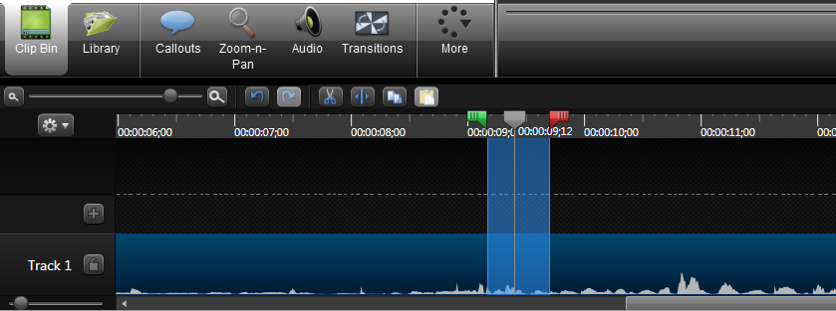You can use the undo/redo arrows to reverse edits

Use the red and green slider bars to select portions of the recorded briefing

Use the scissors to cut out unwanted sections of the briefing.

* 1. If the audio is too loud or quiet, you can adjust it
     1. Click on ‘Audio’
     2. Click ‘Volume up’ or ‘Volume down’ to adjust volume levels
  2. Once you are done editing your briefing, it’s time to produce it.
  3. 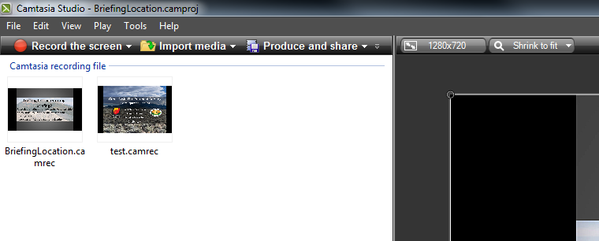Click ‘Produce and Share’ on the top left
  4. 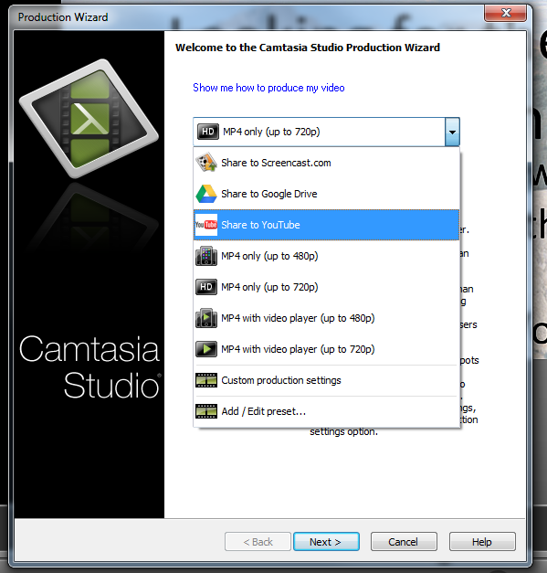A new window will open. Click the dropdown and select ‘Share to YouTube’ then click ‘Next’

1

2

3

* 1. 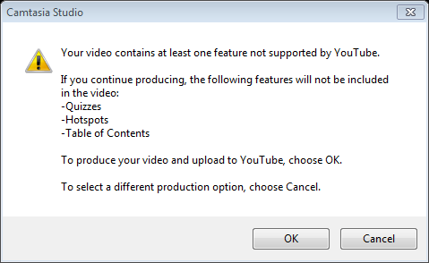Another window will pop up telling you that some features aren’t compatible with YouTube. Click OK
  2. You will need to sign in to YouTube the username is GBPredictiveServices the password will need to be generated for you
  3. Enter a title, description and tags. Example of typical entries:
     1. Title: Great Basin Fire Potential Briefing: (Date)
     2. Description: Great Basin Predictive Services Fire Potential Briefing discussing changes in fire weather and fire potential for the next 7 days. This briefing is updated daily.
     3. Tags: Fire Weather, Great Basin, Weather Briefing, Fire Potential
     4. Category: Science & Technology
     5. Privacy: Public
  4. Click ‘Finish’. A new window will open showing the progress of the upload.

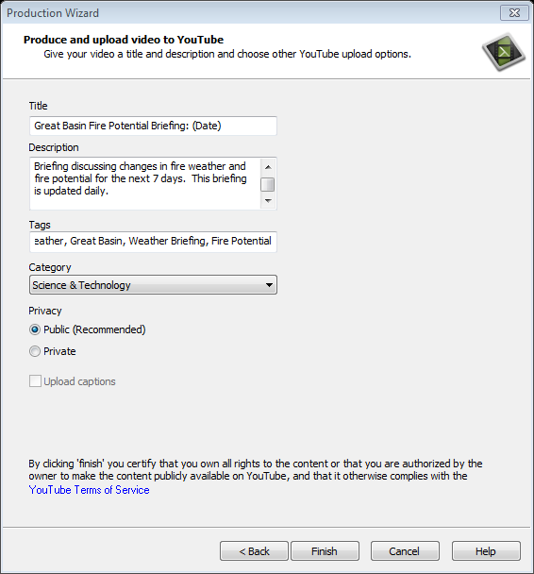

1

2

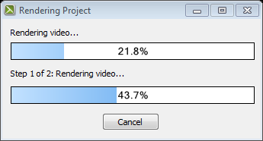

* 1. When your briefing is done processing, it will automatically open in a browser window. Initially, it will probably just be a frowny face saying that your video is processing. If you wait about 30 seconds and then refresh the screen, your briefing should appear. Leave this page open.
  2. Once your briefing is done processing/uploading it will automatically appear on the webpage

1. Change the cover image for the video
   1. If you’re not logged in, you’ll need to log in
   2. 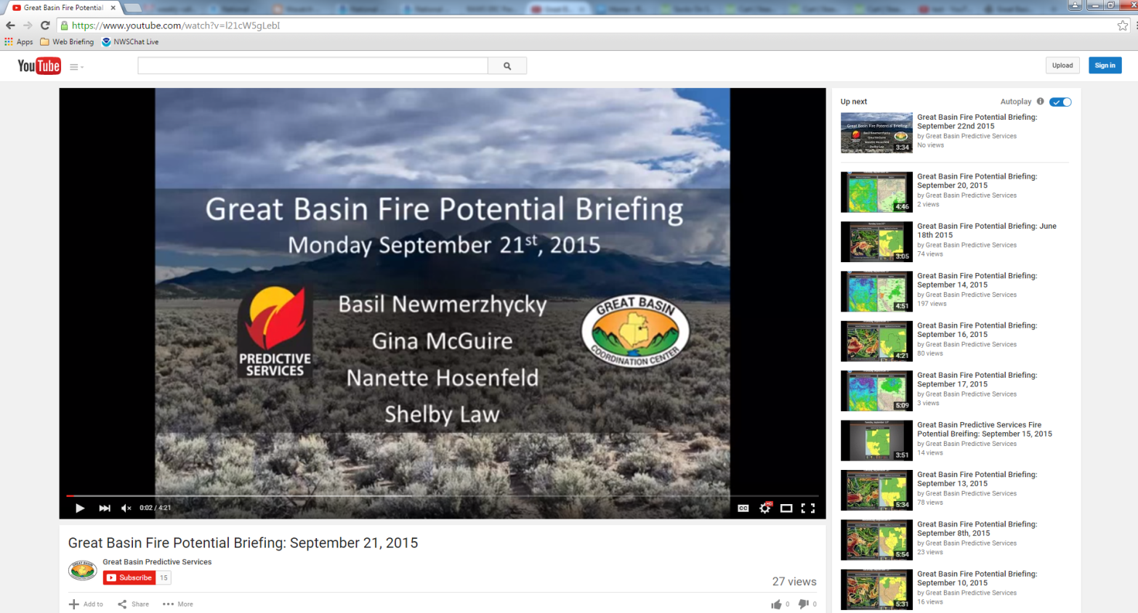Click ‘Sign in’ in the top right of the screen
   3. Username: GBPredictiveServices
   4. Password: GBCCPS01
   5. Once you log in, there will be a ‘Video Manager’ option under the video.

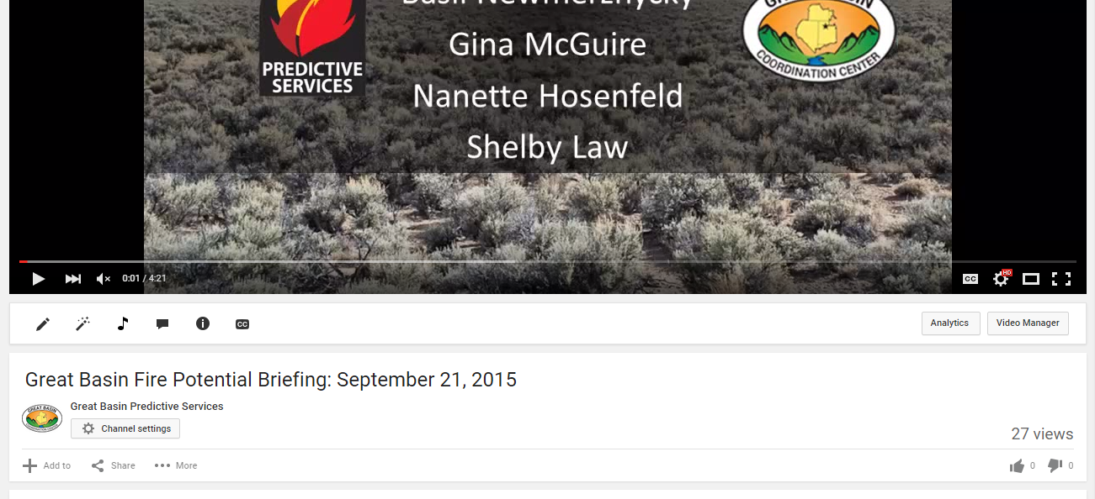

* 1. 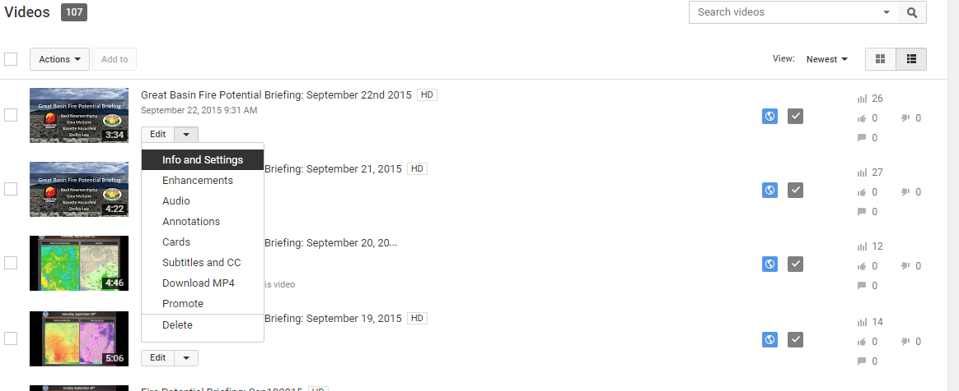A list of videos will open. The one you just uploaded should be on top. Click the down arrow next to ‘Edit’ and then select ‘Info and Settings.’

1

2

* 1. 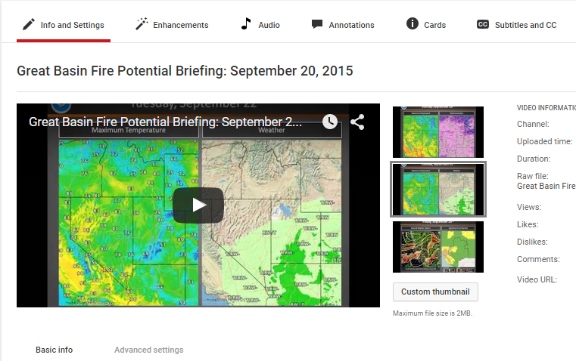A new page will open with settings for your video. Click ‘Custom thumbnail’
  2. A new window will open. Navigate to the folder where your custom thumbnail is saved. Select the image and click open
  3. Once it uploads the new custom thumbnail will appear and be selected. Click ‘Save changes’ and you’re done!

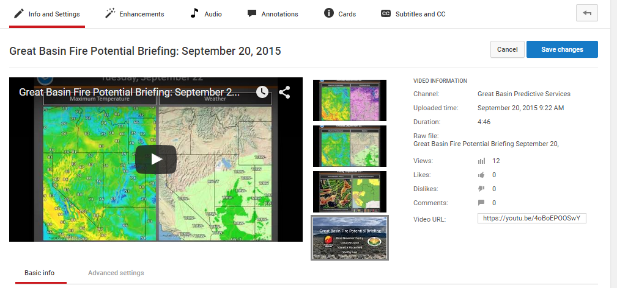

New cover image