Teton Crew – Individual Truck Inventory – Tour # EAST ZONE
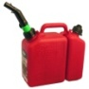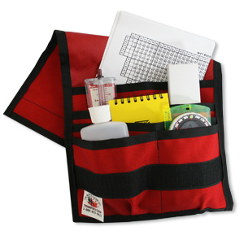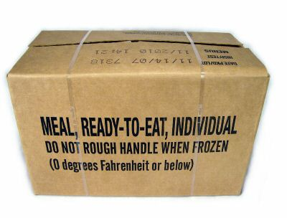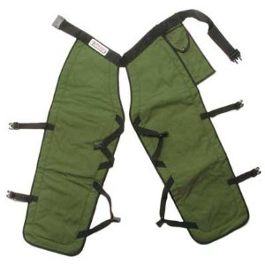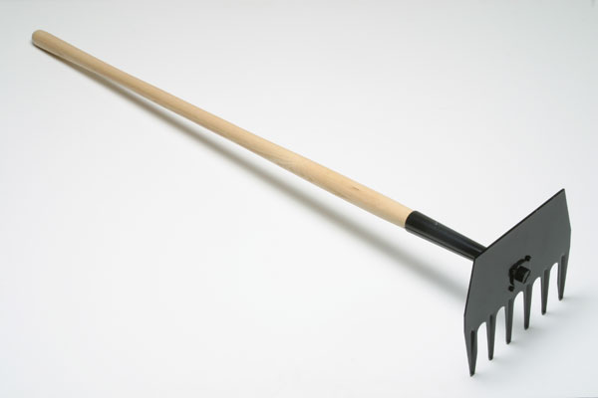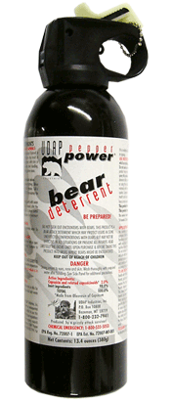
FIRE: | SQDB: | SQDB(T): | DATE: | Page 1 of 2

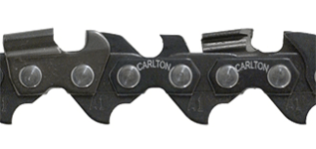 SAW STUFF 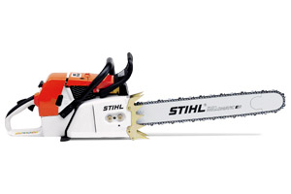
# | Unit | Item | NFES | Amt. Out | Amt. In | Notes
1 | EA | Axe, single bit, 4 LB | 0707
1 | EA | Bar, chainsaw, extra – 25”, in sheath, 1-84D chain | N/A
1 | EA | Bar, chainsaw, extra – 28”, in sheath, 1-84D chain | N/A
2 | EA | #__, #__ Chainsaw, Stihl MS460–28” bar/sheath/91D chain | N/A
2 | EA | # __, #__ Chainsaw Kit – in yellow bag | N/A
2 | PR | Chaps (32”-0045, 36”-0078, 40”-0150) | see left
1 | EA | Pounder (feller swamper tool) | N/A

N
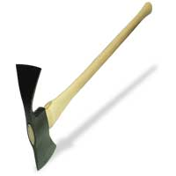 TOOLS 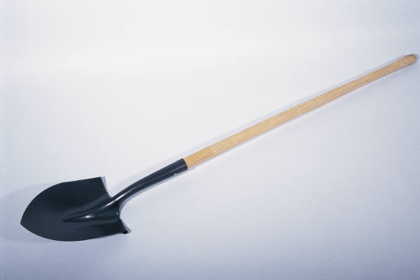
# | Unit | Item | NFES | Amt. Out | Amt. In | Notes
1 | EA | Adze Hoe | N/A
2 | EA | Combi | 1180
1 | EA | McLeod | 0296
1 | EA | Monkey Paw Rake | N/A
2 | EA | Pulaski | 0146
1 | EA | Rake, collapsible | 0657
1 | EA | Rhino | N/A
1 | EA | Shovel | 0171
1 | EA | Super- P | N/A

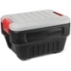 3 EA – TUBS OF SUPPLIES 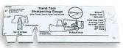 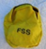 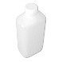
# | Unit | Item |  | NFES | Amt. Out | Amt. In | Notes
1 | BX | Batteries, AA (Usually 192 total batteries) | TUB #1 | 0030
1 | EA | Belt Weather Kit |  | 1050
8 | PG | Earplugs |  | 1027
2 | RO | Fiber Tape |  | 0222
1 | BX | File, mill, 12”, bastard |  | 1059
1 | KT | First Aid Kit, 10-25 person, belt type, w/ cinch bandage |  | 1143
8 | RO | Flagging (EscapeRoute-0566, KillerTree-6066, Orange-2398 ,Pink-2401, S.F.-6067)
1 | RO | Toilet Paper |  | 0142
1 | EA | Tool Sharpening Gauge |  | 0510
2 | EA | Bear Spray in Safety Canister | TUB #2 | N/A
1 | KT | Foot Care Kit (Antifungals, Cushions, Insoles, Moleskin, Powder, Tape) |  | N/A
2 | PR | Gloves (1 PR Medium - 1295, 1 PR Large – 1296) |  | see left
1 | KT | Hose Kit, Toy (3 hose, 2 nozzle, 2 s.off, 1 reducer,1 gated Y) |  | various
1 | BX | Lightsticks (Green - 3009 or Red – 3007) |  | see left
5 | EA | Vests – High Visibility Safety (use in hi-way right of way) |  | 1242
4 | EA | Water Bottles (Canteen) |  | 0037
½ | BX | Fusee (1/2 BX = 36 EA) | TUB #3 | 0105
1 | RO | Towel, bath, disposable (Shower Towels) |  | 1038
½ | BX | Trash Bags ( ½ BX = about 62 EA) |  | 0021

Page 2 of 2
(Continued from page 1) Teton Crew – Individual Truck Inventory – EAST ZONE

 |  |  |  |  | DATE:
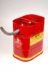 FUEL & OIL 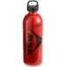
# | Unit | Item | NFES | Amt. Out | Amt. In | Notes
1 | EA | 2 Cycle Oil – 13 oz. | N/A
2 | EA | 2 Cycle Oil – 2.6 oz. | 3444
1 | GL | Bar Oil | 1880
1 | EA | Dolmar, full (In Crate) (50:1 and Bar Oil) | 0741
1 | EA | Drip Torch | 0241
1 | EA | Safety Can – Drip Torch Fuel (3:1 Diesel/Gas) | 0606
1 | EA | Safety Can – Unleaded | 0606
10 | EA | Sigg, full, w/ small carabiner (In Crate) -7 Gas / 3 Bar Oil | 1535

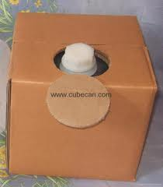 ADDITIONAL SUPPORT SUPPLIES 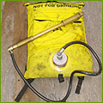
# | Unit | Item | NFES | Amt. Out | Amt. In | Notes
2 | EA | Bladder Bag | 1149
1 | bucket | Cleaning Kit (Armor-all, Gojo, Rags, Simple Green, Squeegee, Windex, Wisk broom)
1 | EA | Cooler (ICE CHEST) | 0557
4 | EA | Cubi – Full | 0048
2 | CS | Gatorade | N/A
3 | BX | MRE | 1842
1 | EA | Vice, tool, inserts into hitch receiver | N/A

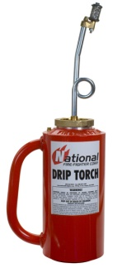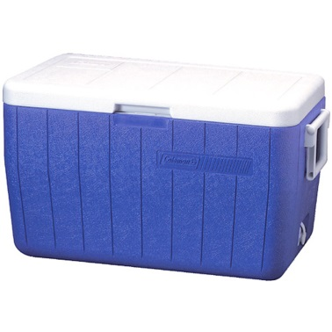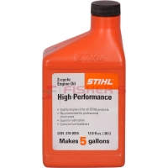

THE END (East Zone Truck Inventory)

