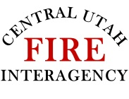 |  | Course Number  RT130 |  | Course Name  Annual Fireline Safety Refresher 2024
IQCS | Shelter Deployed | Course Date |  | Location | Lead Instructor
 |  | Start time: | End time:
 |  | IQCS Session # |  | Entered | Closed
 |  | Printed Name |  | Agency | Duty Station
Grayed out area is for Course Coordinator Use only

Lead Instructor Signature ________________________________

