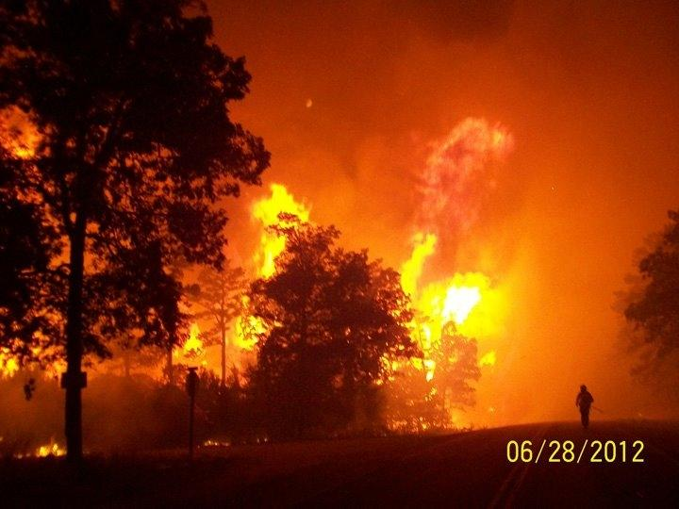
Mark Twain National Forest

2013 DRAFT

Fire Management Plan

Reviewed and Updated by _/s/ Jody Eberly, Forest Fire Management Officer__ December 21, 2012 _

East End Wildfire – Salem District – Shawn Maijala photo

This page intentionally left blank

Interagency Federal fire policy requires that every area with burnable vegetation must have a Fire Management Plan (FMP). This FMP provides information about the fire management planning process for the Mark Twain National Forest and compiles guidance from existing sources such as but not limited to, the Mark Twain National Forest Land and Resource Management Plan (LRMP), national policy, and national and regional directives.
The potential consequences to firefighter and public safety and welfare, natural and cultural resources, and values to be protected help determine the appropriate management response (AMR) during a fire. Firefighter and public safety are the first consideration and are always the priority during every AMR.
The following chapters discuss broad forest and specific Fire Management Unit (FMU) characteristics and guidance.
Chapter 1 introduces the area covered by the FMP, includes a map of the Mark Twain National Forest, addresses the agencies involved, and states why the forest is developing the FMP.
Chapter 2 establishes the link between higher-level planning documents, legislation, and policies and the actions described in FMP.
Chapter 3 articulates specific goals, objectives, standards, guidelines, and/or desired future condition(s), as established in the forest’s LRMP, which apply to all the forest’s FMUs and those that are unique to the forest’s individual FMUs.

Insert your planning area map(s) from the top pull down menu: select INSERT + PICTURE + FROM FILE

Introduction
The Mark Twain National Forest developed this FMP as a decision support tool to help fire personnel and decision makers determine the AMR to an unplanned ignition. FMPs do not make decisions. Instead, they provide information, organized by FMUs, which provides a finer scale summarization of information than is possible at the forest level. These descriptions bring specific detail about the identifiable areas on the ground. FMPs are not static documents. They will evolve and be revised as conditions change on the ground and as modifications are made to the unit’s LRMP.

The purpose of this plan is to define the implementation of the Fire Management Program on the Mark Twain National Forest. This plan is developed in compliance with direction found in the Forest Service Manual, sections 5101, 5103, 5106, and 5108. This Fire Management Plan is also consistent with the Wildland and Prescribed Fire Management Policy and Implementation Procedures Reference Guide; Managing Impacts of Wildfires on Communities and the Environment, and Protecting People and Sustaining Resources in Fire Adapted Ecosystems – A Cohesive Strategy; the interagency fire management plan template; and A Collaborative Approach for Reducing Wildland Fire Risks to Communities and the Environment: 10-year Comprehensive Strategy Implementation Plan.

The Mark Twain National Forest’s annual Fire Management Plan (FMP) is prepared and approved each year to:
- Formally document the forest’s fire program elements, objectives, strategies and resource considerations based on the Forest’s Land and Resource Management Plan of 2005.
- Provide fire managers with specific guidance to safely implement fire related direction for conducting wildland fire suppression and prescribed fire activities.
- Interpret strategic land and resource management plan direction into specific fire management direction for each fire management unit delineated in the fire management plan.
- Set out a specific detailed fire program that most efficiently meets fire management direction including, organization, facilities, equipment, staffing needs and related costs.

This Fire Management Plan is consistent with and guided by the Mark Twain National Forest Land and Resource Management Plan (LRMP) 2005. The LRMP was developed through collaboration with interest groups, other agencies and the public. Consistent with the National Fire Plan, implementation of the FMP will provide opportunities to collaborate with local fire management agencies, including U. S. Fish and Wildlife Service, National Park Service, Missouri Department of Conservation, Missouri Department of Natural Resources, Mingo Job Corps Conservation Center and Municipal Fire Protection Organizations. In addition, collaborative opportunities exist with private property owners within the Mark Twain National Forest proclamation boundary.

Acronyms Used in the Fire Management Plan

FMU – Fire Management Unit MMA – Maximum Manageable Area
FMZ – Fire Management Zone NAAQS – National Ambient Air Quality Standard
FSH – Forest Service Handbook T&E – Threatened & Endangered Species
FSM – Forest Service Manual WFDSS – Wildland Fire Decision Support System
LRMP – Forest Land and Resource Management Plan
Briefly describe the mission, land ownership, significant resources, desired conditions, and objectives for the forest and for other participating agencies.
The Mark Twain National Forest administers approximately 1,485,800 acres in southern Missouri. The Forest is composed of nine separate geographic units in 29 counties which span the state 200 miles east to west and 175 miles north to south. Private land parcels are scattered throughout the Forest boundaries. On average, Federal ownership within the boundaries of the National Forest is about 49%, and ranges from a low of 24% at Cedar Creek unit to a high of 71% at Doniphan/Eleven Point unit.

Population has grown rapidly in recent decades and seems to be more strongly associated with counties near metropolitan areas. Overall, population of the Mark Twain National Forest area grew an average of 19% from 1990 to 2000. However, the counties that make up the Forest area continue to be the least densely populated in the state.

The Mark Twain National Forest lies mostly within the Ozark Highlands, a region long distinguished for its extraordinary geological, hydrological, and biological diversity. Signature features include crystal clear springs, over 5,000 caves, rocky barren glades, ancient volcanic mountains, and nationally recognized streams. The Ozarks is perhaps the oldest continuously exposed landmass in North America (Yatskievych 1999). In the Ozarks, eastern oak hardwoods and southern pine woodlands converge with the drier western tallgrass prairie, creating a distinctive array of open grassy woodlands and savannas. This rich mixture of unique, diverse and ecologically complex natural communities provides a high level of habitat diversity.

Natural disturbance factors that shape vegetation in Missouri include insects, disease, floods, wind, and fire. Each disturbance type had its own range of variability measured in intensity, frequency, duration, scale, and timing. Fire has historically been a major disturbance element influencing development of Missouri's diverse ecosystems. Plant species presence, forest structure and composition across the landscape are influenced by fire. Landscape alteration, conversion to croplands and pasture, urban/housing development, and fire suppression have all contributed to a loss of Missouri's native biodiversity due to changes in its fire-adapted ecosystems. Extensive logging in the early 1900's, combined with decades of fire suppression, has resulted in forests with a high density of trees and an increase in the amount of woody debris on the forest floor. In addition to increasing fire intensity, these accumulated fuels damage otherwise diverse, healthy ground vegetation.

Biological systems of the Ozarks are human-influenced and fire-mediated. As far back as 12,500 years ago, Native Americans began manipulating and utilizing Missouri's vegetation. These influences likely included the use of fire to keep woodlands open with frequent, low-intensity fires. The only heavily forested areas were found along major rivers. The behavior of fire on the landscape is likely the best explanation for why certain natural communities were historically distributed in distinctive patterns across the Ozarks in relationship to vegetation, variations in human habitation patterns, human population size and the flatness or steepness of the topography (Batek et al. 1999).

In 1936, the Forest Service, unaware of the ecological role of fire, began implementing fire control and suppression measures. Prior to this, an average of about 280,000 acres of the now National Forest ownership burned each year. Ten years later, the average annual burned area was only about 8,000 acres. However, many local landowners continued the practice of annual burning on their own properties, with some fires escaping onto National Forest lands. Arson, often used to express disapproval of government actions, became the major cause of wildfire in the Ozarks. As knowledge of ecological systems increased, it became obvious that Smokey Bear's fire message had worked too well in many fire-adpated systems. Natural communities that were historically common, were now absent or severely altered by lack of fire to rejuvenate vegetation and reduce woody species invasion. Prescribed fire became an important tool to improve wildlife habitats, prepare sites for shortleaf pine seedbeds, and reduce fuel accumulations.

Forest management activities like prescribed fire are now being used to mimic natural disturbance events and patterns. In the long-term, the Mark Twain National Forest should reflect a full range of natural communities, from prairie to glade, savanna to open woodland and closed woodland to forest on sites where they historically would have occurred.

Insert your planning area map(s) from the top pull down menu: select INSERT + PICTURE + FROM FILE

Figure 1 - Mark Twain National Forest
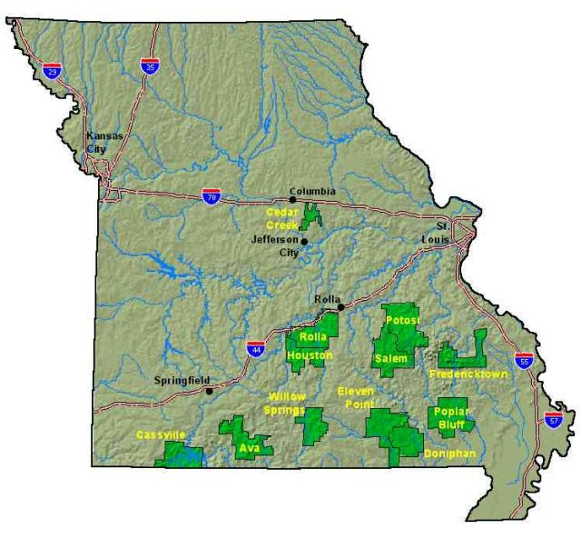

Policy, Land Management Planning, and Partnerships
Review the forest’s LRMP guidance and fire policy direction as it relates to the forest-wide fire management program, specifically, the forest’s goals, objectives, standards, guidelines, and desired future condition(s).
The Mark Twain NF Forest Plan was revised in 2005 under the planning rule that was adopted in 1982. Forest Plans guide all natural resource management activities and establish management goals and objectives, allocate lands to different management emphases, and establish standards and guidelines for Plan implementation. Forest Plan revision determined how, where, and to what extent prescribed fire may be used to mimic natural processes and to restore natural processes and functions to ecosystems and to reduce fuels. Key indicators of success for the fire management program are: Acres treated to progress toward FRCC 1 and Acres burned to reduce fuels and restore ecosystems.

The Mark Twain National Forest Land and Resource Management Plan (2005) is the guiding policy document for fire management on the Mark Twain National Forest. Fire management on the Mark Twain National Forest focuses on two aspects: 1) the use of fire to meet resource and land management goals; and 2) all activities required to protect life, property, and natural resources from fire. The 2005 Forest Plan developed management direction guiding the use of prescribed fire to restore ecosystems, maintain healthy forests, provide wildlife habitat, and reduce hazardous fuels; using a proactive approach to fire and fuels management to improve and maintain forest health and reduce the intensity of wildand fires. In addition, the plan improved direction for managing wildland fires to protect life, property, and communities.

Ensuring the safety of fire management personnel and the public is the primary objective of all fire management planning and operations. A fire management plan shall be maintained that provides direction for wildfire prevention, detection and suppression, fire use, and hazardous fuels reduction. The plan shall be updated annually.

Response to any wildland fire is based on the ecological, social, and legal consequences of the fire. The appropriate response is dictated by the circumstances under which a fire occurs and the likely consequences on firefighter and public safety and welfare, natural and cultural resources, and any other values to be protected. Fire is an essential natural process that should be incorporated into all levels of planning and activities at the landscape scale and across national forest boundaries. As nearly as possible, wildland fire should be allowed to play its role in the creation and maintenance of disturbance-dependent ecosystems. Accordingly, fire should be used as a management tool, including planned ignitions and wildland fire use.

WILDFIRE
Unplanned ignitions (wildland fires) will be suppressed as necessary utilizing the full range of suppression strategies applicable and appropriate to the management area and the conditions in which the fire is burning, to protect lives and property, national forest lands, and other ownerships. See Table 2-7 in the Forest Plan.

Agreements for fire detection and suppression on National Forest System lands by cooperating firefighting agencies must define suppression action commensurate with established resource management prescriptions and fire suppression action plans.

PRESCRIBED FIRE
Prescribed fire may be employed to accomplish a variety of resource management activities including, but not limited to, oak and other species regeneration, hazardous fuels reduction, wildlife habitat management, ecological restoration, maintenance of fire dependent plant communities, timber-stand improvement and other management objectives. Preference should be given to landscape –scale burns. When possible, natural or existing features, such as streams, roads, and trails, should be used as firebreaks.

All management ignited prescribed fires shall be carried out in accordance with the provisions of an approved burn plan. Smoke management planning must be used to control the effects of smoke emissions and meet air quality standards.

HAZARDOUS FUELS
Natural and activity fuels are managed for wildland –urban interface-community and resource protection, and other resource objectives. Agreements with cooperating agencies for fuels management activities are encouraged. Fuels management activities may include a range of available treatment methods, including prescribed burning, hand and mechanical treatments, and others in accordance with management prescriptions.

The regulations and policy in the following documents guide the fire management as outlined in this FMP.

National and Regional Fire Management Policy
Identify the following sources of guidance and direction that relate to actions described in the FMP. Determine and include unit-specific policies, other authorities, and programmatic agreements, if applicable.
Forest Service policy and direction that are relevant to this plan include:
- [1995 Federal Wildland Fire Management Policy and Program Review (January 2001)]
- [National Fire Plan]
- [Forest Service Manual 5100]
- [Forest Service Handbook 5109]
- Interagency Standards for Fire and Aviation Operations 2009
- Guidance for Implementation of Federal Wildland Fire Management Policy, February 13, 2009
- Interagency Strategy for the Updated Guidance for Implementation of the Federal Wildland Fire Management Policy, February 2009
- Wildland Fire Decision Support System (WFDSS), February 12, 2009

Mark Twain Land and Resource Management Plan
    - Mark Twain National Forest Land and Resource Management Plan and Record of Decision September 2005
    - Mark Twain National Forest Final Environmental Impact Statement To acompany the 2005 Land and Resource Management Plan (2005 Forest Plan)
    - Mark Twain National Forest Fire Risk Assessment

Partnership
To document the level of cooperation occurring, identify and list any internal and external fire management partnerships or planning teams that helped you develop this FMP.
The following agencies and organizations were not directly involved with the development of this Fire Management Plan, but were involved in development of the 2005 Forest Plan, and continue to work with the Mark Twain National Forest to coordinate fire management programs across ownerships in Missouri.

    - The Missouri Department of Conservation (MDC) is the state agency responsible for fire suppression. The Mark Twain National Forest has entered into an Interagency Cooperative Fire Management Agreement with MDC and the National Park Service to identify how each agency will work with the others to manage fire and suppress wildfires on lands under their respective protection.

    - The National Park Service, Ozark National Scenic Riverways (ONSR) manages lands that are within MTNF proclamation boundary and adjacent to National Forest system lands. ONSR uses fire management to achieve resource objectives, and is responsible for fire suppression on National Park Service lands. ONSR is a partner in the Interagency Cooperative Fire Management Agreement. Because of the intermingling of NFS lands and NPS lands, the Forest Service and Park Service share resources for wildfire suppression, particularly in FMU’s 1a and 2.
    - MTNF has an annual agreement for utilizing fire resources from Americorps St. Louis.
    - Mingo Job Corps Center incorporates a firefighter training program into its curriculum. Mingo JCC students participate in firefighter training, physical fitness conditioning, and assist in fire suppression and prescribed fires on the Mark Twain National Forest. The Forest also has one full-time position that functions as a liaison between the Forest and Job Corps Center to help integrate JCC students into conservation and resource management programs on the Forest.
    - The Nature Conservancy and Missouri Department of Natural Resources also use prescribed burning on their lands which may be adjacent to MTNF. Specific agreements are developed for individual instances of cooperation between the Forest Service and these partners.
    - The Mark Twain National Forest cooperates with three National Weather Service offices: St. Louis, Paducah, KY, and Springfield, MO. Each office has responsibility for fire weather forecasts for part of the Forest. The annual Fire Weather Operating Plan issued by the Weather Service details procedures for obtaining fire weather services. The Forest maintains 3 NFDRS weather stations at Doniphan, Ava, and Sinkin Creek. An additional station at Carr Creek has been operational, but is scheduled for decommissioning due to an unsuitable location. A new station at Council Bluff Lake came on-line in late 2010.
    - The Missouri Department of Natural Resources (DNR) is the state agency responsible for environmental regulation, including air quality. Currently, prescribed burning is exempt from open burning restrictions in the state (10 CSR 10-3.030 (4)(C). There is no current state smoke management plan.
    - USDI Fish & Wildlife Service is a signatory to the Missouri Interagency Cooperative Fire Management Agreement, and is able to provide firefighters to assist with suppression and fuels management work, while gaining valuable experience for their employees in Missouri.

Summary of Management Area Direction (Table 2-3 page 2-17 LRMP)
MP | DESCRIPTION | Acres | Suppression  Tactic⁶ | ME | AR | Wildland Fire Use Authorized | Prescribed  Fire
1.1 | Natural community restoration – Roaded natural ROS | 376,200 | All | Yes | Yes | Yes | Yes
1.2 | Natural community restoration – Semi-primitive motorized ROS | 62,200 | All | Yes | Yes | Yes | Yes
2.1 | General Forest | 669,900 | All | Yes |  | Yes | Yes
5.1 | Designated Wilderness | 64,100 | All⁵ | Yes^{2,3} | NO | Yes¹ | Yes¹
6.1 | Semi-primitive non-motorized | 73,600 | All⁴ | Yes⁴ | Yes | Yes | Yes
6.2 | Semi-primitive motorized | 196,400 | All | Yes | Yes | Yes | Yes
6.3 | Candidate Wild, Scenic, Recreation Rivers | 17,200 | All⁵ | Yes^{4,5} | NO | Yes | Yes
7.1 | Developed Recreation Areas | 5,900 | Control | Yes⁴ | NO | NO | Yes
8.1 | Designated “Special Areas” other than Wilderness | 30,600 | All⁵ | Yes⁵ | NO | Yes⁵ | Yes⁵

ME = Motorized equipment AR = Aerial retardant application

¹ Allowable only when approved in a signed Wilderness Fire Management Plan
² Forest Supervisor must approve motorized equipment such as chainsaws, leaf blowers, mechanical transport and helicopter water drops
³ The Regional Forester must approve the use of tractor plows and dozers
⁴ Requires District Ranger approval
⁵ See standards and guides for each specific area
⁶ Monitor may be used as a control strategy for all MPs except 7.1 and then only when authorized for use in a designated fire management unit with an approval plan

Fire Management Unit Descriptions
The primary purpose of developing FMUs in fire management planning is to assist in organizing information in complex landscapes. FMUs divide the landscape into smaller geographic areas to easily describe safety considerations, physical, biological, social characteristics and to frame associated planning guidance based on these characteristics.

The following information, including the summaries of fuels conditions, weather and burning patterns, and other conditions in specific FMUs, helps determine the AMR to an unplanned ignition and provides a quick reference to the strategic goals in the forest’s LRMP.

Decide on the amount of detail to include in the forest-wide considerations section below (3.1) versus the specific FMUs section (3.2). In a forest with low-landscape complexity and/or a forest that is small, FMUs will likely have many common characteristics and section 3.1 will have most of the information. Conversely, in a forest with a complex landscape and/or a forest that is large, each FMU will likely have unique characteristics and section 3.2 will have most of the information. If possible, develop FMUs through interagency efforts and interactions that facilitate common fire management across boundaries.
Fire Management Units (FMU's) on the Mark Twain National Forest are based in part on a risk assessement (Appendix G of the 2005 Forest Plan) that includes housing density, fire history, fuel types, fuel loading and suppression resource availability. The risk assessment was intended to identify and prioritize areas for treatment and active management, as well as identify areas of low risk to residents where aggressive suppression activities could be reduced and appropriate suppression responses may be practiced. The appropriate management response to wildland fire may range from an aggressive suppression response in areas of high and moderate risk, to a confine strategy in areas of low risk. An aggressive suppression response may include pre-positioning resources to insure a quick response time to areas where there are high concentrations of structures.

Regardless of possible resource benefits, human-caused unplanned ignitions must be suppressed. This has been a limiting factor in the use of wildfire for resource benefits, since the majority of wildfires on the Mark Twain National Forest are human-caused. In 2010 and 2011, there were 2 and 0 lightning fires respectively, and acreage burned was minimal (144 acres). During the hot and dry summer of 2012 however, there were 13 lightning fires that burned 1,341 acres. Despite this unusual summer season, managing wildfires for resource benefits is not appropriate in urban interface areas and an aggressive suppression response would be required. (Chapter 3 - page 205 FEIS).

The Fire Risk Assessment (FRA) can be used:
• as a guide to identify where fuel reduction projects are needed,
• to identify projects needed to prevent fire from entering high risk areas,
• to preposition suppression resources for initial attack,
• to determine where modified suppression responses may best be utilized,
• and to "target" private landowners and communities for participation in Firewise or other prevention programs.

Risk in FMU's is divided into two categories: General Risk and Specific Risk.

General risk categories are identified by a concentration of at-risk conditions within a geographic area and are used to describe relative risk to resources on and residents living within the boundaries of the Mark Twain National Forest. Fuel conditions, concentrations of wildland/urban/rural interface, and areas defined for protection from wildfire by the MTNF 2005 Forest Plan were used to geographically define general risk categories. General Risk categories include:

High Risk (Red on maps) - Fire may perform an important role in the function of the ecosystem, but because of resource concerns and potentially high economic impacts from unplanned ignitions, fire suppression must be conducted with considerable constraints and mitigation measures. The appropriate management response is usually aggressive suppression action (full suppression/perimeter control). High (and Moderate) Risk areas in Management Areas 1.1 or 1.2 are the highest priority for completing hazard fuel reduction projects. High (and Moderate) Risk areas in other Management Areas would be second priority. Prescribed fire is a major means of mitigating potential risk and losses in High Risk areas. Prescribed fire projects may be complex and more costly due to stringent contingency planning and monitoring. Naturally ignited wildfires are typically not managed to meet resource management objectives due to the proximity of high value improvements, concentration of areas excluded from wildland fire use by the Mark Twain National Forest 2005 Forest Plan, and relative scarcity of natural ignitions. High Risk areas may have relatively large concentrations of private land inholdings surrounded by fire-prone vegetation.

Moderate Risk (Yellow on maps) - Fire is a desireable component of the ecosystem with only moderate mitigations and constraints on suppression activities. Aggressive suppression action (full suppression/perimeter control) would be taken to a somewhat lesser degree than in High Risk areas, and less aggressive suppression actions ( monitor/confine/contain or point/zone protection/limited perimeter control) may be appropriate given current and predicted fire weather and behavior. Moderate (and High) Risk areas in Management Areas 1.1 or 1.2 are the highest priority for completing hazard fuel reduction projects. Moderate (and High) Risk areas in other Management Areas would be second priority. A significant level of prescribed fire activity is used to attain desired resource and ecological conditions. Naturally ignited wildfires may be managed to meet resource objectives, but are not normally due to scarcity of natural ignitions. Moderate Risk areas may include scattered individual campgrounds or improvements and vegetation that could sustain undesired effects from wildland fire.

Low Risk (Green on maps) - Fire is an integral component in maintaining or achieving the desired future condition with few mitigations or resource constraints. Low Risk areas may present an opportunity for a reduced or less aggressive suppression strategy based on current and expected fire behavior (monitor/confine/contain or point/zone protection/limited perimeter control). Prescribed fire for hazard fuel reduction is a low priority except where an immediate threat to public health and safety exists, to keep wildfire out of high or moderate risk areas, or where Specific Risks are located within the General Risk area. Naturally ignited wildfires may be managed to meet resource management objectives, but normally are not due to the scarcity of natural ignitions. Low Risk areas typically have few improvements or vegetation that has high potential for beneficial impacts from wildland fire.

Maps of General Risk Areas are attached as Appendix A to this document.

Specific risks are subsets of the general risk category and are individual improvements or resource values that have the potential to be at risk under identified fire behaviors. Specific risks are displayed in the Forest's GIS library. Some examples of specific risks include, but are not limited to:
• Administrative sites
• Areas of fire fighter safety concerns
• Developed recreation sites
• Designated communication sites
• Private land with structures
• Above-ground utility corridors
• High-use travel corridors
• Historic/Cultural Resource areas
• Threatened/Endangered Wildlife Species Habitat

Fire Management Considerations Applicable to All Forest Fire Management Units
Document overall wildland fire management program guidance and characteristics common to all FMUs.

Wildfire Occurrence and Fire Behavior
Wildfires can occur any time of the year and it is possible for large fires to happen any time conditions warrant. There are two times of year when wildfires are most common due to weather patterns and fuel accumulations. Spring season runs from February 15 - May 10, and is normally when the most severe and intense fires occur. Fall season is October 10 - December 10. These dates are used as guidance for staffing initial attack resources on the Forest.

The Forest's twenty year annual average is 174 wildfires per year, burning about 5145 acres annually (1990-2010). Approximately 99% of these fires are human-caused ignitions. About 94% of the fires are Class C or less (100 acres or less) and most fires burn at Fire Intensity Level (FIL) 1 corresponding to flame heights between 0 and 2 feet. Wind-driven fires are the most common, although sometimes topography can influence wind direction and speed in specific locations. Most of these fires can be effectively suppressed with hand tools and/or mechanically constructed fireline. In many areas, natural fuel breaks, such as roads, trails, and drainages, can be used effectively to stop or slow the spread of the fire.

Large fires (greater than 100 acres) in timber areas usually burn at FIL 2 or 3 (flame lengths of 2-4 or 4-6 feet). The Forest can experience extremely fast-moving fires and has experienced crown fires that consume large acreages in a single burning period. These situations are rare and tend to occur during periods of long-term drought. These fires must be attacked indirectly and require mechanical fireline construction and potentially air support to protect homes and firefighter safety.

During Fiscal Year 2012 (10/1/11 – 9/30/12), the Forest responded to 187 wildfires that burned 10,532 acres of National Forest and private lands. Because of the unusual summer wildfire season, a record number of lightning-caused fires were recorded (17 fires burning 1,903 acres). From May 11 through September 19, the Forest responded to 96 wildfires which burned 6,259 acres. Fires ranged in size from 0.02 acres to 1,625 acres, with 7 fires over 100 acres. Average size was 65 acres. The Eastern Region Type 2 Team was called in to assist with two Type 2 wildfires. There were also three Type 3 wildfires during the summer.
The Forest spent over $2.1 million dollars suppressing these fires and brought in resources from all over R9, and other parts of the country.
Areas of the Mark Twain National Forest can be classified according to how far removed they are from historical fire regimes, and the potential risk of losing key ecosystem components. Fire Regime Condition Class (FRCC) characterizes the degree of departure from natural fire, vegetation, and fire regimes. Much of the MTNF (73%) is currently classified as FRCC 3 which is the most departure from historical fire regimes (Forest Plan EIS page 3-198). Historically these areas were pine or oak woodlands and savannas, or open glades with a ground layer of grasses and forbs. About 26% of the Forest is in FRCC 2 which are moderately altered from historical range. Glades invaded by red cedar, oak stands experiencing oak decline, and shortleaf pine invaded by hardwoods best represent this condition. Only 0.4% of the Forest is currently in FRCC 1, which is the least departure from historic fire regime. These areas have been in a prescribed burning program for the longest period of time and are exhibiting significant white oak and pine regeneration in the midstory with a diversity of grasses and forbs in the understory.

Weather: The Mark Twain National Forest has three official automated (RAWS) weather stations that have been converted to GOES satellite transmission. They are located at the Doniphan Ranger District office, at Council Bluff Lake campground, at Tidwell Helispot on the Ava District, and at the Sinking Creek Experimental Forest. The Carr Creek station is scheduled for decommissioning due to inappropriate location. A new station came on-line at Roby Tower Administrative Site in 2012.

The Forest experiences hot, humid summers with normal temperatures ranging from 63 to 88 degrees Fahrenheit. Autumns are warm and moist with average temperatures from 35 to 79 degrees Fahrenheit. Winters are relatively mild with temperatures ranging from 18 to 43 degrees Fahrenheit. Spring can be cool to warm with temperatures ranging from 33 to 75 degrees Fahrenheit. Annual monthly precipitation ranges from a low in winter of less than 2 inches to a high of almost 5 inches in spring. April and May are the wettest months. Annual precipitation across the Forest ranges from 43 to 44.5 inches, mostly in the form of rain. Prevailing winds are south/southwest during the spring and summer ranging from calm to over 20 mph. Red flag warnings are issued for the Forest when winds are predicted to be 15-20 mph or greater (depending on weather station issuing warning), 10 hour fuel moistures are less than 9% and relative humidity is less than or equal to 25%. Wind events (tornadoes, straight line, derecho) may occur in any month of the year and have been responsible for creating concentrations of heavy downed fuel. Ice storms are also fairly common in the winter months and have contributed to fuel loadings across the Forest.

Fuel Models: NFDRS Fuel Models E and R represent the majority of the Forest. Fuel Model E represents leaf-off conditions for hardwoods and mixed hardwood-conifer types where hardwoods dominate. In high winds, fire danger may be underrated, because rolling and blowing leaves are not accounted for. Fuel Model R represents hardwood and mixed hardwood-conifer types after canopies leaf out in spring. It is used during summer where more than half the overstory is deciduous. Fuel Model K represents small parts of the Forest where slash from light thinning and partial cuts in conifers has occurred. It is also applied hardwood slash and pine clearcuts where fuel loading is less than 15 tons/acre. Fuel Model L also represents a small portion of the Forest where grassland vegetation dominates with shrubs and trees occupying less than 1/3 of the area.

The primary carrier of fire on the Forest is hardwood leaf litter and pine needle litter (Fuel Models 8 & 9). Fuel models 1, 2, 5, 6, 10, 11 and 12 are also present in varying amounts across the Forest. Within areas affected by the 2009 Derecho, fuel models 12 & 13 more accurately represent current conditions.

Fuel Model 9 – Heavy leaf litter (semi-open short leaf pine and hardwoods)
Dormant season Hardwood and Hardwood/conifer mix forest types 25 years and older or Shortleaf pine types with moderate to sparse canopy. Leaves/needles have dropped, fuel loading is high and fuel moisture is generally low. Fires can run through the surface litter at fast rates and have long flame heights. High winds cause higher rates of spread because of spotting. Heavy accumulations of dead/downed fuels can contribute to torching, spotting, and crowning behavior.

Scott-Burgan Equivalent: TL6 (186) The primary carrier of fire in TL6 is moderate load broadleaf litter, less compact than TL2. Spread rate is moderate; flame length is generally low.

Fuel Model 8 – Closed canopy stands of pine and pine/oak mixed types
Closed canopy stands (<=70% stocking) of short-needle conifers or hardwoods that have leafed out support fire in the compact litter layer. Slow burning fire in the fine litter layer with low flame lengths is the general case, although fires may flare up in concentrated pockets of litter. Only under severe weather conditions involving high temperatures, low humidity levels, and high winds do the fuels pose a fire hazard.

Scott-Burgan Equivalent:
TL2 (182) The primary carrier of fire in TL2 is broadleaf (hardwood) litter. Low load, compact broadleaf litter. Spread rate is very low; flame length very low.

Fuel Model 1 – Annual Grasses
This is a grass group model for cool season grasses like tall fescue. Grass is the dominant carrier of fire with less than 10 percent crown closure of woody plants. Fires are surface fires that move rapidly through the cured grass and other available fuels.

Fuel model 2 – Open savannas containing pine or shrubs as a overstory
These are semi-open areas with scattered large shortleaf pine trees or scattered clusters of eastern redcedar shrubs and trees. Canopy closure is 20 to 40 percent. The understory may consist of smaller trees and shrubs. Grasses and forbs may be moderately dense in some areas. This fuel model normally results in surface fires in which the herbaceous material, in addition to litter and dead-down woody material, contributes to the fire intensity.

Scott-Burgan Equivalent:
GR3 (103)The primary carrier of fire in GR3 is continuous, coarse, humid-climate grass. Grass and herb fuel load is relatively light; fuelbed depth is about 2 feet. Shrubs are not present in significant quantity to affect fire behavior.

Fuel Model 5 – Green shrubs, light fuel loads
These are young green stands of mixed hardwoods with a stocking level from 39% to 70%. The available fuel consists of litter cast from shrubs and a combination of grasses and forbs. Surface fuel loads are light, the shrub layer is small dead material, and the foliage contains little volatile material. As a result, fire intensity is usually low.

Fuel Model 6 – Cedar stands or mixed cedar stands
Large stands of eastern redcedars that are still in a shrub stage. This shrub model considers a combination of moderate winds and volatile vegetation. In these conditions a surface fire could become a crown fire with winds as a driving force. Fire drops to the ground at low wind speeds or at openings in the stands with only surface fuels.

Scott-Burgan Equivalent:
SH7 (147) The primary carrier of fire in SH7 is woody shrubs and shrub litter. Very heavy shrub load, depth 4 to 6 feet. Spread rate lower than SH5, but flame length similar. Spread rate is high; flame length very high.

Fuel Model 10 – Over mature stands with large down/woody material
Pine and Oak/Pine mixed forest types older than 70 years. Large loads of dead material on the forest floor created by age of the trees, natural events, insect/disease infestations, or timber harvest. These areas are generally over-stocked, multilayered conifer stands consisting of dense understory thickets of suppressed trees. Crowning, spotting, and torching of individual trees are more frequent in this fuel situation. This can lead to potential fire control difficulties.

Fuel 11 and 12 – Logging Slash Models (11-light) (12-Clear cut)
11 – All stands that have had a thinning or UEAM selection cut in the last 5 years. Light partial cut or thinning operations in mixed confers or hardwood stands would be an example. Fires are fairly active in the slash and herbaceous material intermixed with the slash. Spacing, shading, and aging of light fuel loads could limit the fire potential.
12 – All stands that have had a salvage thinning, UEAM Group Selection, Salvage or Clear Cutting in the last 5 years. In such areas heavily thinned conifer stands, clearcuts, and medium or heavy partial cuts are represented. Fires spread rapidly with high intensities capable of creating firebrands.

*Anderson’s 13 Guide suggest using a fuel model 6 in hardwood slash conditions for more comparative fire behavior.

Physical Considerations
Air quality in Missouri generally meets National Ambient Air Quality Standard accepted levels. The Forest is entirely within an attainment area and is primarily a Class II airshed. The only Class I airshed on the Forest is Hercules Glade Wilderness in FMU 4. A second Class I airshed at Mingo National Wildlife Refuge is close enough to FMU 2 to warrant consideration when planning prescribed burns in that FMU. A non-attainment area for PM 2.5 exists in the St. Louis area near enough to FMU 1b to warrant consideration when planning prescribed burns in that FMU.

Soils on the Forest are moderately well to well drained and have moderate to slow permeability. Soils are generally old, shallow, stony, highly weathered and acidic, except on some broad ridges and bottomlands. Soils on these topographic positions tend to be neutral to slightly alkaline. Limitations to land use include droughtiness, steep slopes, and high chert content. Most soils on the Forest are susceptible to erosion, compaction, puddling, and displacement during activities that result in ground disturbance and loss of ground cover (such as mechanical construction of firelines). In general, the Forest does not have fuel loading concentrations that would create fire behavior conditions intense enough to alter soil chemical, physical or biological functions.

There are a variety of natural fuel breaks present across the Forest. Small streams, drainages, rock bluffs or outcroppings, trails and old roads are all capable of stopping fire depending on the intensity of the fire and other weather conditions.

Biological Considerations
Fire is an important disturbance factor that has shaped the plant and animal communities of the Forest. Its continued use is vital to maintaining the diversity and abundance of wildlife and plants which naturally occur here.

Dead, dying, and hazard trees are valuable for many species of wildlife on the Forest, including Federally endangered species. The Forest Plan encourages leaving these trees whenever possible, while providing for public safety and the achievement of resource management goals and objectives. (page 2-14). When it is necessary to remove these trees, the Forest Plan encourages removal from November 1 through April 1 to minimize impacts to species. (page 2-6).

There are a variety of areas where mechanical construction of fireline is discouraged or prohibited, including watercourse protection zones (WPZs), riparian management zones (RMZs), glades, sinkholes, fens, rock bluffs, near cave and abandoned mine entrances and above known cave passages, known heritage resource sites, slopes greater than 35%, seeps, cliffs, etc. (pages 2-10, 2-11, 2-16, 2-18, 2-19). Water withdrawals are not permitted from natural sinkhole ponds (page 2-19).

Several federally endangered/threatened species have specific standards and guidelines related to prescribed fire and fire suppression activities (pages 2-7, 2-8, 2-12, 2-15). There are restrictions on timing of prescribed fire for various species and on the methods of fireline construction in or near species' habitat.

Social Considerations
The Mark Twain National Forest does not have continuous ownership within the boundary. Private land parcels of small to very large acreages are scattered throughout the Forest boundaries. On average, National Forest ownership is about 49% and ranges from 24% at Cedar Creek (part of FMU 1b) to about 71% on the Eleven Point District (FMU 2). Counties in which National Forest land occurs continue to be some of the least populated in the state, but population of the Mark Twain NF area grew an average of 19% from 1990 to 2000. The people of the area are primarily Caucasian and education levels are relatively low. Per capita income in Missouri is about 7% below the national average, and the average per capita income in counties with MTNF is about $9,000 below the state average. Nearly half of the 26 non-metropolitan counties which contain national forest land are persistent poverty counties. These figures have implications for community sustainability and resilience.

Because of the intermix of private and national forest lands, smoke management is an important consideration when planning prescribed burns. There are smoke-sensitive areas within a short distance of most of the Forest's planned/proposed prescribed burns. In addition, FMU 1 is near a non-attainment area (St. Louis) and prescribed burning in or adjacent to counties with forecasted high Air Quality Index (AQI) values may be done only if meteorological conditions indicate that smoke will be carried away from the high AQI area (page 2-19). Traffic control on county and forest roads can also be important during prescribed burning and wildfire suppression. There are also opportunities for cooperation and joint prescribed burn or mechanical fuels projects between the Forest Service and private landowners or other agencies.

Protection responsibilities for private lands within the Forest boundary are shared by the Missouri Department of Conservation (and rural or volunteer fire departments) and the Forest Service. There is also National Park Service ownership within and adjacent to Forest boundaries and they have additional firefighting resources which can be shared.

The Forest has several large developed recreation areas and many smaller dispersed or less developed recreation sites where a few to large numbers of people visit seasonally or throughout the year. Within the large developed recreation areas, control is the only acceptable wildfire suppression strategy, but prescribed burns can be conducted if authorized by approved plans (page 2-17). Use of mechanical equipment for wildfire suppression within a developed site requires District Ranger approval (page 2-17).

The Forest has a variety of heritage resources, some burnable, and others at risk by ground disturbing activities such as fireline construction. Mechanically constructed firelines for prescribed fire are prohibited within known heritage resources sites (page 2-16) and are prohibited during wildfire suppression actions unless necessary to protect life, structures, private property, or to maintain public and firefighter safety (page 2-18).

The Wilderness Act mandates that designated Wildernesses be managed in a primitive state. Further direction in the FSM 2320 and in the Mark Twain National Forest Land and Resource Management Plan give more specific guidance. To keep Wildernesses appearing natural and untrammeled by humans as much as possible, personnel are to employ Minimum Impact Management Techniques for all fire suppression activities. This involves using strategies and tactics that result in the least impact to the land (MIST or Minimum Impact Suppression Tactics). Such strategies may involve increased monitoring versus aggressive suppression, and locating camps and facilities outside of wilderness. Minimum impact tactics could include using water, foam, or fireline explosives versus line dug to mineral soil, hand line versus dozer or plow line, burning out from existing control lines versus direct fireline construction, increased cold trailing versus spading the ground, burning or blasting trees down versus felling, using pack strings for supplying personnel versus helicopter longline missions, etc. In general, this means using the “minimum tool” concept; or, using the least impacting tool to achieve mission objectives. In some instances the minimum tool may indicate that heavy equipment or aerial resources are employed. Forest Supervisor approval is required for using motorized equipment such as chainsaws, leaf blowers, or helicopters in the wilderness. Regional Forester Approval is required prior to using dozers or other heavy equipment. The Incident Commander has the delegated authority to initially determine the appropriate minimum impact tools and tactics. Whatever tactics are used, every effort will be made to restore and rehabilitate the area to its previous state once the emergency has concluded. This may include scattering, hiding, or burning cut faces of logs, refilling fireline trenches, scattering wood and brush over firelines, etc.

Permission to use mechanical equipment in Wilderness for wildfire suppression must be obtained from the Forest Supervisor (mechanized equipment and aerial water drops) or Regional Forester (dozers and tractor plows). Because wildfires rarely last more than one operational period on the Mark Twain, there is no written procedure for requesting permission – all contact is by phone or email. The Incident Commander contacts dispatch with the request; dispatch contacts the Zone FMO and/or District Ranger; the District Ranger contacts the Forest Supervisor; and the Forest Supervisor contacts the Regional Forester. These contacts are documented in the WildCad system by the Initial Attack dispatcher.

The Mark Twain follows national and regional policies for Burned Area Emergency Response (BAER). Any fire may be evaluated for BAER needs, but all fires over 300 acres will be evaluated to determine if BAER funds are needed.

The Forest has an Emergency Red Lights and Sirens Operations Plan signed by Forest Supervisor David Whittekiend on 4/23/12. This plan allows for the use of emergency warning lights and sirens on fire engines and designated command vehicles to provide visibility for vehicles travelling to or working on wildland fire or all-hazard incidents where life and property values may be at risk. Following national direction, all employees must complete approved training prior before being certified to operate with emergency red lights & sirens.

Each year, the Forest Supervisor delegates authority to each of the six District Rangers on the Forest to approve hand-ignited Prescribed Burn Plans for their units. Prescribed burns using aerial ignition may be signed by the District Ranger after review by the Forest FMO and approval by the Forest Aviation Officer. For CY 13, the following District Rangers have been delegated the authority to sign prescribed burn plans: Kim Bittle – Houston/Rolla/Cedar Creek; Tim Bond – Eleven Point; Jenny Farenbaugh – Ava/Cassville/Willow Springs; Thom Haines – Salem; Doug Oliver – Poplar Bluff.

Safety Considerations
Physical: Steep and rocky terrain can make footing or ATV use treacherous. Grass fuel models have the potential for fast-moving fires that may take firefighters by surprise. Cliffs and bluffs are difficult to see when working at night. Because the elevation range is somewhat limited, there are very few areas of the Forest where lookouts can be posted where the entire fire would be visible. This makes LCES even more important to implement on every fire, no matter how small or how intense. There are dead, dying, and hazard trees everywhere across the Forest. Especially during wildfire suppression and prescribed burning operations, it is important to keep heads up for falling limbs or trees coming down with little or no warning.

Of particular concern for the next several years are about 30,000 acres on the southern end of the Salem/Potosi-Fredericktown Districts which were moderately to severely affected by the Derecho windstorm in May 2009. Areas affected by this weather phenomenon contain entire trees that are downed across the landscape like a “pick up sticks”game. 1000 and 10,000 hour fuels are on the ground and jackstrawed across each other, so that many are aerial fuels, not just ground fuels. As these fuels continue to dry, they will become available fuel to help carry wildfire. In addition, normal fire suppression tactics for fuel model 9 are not effective in these fuel conditions. The Forest is implementing different strategies for safely suppressing fuels in these areas, as a result of experience with wildfires in Derecho fuels in 2010. In 2011, the Derecho Action Plan was developed to address the specific concerns of wildfire suppression in this fuel type. This Plan was implemented successfully for the Minninghaw wildfire in November 2011, which was an arson fire attacked indirectly.

All FMUs have experienced wind, ice, and tornado damage in the past that leave small pockets to very large areas of downed, heavy fuels. These fuels create safety issues for firefighters as it is difficult to construct line through this fuel type. For several years after one of these events, these areas are likely to experience more intense fire behavior until the heavy fuels break up and deteriorate. Firefighters will need to consider firefighter and public safety carefully when determining suppression strategies in these areas. Indirect attack may be an appropriate strategy for some of these areas.

Biological: The Mark Twain National Forest is home to four species of venomous snakes, two venomous spiders, and an assortment of bees, wasps, and yellowjackets. Ticks and chiggers can cause severe skin reactions and ticks carry a variety of diseases which can cause long-term health problems. Poison ivy is ubiquitous across the Forest. Feral hogs are present on all units of the Forest. While normally secretive and active at night, they can be dangerous if wounded, cornered, or have piglets to defend.

Social: Traffic along County and Forest roads normally includes logging trucks, recreational vehicles, school buses, farm vehicles, and local vehicles all travelling at different speeds. Some of the roads are narrow gravel roads that can be dangerous to drive during or after inclement weather. Illegal activities continue to occur on National Forest System lands, with the most prevalent being garbage dumps, meth labs & marijuana patches. The people involved in these activities sometimes booby-trap their sites, keep dangerous dogs, and/or carry firearms and can be dangerous to confront. Although buried propane tanks have not been a problem in the past, the practice is becoming more common and should be considered when fighting fire in the wildland urban/rural interface.

Operational: Fire operations on the Mark Twain can include Type 6 engines, bulldozers with plow and/or blade, ATV's/UTV's, chainsaws, leaf blowers, and helicopter use. All these types of mechanized equipment have some safety risk associated with their use. The military occasionally conducts low-level flights across the Forest, which are startling at a minimum, and may cause downdrafts that affect fire behavior.

Mark Twain National Forest Land and Resource Management Plan Guidance
Describe fire management related goals, objectives, standards, guidelines, and/or desired future conditions in the LRMP that apply to all FMUs. Include fire-management related goals that come from non-fire program areas within the LRMP or other planning documents. Examples of the desired conditions, objective, guidelines, goals, and standards include firefighter and public safety, using fire to restore ecosystem health, using the AMR, cost containment, desired plant community composition and structure, and constraints common to all FMUs (e.g., restrictions on retardant use, preventing spread of invasive species through washing of vehicles).
- Desired Conditions
- Tables 1-1 and 1-2 in the 2005 Forest Plan (page 1-2) show desired percentages of National Forest lands treated to restore the various natural community types in Management Prescription 1.1 and 1.2 areas.
- Management Prescription 1.1 and 1.2 - Prescribed fire emulates historical fire regimes, creating variable patterns of vegetation structure and abundance that meet habitat needs for associated wildlife. (page 3-3 and 3-7).
- Management Prescription 2.1 - Vegetation consists of a variety of stand sizes, shapes, crown closures, and age structures in patterns that simulate the structural variability of natural communities. Natural communities are distributed similar to historic vegetation patterns. (page 3-11).
- Management Prescription 5.1 (Wilderness:FMU 4) - Plant and animal diversity will depend entirely on the forces of nature. No motorized use will be permitted except as authorized by Law and Regulation. Evidence of …man's work will be substantially unnoticeable. (page 3-13).
- Management Prescription 6.1 - There is no motorized vehicular access for recreational activities, and access for project activities is limited to temporary roads and skid trails. Vegetation composition and structure for savannas, open woodlands and some glades may succeed to that which is different from their known historical condition, although their appearance may still look natural. There are few, if any, facilities, structures, utility corridors, and developments. (page 3-33).
- Management Prescription 6.2 - There is limited motorized vehicular access for recreational activities. The environment may be natural appearing, but structural characteristics of specific natural communities will be different than their known historical condition. Only those facilities, structures, utility corridors, and developments subject to existing rights are present. (page 3/37).
- Management Prescription 6.3 - Candidate Wild, Scenic, Recreation Rivers: The unique attributes of the eligible rivers are maintained or enhanced. Facility development is the minimum necessary to reach the objective and designed so as not to preclude the river's eligibility. (page 3-41).
- Management Prescription 7.1 - Recreation areas have motorized access and a moderate to high level of developed recreation facilities and structures that may dominate the landscape. These areas have a substantially modified natural environment. Resources are modified and used primarily to enhance specific recreational activities and to maintain vegetative cover and prevent soil loss. (page 3-45).
- Management Prescription 8.1 - Officially classified areas of exceptional ecological, geological or other features of scientific, educational, scenic, or historical values (other than Wilderness) are protected. Vegetation management varies based on the specific management objectives for each area. Management activities, facility development or motorized use are present only if compatible with area objectives. (page 3-49).
Objectives
- Objective 2.2a: In addition to the traditional late-winter through early-spring burn season, facilitate restoration treatments that emulate range of natural variability for historicla fire regimes in glades, savannas, and woodlands by: Prescribe burning up to 20% of total projected burn acres from May through September, and Prescribe burning up to 40% of total projected burn acres from September through December (page 1-5).
- Objective 2.2b: Use prescribed fire to reduce hazardous fuels and improve Fire Regime Condition Class on 45,000 acres or more per year. (page 1-5).
- Objective 2.2c: Treat those fuels that pose moderate to high risk to communities or community infrastructure, and threatened and endangered species. (page 1-5).
- Objective 2.2d: Develop a suppression strategy to respond to communities or community infrastructures and threatened and endangered species that are at high risk. (page 1-5).
- Objective 2.2e: Develop fire management units and wildland fire implementation plans for wildland fire use. (page 1-5).
Guidelines PRESCRIBED FIRE
- Emphasize large burns using year-round prescribed burning to meet management direction as appropriate to ecosystems involved and project objectives. (page 2-15).
- Allow fire to burn into all natural community types on compartment-size (or larger) prescribed burns. Allow fire to burn through sensitive natural communities, in designated old growth areas, and toward streams and drainages. Fires should be allowed to extinguish naturally within these areas unless otherwise needed to meet project specific objectives. (page 2-15).
- Fens that harbor known populations of Hine's emerald dragonfly should be prescribe burned to control invasion of woody speices or as part of larger landscape restoration or enhancement projects. (page 2-15).
- Where practical and safe for firefighters and the public, utilize existing natural or manmade barriers, such as drainages, cliffs, streams, roads and trails instead of constructed firelines. (page 2-15).
- Encourage hand-constructed firelines where feasible and practical.
- Locate firelines to minimize the need to remove standing dead trees before, during, or after prescribed burn operations. (page 2-15).
- Implement adequate erosion control measures (water bars, rolling dips, etc.) as shown in Table 2.2 on all constructed firelines where necessary to reduce the amount of sediment leaving a given area. (page 2-16).
- Mechanically constructed firelines for prescribed burns should avoid the WPZ whenever possible. When there is no feasible alternative, lines crossing these areas should not distub the ground (i.e. lift the blade) for 50 feet on each side of the channel. (page 2-16).
- Mechanically constructed firelines for prescribed burns should avoid fragipan soils where feasible. For a list of fragipan soils See Appendix B. (page 2-16).
Guidelines WILDFIRE SUPPRESSION
- Define suppression action that is compatible with management area objectives and fire suppression action plans in cooperative agreements with other agencies. Reference Table 2-3. (page 2-17).
- When the value-at-risk is low, and the Fire Intensity Level (FIL) is two or less, suppression activities should be the least impacting that still achieve the objective, such as allowing the fire to burn to a natural or manmade fuel break. When the value-at-risk is medium to high, a variety of suppression activities may be used including, but not limited to construction of fire lines. (page 2-17).
- For fires originating on private lands inside the Forest's fire protection boundary as defined under agreement with the Missouri Department of Conservation, provide the same suppression strategies as NFS land unless suppression measures are specifically qualified by the protection agreement. (page 2-18).
- Avoid mechanical construction of firelines in natural areas whenever possible. (page 2-18).
- Standing dead trees that constitute a safety hazard for the public or for safe fire suppression operations may be cut or removed as necessary. (page 2-18).
- Mechanically constructed firelines for suppression should avoid WPZ and RMZ, unless there is no feasible alternative. Firelines crossing these zones should not disturb the ground (i.e., lift the blade) for 50 feet on each side of the channel, unless necessary to protect life, structures, private property, or to maintain public and firefighter safety. (page 2-19).
- Do not apply fire retardants directly over water bodies unless needed for firefighter or public safety. (page 2-19).
Guidelines OTHER RESOURCES AND FIRE
- Maintain trees with characteristics of suitable roosts (i.e., dead or dying with exfoliating bark or large living trees with flaking bark) wherever possible with regard for public safety and accomplishment of overall resource goals and objectives. (page 2-6).
- Identify and remove hazard trees between November 1 and April 1 whenever possible. (page 2-6).
- Fens that harbor known populations of Hine's emerald dragonfly should be prescribe burned to control invasion of woody species or as part of larger landscape restoration and enhancement projects. (page 2-8).
- Leave downed woody material on-site whenever possible. (page 2-9).
- Minimize surface-disturbing activities within 100 feet of the border of glades. (page 2-9).
- For fire suppression, use manually constructed firelines on and within 100 feet of glades unless mechanically constructed firelines are needed to protect life, private property, structures, public health, or firefighter safety. (page 2-10).
- Protect cliffs, rock bluffs, and outcrops from ground disturbing activities, unless those activities are needed to meet desired condition or to conduct safe fire suppression operations. (page 2-13).
- Whenever vegetation management is undertaken, leave standing dead trees, cavity or den trees, and downed woody material whenever possible, while providing for public safety and the achievement of resource management goals and objectives. (page 2-14).
- Grazing permits should be adjusted to allow fuel buildup prior to prescribed burning. (page 2-20).
- Project activities should avoid known potentially significant heritage resources whenever possible, including sites which have not been evaluated or which have been determined to be eligible for listing in the National Register of Historic Places. (page 2-27).
- Where avoidance (of heritage resource sites) is not possible, consider project deferral or relocation as a means of protecting heritage resources. (page 2-27).
Goals Goal 2.2 -Prescribed Fire, Fuels, and Wildland Fire Management (page 1-4 through 1-5):
- Re-establish the role of fire in the natural communities of the Ozarks by emulating the historic fire regime.
- Restore fire regime condition class two or three lands to condition class one.
- Reduce hazardous fuels.
- Reduce wildland fire risk to communities.
- Manage prescribed fires so that emissions do not hinder the State's progress toward attaining air quality standards and visibility goals.
- Provide well-planned and executed fire protection and fire-use programs that are responsive to values at risk and management area objectives.
GOAL Specific to Management Prescription 1.1 & 1.2
- Restore the ecological role of fire in natural communities.
Standards PRESCRIBED FIRE
- Acres to be treated for hazardous fuel reduction must be near or adjacent to interface or intermix communities, in lands classified as fire regime 1,2, or 3, and condition class II or III. Maintain lands classified as condition class I. (page 2-15).
- Prescribed burns on fens that harbor known or suspected populations of Hine's emerald dragonfly must be scheduled to occur from November through April. (page 2-15).
- The area around occupied Indiana or gray bat caves is a smoke-sensitive area. Develop prescribed burn plans to avoid or minimize smoke influences at or near these caves. Give the U.S. Fish and Wildlife Servie an opportunity to review and comment on prescribed burn plans within these areas. (page 2-15).
- Prescribed burning may be done within the buffer zone for occupied Indiana bat male roost trees, if a fireline is manually constructed no less than 25 feet from, and completely around, the tree to prevent it from catching fire. (page 2-15).
- Firelines and water diversion structures must not drain directly into stream channels, sinkholes, or other specialized habitats. (page 2-16).
- Revegetate soils disturbed by constructed firelines by encouraging growth of existing on-stie vegetation where possible. (page 2-16).
- Where on-site vegetation is not desireable, or not likely to quickly revegetate the site, use one or more of the following methods: Fertilize to encourage growth of desirable on-site vegetation; Apply local surrounding organic mulch (i.e., leaf litter and pine needles) or cover with sterile weed-free straw to promote reestablishment of native vegetation; Reseed or replant with native species appropriate to the site or sterile annuals (wheat, rye, etc.) and fertilizing if necessary; or Scarifying to establish seedbed. (page 2-16).
- Hand-constructed firelines shall be located at least 50 feet from cave and abandoned mine entrances. (page 2-16).
- Mechanically constructed firelines for prescribed fires are prohibited in the following areas: Above known cave passages; On slopes greater than 35%, except for short runs with low erosion potential (for example, coming off of a road grade); Within 100 feet of known cave and abandoned mine entrances; Within 100 feet from the upslope break or crest of the sinkhole; Within 100 feet of sinkhole ponds, springs, seeps, fens, shrub swamps, rock bluffs, outcrops, cliffs, and glades; Within the RMZ; Within known heritage resource sites. (page 2-16).
- If heritage resources or human remains are discovered during project implementation, halt the work near the find until a professional archaeologist assesses the situation. (page 2-16).
Standards WILDFIRE SUPPRESSION
- Base wildfire prevention, detection, and suppression on the forest wide forest risk assessment. Base value-at-risk on the following criteria: Ignition probability; Proximity to Urban Interface or Intermix; Density of structures within the forest protection boundary; Response times; Fuel models; and Proximity to sensitive resources. (page 2-17).
- Each wildfire requires an appropriate suppression response (with attached Table 2-3) (page 2-17).
- Coordinate banning of open burning on National Forest System lands with the Missouri Department of Conservation and the Ozark National Scenic Riverways. (page 2-18).
- Use existing natural or manmade barriers - such as drainages, cliffs, streams, roads, and trails - instead of constructed firelines for suppression activities when the value-at-risk is low and where practical and safe for firefighters and the public. (page 2-18).
- Implement adquate erosion control measures (water bars, rolling dips, etc.) on all constructed firelines where necessary to reduce the amount of sediment leaving on a given area as shown in Table 2-4. Erosion control should occur as soon as possible after suppression activity is complete. (page 2-18).
- Revegetate soils disturbed by constructed firelines by allowing growth of existing on-site vegetation where possible and desirable. (page 2-18).
- Where on-site vegetation is not desireable, or not likely to quickly revegetate the site, use one or more of the following methods: Fertilize to encourage growth of desirable on-site vegetation; Apply local surrounding organic mulch (i.e., leaf litter and pine needles) or cover with sterile weed-free straw to promote reestablishment of native vegetation; Reseed or replant with native species appropriate to the site or sterile annuals (wheat, rye, etc.) and fertilizing if necessary; or Scarifying to establish seedbed. (page 2-18).
- Hand constructed firelines shall be located at least 50 feet from cave and abandoned mine entrances. (page 2-18).
- Unless necessary to protect life, structures, private property, or to maintain public and firefighter safety, mechanically constructed firelines for suppression are prohibited: On slopes over 35% except for short runs with low erosion potential, (for example, coming off a road grade); Above known cave passages; Within 100 feet of known cave and abandoned mine entrances; Within 100 feet from the upslope break or crest of the sinkhole; Within 100 feet of sinkhole ponds, springs, seeps, fens, shrub swamps, rock bluffs, outcrops, cliffs, and glades; and Within known heritage resource sites. (page 2-18/19).
- When using heavy equipment for suppression activities, cross stream channels at right angles. Stabilize and revegetate the crossing as soon as possible after the fire is controlled. (page 2-19).
- Water withdrawals are not permitted from natural sinkhole ponds. (page 2-19).
Standards SMOKE MANAGEMENT
- Use best available smoke management practices to minimize adverse effects on public health, public safety, or visibility from prescribed fire. (page 2-19).
- Conduct prescribed burning in, or adjacent to, counties with forecasted high Air Quality Index (AQI) values (AQI = orange or higher) only if meteorological conditions indicate that smoke will be carried away from the high AQI areas. (page 2-19).
- Minimize the impact of smoke for each prescribed fire by identifying smoke-sensitive areas, using best available control measures, monitoring smoke impacts, and following applicable guidance. (page 2-19).
Standards OTHER RESOURCES AND FIRE
- Design all ground disturbing activities to prevent or minimize rutting, erosion, compaction, rapid runoff, disruption of water movement, and distribution or loss of water and soil quality. (page 2-5).
- Prohibit mechanical disturbance to rare plant sites. (page 2-6).
- Conduct management activities planned near known nesting sites (bald eagles) in a manner that protects the existing nest site, maintains suitable alternate nesting habitat, and occurs outside of the breeding, incubation, and brood rearing periods (approximately January through July). (page 2-6).
- Conduct prescribed burning within the maternity colony area of use (Indiana bats) only during the hibernation season. (page 2-7).
- Apply management activities in old growth only when the objective is enhancement of natural communities and old growth characteristics. (page 2-9).
- Manage natural grasslands to enhance ground flora species diversity and abundance and minimize woody encroachment. (page 2-9).
- Maintain openlands within the WPZ and RMZ only if they are naturally occurring. (page 2-9).
- When implementing management activities, make provisions so that the area remains natural appearing, practices or structures blend with the environment, and other applicable Forest Plan standards are met. (applies to Rivers only) (page 2-23).
- Resource management activities must meet or exceed the established VQO. (page 2-24).
- Comply with current Memorandum of Understanding (between the State Historic Preservation Office (SHPO) and Mark Twain National Forest), Programmatic Agreements, or other requirements regarding implementation of the forest heritage program. (page 2-26).
- Ensure that adequate heritage surveys are complete and assess project effects on significant heritage resources prior to decisions related to management activities. (page 2-26).
- Evaluate (heritage resource) sites which cannot be avoided, or when project cannot be deferred or relocated. (page 2-27).
- Use prescribed fire for maintaining pipeline ROW's only when they are not transporting flammable substances. (page 2-34).
Standards SPECIFIC TO MANAGEMENT PRESCRIPTION 6.1 and 6.2
- Limit investments for vegetation management treatments to those necessary for restoration and/or maintenance of natural communities, or provides a specific resource output. (page 3-33).

Fire Management Considerations for Specific Fire Management Units

FMU Snap Shot – FMU 1A
  - This section is optional. If included, complete only the information that is applicable and necessary for initial dispatch and include a map of the specific FMU.
    - FMU Number: FMU 1A (Salem and Potosi/Fredericktown units)
    - Radio Frequency: Repeaters at Buick, Taum Sauk, Matthews
    - General Risk Category: Primarily Low with some Moderate and minor amounts of High
    - Fire Behavior Indicator: Burning Index and Ignition Component
    - NFDRS Weather Station: Sinking Creek, Council Bluff
    - Nearest Weather Station: Sinking Creek, Salem; Council Bluff, Potosi
    - Acres/Agency: 418,676 USDA Forest Service
    - Predominant Vegetation Types: Oak-hickory; Oak-pine; Shortleaf pine
    - Unit: Salem, Potosi/Fredericktown
    - IA assets assigned to this FMU: 1 Zone FMO, 1 Zone AFMO, 1 Zone Fuels Specialist, 5 18/8 Firefighters, 4 dozers, two Type 6 engines
    - Duty Officer: Zone FMO James Cornelius (Salem/Potosi/Fredericktown)
    - IA Dispatch Office: Missouri-Iowa Coordination Center (MOCC) (MO-MTF)
    - Communities adjacent or within FMU: Salem, Bunker, Viburnum, Potosi, Fredericktown, Ironton, Marquand
    - LMP Options available for AMR: See Table 2-3 on page 2-17 of the 2005 Forest Plan. All options are available without restrictions for Management Prescriptions 1.1, 1.2, 2.1, and 6.2. All options are available in MP 6.1 but the District Ranger must approve motorized equipment use. All options except aerial retardant application are available in MP 6.3 with some restrictions on motorized equipment. All options except aerial retardant application are available in MP 8.1 with some restrictions on motorized equipment and use of unplanned ignitions for resource benefit in individual units. The only option available in MP 7.1 (developed recreation areas) is a perimeter strategy of control and the District Ranger must approve motorized equipment use.
    - Special safety considerations: The 2009 Derecho created large areas with heavy concentrations of downed woody material. These areas will cause fire control challenges for the next several years, including higher fire intensities, more difficult access, and slower line building capability.
    - The United State's largest lead mining district occurs within the boundary of this FMU. Large trucks hauling mining waste and material are common on some area roads, sometimes driving much slower or much faster than normal traffic.

Insert your FMU map(s) from the top pull down menu: select INSERT + PICTURE + FROM FILE

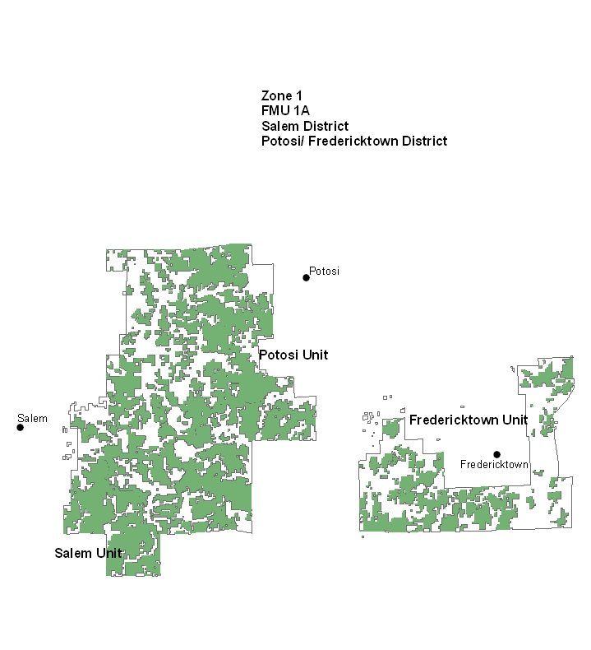

FMU Guidance
Review the guidance in the forest’s LRMP and other planning documents if multiple agencies are involved. List the desired conditions, objectives, standards, and guidelines that apply to the specific FMU. Directly tie the information in the forest’s LRMP to the specific FMU.
This FMU includes:
MP 1.1 Lower St. Francois Mountains, Meramec River Hills East, Current River Watershed;
MP 1.2 Upper St. Francois Mountains, Meramec River Hills West;
National Register of Historic Places Nova Scotia site;
State Natural Areas Blair Creek Raised fen and Grasshopper Hollow fen;
Forest special areas Bidwell Creek Bog, Medley Hollow Hanging Fen, Barton Fen, Bates Hollow Fen, Clear Creek Fen, Swamp Hollow Fen, Wash Creek Alder Fen, and Wet Hollow Fen;
Other special areas Turtle Flatwoods; Sinkin Experimental Forest,
Developed recreation areas Council Bluff Lake, Marble Creek, Sutton Bluff ATV Area, and Loggers Lake; Red Bluff; National Recreation Trails -Berryman Trail and Crane Lake Trail;
Several small lakes that include dispersed recreation sites.
This FMU also includes one Indiana bat maternity area of use and one Indiana bat hibernaculum that has specific standards and guidelines to protect Indiana bat summer habitat.
- Desired Conditions: See Forest-wide
- Objectives: See Forest-wide
- Guidelines: See Forest-wide
- Goals: See Forest-wide
- Standards: for Indiana bat maternity colony area of use
- If occupied Indiana bat maternity roost trees are discovered, protect them from physical disturbance until they naturally fall to the ground (page 2-7).
- Based on site-specific consultation, designate an area of use (foraging and roosting) based on site conditions, radio-tracking or other survey information, and best available information regarding maternity habitat needs. (page 2-7) (NOTE: This has been done for this FMU).
- Minimize human disturbance in the maternity colony area of use unitl the colony has left the maternity area for hibernation. (page 2-7).
- Conduct prescribed burning during the maternity colony area of use only during the hibernation season. (page 2-7)
- Standards for Indiana bat hibernaculum:
- Prohibit removal of suitable roost trees and prescribed burning within the 20 acres of old growth and 130 acres of forest or mature woodland surrounding an Indiana bat hibernacula during the swarming and staging periods. Determin dates individually for each cave (normally between September 1 and November 1 and between March 15 and April 30 respectively.) (page 2-7).
- The area around occupied Indiana or gray bat caves is a smoke-sensitive area. Develop prescribed burn plans to avoid or minimize smoke influences at or near these caves. Give the U.S. Fish and Wildlife Service an opportunity to review and comment on prescribed burn plans within these areas. (page 2-7).

FMU Characteristics
Describe the safety considerations and the physical, biological, and resource characteristics of the specific FMU. Cite sources and include maps, when appropriate.

Safety
      - In addition to Forest-wide safety considerations;
      - This FMU includes the largest lead mining district in the United States. Heavily laden haul trucks use area roads and are often travelling either much slower or faster than normal traffic.
      - The May 2009 Derecho increased heavy fuel loading in this FMU in large, scattered pockets ranging from a few acres to hundreds of acres. This fuel loading has the potential to increase the difficulty of control by limiting access to areas, decreasing the amount of line that can be constructed in a certain time, limiting line construction to either hand or mechanical depending on the circumstances, and increasing the intensity, size, and duration of wildfires. Safety of firefighters and the public may be in jeopardy during suppression operations in these areas. Effective suppression of fires in this area will depend on quick response and pre-positioning of additional resources during spring fire season.

Physical
  - List and briefly describe specific FMU physical characteristics including, but not limited to, FMU boundaries, topography, elevation range, soils, and air quality.
  - This FMU includes areas of igneous rock outcroppings and the highest elevations in the state. Mechanically constructed fireline is prohibited for suppression unless necessary to protect life or property within 100 feet of rock bluffs, outcrops, or glades (Forest Plan page 2-19).
  - This FMU is nearest to the St. Louis PM 2.5 non-attainment area, and southwest winds would carry smoke from prescribed burning in this FMU toward the non-attainment area. Therefore, a specific standard was developed to address this issue (Forest Plan page 2-19).

Biological
  - List and briefly describe specific FMU biological characteristics including, but not limited to, vegetation types, wildlife habitats, threatened/endangered/sensitive species, fisheries, and areas of special interest.
  - An Indiana bat maternity colony area of use has been delineated within this FMU. There area specific standards and guidelines associated with that area. Prescribed fire may be used within the area, but only during the hibernation period (late fall - early spring).
  - An Indiana bat hibernaculum is located within this FMU. There are specific standards and guidelines associated with that area.
  - This FMU also includes an area where federally endangered running buffalo clover occurs. This plant needs prescribed fire to reduce vegetative competition and prepare bare-ground seedbed for the plants.
  - This FMU includes several fens which harbor federally endangered Hine’s emerald dragonfly. Prescribed burning may be done in these areas, but only from November through April (Forest Plan page 2-15).

Resources
There are no specific standards and guidelines for fire outside the Forest-wide for these areas.
  - List and briefly describe specific FMU resources including, but not limited to, recreation types, special designations areas, infrastructure and other values, communities and subdivisions, private property and improvements, private and public recreation sites, guard stations, cultural and historical sites, in holdings, power lines, and the wildland urban interface.
  - Developed recreation areas in this FMU are Council Bluff Lake, Sutton Bluff ATV Area, and Loggers Lake; and National Recreation Trails -Berryman Trail and Crane Lake Trail.
  - The Nova Scotia site is listed on the National Register of Historic Places.
  - State Natural Areas Blair Creek Raised fen and Grasshopper Hollow fen occur in the FMU;
  - Forest special areas Bidwell Creek Bog, Medley Hollow Hanging Fen, Barton Fen, Bates Hollow Fen, Clear Creek Fen, Swamp Hollow Fen, Wash Creek Alder Fen, and Wet Hollow Fen occur in the FMU; and the Turtle Flatwoods occur in this FMU.

FMU Fire Environment
    - This FMU is located near a non-attainment area around St. Louis, Missouri. Prescribed burning must be carefully planned and coordinated to avoid increasing particulates during non-attainment periods. Prescribed burning in or adjacent to non-attainment counties with forecasted high Air Quality Index (AQI) values may be done only if meteorological conditions indicate that smoke will be carried away from the high AQI area (Forest Plan page 2-19).
    - The Derecho event of May 2009 resulted in large amounts of heavy fuel on the ground. This fuel reached record low levels of fuel moisture in fall 2010, and has the potential to cause fire control concerns for several years. In addition, access into and through some areas is extremely difficult due to the amount and arrangement of heavy fuel on the ground. Fire suppression in these areas will take more time than other parts of the Forest, will require extensive mop-up, and will require additional off-forest resources to be prepositioned for quick response. Fire suppression decisions will be consistent with the Derecho Action Plan approved by the Forest Supervisor in 2011.

Fire Behavior
  - List and briefly describe the fuels layer, including fuels conditions, fire regime alternation, potential to control problems, dominant topographic features, and historic fire occurrence and behavior.
  - See Forest-wide

Weather
  - List and briefly describe the historic weather patterns, average annual precipitation, weather patterns influencing fire behavior, smoke management, and fire season weather conditions.
  - Fire Weather forecasts are provided from the St. Louis Weather Station.

3.2.1.1B. FMU Snap Shot – FMU 1B
- FMU Number: FMU 1B (Houston/Rolla/Cedar Creek unit)
- Radio Frequency: Roby and Flat repeaters
- General Risk Category: Primarily Low with some Moderate and a few areas of High
- Fire Behavior Indicator: Burning Index and Ignition Component
- NFDRS Weather Station: Roby
- Nearest Weather Station: Roby
- Acres/Agency: 200,818 Forest Service
- Predominant Vegetation Type: Oak-hickory; Oak-pine; Shortleaf pine; Cedar/hardwood
- Unit: Houston/Rolla/Cedar Creek
- IA Assets assigned to this FMU: 1 Zone FMO (shared with FMU 3); 1 Zone Fuels Specialist; 2 18/8 Firefighters; 2 dozers; 1 Type 6 engine
- Duty Officer: Zone FMO Reggie Bray
- IA Dispatch Office: Missouri Iowa Coordination Center (MOCC) (MO-MTF)
- Communities adjacent to or within FMU: Rolla, Doolittle, Newburg, Houston, Licking, Waynesville, St. Robert, Roby, Duke, Lynchburg, Falcon, Brownfield, Evening Shade, Laquey and at Cedar Creek, Fulton, Millersburg, Boydsville, Englewood, Carrington
- LMP Options available for AMR: See Table 2-3 on page 2-17 of the 2005 Forest Plan. All options are available without restrictions for Management Prescriptions 1.1, 1.2, 2.1, and 6.2. All options are available in MP 6.1 but the District Ranger must approve motorized equipment use. All options except aerial retardant application are available in MP 6.3 with some restrictions on motorized equipment. All options except aerial retardant application are available in MP 8.1 with some restrictions on motorized equipment and use of unplanned ignitions for resource benefit in individual units. The only option available in MP 7.1 (developed recreation areas) is a perimeter strategy of control and the District Ranger must approve motorized equipment use.
- Special Safety Considerations: Fort Leonard Wood Military Reservation occurs within the boundary of this FMU. There is restricted access to the Fort, which sometimes makes access to National Forest wildfires more difficult. The Fort conducts prescribed burning, and military exercises which use real and dummy ordinance. There are also restrictions on aerial travel across the Fort.
- On K Highway, near the community of Brownfield, there is a fireworks factory. US Highway 44 and US Highway 70 cross the northern part of the Rolla/Houston unit and the Cedar Creek unit respectively. These are high volume, high speed trafficways that Forest Service employees sometimes use to get to/from areas of the unit.

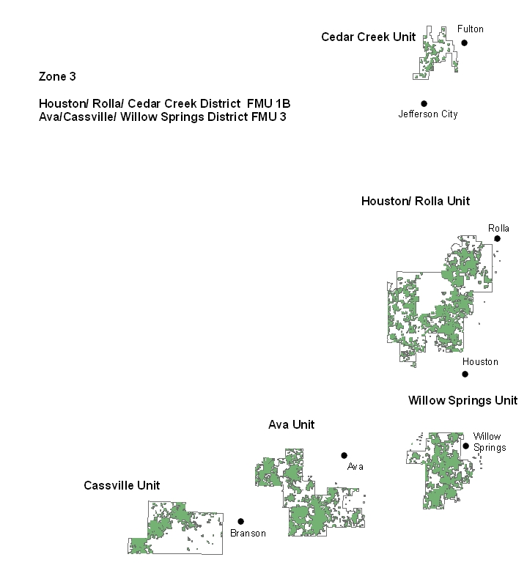

3.2.2.1B. FMU Guidance
This FMU includes:
MP 1.1; Cedar Creek Prairie, Western Star Savanna & Woodland, Big Piney South
MP 1.2; Kaintuck Hollow, Big Piney North
National Register of Historic Places; Decker Cave
State Natural Area; Solomon Hollow Glades
Forest special areas; Kaintuck Hollow Fen, Mayfield Spring Wet Meadow, King Sink, Slaughter Sink
Other special areas; Natural Bridge
Developed recreation area; Lane Spring, Pine Ridge
This FMU also includes one Indiana bat hibernaculum that has specific standards and guidelines to protect Indiana bat winter habitat.
Desired Conditions: See Forest-wide
Objectives: See Forest-wide
Guidelines: See Forest-wide
Goals: See Forest-wide
Standards for Indiana bat hibernaculum:
- Prohibit removal of suitable roost trees and prescribed burning within the 20 acres of old growth and 130 acres of forest or mature woodland surrounding an Indiana bat hibernacula during the swarming and staging periods. Determin dates individually for each cave (normally between September 1 and November 1 and between March 15 and April 30 respectively.) (page 2-7).
- The area around occupied Indiana or gray bat caves is a smoke-sensitive area. Develop prescribed burn plans to avoid or minimize smoke influences at or near these caves. Give the U.S. Fish and Wildlife Service an opportunity to review and comment on prescribed burn plans within these areas. (page 2-7).

3.2.3.1B FMU Characteristics

3.2.3.1B.1. Safety
- In addition to Forest-wide safety considerations: Fort Leonard Wood is located in the north central part of the Rolla/Houston unit and effectively cuts the unit in half. Forest Service employees must drive around the Fort to get from one side of the unit to the other. In addition, the Forest’s Exclusive Use Type III helicopter cannot fly over the Fort’s airspace.
- On the northeast side of the Fort, there is an area of NFS land acquired from DOD that is an old firing range. There is a possibility that unexploded ordnance is still present on this area.
- A fireworks factory is located along K highway on the west side of the Rolla unit in an area with fairly frequent arson activity.

3.2.3.1B.2. Physical
- See Forest-wide

3.2.3.1B.3. Biological
- An Indiana bat hibernaculum is located within this FMU. There are specific standards and guidelines associated with that area, particularly as related to smoke management (Forest Plan page 2-15).

3.2.3.1B.4. Resources
There are no specific standards and guidelines for fire outside the Forest-wide for these areas.
- Developed recreation areas in this FMU are Lane Spring and Pine Ridge;
- Decker Cave is on the National Register of Historic Places;
- State Natural Area Solomon Hollow Glades occurs in the FMU;
- Forest special areas Kaintuck Hollow Fen, Mayfield Spring Wet Meadow, King Sink, Slaughter Sink occur in the FMU;
- Natural Bridges special area is in this FMU.

3.2.4.1B FMU Fire Environment

3.2.4.1B.1. Fire Behavior
- See Forest-wide

3.2.4.1B.2. Weather
- This FMU receives its fire weather information from the Springfield, Missouri weather service office.

3.2.1.2 FMU Snap Shot – FMU 2
- FMU Number: FMU 2 (Eleven Point & Poplar Bluff Units)
- Radio Frequency: High Hill, Sinking Creek, and Williamsville repeaters
- General Risk Category: Primarily Low with some areas of Moderate, particularly on the Poplar Bluff unit, and a few areas of High
- Fire Behavior Indicator: Burning Index and Ignition Component
- NFDRS Weather Station: Doniphan
- Nearest Weather Station: Doniphan, Big Spring,
- Acres/Agency: 496,843 Forest Service; 78,457 National Park Service (Ozark National Scenic Riverways)
- Predominant Vegetation Type: Oak-Pine; Oak-Hickory; Shortleaf Pine
- Unit: Eleven Point and Poplar Bluff
- IA Assets assigned to this FMU: 1 Zone FMO; 1 Zone AFMO; 1 Zone Fuels Specialist; 4 18/8 Firefighters; 3 dozers; 2 Type 6 engines
- Duty Officer: Zone FMO Keith Kelley
- IA Dispatch Office: Missouri Iowa Coordination Center (MOCC) (MO-MTF)
- Communities adjacent to or within FMU: Winona, Van Buren, Doniphan, Birch Tree, Handy, Bartlett, Fremont, Thomasville, Alton, Riverton, Eastwood, Bardley, Pine, Briar; Poplar Bluff, Ellsinore, Piedmont, Williamsville, Greenville
- LMP Options available for AMR: See Table 2-3 on page 2-17 of the 2005 Forest Plan. All options are available without restrictions for Management Prescriptions 1.1, 1.2, 2.1, and 6.2. All options are available in MP 6.1 but the District Ranger must approve motorized equipment use. All options except aerial retardant application are available in MP 6.3 with some restrictions on motorized equipment. All options except aerial retardant application are available in MP 8.1 with some restrictions on motorized equipment and use of unplanned ignitions for resource benefit in individual units. The only option available in MP 7.1 (developed recreation areas) is a perimeter strategy of control and the District Ranger must approve motorized equipment use.
- Special Safety Considerations: In addition to Forest-wide safety concerns, there are steep, rocky bluffs along the Eleven Point River corridor that end in sheer drops to the river level. Some areas of the Poplar Bluff District were impacted by a tornado in 2010 that left pockets of heavy fuel. For several years, these areas will have more intense fire behavior and will be more difficult to construct fireline through until the heavy fuels break up and deteriorate. Firefighters will need to consider firefighter and public safety carefully when determining suppression strategies in these areas. Indirect attack may be an appropriate strategy for some of these areas.

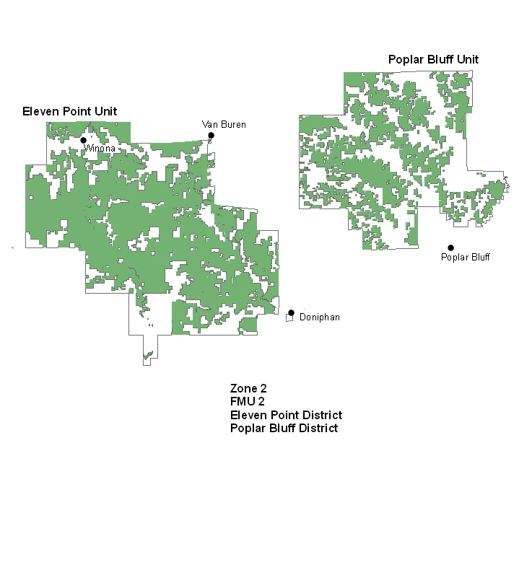

3.2.2.2 FMU Guidance
This FMU includes:
MP 1.1; Current River Pinery, Eleven Point Breaks, Bald Hill Glades and Woodlands, Cane Ridge Pinery, Mud Creek Hardwoods
MP 1.2; None
National Scenic River: Eleven Point
National Natural Landmark: Cupola Pond, Greer Spring
National Register of Historic Places; None
State Natural Areas; Bald Hill, Big Barren Creek, Brushy Pond, Coward’s Hollow, Cupola Pond, Haney Pond, Marg Pond, Mud Pond, Overcup Oak Sink, Red Maple Pond, Tunnel Bluff Woods, Tupelo Gum Pond, Wells Branch Fen
Forest special areas; Blue Flag Fen, Bear Pond, Camp Eight Pond, Charcoal Pond, Dammed Sinkhole Pond, Flat Pond, Fox Pond, FS Road 4147 Sinkhole, Grassy Pond, Hwy C Sinkhole Pond, McCormack Pond, Mud Pond, Old Kehres Pond, Oldham Pond, Otter Creek Ponds, Pin Oak Pond, Pine Pond, Polecat Pond, Tanbark Pond, Twin Ponds, Victory Pond, Whitten Church Pond, Young Hollow, The Gulf
Other special areas: Lower Current River, Irish Wilderness Excluded Lands, Pump Hollow
Developed recreation areas; Watercress, Markham Springs, Pinewoods, Float Camp, Greer
Several small lakes that include dispersed recreation sites.
This FMU also includes two Indiana bat hibernaculum and one Indiana bat maternity colony area of use that have specific standards and guidelines.

Desired Conditions: See Forest-wide
Objectives: See Forest-wide
Guidelines: See Forest-wide
Goals: See Forest-wide
Standards for Indiana bat hibernaculum:
- Prohibit removal of suitable roost trees and prescribed burning within the 20 acres of old growth and 130 acres of forest or mature woodland surrounding an Indiana bat hibernacula during the swarming and staging periods. Determin dates individually for each cave (normally between September 1 and November 1 and between March 15 and April 30 respectively.) (page 2-7).
- The area around occupied Indiana or gray bat caves is a smoke-sensitive area. Develop prescribed burn plans to avoid or minimize smoke influences at or near these caves. Give the U.S. Fish and Wildlife Service an opportunity to review and comment on prescribed burn plans within these areas. (page 2-7).
Standards for special areas:
- There are specific standards and guidelines for the Eleven Point National Scenic River, Cupola Pond, Greer Spring, but none that are specific to fire management.

3.2.3.2 FMU Characteristics

3.2.3.2.1. Safety
- Persons unfamiliar with the topography near the Eleven Point River should be cautious when constructing line due to the presence of sheer cliff faces.

3.2.3.2.2. Physical
- The east side of this FMU is near the Mingo National Wildlife Refuge Class I airshed. Prescribed burning on the Poplar Bluff unit with westerly winds would push smoke toward that area.

3.2.3.2.3. Biological
- An Indiana bat hibernaculum is located within this FMU. There are specific standards and guidelines associated with that area, particularly as related to smoke management (Forest Plan page 2-15).

3.2.3.2.4. Resources
There are no specific standards and guidelines for fire outside the Forest-wide for these areas.
- Developed recreation areas in this FMU are Watercress, Markham Springs and Pinewoods;
- State Natural Areas Bald Hill, Big Barren Creek, Brushy Pond, Coward’s Hollow, Cupola Pond, Haney Pond, Marg Pond, Mud Pond, Overcup Oak Sink, Red Maple Pond, Tunnel Bluff Woods, Tupelo Gum Pond, and Wells Branch Fen occur in this FMU;
- Forest special areas Blue Flag Fen, Bear Pond, Camp Eight Pond, Charcoal Pond, Dammed Sinkhole Pond, Flat Pond, Fox Pond, FS Road 4147 Sinkhole, Grassy Pond, Hwy C Sinkhole Pond, McCormack Pond, Mud Pond, Old Kehres Pond, Oldham Pond, Otter Creek Ponds, Pin Oak Pond, Pine Pond, Polecat Pond, Tanbark Pond, Twin Ponds, Victory Pond, Whitten Church Pond, Young Hollow, The Gulf occur in the FMU;
- Lower Current River and Pump Hollow special areas are in this FMU;
- While there are no specific standards for wildfire suppression for the Eleven Point National Scenic River zone, there are concerns for the experience of the recreating public within that zone. The Line Officer has asked to be involved in decisions regarding strategy and tactics within the river zone.

3.2.4.2 FMU Fire Environment

3.2.4.2.1. Fire Behavior
- See Forest-wide

3.2.4.2.2. Weather
- This FMU receives its fire weather information from the Paducah, Kentucky weather service office.

3.2.1.3 FMU Snap Shot – FMU 3
- FMU Number: FMU 3 (Ava/Cassville/Willow Springs Unit)
- Radio Frequency: Blue Buck, Hercules, and Lohmer repeaters
- General Risk Category: Primarily Moderate with a large amount of High on the Cassville and Willow Springs units and some High on the Ava unit, and a fair amount of Moderate
- Fire Behavior Indicator: Burning Index and Ignition Component
- NFDRS Weather Station: Ava
- Nearest Weather Station: Ava
- Acres/Agency: 284,928 acres Forest Service; 1,937 acres National Park Service (Wilson’s Creek National Battlefield and George Washington Carver National Monument)
- Predominant Vegetation Type: Eastern redcedar/oak-hickory, native grass (glades), oak-hickory, oak-pine, shortleaf pine
- Unit: Ava/Cassville/Willow Springs
- IA Assets assigned to this FMU: 1 Zone FMO (shared with FMU 1b), 1 Zone AFMO, 3 18/8 Firefighters, 2 dozers and 1 Type 6 engine.
- Duty Officer: Zone FMO Reggie Bray
- IA Dispatch Office: Missouri Iowa Coordination Center (MOCC) (MO-MTF)
- Communities adjacent to or within FMU: Ava, Chadwick, Low Gap, Pine Ridge, Garrison, Taneyville, Bradleyville, Hercules,Fairview, Longrun, Brownbranch, McClurg, Pondfork, Thornfield, Cassville, Shell Knob, Branson West, Branson, Kimberling City, Lampe, Seligman, Bates Corner, Hailey, Hill City, Lohmer, Willow Springs, West Plains, Vanzant, Dora, Siloam Springs, Pomona,
- LMP Options available for AMR: See Table 2-3 on page 2-17 of the 2005 Forest Plan. All options are available without restrictions for Management Prescriptions 1.1, 1.2, 2.1, and 6.2. All options are available in MP 6.1 but the District Ranger must approve motorized equipment use. All options except aerial retardant application are available in MP 6.3 with some restrictions on motorized equipment. All options except aerial retardant application are available in MP 8.1 with some restrictions on motorized equipment and use of unplanned ignitions for resource benefit in individual units. The only option available in MP 7.1 (developed recreation areas) is a perimeter strategy of control and the District Ranger must approve motorized equipment use.
- Special Safety Considerations: This FMU has the fastest growing population, particularly around the Table Rock Lake/Branson area. The number of homes and communities near National Forest lands keeps increasing. The fuel types in this area are primarily eastern redcedar/hardwood with many glades having flashy grassland fuels. This is the area of the Forest most likely to have significant control problems if a fire occurs here during the right weather conditions. The grassland fuel types have the potential for fast-moving fires with extreme flame lengths that could take firefighters and the public by surprise. This FMU also has the steepest terrain with greatest elevation change in a short distance of all the Forest’s FMUs. Use of mechanical equipment to construct fireline is limited or impossible in many parts of this FMU. The shallow soils and presence of large and numerous glades also limits the use of mechanically constructed fireline (pages 2-16, 2-18, 2-19).

3.2.2.3 FMU Guidance
This FMU includes:
MP 1.1: Big Creek Basin Glades, Cassville Glades, North Fork River
MP 1.2: Ava Glades
National Forest Scenic Byways: Blue Buck Knob, Glade Top Trail, Sugar Camp
National Recreation Trail: Ridge Runner
National Register of Historic Places: None
Society of American Foresters Natural Area: Hayden Bald
State Natural Areas: Butler Hollow Glades, Carman Springs, Hayden Bald,
Forest special areas: None
Other special areas: Galloway Spring, Indian Creek, Twin Sink Hollows
Developed recreation areas; Big Bay, Shell Knob, Cobb Ridge, North Fork
Several small lakes that include dispersed recreation sites.
Desired Conditions: See Forest-wide
Objectives: See Forest-wide
Guidelines:
Activities related to recreation, scenic quality, heritage resources travel and tourism will take priority within and adjacent to these routes (National Forest Scenic Byways). Other resource activities should enhance rather than detract from recreation or visual management. (page 3-62).
Goals: See Forest-wide
Standards:
Burn the site (Hayden Bald) every 4 to 6 years. (page 3-59).

3.2.3.3 FMU Characteristics

3.2.3.3.1. Safety
- Flashy fuels in this FMU can result in fast-moving fires, even on moderate fire danger days. Suppression strategies must take into account the potential growth of fires in these fuel models. Firefighter safety can be compromised if firefighters are unaware of the potential for fast-moving fires. Do not place firefighters at the head of these kinds of fires without a secure anchor point and established safety zones and escape routes.
- The presence of homes intermingled with National Forest lands increases the potential for Forest Service firefighters to be involved in structure protection activities. Firefighters must understand the limits of their knowledge and equipment and know what the trigger points are to abandon firefighting activities at structures.
- Construction of fireline by hand instead of mechanically across glades and rock outcroppings presents its own hazards from using varying hand tools, and constructing line more slowly.

3.2.3.3.2. Physical
- Glade soils are very shallow and there are specific restrictions on fireline construction across these soils/areas (Forest Plan pages 2-16 and 2-18/19).

3.2.3.3.3. Biological
- The glades in this FMU are a unique natural and biological resource. There are specific standards and guidelines to reduce or remove impacts to these areas, particularly in regard to fireline construction for both prescribed fires and wildfire suppression (Forest Plan pages 2-16 and 2-18/19).

3.2.3.3.4. Resources
- Other than Hayden Bald, there are no specific standards and guidelines for these areas that are related to fire management.
- The Ridge Runner National Recreation Trail, Blue Buck Knob, Glade Top Trail, and Sugar Camp National Forest Scenic Byways are all within this FMU. Hayden Bald is a Society of American Foresters Natural Area. State Natural Areas: Butler Hollow Glades, Carman Springs and Hayden Bald are in this FMU, as are special areas Galloway Spring, Indian Creek, and Twin Sink Hollows.

3.2.4.3 FMU Fire Environment

3.2.4.3.1. Fire Behavior
- See Forest-wide

3.2.4.3.2. Weather
- This FMU receives its fire weather information from the Springfield, Missouri weather service office.

3.2.1.4 FMU Snap Shot – FMU 4
- FMU Number: FMU 4 (Wilderness and Recommended Wilderness Additions)
- Radio Frequency: Hercules, Blue Buck, Roby, Buick, Sinking, High Hill
- General Risk Category: Paddy Creek Low; Hercules Glade mostly Moderate and some Low; Devils Backbone Moderate; Piney Creek mostly Low with some Moderate; Rock Pile Mountain Low; Bell Mountain Moderate; Irish Wilderness Low with small patch of High
- Fire Behavior Indicator: Burning Index and Ignition Component
- NFDRS Weather Station: Ava (Hercules, Piney Creek, Devils Backbone); Sinkin Creek (Rock Pile Mountain, Paddy Creek); Doniphan (Irish); Council Bluff (Bell Mountain)
- Nearest Weather Station: Same as NFDRS
- Acres/Agency Wilderness: Paddy Creek 6,728; Hercules Glade 12,314; Devils Backbone 6,595; Piney Creek 7,927; Rock Pile Mountain 4,159; Bell Mountain 8,777; Irish Wilderness 16,500.
- Acres/Agency Recommended Wilderness Additions: Paddy Creek 200; Hercules Glade 80; Piney Creek 20; Rock Pile Mountain 120; Bell Mountain 230
- Predominant Vegetation Type:
- Paddy Creek – Oak-Hickory; Oak-Pine (within FMU 3 Cassville unit).
- Hercules Glade – Prairie vegetation intermingled with Eastern Redcedar on the thinnest soils; Eastern Redcedar/Hardwoods and Oak-Hickory on deeper soils (within FMU 3 Ava Unit).
- Devils Backbone – Oak-Hickory with scattered limestone glades (within FMU 3 Willow Springs Unit).
- Piney Creek – Oak-Hickory; Eastern Redcedar/Hardwood; limestone/dolomite glades with prairie vegetation (within FMU 1B Houston unit).
- Rock Pile Mountain – Oak-Pine; Eastern Redcedar/Hardwoods; granite glades with prairie vegetation; Bottomland Hardwoods (within FMU 1A Fredericktown unit).
- Bell Mountain – Oak-Hickory; Oak-Pine; Shortleaf Pine; Igneous glades with praire vegetation (within FMU 1A Potosi District)
- Irish Wilderness – Oak-Hickory; Oak-Pine; Shortleaf Pine; Bottomland Hardwoods; a few limestone glades with prairie vegetation (within FMU 2 Eleven Point District)
- Unit: Paddy Creek, Hercules Glade, Devils Backbone Piney Creek, Rock Pile Mountain, Bell Mountain, Irish Wilderness and recommended wilderness additions to Paddy Creek, Hercules Glade, Piney Creek, Rock Pile Mountain, and Bell Mountain
- IA Assets assigned to this FMU: FMU 1, FMU 1a, FMU 2, and FMU 3 assets are all available for this FMU
- Duty Officer: Zone FMO’s assigned to FMUs 1, 2, 3
- IA Dispatch Office: Missouri Iowa Coordination Center (MOCC) (MO-MTF)
- Wilderness Rangers: vice James Murrell (Paddy Creek, Hercules Glade, Devil’s Backbone, Piney Creek) and Wilmer (Scotty) Scott (Rock Pile Mountain, Bell Mountain, Irish Wilderness)
- Communities adjacent to or within FMU:
- Paddy Creek –Roby, Hazelton, Evening Shade, Slabtown
- Hercules Glade – Hercules, Bradleyville, Hilda, Fairview
- Devils Backbone – West Plains
- Piney Creek – Shell Knob, Hill City, Cato, Lohmer
- Rock Pile Mountain – Cherokee Pass, Central, Jewett
- Bell Mountain – Redmondville, Banner, Belleview, Edgehill
- Irish Wilderness – Pine, Bardley, Wilderness
- Outfitter/Guide Special Use Permits:
- As of November 2011, there are 8 Outfitter/Guide special use permits on the Forest for canoe outfitters for customers floating the North Fork River through the Devil’s Backbone Wilderness on the Willow Springs unit (addresses on file with Forest Recreation specialist).
- LMP Options available for AMR: All options (with restrictions) are available for fire suppression except aerial retardant application. Naturally ignited wildfire may be used for resource benefit only when approved in a signed Wilderness Fire Management Plan. Control and monitoring strategies are allowed, but with approvals needed for motorized equipment use and helicopter water drops. (page 2-17).
- Special Safety Considerations: Within FMU 4, there is no motorized access and no use of mechanized equipment unless authorized by either the Forest Supervisor (chainsaws, leaf blowers, ATVs) or Regional Forester (tractors) (page 3-24). Suppression strategies of containment and control are allowed, dependent on the Fire Intensity Level present at the time (page 3-24). Limitations on the use of mechanized equipment may increase the amount of time it would take to construct line and contain a fire. It will probably also increase the size of wildfires in this FMU due to the amount of time the fire would burn prior to a control line being established. Firefighters used to constructing line with bulldozers and leafblowers will have to adapt to implementing LCES and adjusting to fire behavior without being able to count on the line building capability of mechanized equipment. Firefighters will also have to guard against the factors of increased physical effort and fatigue when constructing handline and hiking to and from the fire location.

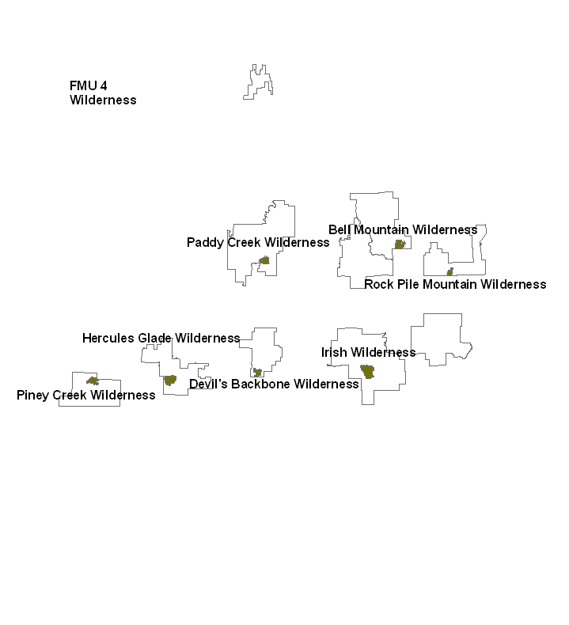

3.2.2.4 FMU Guidance

Desired Conditions: Wildernesses provide outstanding opportunities for solitude and primitive or unconfined types of recreation. Plant and animal diversity will depend entirely on the forces of nature. No motorized use will be permitted except as authorized by Law and Regulation. Evidence of other uses and man’s work will be substantially unnoticeable. (page 3-13)
Objectives: None given
Guidelines:
- The suppression strategy of control will be used for any wildfire with flame lengths in excess of four feet (fire intensity level 3+). (page 3-24)
- In the Hercules Glades, during either high or low damage period as stated in the Fire Management Action Guide and as modified by silviculturists, the suppression strategy of containment will be used for any wildfire with flame lengths of less than four feet (fire intensity level 0-2). (page 3-24).
- In other Wildernesses, during the high damage period as stated in the Fire Management Action Guide and as modified by silviculturists, the suppression strategy of containment will be used for any wildfire with flame lengths of less than four feet (fire intensity level 0-1). The suppression strategy of control will be used for any wildfire with flame lengths of three to four feet (fire intensity level 2). (page 3-24).
Goals: Provide for the use of prescribed fire as a management tool to perpetuate fire dependent ecosystems found within the Hercules Glade Wilderness when approved by the Chief of the Forest Service through a change in, or exception to, the National Wilderness Policy. (page 1-7). Administer Wilderness for use and enjoyment by people in a manner that leaves the areas natural characteristics unimpaired. (page 3-13).
Standards:
- No man-caused vegetative manipulation will be permitted beyond the minimum needed for trails and signs. Exceptions are…(2) vegetation may be removed to control man-caused wildfires and those natural wildfires and insect and disease outbreaks which threaten to spread beyond the Wilderness, (3) vegetation may be removed when absolutely necessary for rescue operations. (page 3-18).
- Protect Hercules Glade Wilderness as the only Class I air quality area on the Forest. (page 3-18).
- Projects involving manipulation of vegetative cover shall be approved by the Chief of the Forest Service on a project-by-project basis. All projects must have, as their objective, enhancement of the Wilderness resource. (page 3-23).
- The Forest Supervisor must approve the use of motorized equipment, including chain saws and mechanical transport, except tractors. (page 3-24).
- The Regional Forester must approve the use of tractors for fire suppression. (page 3-24).
- Evidence and damage resulting from vehicle travel will be obliterated or repaired as a cost of the fire. (page 3-24).
Guidelines:
- When approved by the Regional Forester thru a change in, or exception to, National Wilderness Policy, prescribed fire will be used where it can be determined that a certain frequency of fire is essential to aid, maintain, or restore natural plant communities or threatened and endangered plant species. (page 3-18).
- In cooperation with the State identify and quantify the indicators for Class I air quality to be used as the limits of acceptable change (LAC) for Air Quality Related Values (AQRV). This LAC will then be incorporated into the monitoring of the Hercules Glades Wilderness. (page 3-18).
- Accept the effects of flood, wind, pests, erosion, and other natural forces as part of the Wilderness experience and environment except as need to prevent unnatural loss of the Wilderness resource; unacceptable damage to resources on adjacent lands; or pose a threat to continued use and activities of the area. (page 3-19).
- The suppression strategy of control will be used for any wildfire with flame lengths in excess of four feet (fire intensity level 3+) (page 3-24).
- In the Hercules Glades, during either high or low damage period as stated in the Fire Management Action Guide and as modified by silviculturists, the suppression strategy of containment will be used for any wildfire with flame lengths of less than four feet (fire intensity level 0-2). (page 3-24).
- In other Wildernesses, during the high damage period as stated in the Fire Management Action Guide and as modified by silviculturists, the suppression strategy of containment will be used for any wildfire with flame lengths of less than three feet (fire intensity level 0-1). The suppression strategy of control will be used for any wildfire with flame lengths of three to four feet (fire intensity level 2). (page 3-24).

3.2.3.4 FMU Characteristics

3.2.3.4.1. Safety
- Firefighters will have to walk in to suppress fires within Wilderness boundaries, possibly for several miles. Pacing will be important to minimize fatigue and increased risk of accidents. All needed tools, equipment, and supplies will have to be packed in on foot or horseback.
- Because most work in wilderness would be done without benefit of mechanical equipment, firefighters will be exposed to the hazards inherent in using hand tools. Suppression efforts are likely to take longer, thereby increasing the risk of fatigue and potential accidents.
- Wilderness visitors may be unable to quickly leave an area within Wilderness affected by wildfire since they would be on foot or on horseback. Once visitors have entered a Wilderness, there is no quick or effective way to inform them of wildfire activity in the Wilderness. Information posted on trailheads can warn visitors of fire danger or ongoing wildfires.
- There may be outfitter-guide permits in MTNF Wildernesses. Permittees should be notified when there is wildfire within Wildernesses where they may have clients. The Forest Supervisor may temporarily close Wildernesses to visitors and to outfitter-guides if wildfires threaten public safety.

3.2.3.4.2. Physical
- Each Wilderness has its own physical setting described in Management Prescription 5.1 (Forest Plan pages 3-13 through 3-18).

3.2.3.4.3. Biological
- Each Wilderness has its own biological setting described in Management Prescription 5.1 (Forest Plan pages 3-13 through 3-18).

3.2.3.4.4. Resources
- Evidence of human activity is present in varying amounts and kinds within each individual Wilderness. Woods roads, constructed wildlife ponds, utility rights-of-way, old fences, and old house place sites are the most common. A few Wildernesses have tracts of private land within their boundaries as described in Management Prescription 5.1 (Forest Plan pages 3-13 through 3-18).
- Hiking trails are present in several of the Wildernesses.

3.2.4.4 FMU Fire Environment

3.2.4.4.1. Fire Behavior
- See Forest-wide

3.2.4.4.2. Weather
- Since there are Wildernesses located within the boundaries of each of the other FMU’s, all three weather service offices are involved in fire weather information for FMU 4.
APPENDIX A – General Risk Areas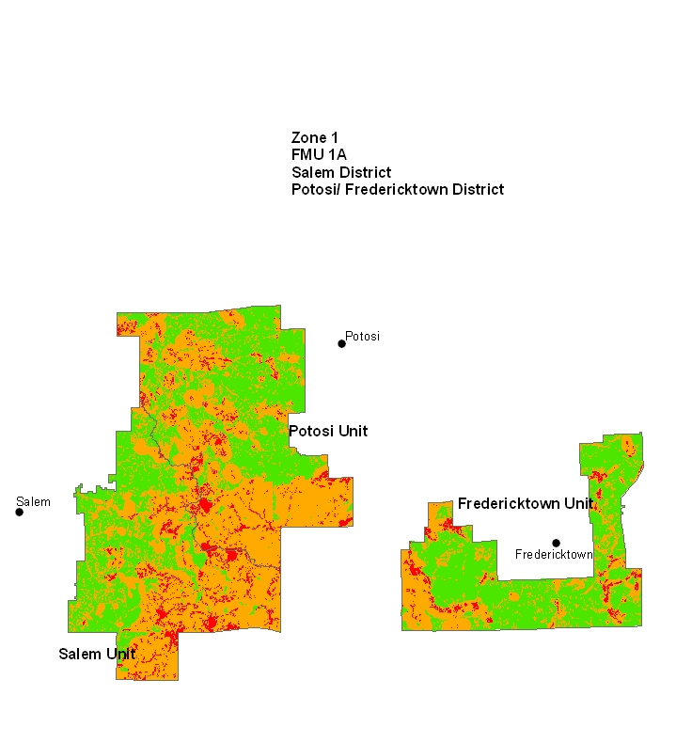

Red = High Risk
Orange = Moderate Risk
Green = Low Risk
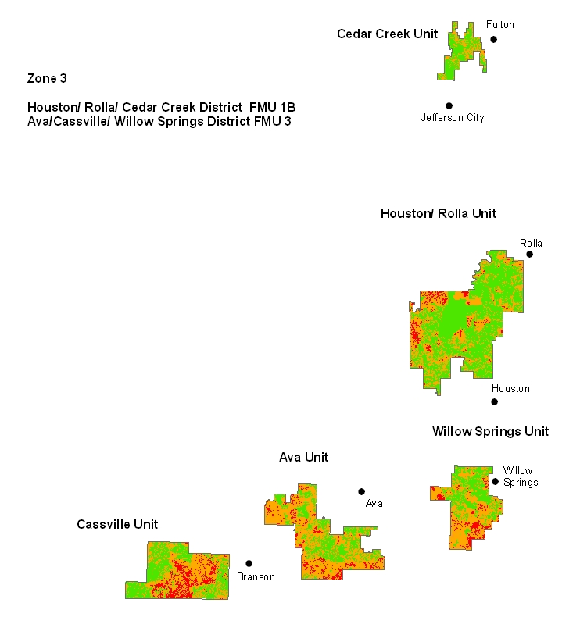

Red = High Risk
Orange = Moderate Risk
Green = Low Risk

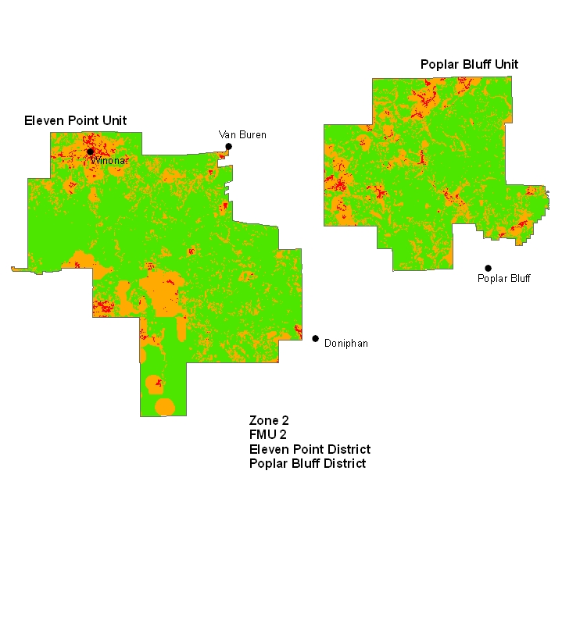

Red = High Risk
Orange = Moderate Risk
Green = Low Risk

Template document creation by USDA Forest Service, EMC-WOD, Publishing Arts, http://www.fs.fed.us/emc/pa
— Published January 2009 —

